**Student Final Grades Report**

|  |  |  |  |  |
| --- | --- | --- | --- | --- |
| **FirstName** | **LastName** | **grades.studentID** | **ID** | **course** |
| Syrena | Endivain | 2015_1 | 3 | CP104 |
| Irizon | Exibil | 2015_2 | 11 | CP104 |
| Del-Nara | Cardan | 2015_3 | 19 | CP104 |
| Ara | Zerga | 2015_4 | 27 | CP104 |
| Agnook | Tiovata | 2015_5 | 35 | CP104 |
| Ghent | Taurendil | 2015_6 | 43 | CP104 |
| Shass | Major | 2015_7 | 51 | CP104 |
| Anjylle | Ulluto | 2015_8 | 59 | CP104 |
| Sim | Ashen | 2015_9 | 67 | CP104 |
| Kahar | Donos | 2015_10 | 75 | CP104 |
| Zae | Kaiser | 2015_11 | 83 | CP104 |
| Koro | Magre | 2015_12 | 91 | CP104 |
| Lenders | Turon | 2015_13 | 99 | CP104 |
| Mala | Varless | 2015_14 | 107 | CP104 |
| Jag | Nafeel | 2015_15 | 115 | CP104 |
| Innoruuk | Finn | 2015_16 | 123 | CP104 |
| Keever | Phrog | 2015_17 | 131 | CP104 |
| Kaarl | Nooram | 2015_18 | 139 | CP104 |
| Tomas | Pescer | 2015_19 | 147 | CP104 |
| Allen | Bernard | 2015_20 | 155 | CP104 |
| Strilath | Mnaa | 2015_21 | 163 | CP104 |
| Tomra | Yavoog | 2015_22 | 171 | CP104 |
| Adoniram | Vadith | 2015_23 | 179 | CP104 |
| Braganti | Sudime | 2015_24 | 187 | CP104 |
| Oren | Haruhana | 2015_25 | 195 | CP104 |
| Reiko | Erelen | 2015_26 | 203 | CP104 |
| Jakuu | Hawkes | 2015_27 | 211 | CP104 |
| Tifa | Nere | 2015_28 | 219 | CP104 |
| Adan | Mackali | 2015_29 | 227 | CP104 |
| Xerda | Duann | 2015_30 | 235 | CP104 |
| Lila | Bintaghr | 2015_31 | 243 | CP104 |
| Noah | Rohtul | 2015_32 | 251 | CP104 |
| Yiukie | Eronoss | 2015_33 | 259 | CP104 |
| Kai | Dalgas | 2015_34 | 267 | CP104 |
| Tobian | Tarmin | 2015_35 | 275 | CP104 |
| Gaeton | Lerann | 2015_36 | 283 | CP104 |
| Montross | Anarth | 2015_37 | 291 | CP104 |
| Karn | Tong | 2015_38 | 299 | CP104 |
| Tendra | Olgad | 2015_39 | 307 | CP104 |
| Ubinaarisan | Shaknaw | 2015_40 | 315 | CP104 |
| Tarash | Selkayim | 2015_41 | 323 | CP104 |
| Shivas | Leqarna | 2015_42 | 331 | CP104 |
| Akana | Morrow | 2015_43 | 339 | CP104 |
| Kristofer | Kriek Kolbrun | 2015_44 | 347 | CP104 |
| Roth | We | 2015_45 | 355 | CP104 |
| Roy | Starwalker | 2015_46 | 363 | CP104 |
| Dorn | Shysha | 2015_47 | 371 | CP104 |
| Karva | Shapris | 2015_48 | 379 | CP104 |
| Cess | Zayelt | 2015_49 | 387 | CP104 |
| Dodge | Jantsk | 2015_50 | 395 | CP104 |

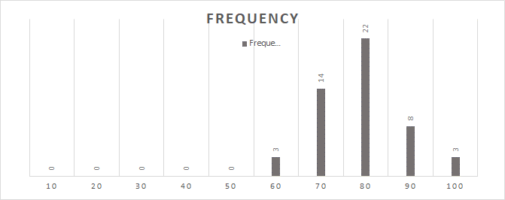

The histogram shows the final grade averages, the x-axis is the grades of the student's which are the frequency. Represented by the Y-axis is the bound that shows the amount of students who achieved that score.

|  |  |  |  |  |  |  |
| --- | --- | --- | --- | --- | --- | --- |
| **Data** | **A1** | **A2** | **A3** | **A4** | **Midterm** | **Exam** |
| **Min** | **47** | **45** | **47** | **48** | **45** | **46** |
| **Max** | **98** | **97** | **98** | **97** | **98** | **97** |
| **Mode** | **53** | **57** | **60** | **62** | **79** | **95** |
| **Median** | **78** | **68** | **68.5** | **64.5** | **77** | **61.5** |
| **Average** | **75.72** | **68.48** | **70.78** | **68.46** | **75.88** | **66.1** |
| **St Dev.** | **15.6961** | **14.2087** | **14.5998** | **14.57732374** | **14.133** | **16.2069** |

The above table displays the minimum, maximum, mode, median, average, and standard deviation of all course work