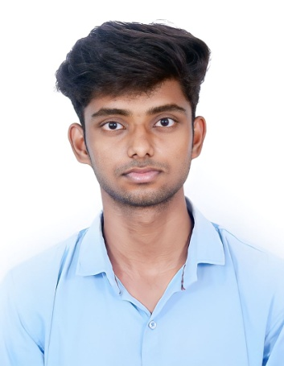

**DINESH A S**

**+91 8072558298**

E-mail Id: sureshdinesh71@gmail.com

# LinkedIn ID: https://www.linkedin.com/in/dinesh-as-8609aa228

**OBJECTIVE:**

A deeply focused and organized individual looking for opportunities

To grow and enhance myself while learning in different environment which will hone my skills.

# +EDUCATION QUALIFICATION:

|  |  |  |  |  |
| --- | --- | --- | --- | --- |
| **DEGREE** | **DISCIPLINE** | **INSTITUTION** | **COUNTRY** | **YEAR OF PASSING/PERCENTAGE** |
| B. Tech | AI&DS | Karpagam  Academy of Higher Education | INDIA | 2025  (pursuing)  CGPA-8.57  (upto 5th sem) |
| HSC | Math-IP | Sri Sankara Vidyalayaa Senior Secondary School | INDIA | 2021  75% |
| SSLC | __ | Sri Sankara Vidyalayaa Senior Secondary School | INDIA | 2019  74.4% |

# PROJECT:

* **Alumni Management**

Alumni Management is the practice of Managing and communicating with an organization's Alumni Network. This may require maintaining a database of contacts for alumni, organizing reunions and events, offering chances for networking and mentoring, and managing contribution and fundraising campaigns. In this project we are creating an simple Alumni application for our College

* + **Software :**
* Android Studio
* XML
* Java
* Firebase

# TECHNICAL SKILLS:

* **Programming Language**: C , Python
* **Web development**: HTML , CSS
* **Tools**: Power BI(basic)
* **Query Language:** SQL

# INTERNSHIP:

# Python Period of 30 days (June ,2022)

**Pantech e learning PVT LTD , Chennai.**

Python is a popular Object Oriented Programming Language .Python plays huge role in the Data Science field for analysis of data . High level programming language with Dynamic Semantics.

* **Web Development Period Of 30 days (Feb ,2023)**

**Pantech e learning PVT LTD ,Chennai.**

Web Development is associated with Creating ,Building and Maintaining websites and web applications that run online on a browser. It also include web design and programming and Database Management .

# CERTIFICATE:

* Certified in ‘Data Analysis’ from Pantech e learning PVT LTD
* Certified in ‘Tableau’, Data visualization tool for attending from Karpagam Academy of Higher Education
* Certified in ‘Web Development’ from Pantech e learning PVT LTD
* Certified in ‘Python’ from Pantech e learning PVT LTD

# ACHIEVEMENTS:

# Received a Certificate in CBSE clusters in volleyball.

# AREA OF INTEREST:

* Data Analysis
* Data Visualization
* Programming
* App development

# SOFT SKILLS:

* Communication
* Decision Making
* Punctual
* Team work
* Adaptability

# LANGUAGES KNOWN:

* English
* Tamil

# PERSONAL DETAILS:

Address : 9/163,L.R.G Colony,C.A.K Road,Karur-639001

Father’s Name : Sureshkumar S

Date of Birth : 18/ 08/ 2004

# DECLARATION:

I hereby declare that all above mentioned information is in accordance with factor truth up to my knowledge.