

IT 311 Hybrid Encryption Project
Section: 5C6
Group no. 1

No. | Student Name | Student Number
1 | Leen Alsanad
2
3
4

First Semester 2025

Table of Contents
Project Description: 3
System design 4
Encryption 4
Decryption 5
Implementation steps 6
PART 1: ENCRYPTION & HASHING 6
Step 1: Generate AES Key 6
Step 2: Input Plain Text 7
Step 3: Encrypt Plain Text 7
Step 4: Generate Hash 8
Part 2 : Decryption and Hash Verification Code 9
Step 1: Input Cipher Text 9
Step 2: Input Hash Value 10
Step 3: Recompute Hash 10
Step 4: Integrity Check 11
Step 5&6: Decrypt Cipher Text 12
Step 7: Summary Report 13
APPENDIX: 14
REFERENCES: 20

Project Description:

This project implements a Hybrid Encryption and Hashing System
that showcases how cryptographic techniques can be applied to
protect sensitive information and verify data authenticity.
The solution merges two critical security mechanisms: AES
symmetric encryption for data confidentiality and SHA-256
hashing for ensuring data has not been altered.
The application functions through a two-stage process:
encryption with hash generation, followed by verification
and decryption.

System design

Encryption
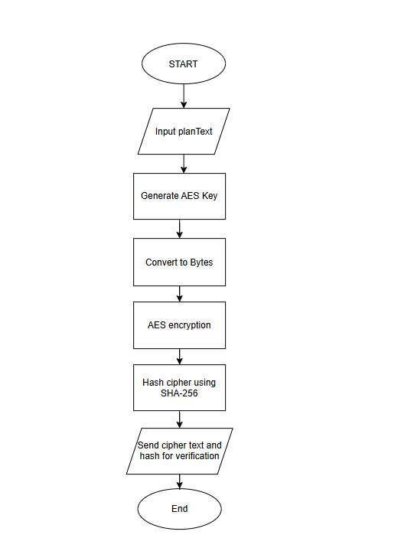

Decryption
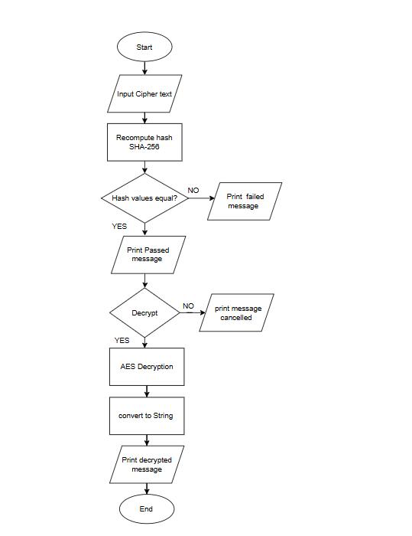

Implementation steps

PART 1: ENCRYPTION & HASHING

Step 1: Generate AES Key
- System generates random 128-bit AES key
- Key is displayed in Base64 format
- User should save this key
Code implementation:
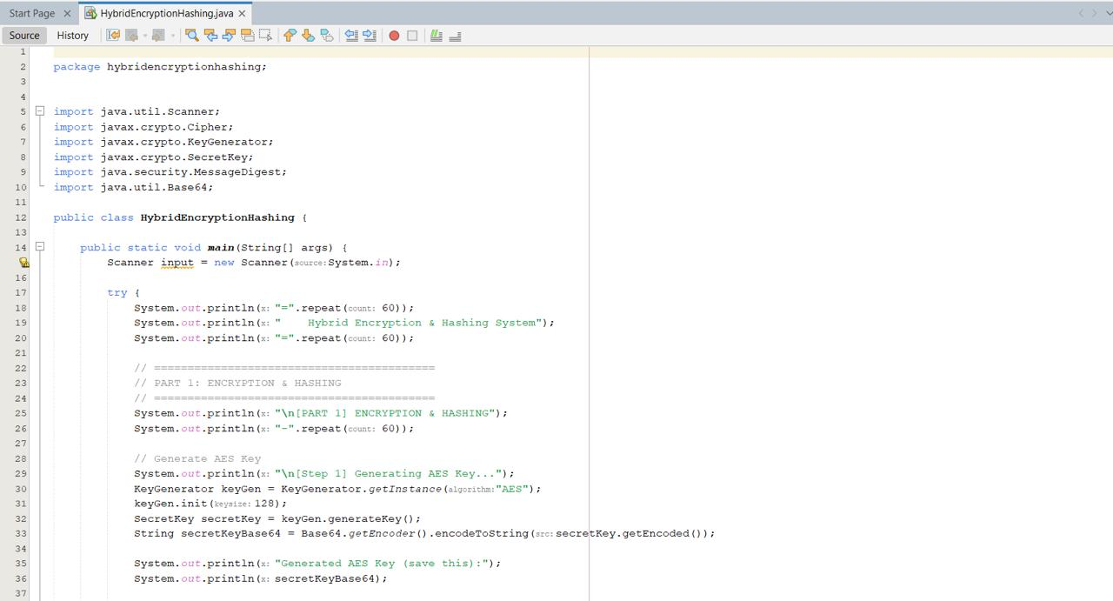
Output:
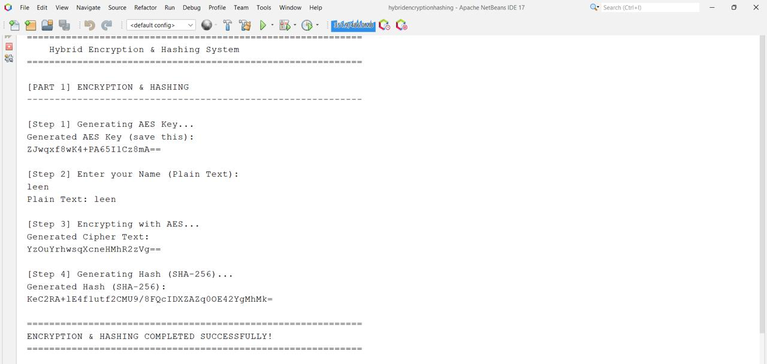

Step 2: Input Plain Text
- User enters their name or message
- This is the data to be encrypted
Code implementation:
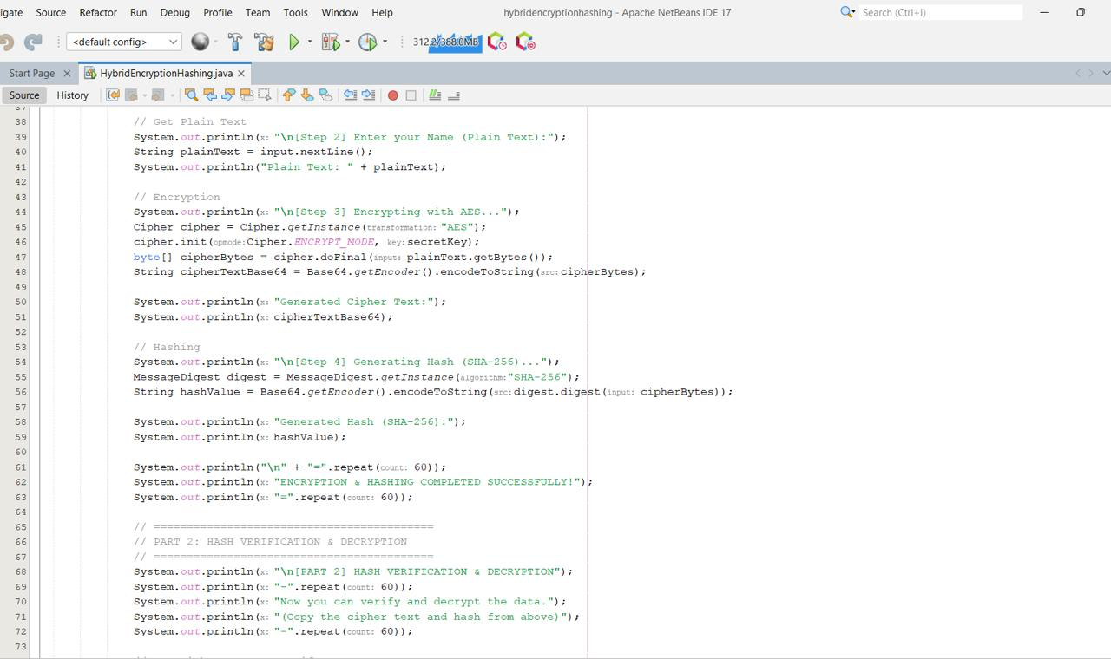
Output:

Step 3: Encrypt Plain Text
- System encrypts the text using AES
- Cipher text is displayed in Base64
Code implementation:
Output:

Step 4: Generate Hash
- SHA-256 hash is created from cipher text
- Hash ensures data integrity
Code implementation:
Output:

Part 2 : Decryption and Hash Verification Code

Step 1: Input Cipher Text
- User enters the cipher text for verification
Code implementation:
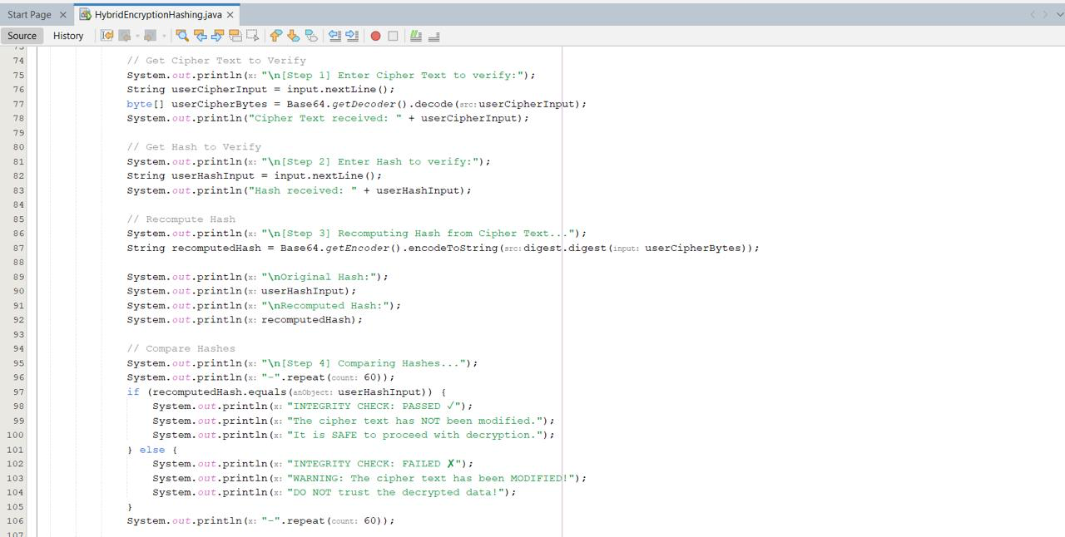
Output:
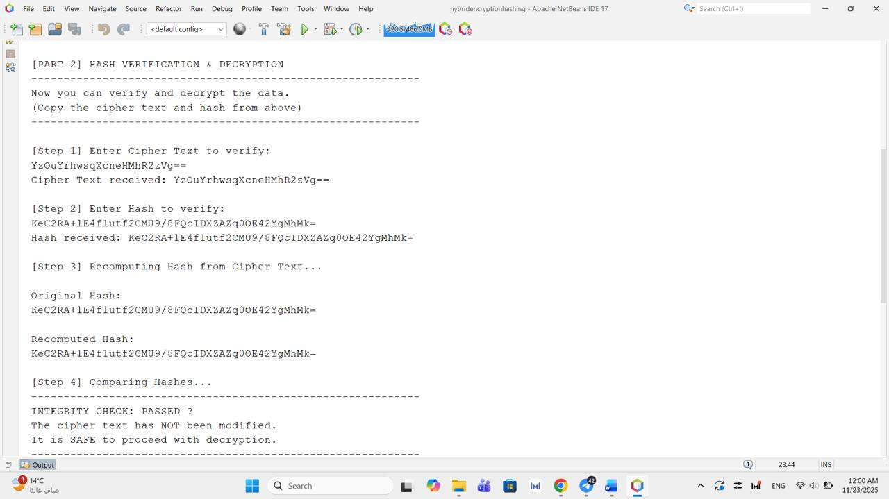

Step 2: Input Hash Value
- User provides the original hash
Code implementation:
Output:

Step 3: Recompute Hash
- System calculates hash from cipher text again
Code implementation:
Output:

Step 4: Integrity Check
- System compares original hash with new hash
- PASSED: Data is safe ✓
- FAILED: Data was modified ✗
Code implementation:
Output:

Step 5&6: Decrypt Cipher Text
- If integrity check passes, decrypt the data
- Original message is recovered
Code implementation:
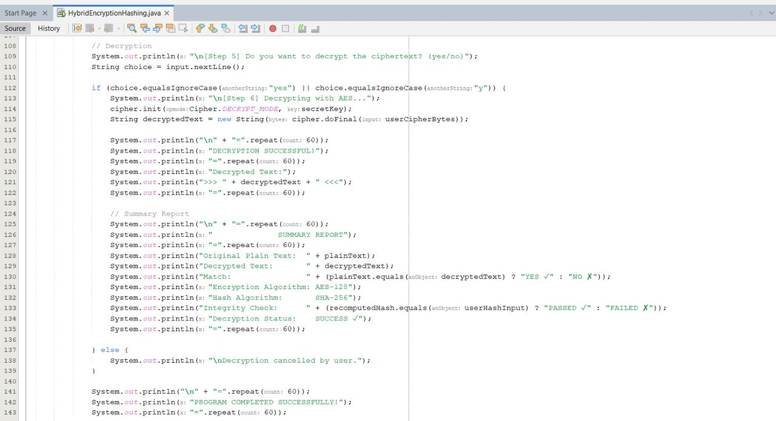
Output:
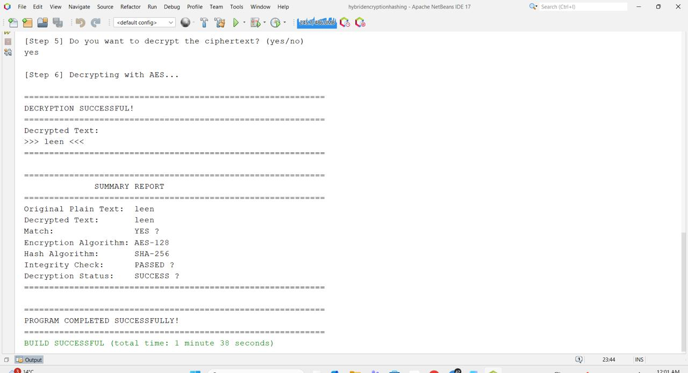

Step 7: Summary Report
- Shows complete process summary
- Confirms encryption success
Code implementation:
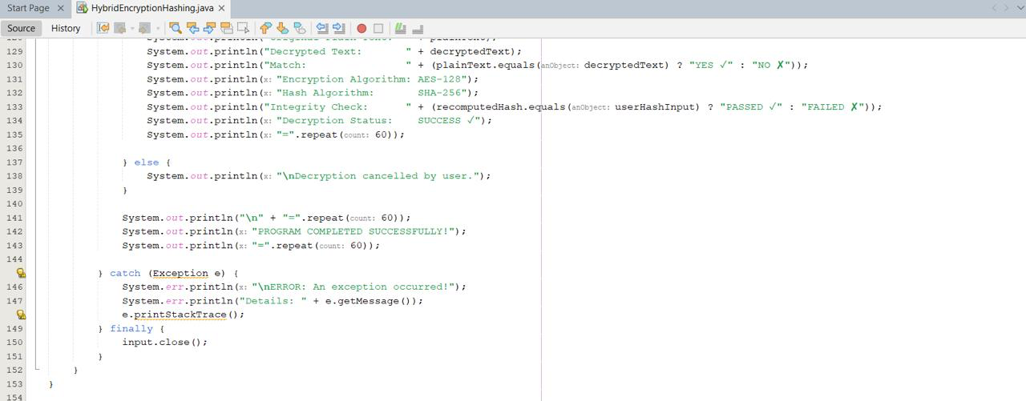
Output:

APPENDIX:

package hybridencryptionhashing;

import java.util.Scanner;
import javax.crypto.Cipher;
import javax.crypto.KeyGenerator;
import javax.crypto.SecretKey;
import java.security.MessageDigest;
import java.util.Base64;

public class HybridEncryptionHashing {

public static void main(String[] args) {
Scanner input = new Scanner(System.in);

try {
System.out.println("=".repeat(60));
System.out.println(" Hybrid Encryption & Hashing System");
System.out.println("=".repeat(60));

// ==========================================
// PART 1: ENCRYPTION & HASHING
// ==========================================
System.out.println("\n[PART 1] ENCRYPTION & HASHING");
System.out.println("-".repeat(60));

// Generate AES Key
System.out.println("\n[Step 1] Generating AES Key...");
KeyGenerator keyGen = KeyGenerator.getInstance("AES");
keyGen.init(128);
SecretKey secretKey = keyGen.generateKey();
String secretKeyBase64 = Base64.getEncoder().encodeToString(secretKey.getEncoded());

System.out.println("Generated AES Key (save this):");
System.out.println(secretKeyBase64);

// Get Plain Text
System.out.println("\n[Step 2] Enter your Name (Plain Text):");
String plainText = input.nextLine();
System.out.println("Plain Text: " + plainText);

// Encryption
System.out.println("\n[Step 3] Encrypting with AES...");
Cipher cipher = Cipher.getInstance("AES");
cipher.init(Cipher.ENCRYPT_MODE, secretKey);
byte[] cipherBytes = cipher.doFinal(plainText.getBytes());
String cipherTextBase64 = Base64.getEncoder().encodeToString(cipherBytes);

System.out.println("Generated Cipher Text:");
System.out.println(cipherTextBase64);

// Hashing
System.out.println("\n[Step 4] Generating Hash (SHA-256)...");
MessageDigest digest = MessageDigest.getInstance("SHA-256");
String hashValue = Base64.getEncoder().encodeToString(digest.digest(cipherBytes));

System.out.println("Generated Hash (SHA-256):");
System.out.println(hashValue);

System.out.println("\n" + "=".repeat(60));
System.out.println("ENCRYPTION & HASHING COMPLETED SUCCESSFULLY!");
System.out.println("=".repeat(60));

// ==========================================
// PART 2: HASH VERIFICATION & DECRYPTION
// ==========================================
System.out.println("\n[PART 2] HASH VERIFICATION & DECRYPTION");
System.out.println("-".repeat(60));
System.out.println("Now you can verify and decrypt the data.");
System.out.println("(Copy the cipher text and hash from above)");
System.out.println("-".repeat(60));

// Get Cipher Text to Verify
System.out.println("\n[Step 1] Enter Cipher Text to verify:");
String userCipherInput = input.nextLine();
byte[] userCipherBytes = Base64.getDecoder().decode(userCipherInput);
System.out.println("Cipher Text received: " + userCipherInput);

// Get Hash to Verify
System.out.println("\n[Step 2] Enter Hash to verify:");
String userHashInput = input.nextLine();
System.out.println("Hash received: " + userHashInput);

// Recompute Hash
System.out.println("\n[Step 3] Recomputing Hash from Cipher Text...");
String recomputedHash = Base64.getEncoder().encodeToString(digest.digest(userCipherBytes));

System.out.println("\nOriginal Hash:");
System.out.println(userHashInput);
System.out.println("\nRecomputed Hash:");
System.out.println(recomputedHash);

// Compare Hashes
System.out.println("\n[Step 4] Comparing Hashes...");
System.out.println("-".repeat(60));
if (recomputedHash.equals(userHashInput)) {
System.out.println("INTEGRITY CHECK: PASSED ✓");
System.out.println("The cipher text has NOT been modified.");
System.out.println("It is SAFE to proceed with decryption.");
} else {
System.out.println("INTEGRITY CHECK: FAILED ✘");
System.out.println("WARNING: The cipher text has been MODIFIED!");
System.out.println("DO NOT trust the decrypted data!");
}
System.out.println("-".repeat(60));

// Decryption
System.out.println("\n[Step 5] Do you want to decrypt the ciphertext? (yes/no)");
String choice = input.nextLine();

if (choice.equalsIgnoreCase("yes") || choice.equalsIgnoreCase("y")) {
System.out.println("\n[Step 6] Decrypting with AES...");
cipher.init(Cipher.DECRYPT_MODE, secretKey);
String decryptedText = new String(cipher.doFinal(userCipherBytes));

System.out.println("\n" + "=".repeat(60));
System.out.println("DECRYPTION SUCCESSFUL!");
System.out.println("=".repeat(60));
System.out.println("Decrypted Text:");
System.out.println(">>> " + decryptedText + " <<<");
System.out.println("=".repeat(60));

// Summary Report
System.out.println("\n" + "=".repeat(60));
System.out.println(" SUMMARY REPORT");
System.out.println("=".repeat(60));
System.out.println("Original Plain Text: " + plainText);
System.out.println("Decrypted Text: " + decryptedText);
System.out.println("Match: " + (plainText.equals(decryptedText) ? "YES ✓" : "NO ✘"));
System.out.println("Encryption Algorithm: AES-128");
System.out.println("Hash Algorithm: SHA-256");
System.out.println("Integrity Check: " + (recomputedHash.equals(userHashInput) ? "PASSED ✓" : "FAILED ✘"));
System.out.println("Decryption Status: SUCCESS ✓");
System.out.println("=".repeat(60));

} else {
System.out.println("\nDecryption cancelled by user.");
}

System.out.println("\n" + "=".repeat(60));
System.out.println("PROGRAM COMPLETED SUCCESSFULLY!");
System.out.println("=".repeat(60));

} catch (Exception e) {
System.err.println("\nERROR: An exception occurred!");
System.err.println("Details: " + e.getMessage());
e.printStackTrace();
} finally {
input.close();
}
}
}

REFERENCES:
For Java Cryptography Libraries:
Oracle Corporation. (2024). Java Cryptography Architecture (JCA) reference guide. Retrieved November 23, 2025, from https://docs.oracle.com/en/java/javase/17/security/java-cryptography-architecture-jca-reference-guide.html
Oracle Corporation. (2024). javax.crypto (Java SE 17 & JDK 17). Retrieved November 23, 2025, from https://docs.oracle.com/en/java/javase/17/docs/api/java.base/javax/crypto/package-summary.html
For Flowchart and Diagram Design:
International Organization for Standardization. (2019). Information technology—Process diagrams—Part 1: Technique for process modelling (ISO/IEC 15909-1:2019). ISO. https://www.iso.org/standard/67235.html
Institute of Electrical and Electronics Engineers. (1998). IEEE standard for functional modeling language—Syntax and semantics for IDEF0 (IEEE Std 1320.1-1998). IEEE Standards Association. https://standards.ieee.org/standard/1320_1-1998.html

