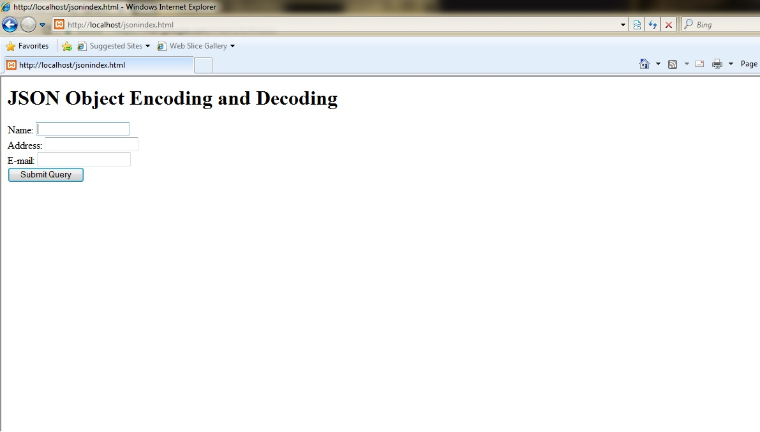

**Encoding php object in JSON**

{"name":"Swara","address":"Nashik","email":"swaradeshmukh@gmail.com"}

**Decoding json to php object**

object(stdClass)#2 (3) { ["name"]=> string(5) "Parth" ["rollno"]=> int(2) ["class"]=> string(4) "T.E." }

<html>

<body>

<h1> JSON Object Encoding and Decoding</h1>

<form action="jsontest.php" method="post">

Name: <input type="text" name="name"><br>

Address: <input type="text" name="address"><br>

E-mail: <input type="text" name="email"><br>

<input type="submit">

</form>

</body>

</html>