HHTI - Documentation

Prerequisites

- Connect the Buzzer to Nvidia Jetson Nano

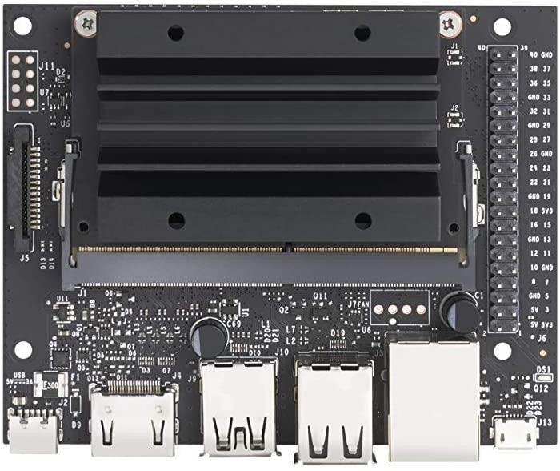

Below image refers to the pins (on the far right side) shown in the above image.

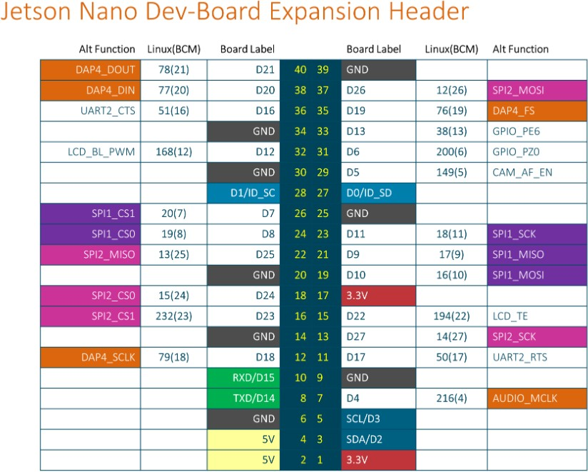

  - Connect white wire of the buzzer to the pin no. 29 on the jetson nano. Connect black wire of the buzzer to pin no.
30. Pin 30 refers to GND (ground) pin, which is on the left of pin 29 (Look at the below image, which is a cropped version of the first image). Please refer to shown images while attaching these pins.

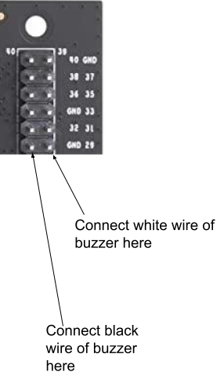

- Turn on the Raspberry Pi Zero
  - Attach power source to the Raspberry Pi Zero.
  - Turn on the power source.
  - Wait for 3-4 minutes till the device boots.
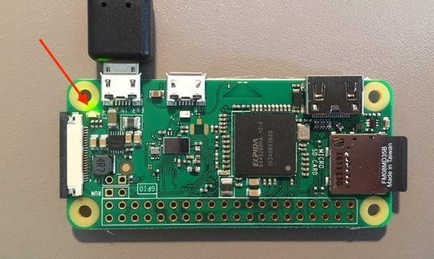
  - Verify if it is ON, by checking the yellow light is ON,
If it’s OFF that means the device has not turned ON.

- Turn on Jetson Nano
  - Attach keyboard, mouse, display cable, WiFi dongle and power source to Jetson Nano.
  - Turn on the power source to start the Jetson Nano.
- Verify that Nano & Raspberry is able to communicate
  - Once opened, write “ping 10.0.0.145” and press Enter.

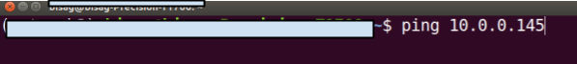
  - Press Ctrl + C after 20 seconds to stop executing this command.
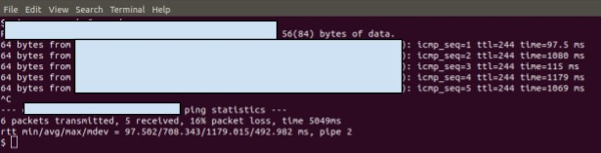
  - If it’s successfully able to ping, a response similar to below image will be shown. Means Jetson Nano and Raspberry Pi Zero are able to communicate to each other.
  - Failure response will look like the below image. That means Nano and Raspberry Pi Zero are not able to communicate to each other. To mitigate this issue, check if both of them are turned on properly, look at steps 2 & 3 in the Prerequisites section. Keep doing this step till you get a successful response shown above.

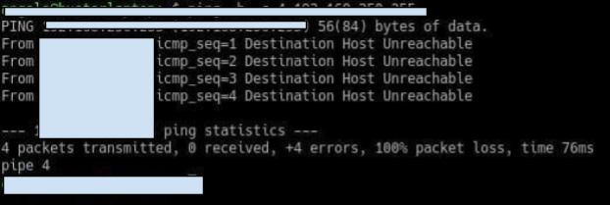
- HHTI will run even if the Raspberry Pi Zero is not ON or Unreachable. The Raspberry Pi Zero will vibrate if it is successfully connected with the HHTI application on Nvidia Jetson Nano.

How to turn on the HHTI Application

Configure below flags by editing
/home/user/Documents/HHTI/Config.py file.

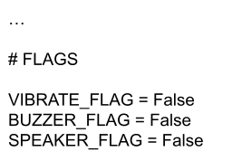

Change this flag value to “True” to turn on that particular flag.
Keep it to default if you don't want any of the listed functionalities (All False).
- Double click on the desktop icon called “HHTI” to turn it on, wait for some time till the GUI shows up.
HHTI Flow Diagram
Start

Web/
Video

No video path
Collection of data
frames
Terminate
image processing
using PyTorch
and opencv
Generate and Train
Data classifier opencv
using Pytorch
Serlalize data
Classifier and save pt
file
Load model pt file
from disk
Load person from
video stream/video
Image preprocssing
using PyTorch and
opencv
Apply bounding box
on detector person
show result
Stop
HHTI Person Detection Flow Diagram

Start

Initialize
the video/
web cam

No video path

Extract image from
the frames
Terminate

Load model pt file
from disk

Load person images form
Frame

Image preprocssing
using PyTorch and
opencv

Apply bounding box
on detector person

show result

Stop

HHIT Class Diagram

+ setupUi (MainWindow)
+ retranslateUi (MainWindow)
Ui_MainWindow

+ «create» MainWindow ()
+ long_range ()
+ connectToCamera ()
+ disconnectCamera (index)
+ showAboutDialog ()
+ getFromDictByTabIndex (dic, tabIndex)
+ updateDictValues (dic, tabIndex)
+ setFullScreen (flag)
+ setTabCloseToolTips (tabs, tooltip)
MainWindow
+ «create» CaptureThread ()
+ run ()
+ generate_metadata_yolov4 (preds)
+ generate_metadata_yolov5 (result_class_ids)
+ stop ()
+ connectToCamera ()
+ disconnectCamera ()
+ isCameraConnected ()
+ getInputSourceWidth ()
+ getInputSourceHeight ()
+ updateFPS (timeElapsed)
updateStatisticsInGUI end

CaptureThread

+ «create» YoLov5TRT ()
+ infer (img)
+ gen_obj_dict (ids)
+ destroy ()
+ preprocess_image (image_raw)
+ transform_boxes (boxes, mask, orig_h, orig_w)
+ post_process (output, orig_h, orig_w)

YoLov5TRT

+ «create» CameraView ()
+ delete ()
+ afterCaptureThreadFinshed ()
+ afterProcessingThreadFinshed ()
+ stopCaptureThread ()
+ stopProcessingThread ()
+ startThread ()
+ openLogFolder ()
+ pauseThread ()
+ updateCaptureThreadStats (statData)
+ updateProcessingThreadStats (statData)
+ updateFrame (frame)
+ clearImageBuffer ()
+ setImageProcessingSettings ()
+ updateMouseCursorPosLabel ()
+ newMouseData (mouseData)
+ handleContextMenuAction (action)

newImageProcessingFlags setROI
self.captureThread
self.processingThread self.isCameraConnected
CameraView

+ setupUi (CameraView)
+ retranslateUi (CameraView)
Ui_CameraView

+ «create» ImageProcessingSettingsDialog ()
+ updateStoredSettingsFromDialog ()
+ updateDialogSettingsFromStored ()
+ resetAllDialogToDefaults ()
+ smoothTypeChange (input)
+ validateDialog ()
+ resetSmoothDialogToDefaults ()
+ resetDilateDialogToDefaults ()
+ resetErodeDialogToDefaults ()
+ resetFlipDialogToDefaults ()
+ resetCannyDialogToDefaults ()

NewImageProcessingSettings

ImageProcessingSettingsDialog

+ «create» CameraConnectDialog ()
+ getDeviceUrl ()
+ getResolutionWidth ()
+ getResolutionHeight ()
+ getImageBufferSize ()
+ getDropFrameCheckBoxState ()
+ getApiPreference ()
+ getCaptureThreadPrio ()
+ getProcessingThreadPrio ()
+ getTabLabel ()
+ getEnableFrameProcessingCheckBoxState ()
+ setUrlMode (mode)
+ openFile ()
+ resetToDefaults ()
CameraConnectDialog

+ «create» SharedImageBuffer ()
+ getByDeviceUrl (deviceUrl)
+ removeByDeviceUrl (deviceUrl)
+ sync (deviceUrl)
+ wakeAll ()
+ setSyncEnabled (enable)
+ isSyncEnabledForDeviceUrl (deviceUrl)
+ getSyncEnabled ()
+ containsImageBufferForDeviceUrl (deviceUrl)
SharedImageBuffer
+ «create» FrameLabel ()
+ mouseMoveEvent (ev)
+ setMouseCursorPos (data)
+ getMouseCursorPos ()
+ mouseReleaseEvent (ev)
+ mousePressEvent (ev)
+ paintEvent (ev)
+ createContextMenu ()
newMouseData onMouseMoveEvent
FrameLabel

HHTI Requirements librarys

Package Version
------------------------------------------------------------------------------------------

PyQt5 5.15.7

pyqtgraph 0.11.1

opencv-contrib-python 4.5.4.58

opencv-python 4.5.3.56

torch 1.9.0

Pillow 8.3.2

numpy 1.19.5

tensorrt 8.0.1.6

torchvision 0.10.0

PyYAML 5.4.1

Jetson.GPIO 2.0.17

jetson-stats 3.1.3

matplotlib 2.1.1

scikit-learn 0.24.2

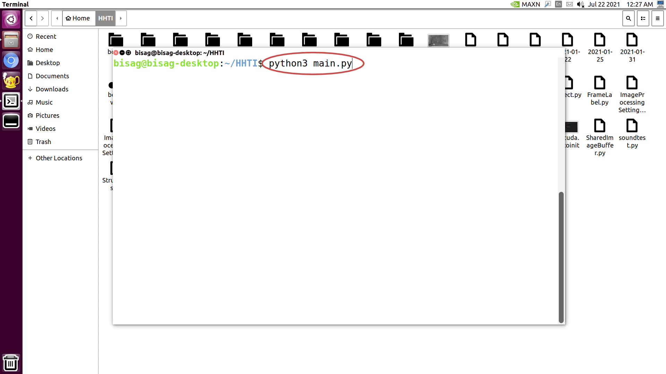

- After waiting for some time, if GUI is not showing up follow below steps to run the application,
- Open up terminal.(shortcut: Ctrl + Alt + T) If the shortcut is not working try to search “terminal” in the search bar. (shortcut: Windows key).
- Once opened, write “cd ~” and press Enter.
- Then, write “cd HHTI” and press Enter.
- Write “python3 main.py” and press Enter. This command will turn on the application.



How to close the HHTI Application
- There is a “quit” option inside the “File” button. File button will be located somewhere around the top left corner of the screen.
- Put the cursor on this button, and the “quit” button will show up. Click on it to close the application.
- Afterwards click on the desktop icon titled “Terminate”. This will turn off all the processes to our application which are running in the background.
How Connect to Camera

HHTI Main Window => Click Connect to camera Button

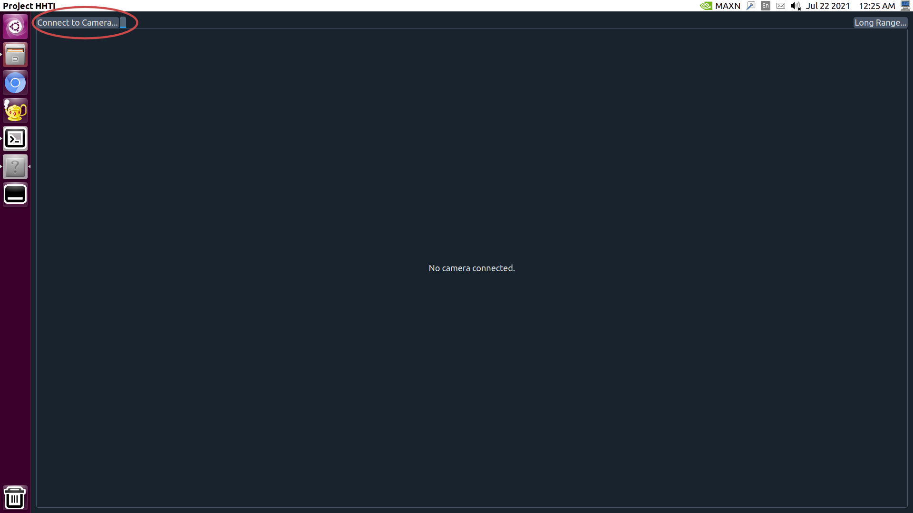

Fig.2

Fig 2:- In the figure 2 display HHTI main window the main window
contain 2 button Connect to camera and Long Range .

:- connect to camera contain detection the person
and animal vehicle.

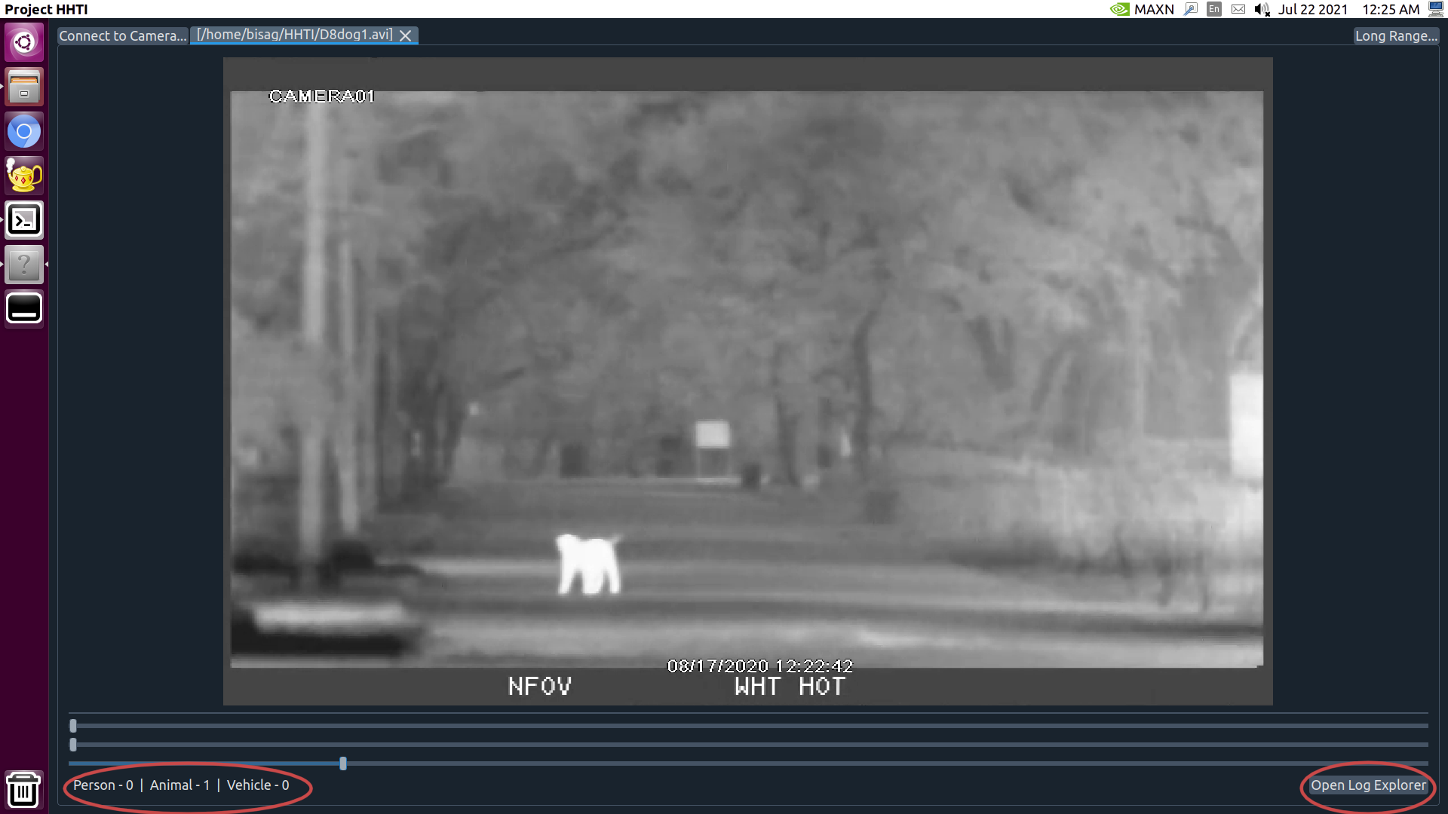
Fig.3

Fig 3:- In the figure 3 display video and it contains labels and log
file button.

:- labels count the detected person, animal and vehicle

:- open log explor button contain the log file in HHTI

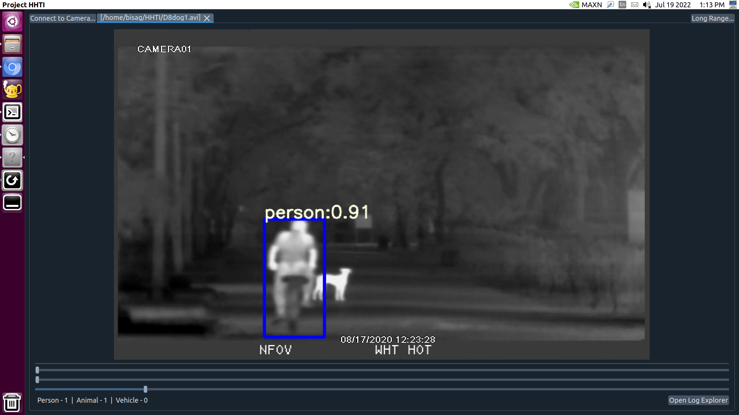
Fig.4

Fig 4:- The figure 4 detected person and draw bounding box around person.

:- The bounding box identify person and also provide accuracy.

- If somehow application is not closing properly follow below steps to turn off the application,
- Open up terminal.(shortcut: Ctrl + Alt + T) If the shortcut is not working try to search “terminal” in the search bar (shortcut: Windows key).
- Once opened, write “cd ~” and press Enter.
- Then, write “bash terminate.sh” and press Enter. This command will close the application.

Raspberry Pi Vibration:

Display all available networks in Wi-Fi
nmcli dev wifi

Connect to Jetson Nano Hotspot
nmcli device wifi connect test-ap password PASSWORD

Auto Connect Jetson Nano Hotspot using following Command
nmcli device set wlan0 autoconnect yes

