VoltRelay Energy
Battery-Swap Network Performance Analysis
Gradient Learnings Data Analytics Hackathon
Analysis Report
Prepared for: VoltRelay Operations & Customer Experience Leadership

1. Problem Understanding
VoltRelay Energy operates an unmanned battery-swap network for electric two- and three-wheelers across six Indian cities — Bengaluru, Delhi NCR, Hyderabad, Pune, Mumbai, and Jaipur. Its riders are gig and logistics workers who need a charged battery in about two minutes rather than hours on a plug. Over the 18 months covered by this dataset (January 2024–June 2025), VoltRelay expanded its station network in two waves, raised its base price, piloted peak/off-peak pricing in two cities, onboarded a new battery supplier, and renegotiated its largest fleet contract.
Completed swaps and revenue both grew substantially over this period. But leadership has observed three concerning signals alongside that growth: service failures rising faster than volume, new-rider retention softening, and per-swap profitability eroding — without a single consolidated analysis connecting these threads. This report investigates what the data actually shows about each of these, and what VoltRelay should prioritize next.

Scope of this analysis
This report addresses all six core questions posed in the hackathon brief — network performance over time, service failures and customer experience, station and geographic patterns, battery and equipment performance, pricing and partner economics, and root-cause analysis of retention — plus one optional deep-dive (an equipment anomaly in one battery supplier's initial production batch) and a light-touch view on VoltRelay's next budget decision.
As an observational, simulation-generated dataset, this analysis surfaces well-evidenced associations rather than proven causation. Where more than one explanation was plausible, we favored the interpretation supported by more than one independent cut of the data, and we say so explicitly.

2. Analytical Approach

2.1 Tools and method
The full pipeline — data loading, cleaning, exploratory analysis, and all six core questions — was built in Python using DuckDB for SQL-based analysis directly against the raw CSVs (avoiding the need to load the ~3.9 million-row swap event log entirely into memory), pandas for tabular manipulation, and matplotlib for visualization. The complete, runnable pipeline is provided as a companion Google Colab notebook.

2.2 Data cleaning decisions
Five deliberate cleaning steps were applied before analysis, all as flagged in the dataset's documented data-quality notes:
- City standardization: Collapsed inconsistent city-name spellings in riders.home_city (e.g. "Bangalore", "BLR", "bengaluru" → "Bengaluru") into six canonical cities.
- Firmware timezone bug: Corrected event_ts for swap events logged at stations on firmware v3.2.0 between 10 Mar–14 Apr 2025, which were written ~5h30m earlier than true local time, by adding back the offset for hour-of-day analysis.
- Duplicate detection: Flagged events at the same rider/station within 3 minutes of each other where at least one side was sync_mode = offline_batch (consistent with an offline-sync retry) and excluded the later event from analysis. This affected roughly 0.04% of events and, as expected, concentrated at fair/poor-connectivity stations — a check we ran to confirm the flag was catching the right pattern.
- Test stations: Excluded the small number of internal STN-TST* test stations from all network-performance analysis.
- Outlier handling: Left odometer-reset outliers in km_since_last_swap and slightly-above-100% sensor readings in place at the row level, filtering them out only in the specific calculations that use those fields, rather than discarding otherwise-valid rows.

2.3 Metric construction
Two metrics were purpose-built for this analysis because they aren't columns in the raw data:
- Contribution margin per swap: For each completed swap: amount charged, minus energy cost (energy drawn × the station's local grid tariff), minus a per-battery wear cost, minus an allocated share of that station's monthly rent and maintenance. The wear cost for each battery is its purchase cost × the share of state-of-health it has lost so far, spread evenly across its own cycles to date — this lets equipment that degrades faster (see Section 5) carry a proportionally higher cost per swap.
- New-rider retention: A rider who signed up on or after Jan 2024 is "activated" if they completed a swap within 14 days of signup, and "retained" if an activated rider completed a further swap between day 15 and day 45. We chose this window after checking the data: the median gap between consecutive swaps for active riders is only ~22 hours, so a naive 30-day-any-activity definition turned out to be almost meaningless (>99% of riders trivially cleared it) — a 14/45-day activation-then-return framing is far more discriminating for this rider base.

3. Key Insights & Business Findings

3.1 Network Performance Over Time
Completed swaps and revenue both grew steadily across the 18 months — roughly tripling from the first to the last full month of data. Failure rate did not track volume smoothly: it spikes sharply every April–June each year, roughly doubling relative to the rest of the year.
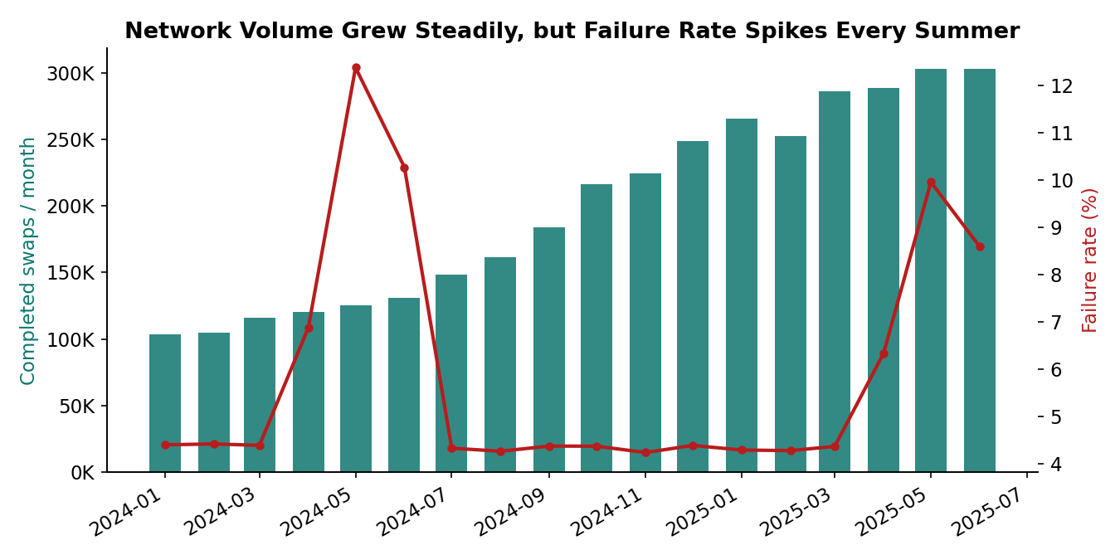
Figure 1. Monthly completed swaps (bars) vs. failure rate (line). Volume grows steadily; failure rate is seasonal, not trending.
On a pure per-completed-swap basis, blended contribution margin actually rose over the period — driven by the July 2024 base-price increase and falling average energy cost per swap. But this blended number obscures two countervailing forces. Margin-per-attempt (which reflects that a failed swap still consumes station capacity and rider goodwill for zero revenue) visibly dips in exactly the April–June failure-spike months. And starting in the second half of 2024, rising average battery wear cost (Section 3.4) and a wider average fleet discount (Section 3.5) both quietly offset the price increase.
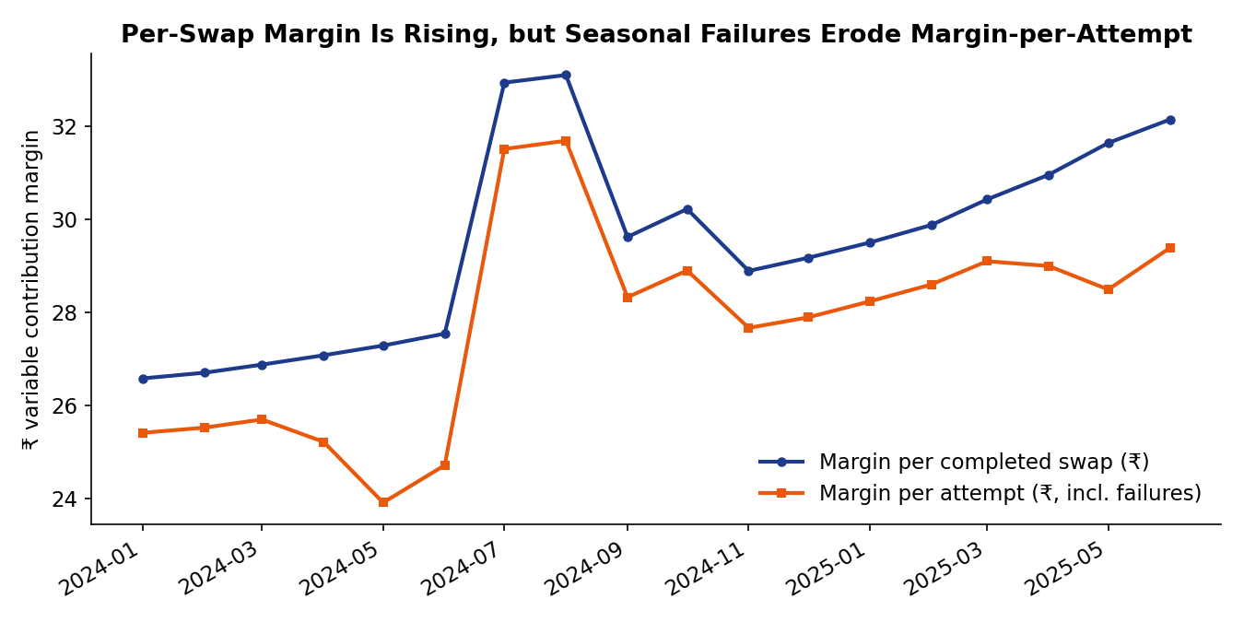
Figure 2. Contribution margin per completed swap (navy) keeps rising; margin per attempt (orange), which absorbs failed swaps at zero revenue, dips every summer.
Bottom line: revenue-and-volume health and unit-economics health are telling different stories. Growth metrics alone would miss the erosion; it only shows up once failures, wear, and discounting are netted against the price increase.

3.2 Service Failures and Customer Experience
Service quality is concentrated, not evenly spread across the network:
- Time of day: Failures cluster in the 7–10 PM evening rush, when queueing and stockouts are most likely.
- Season: Failure rate roughly doubles every April–June relative to the rest of the year — consistent with heat-driven charging and thermal issues, compounded by monsoon onset in June.
- Vehicle class: Three-wheelers fail at roughly twice the rate of two-wheelers (10.4% vs. 5.4%) — most likely a 3W-specific inventory/stockout problem rather than a mechanical one.
- Station concentration: Failure rate varies far more across individual stations than the network average suggests — a targeted, not network-wide, fix opportunity (see Section 3.3).
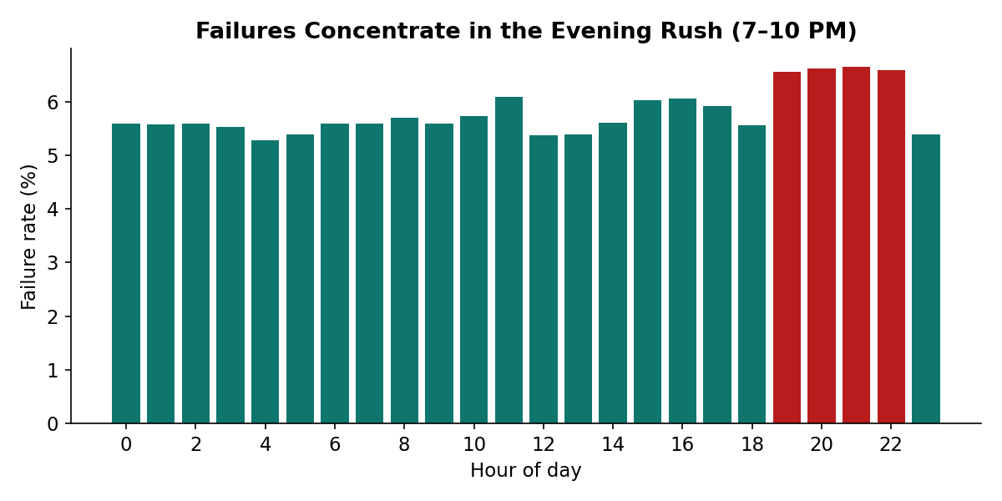
Figure 3. Failure rate by hour of day — evening hours (highlighted) run highest.
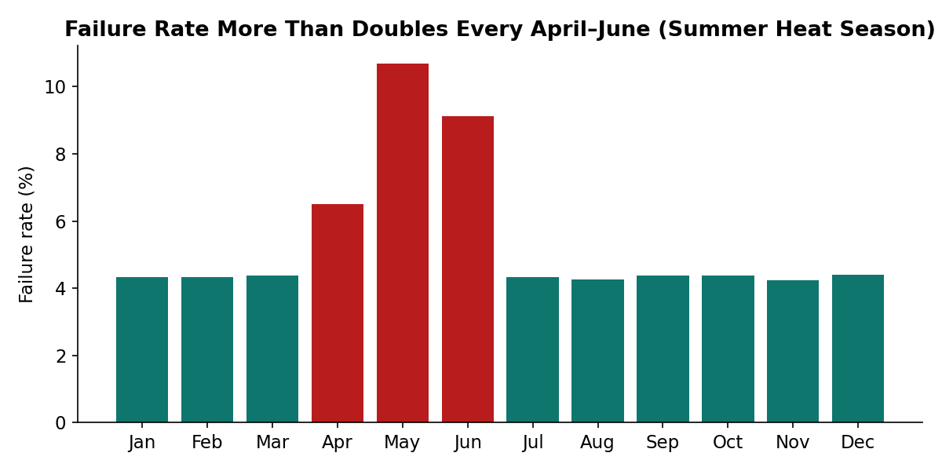
Figure 4. Failure rate by calendar month — April–June (highlighted) roughly doubles the rest of the year.
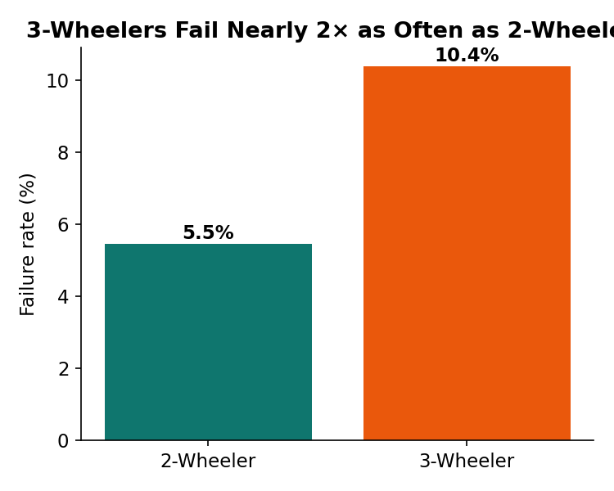
Figure 5. Three-wheeler swap attempts fail at nearly double the rate of two-wheelers.

3.3 Station and Geographic Patterns
Two compounding effects explain most of the station-level and geographic spread in service quality. First, equipment generation: Gen1 chargers fail roughly 50% more often than Gen2/Gen3 across every city, and the original "Launch"-wave stations are disproportionately Gen1. Second, geography is not purely an equipment story — even within the same charger generation, Delhi NCR and Jaipur stations run meaningfully higher failure rates and longer charge times than Mumbai, Bengaluru, or Pune, consistent with hotter average conditions and greater thermal stress in those cities. High-footfall location types (market, commercial_hub) also fail more often than quieter residential sites, pointing to a capacity/stockout issue at the busiest sites specifically.
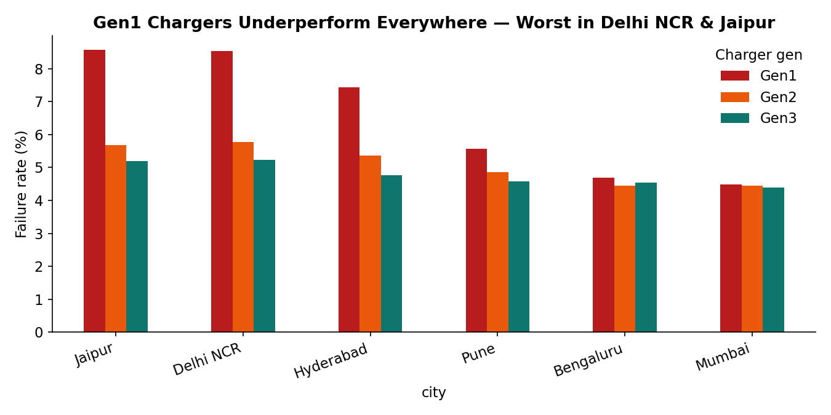
Figure 6. Failure rate by charger generation and city. Gen1 underperforms everywhere; Delhi NCR and Jaipur underperform within every generation.
Practical read: the fix is not "upgrade the whole network" — it's "prioritize Gen1 stations in Jaipur and Delhi NCR, especially at high-footfall sites," a far smaller and cheaper intervention than a blanket upgrade.

3.4 Battery and Equipment Performance
Kyron — the new battery supplier onboarded in bulk in July–September 2024 — stands out sharply. Its packs have degraded to an average of only ~62–64% state-of-health in under a year, versus ~80–82% for Cellora and Amptek packs of similar age, and deliver noticeably less range per swap (~53 km vs. ~64 km on the km_since_last_swap proxy).
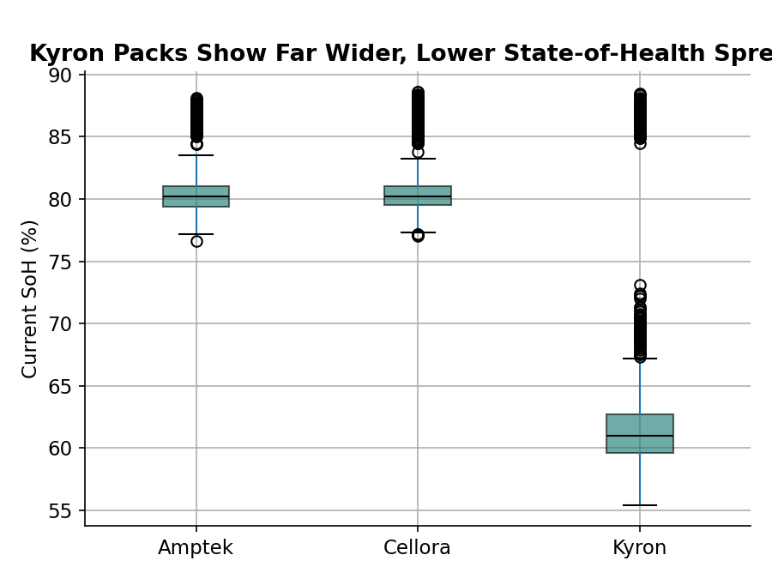
Figure 7. State-of-health distribution by supplier. Kyron's spread is far wider and lower than the other two suppliers.
Breaking Kyron down by manufacturing lot isolates the problem precisely: only the first three onboarding lots — roughly 1,460 packs purchased at initial scale in mid-2024 — show this severe degradation. Every Kyron lot commissioned from October 2024 onward performs in line with the other suppliers (86%+ SoH).
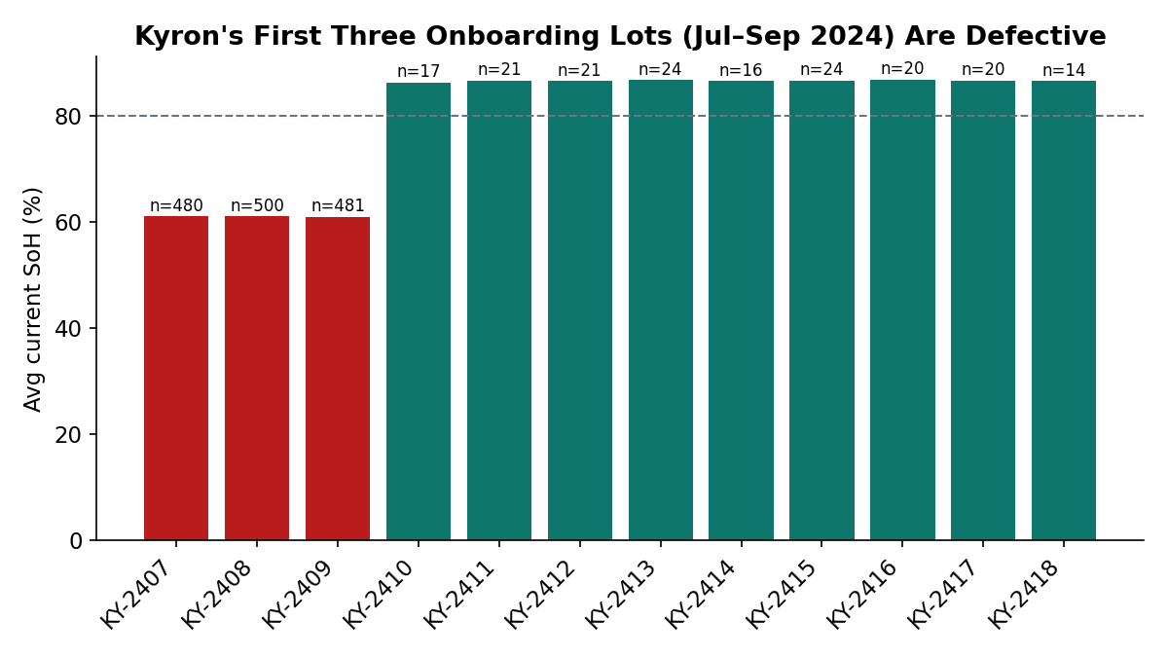
Figure 8. Average state-of-health by Kyron manufacturing lot. Only the first three lots (highlighted) are defective; every later lot is normal.
This is a strong signal of a since-corrected manufacturing or cell-chemistry defect confined to Kyron's initial production batch, not a supplier-wide or ongoing problem. Importantly, this shows up as a range/degradation/complaint issue, not a swap-completion-failure issue — swap completion rates by battery supplier are not meaningfully different, so it would not have surfaced in Section 3.2's failure-rate metrics at all.

3.5 Pricing and Partner Economics
VoltRelay's base price rose approximately 8% in July 2024. The peak/off-peak pricing pilot launched in October 2024, in Bengaluru and Pune only. Comparing evening-peak (7–9 PM) swap share before vs. after the pilot, pilot cities show roughly a 1.5-percentage-point shift of demand out of the evening peak, while non-pilot cities show no such shift over the same period — a modest but real, directionally consistent price-elasticity effect.
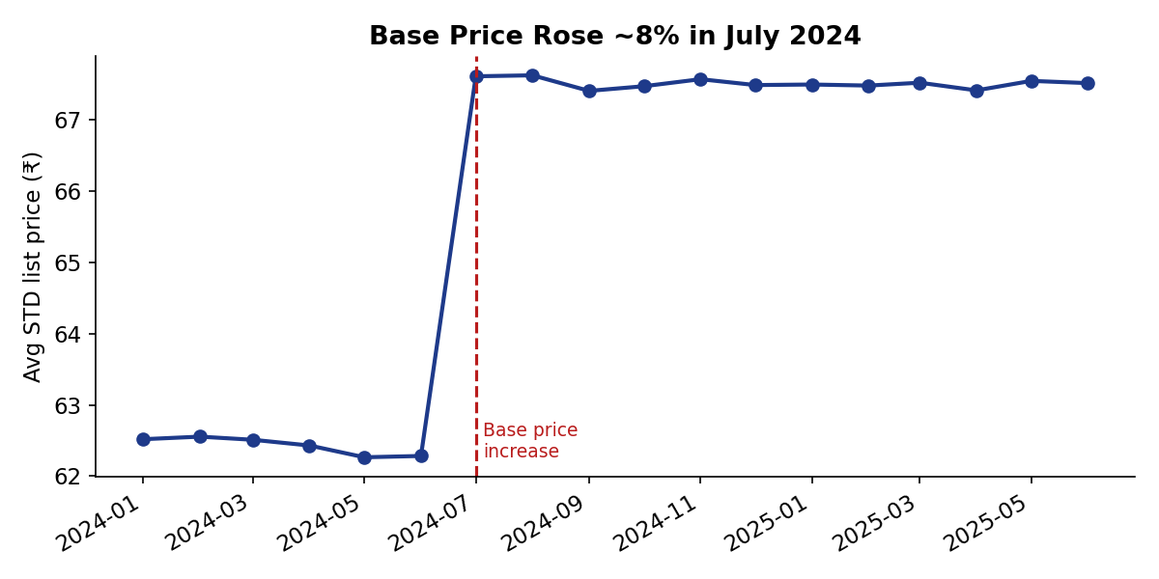
Figure 9. Average standard-tariff list price by month — the July 2024 increase is clearly visible.
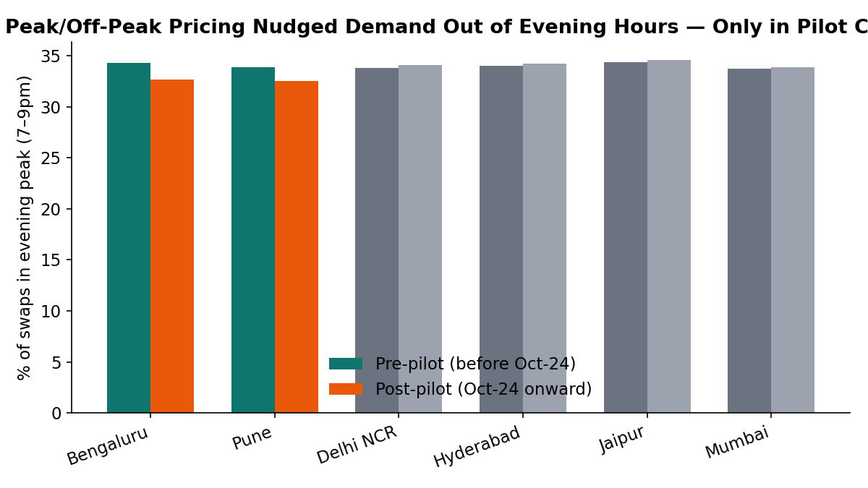
Figure 10. Share of swaps occurring in the evening peak, before vs. after the pricing pilot began, pilot cities vs. controls.
Fleet-partner value diverges from revenue rank: the largest-revenue partner is not necessarily the most profitable once energy and battery-wear costs are netted out. Several mid-size partners on pay-per-swap contracts show a higher average variable margin per swap than the largest volume-tiered partner, whose post-amendment discount is the widest in the portfolio — directly relevant to the budget question in Section 4.

3.6 Root Cause Analysis of Retention
Early new-rider retention is high overall (roughly 93–95% under our 14/45-day activation-and-return definition) and does not show a strong, steady decline across signup cohorts in this framing — it fluctuates in a fairly narrow band rather than trending clearly downward. Within that band, two consistent (if modest) correlates of not returning stand out, and one apparent correlate is a trap to avoid:
- Primary, most defensible driver — vehicle class: Three-wheeler riders retain at a lower rate than two-wheelers — consistent with 3W's roughly double failure rate found in Section 3.2. A plausible causal chain: worse service creates more friction in the first weeks, and some new riders give up.
- Secondary, contributing driver — home-city service quality: Riders from Jaipur, Delhi NCR, and Hyderabad retain a little worse than Mumbai riders — the same cities flagged in Sections 3.2–3.3 for weaker station and equipment performance.
- A trap to avoid — support tickets: Riders who filed a support ticket in their first 45 days retain much better than those who didn't (98% vs. 91%). This looks backwards but is very likely reverse causality: a rider has to still be active to file a ticket at all, so "filed a ticket" is partly just a proxy for "was still around." We flag this explicitly rather than reporting it as a driver.
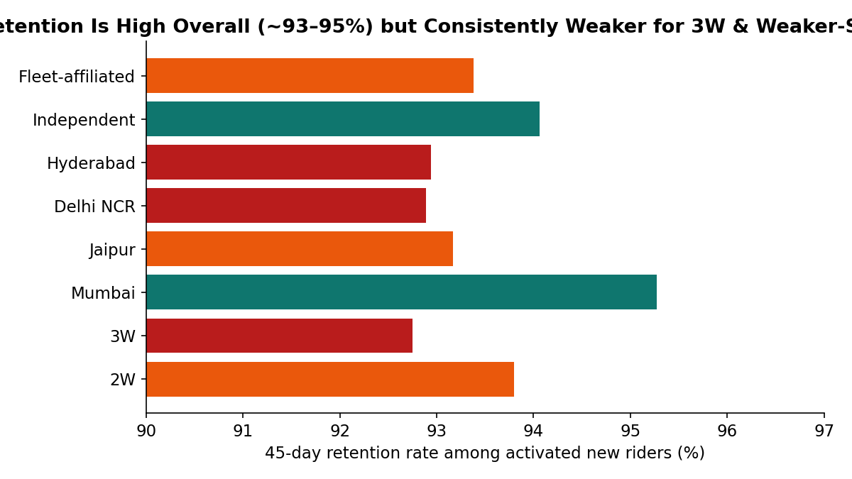
Figure 11. 45-day retention rate among activated new riders, by segment. Retention is uniformly high, but consistently a few points weaker for 3W riders and weaker-service cities.
Signup channel, plan type, and fleet-vs-independent status showed no strong individual signal — they look like secondary or noise factors rather than primary drivers in this dataset.
Bottom line: the data does not support a single dominant cause of new-rider churn. The most defensible story is that service-quality friction — concentrated in vehicle class and city, exactly where Sections 3.2 and 3.3 already found weaker service — nudges early retention down at the margin, layered on top of a generally high baseline. This is consistent with more than one contributing factor and no single smoking gun, which is what the evidence supports.

3.7 Optional Deep Dive: The Kyron Initial-Batch Anomaly
Flagged separately here because it is the single most actionable, well-isolated anomaly in the dataset: Kyron manufacturing lots KY-2407, KY-2408, and KY-2409 (roughly 1,460 packs, onboarded July–September 2024) degrade at roughly twice the rate of every other lot from every supplier, including Kyron's own later lots. These packs deliver less range, generate a disproportionate share of battery-related support tickets, and have been quietly inflating the network's average battery wear cost since September 2024 (Section 3.1). Because every Kyron lot after KY-2409 performs normally, this looks like a contained, fixable defect rather than a systemic supplier-quality problem — a warranty and root-cause conversation with Kyron, not a decision to drop the supplier.

4. The Budget Decision
VoltRelay's four proposed uses of its next operating budget, weighed against the evidence above:
Option | What the evidence supports
More stations | Justified selectively, not as blanket growth. Priority: replace/upgrade Gen1 stations in Jaipur and Delhi NCR, where the failure-rate gap is largest (Section 3.3). New stations elsewhere would not address the concentration of failures already identified.
More batteries | Justified for 3W inventory specifically — the 3W failure gap (Section 3.2) looks like a stockout problem, not a general battery shortage. Any further Kyron purchase should wait on resolution of the lot-defect conversation (Section 3.7).
Network-wide pricing rollout | The Bengaluru/Pune pilot shows a small, real, positive effect (Section 3.5) — worth expanding to 1–2 more cities with a matched control group first. The effect size found so far is modest, so this is a medium-term lever rather than the single highest-impact spend.
Long-term exclusive with largest fleet partner | Caution warranted. Section 3.5 shows the largest partner is not the highest-margin one after its contract amendment. A long-term exclusive at the current discount could lock in lower margin, not higher.

Overall recommendation: prioritize the targeted Gen1/Jaipur–Delhi service-quality fix and the 3W inventory correction first. They are the most concentrated, best-evidenced problems in the data and plausibly touch failure rate, margin, and retention simultaneously — a stronger foundation than committing immediately to a network-wide pricing rollout or a long-term exclusive contract.

5. Actionable Recommendations
- Prioritize a Gen1-charger refresh in Jaipur and Delhi NCR, targeting the highest-footfall market and commercial-hub sites first — the highest-leverage, most contained fix for the failure concentration found in Sections 3.2–3.3.
- Rebalance 3-wheeler battery inventory targets upward at stations serving 3W demand; investigate whether inventory_target_3w is systematically under-provisioned relative to actual 3W attempt volume.
- Open a warranty and root-cause conversation with Kyron specifically about lots KY-2407 through KY-2409; hold further bulk Kyron purchases until resolved.
- Expand the peak/off-peak pricing pilot to one or two more cities with a matched control group, to build a stronger causal case before committing to a network-wide rollout.
- Revisit the largest fleet partner's contract economics — modeling margin, not just revenue — before considering any long-term exclusivity.
- Target new-rider onboarding support specifically at 3-wheeler riders and Jaipur/Delhi NCR/Hyderabad sign-ups in their first two weeks, since these are the segments with the weakest (if still modest) early retention.

6. Methodology Note & Limitations
This is an evidence-based, observational analysis of a synthetic dataset generated for this hackathon. Associations reported here — e.g., city or equipment generation vs. failure rate, or vehicle class vs. retention — are consistent with, but do not prove, the causal stories offered. Where two explanations were plausible, we favored the interpretation corroborated by more than one independent cut of the data (for example, the Kyron finding in Section 3.7 is supported by both state-of-health data and support-ticket volume, not just one signal in isolation). Contribution margin and battery wear cost are analyst-constructed proxies built from the available fields (energy consumption, grid tariff, battery purchase cost and state-of-health, station rent and maintenance); they are reasonable and internally consistent, but are not VoltRelay's actual cost-accounting figures. All code, queries, and full detail behind every figure in this report are available in the companion Colab notebook, which runs end-to-end from the raw CSV files.

