Q4 2025 HIGHLIGHT REPORT
Program Development, Outreach & Strategic Partnerships
September – December 2025
Prepared by: Aunray Stanford
Man Up! Inc. | Brooklyn, NY

Executive Summary
This report documents strategic initiatives, technical developments, and partnership cultivation from September through December 2025, with emphasis on infrastructure building and institutional relationship development that positions Man Up! Inc. for expanded impact in 2026 and beyond.
Key achievements during this period include:
- Development of fully functional web platforms and participant databases for Fatherhood Initiative and Sisterhood Initiative
- Successful community mobilization events serving 170+ community members across multiple initiatives
- Cultivation of strategic partnerships with NYU institutions, city agencies, and community organizations
- Complete restructuring of Boys Club curriculum and implementation of low-intensity case management protocols
- Organization of &#x201C;The Algorithm of Interruption&#x201D; mini-hackathon at NYU (January 28, 2026)
- Secured commitment from Microsoft GitHub for four-part technical workshop series

I. Technical Infrastructure Development

Fatherhood Initiative Web Platform & Database
Developed comprehensive web-based signup system and administrative dashboard for participant data management. All features are fully ready for integration with Manupinc.org, the organization&#x2019;s existing namesake site.
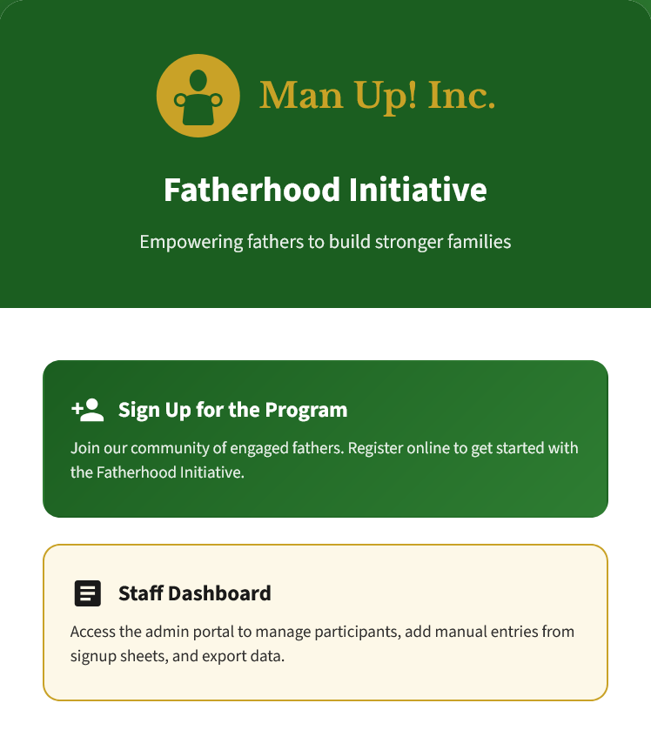
Figure 1: Fatherhood Initiative landing page with program overview and signup call-to-action
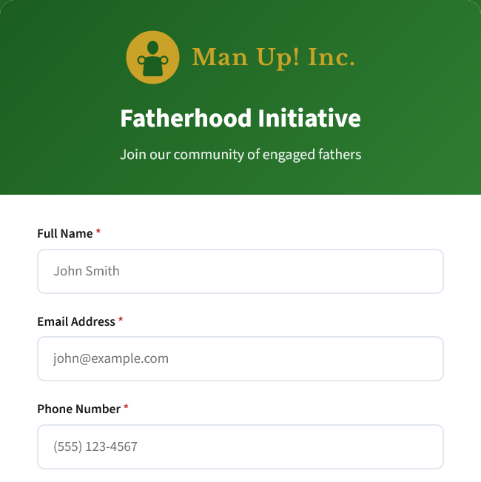
Figure 2: Online signup form capturing participant information with validation
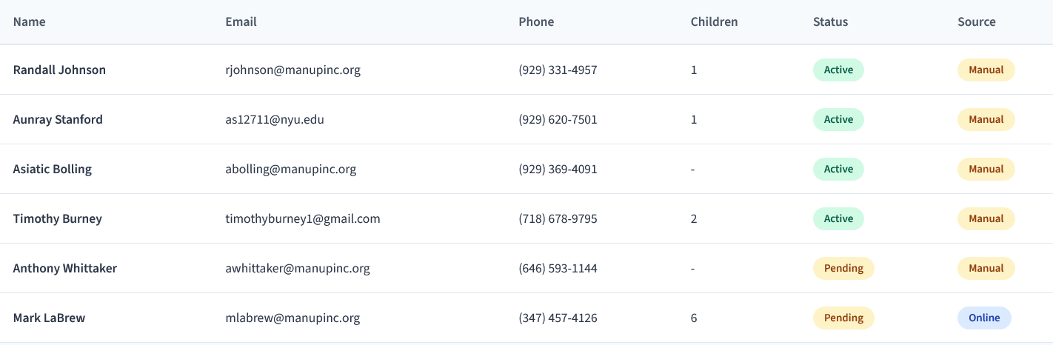
Figure 3: Administrative dashboard for staff to manage participants, add manual entries, and export data
Platform Features:
- Responsive web design optimized for mobile and desktop
- Real-time participant database with status tracking (Active, Pending, Inactive)
- Staff dashboard with manual entry capabilities for paper signup sheets
- Data export functionality for reporting and analysis
- Source tracking to distinguish online vs. manual registrations

Sisterhood Initiative Platform
Recognizing the parallel needs of the Community Development Team (CDT), I took initiative to create a similar web platform and database system for the Sisterhood Initiative, ensuring organizational consistency and expanding technical capacity across departments.

SafeStep Demo Application
Developed SafeStep, a pedestrian safety navigation app inspired by community canvassing and community-led safety initiatives. This application demonstrates how crowdsourced safety data can inform algorithmic route optimization—a concept directly applicable to violence interruption methodologies.
Demo Link: https://safestep-demo.surge.sh/app.html

II. Community Impact & Direct Service

Thanksgiving Community Kickback (November 26, 2025)
Organized and mobilized 12 community volunteers to host a Thanksgiving kickback at the Prince Joshua Avitto Community Center (PJACC). The event served approximately 70 community members with hot food, gently used clothes and footwear. Donated leftovers were delivered to Samaritan Village at 645 Van Siclen Avenue.
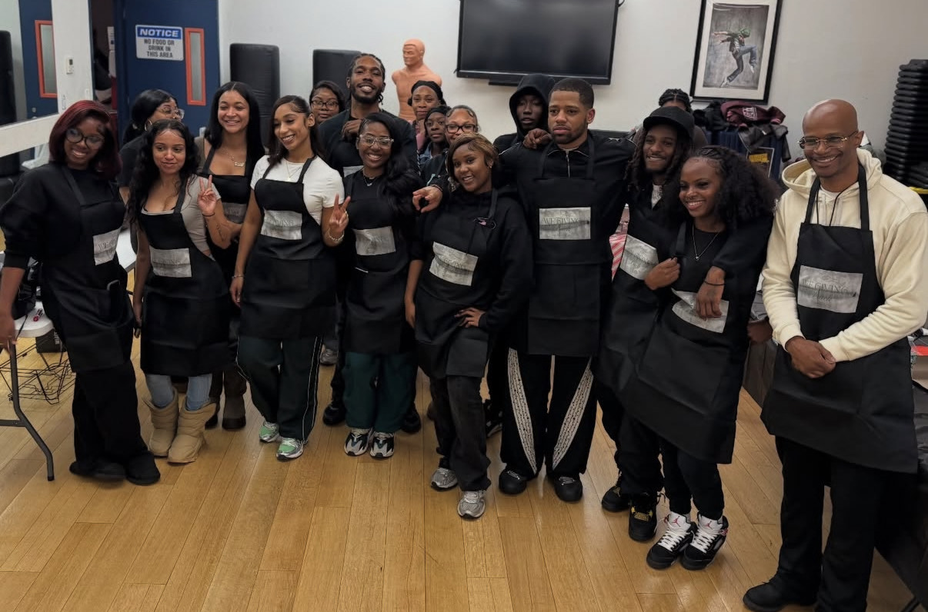
Figure 4: Volunteer team at PJACC Thanksgiving community event (November 26, 2025)

Boys Club Low-Intensity Case Management
Since September 2025, myself and Brother Burney have been tasked with revitalizing the Boys Club department. I led the implementation of holistic mentorship and &#x201C;low-intensive case management,&#x201D; advocating for our higher-risk boys in schools, against ACS involvement, and providing safe spaces as directed by Executive Director A.T. Mitchell-Mann.
This approach included direct requests from the Executive Director to integrate Man Up! Inc. and our peace mantras into every part of participants&#x2019; lives—showing up in their schools, homes, and recreational activities.
Key Activities & Outcomes:
- Eleven (11) total school support visits conducted between October 6 and November 21
  - Nine (9) visits for L. Keiler at Apollo Achievement First
  - Two (2) visits for G. Marte & P. Oxendine at Eagle Academy
- Received commendation from participant&#x2019;s social worker (November 7) noting marked behavioral improvements directly attributable to consistent programmatic support
- Successfully facilitated emergency school transfer for participant experiencing ongoing conflict at Apollo MS (November 24)
- Supported parent in IEP meeting at Eagle Academy for Young Men (December 4)
- Co-facilitated comprehensive five-hour leadership session with NOI x Junior FOI, engaging 30+ youth participants ages 5–15 (November 22)

Million Man March Anniversary (October 16, 2025)
Co-organized with Brother Mitchell-Mann and participated in Million Man March Anniversary event, successfully mobilizing over 100 attendees for this robust fatherhood gathering.

III. Strategic Partnerships & Institutional Relationships
A core component of this work has been cultivating relationships with academic institutions, city agencies, and community organizations to expand Man Up! Inc.&#x2019;s reach and legitimacy as a thought leader in community violence interruption.
Partner Organization | Collaboration Details
NYU Prison Education Program | Productive conversation with Dr. Divine Pryor regarding expansion of Incredible Messenger University (IMU). Meeting scheduled with Executive Director A.T. Mitchell-Mann to progress discussions.
NYU Center for Urban Science + Progress | Primary partner for &#x2018;The Algorithm of Interruption&#x2019; mini-hackathon (January 28, 2026). Exploring opportunities for spring PIT-UN Tech for Change Hackathon—a larger 3-day event positioning MUI to work with universities, City Council, Public Advocate&#x2019;s Office, and countless partners to innovate public safety.
KAVI Data Team | Completed data management training session (November 19) focused on optimizing departmental data organization and reporting narratives. Reviewed unpublished map of CMS assets illustrating Man Up! Inc. providing services throughout all of Brooklyn.
City Council Data Team | Strategic data review and future collaboration discussions (December 11). Interest expressed in collaborative initiatives leveraging MUI&#x2019;s community presence and data insights.
Office of the Public Advocate | Convened December 1 to discuss strategic collaboration on future workshops and community events, expanding civic engagement footprint.
DYCD | Attended DYCD Fatherhood Initiative meeting (November 5), conducted follow-up correspondence to align MUI&#x2019;s work with broader city-wide fatherhood strategies.
SCO Family Services | Initiated contact with emerging SCO fatherhood initiative (October 10) to explore collaborative frameworks and expand referral network for shared clientele.
RISE (Domestic Violence) | Met with Julian at RISE (November 20) to discuss integrating Domestic Violence Awareness into Fatherhood programming. Collaborated with Violence Interrupters to support RISE DVA event (October 8).
Brooklyn Defender Services | Fielded and processed new referral (November 17), further solidifying MUI&#x2019;s role as trusted community partner for Alternative to Incarceration advocacy.
NY Peace Collaborative | Ongoing collaboration and relationship building with statewide peace organization.
Additional partnerships in development with:
- Innovating Justice
- Fortune Society

IV. The Algorithm of Interruption Mini-Hackathon
Organized in collaboration with NYU Center for Urban Science + Progress, this mini-hackathon brings together Community Violence Interrupters and university scholars for hands-on data collection to improve campus safety. The event features keynote address by A.T. Mitchell-Mann, CEO of Man Up! Inc. and NYC Gun Violence Prevention Czar.
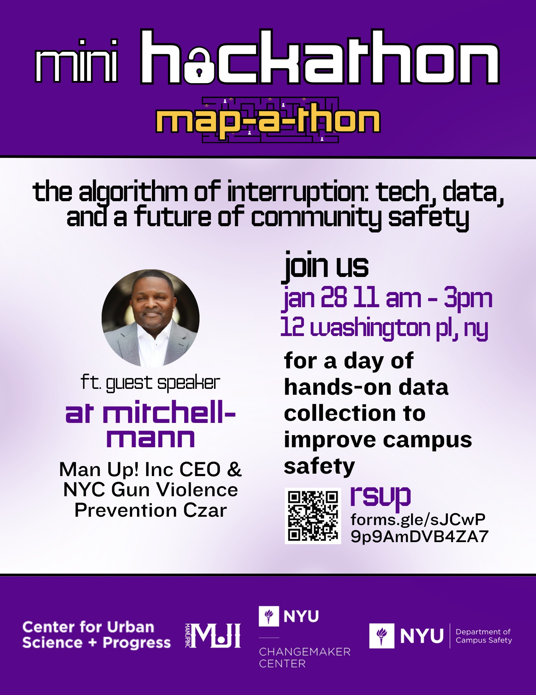
Figure 5: &#x2018;The Algorithm of Interruption&#x2019; mini-hackathon flyer (January 28, 2026)
Event Details:
- Date: January 28, 2026, 11:00 AM – 3:00 PM
- Location: 12 Washington Place, New York, NY
- RSVP: https://forms.gle/sJCwP9p9AmDVB4ZA7
- Luma Event Page: https://luma.com/na5an5dn
This event aspires to create an ongoing relationship between Man Up! Inc. and larger academic entities, creating a pipeline for our interests. It is connected to a much larger 3-day event being organized for Spring 2026: the PIT-UN Tech for Change Hackathon.
PIT-UN Tech for Change Hackathon positions MUI to work with:
- Multiple universities
- City Council
- Public Advocate&#x2019;s Office
- Numerous community and technology partners to innovate public safety

V. Programmatic Development & Curriculum Design

Boys Club Curriculum Restructuring
As requested by Executive Director A.T. Mitchell-Mann, completed full restructuring of Boys Club curriculum and updated participant permission slips/waiver agreements with appropriate legalese to protect the organization from liability.
Curriculum covers three age-based tiers:
- Tier 1 (Ages 5-8): Foundational skills through interactive activities—hygiene, youth leadership, conflict resolution, STEM, games/activities, and educational/vocational/workforce development basics
- Tier 2 (Ages 9-12): Building on basics with more complex topics—personal care as self-respect, group leadership, advanced conflict resolution strategies, project-based STEM learning
- Tier 3 (Ages 13-15): Preparing for young adulthood—resume building, financial literacy, job interview skills, post-secondary education exploration, mentorship opportunities

Updated Promotional Materials
Collaborated with Media & Arts department to create new Fatherhood Initiative promotional materials utilizing QR codes that direct to the new online signup system.
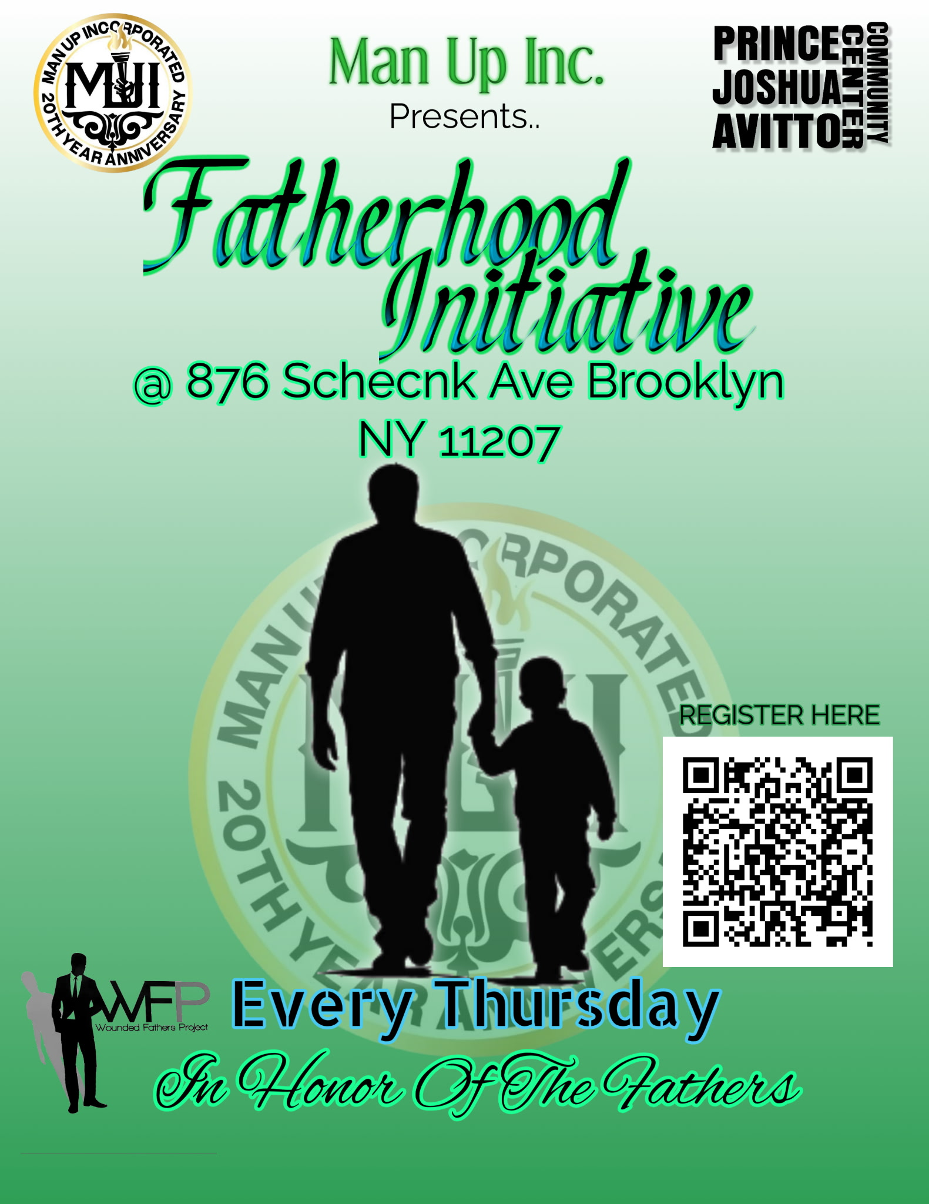
Figure 6: Updated Fatherhood Initiative promotional material with QR code integration

VI. Immediate Next Steps & Q1 2026 Priorities

Confirmed Commitments
- Execute &#x2018;The Algorithm of Interruption&#x2019; Mini-Hackathon (January 28, 2026)
- Launch Microsoft GitHub 4-Part Intro to CS Workshop Series facilitated by Software Engineer Sneha Kripanandan (logistics and promo materials in development with Media & Arts department)
- Integration of suitable Boys Club participants into RISE Youth on the Rise stipend program (tentative dates: December 16, 2025 & January 22, 2026)
- Update Boys Club curriculum incorporating discipline training, call & response aspects from Junior FOI program as suggested by Brother Mitchell-Mann

Partnership Development
- Follow-up discussions with CASES to establish concrete referral pathway
- Follow-up meetings with SCO to define tangible collaboration goals for fatherhood initiatives
- Continue planning committee meetings for PIT-UN Tech for Change Hackathon (Spring 2026)
- NSC Follow-up: Review notes from November NSC meeting to identify specific community safety mandates where MUI can take lead role

Technical & Administrative
- Create efficient/updated streamline for collecting Fatherhood participant data (Goal: 500 participants by next quarter through QR code signup, online outreach, and cross-organizational collaboration)
- Building app/auditing tool for upcoming hackathon event
- Based on engagement from &#x201C;Father&#x2019;s Pain&#x201D; event in December, assess feasibility of making this bi-annual healing series to address ongoing participant trauma

Multi-Departmental Collaboration
- Ongoing discussions with Brother Shoebi in Tech department regarding creation of dashboards and databases for multi-departmental use, building on successful Fatherhood and Sisterhood Initiative platforms

Conclusion
The work documented in this report reflects a strategic approach to organizational development that extends beyond traditional program delivery. By investing in technical infrastructure, cultivating institutional partnerships, and positioning Man Up! Inc. at the intersection of community expertise and academic/civic innovation, these initiatives create sustainable pathways for expanded impact.
The success of this work is measured not only in direct service delivery (170+ community members served, documented behavioral improvements in high-risk youth, successful mobilization of 100+ participants) but in the relationships built, the systems created, and the institutional visibility achieved.
As we enter 2026, Man Up! Inc. is positioned as a credible partner for universities, city agencies, and community organizations seeking authentic community engagement and data-informed violence interruption strategies. This positioning, cultivated through consistent presence in multiple spheres of influence, represents strategic value that will yield returns well beyond the immediate quarter.

Appendix: Reference Documents
Supporting Documentation:
- MUI Yearly Departmental Report 2025 (complete January-December activities)
- Boys Club Curriculum Overview (full 3-tier structure)
- New Boys Club Permission Slip & Waiver Agreement
- SafeStep Demo Application: https://safestep-demo.surge.sh/app.html
Event Links:
- Mini-Hackathon RSVP: https://forms.gle/sJCwP9p9AmDVB4ZA7
- Luma Event Page: https://luma.com/na5an5dn
###

