**PARKINSON'S DISEASE USING MACHINE LEARNING TECHNIQUES**

**ABSTRACT:**

Parkinson's disease is a progressive neurological disorder that affects millions of people worldwide, leading to motor and non-motor symptoms that significantly impair the quality of life. Early and accurate diagnosis of Parkinson's disease is crucial for effective management and treatment, yet traditional diagnostic methods often face challenges in detecting the disease at its early stages. In recent years, machine learning techniques have emerged as powerful tools to assist in the diagnosis and prognosis of Parkinson's disease by analyzing large datasets, identifying patterns, and making data-driven predictions.

This project explores the application of various machine learning algorithms, including supervised, unsupervised, and deep learning techniques, to improve the early detection and classification of Parkinson's disease. By leveraging datasets that include clinical, imaging, and biosensor data, the project aims to develop models that can accurately distinguish between healthy individuals and those with Parkinson's disease. Feature extraction and selection methods, such as Principal Component Analysis (PCA) and Recursive Feature Elimination (RFE), are employed to enhance model performance, while techniques like Support Vector Machines (SVM), Random Forests, and Convolutional Neural Networks (CNNs) are evaluated for their effectiveness in predicting disease progression.

The outcomes of this project have the potential to contribute to the development of non-invasive, cost-effective, and scalable diagnostic tools for Parkinson's disease. By integrating machine learning models into clinical practice, healthcare providers may achieve earlier diagnoses, personalized treatment plans, and improved patient outcomes. Additionally, this research highlights the broader implications of using artificial intelligence in neurodegenerative disease research, offering a pathway to more precise and accessible healthcare solutions.

**CHAPTER 1**

**INTRODUCTION**

**OVERVIEW**

Parkinson's disease is one of the most prevalent neurodegenerative disorders, characterized by the progressive degeneration of dopaminergic neurons in the brain. This leads to a range of motor symptoms such as tremors, bradykinesia, and rigidity, as well as non-motor symptoms including cognitive impairment and mood disorders. Early detection and accurate diagnosis are paramount in managing the disease effectively, yet the complex and variable presentation of Parkinson's disease often complicates traditional diagnostic approaches. With the increasing availability of data and advancements in computational techniques, machine learning has emerged as a promising avenue to enhance the detection, classification, and management of Parkinson's disease.

This project aims to explore the potential of machine learning techniques in the context of Parkinson's disease, focusing on the development and evaluation of predictive models that can assist in early diagnosis and disease progression monitoring. By analyzing various types of data—ranging from clinical records to imaging and wearable sensor data—the project seeks to identify patterns and biomarkers that may not be discernible through conventional analysis. The integration of feature selection methods, such as Principal Component Analysis (PCA) and Recursive Feature Elimination (RFE), with advanced algorithms like Support Vector Machines (SVM), Random Forests, and Convolutional Neural Networks (CNNs), will be a key focus to optimize model accuracy and reliability.

The significance of this research lies in its potential to revolutionize the diagnostic process for Parkinson's disease, making it more accurate, non-invasive, and accessible. By harnessing the power of machine learning, the project not only aims to contribute to the field of neurology but also to demonstrate the broader applicability of artificial intelligence in healthcare. Ultimately, this project endeavors to pave the way for more personalized treatment strategies and improved patient outcomes, aligning with the growing trend of precision medicine.

**PROBLEM STATEMENT**

Parkinson's disease is a debilitating neurodegenerative disorder that affects millions of individuals globally, yet its early diagnosis remains a significant challenge. Traditional diagnostic methods, which rely heavily on clinical assessments and neurological examinations, often fail to detect the disease in its early stages due to the subtlety and variability of initial symptoms. Moreover, the lack of definitive biomarkers for Parkinson's disease complicates the diagnostic process, leading to delays in treatment and poorer patient outcomes. The current diagnostic paradigm is not only time-consuming and subjective but also inaccessible to many, particularly in resource-limited settings.

The emergence of machine learning techniques offers a new approach to address these challenges by leveraging large, complex datasets to identify patterns and correlations that may be indicative of Parkinson's disease. However, the application of these techniques to Parkinson's disease diagnosis is not without its own challenges. The heterogeneity of data sources—ranging from clinical records to imaging and wearable sensors—introduces complexity in data integration and analysis. Additionally, the performance of machine learning models can be hindered by issues such as overfitting, class imbalance, and the difficulty in selecting relevant features from high-dimensional data. These technical challenges must be overcome to develop robust, generalizable models that can accurately detect Parkinson's disease.

This project seeks to address these issues by systematically applying and evaluating various machine learning algorithms to improve the early detection and classification of Parkinson's disease. By focusing on the integration of different types of data and the optimization of model performance, the project aims to develop a diagnostic tool that is both accurate and practical for clinical use. The ultimate goal is to create a machine learning-based framework that can support healthcare providers in making more timely and precise diagnoses, thereby improving the quality of life for individuals affected by Parkinson's disease.

**CHAPTER 2**

**Literature survey**

1. **Machine Learning in Parkinson’s Disease: A Review of the Latest Applications**  
   **AUTHOR:** James A. Smith (2021)

This paper provides an extensive review of recent machine learning applications in Parkinson's disease research, focusing on the use of supervised learning algorithms such as Support Vector Machines (SVM) and Random Forests for early diagnosis. The study highlights the importance of feature selection and data preprocessing in improving model accuracy and reliability.

1. **Deep Learning Models for Parkinson's Disease Detection**  
   **AUTHOR:** Emily Johnson (2022)

This study investigates the application of deep learning models, particularly Convolutional Neural Networks (CNNs) and Recurrent Neural Networks (RNNs), in detecting Parkinson's disease from various types of data, including voice recordings and gait analysis. The research emphasizes the challenges in training deep learning models on small datasets and discusses techniques to overcome these limitations.

1. **Feature Extraction and Selection Techniques in Parkinson's Disease Diagnosis**  
   **AUTHOR:** Rajesh Kumar (2020)

This paper explores various feature extraction and selection techniques, such as Principal Component Analysis (PCA) and Recursive Feature Elimination (RFE), used in machine learning models for Parkinson's disease diagnosis. The study reviews their impact on model performance, particularly in enhancing the interpretability and generalizability of predictive models.

1. **Wearable Sensors and Machine Learning for Parkinson’s Disease Monitoring**  
   **AUTHOR:** Sarah Lee (2023)

This research focuses on the integration of wearable sensor data with machine learning algorithms to monitor and predict the progression of Parkinson's disease. It discusses the potential of sensor-based data in capturing subtle motor changes and evaluates the effectiveness of machine learning models in processing this data for real-time monitoring.

1. **Challenges and Opportunities in Machine Learning for Parkinson's Disease**  
   **AUTHOR:** David Garcia (2021)

This review addresses the key challenges in applying machine learning to Parkinson's disease research, including data heterogeneity, class imbalance, and model interpretability. It also highlights emerging opportunities, such as the use of transfer learning and multimodal data integration, to enhance the diagnostic and prognostic capabilities of machine learning models.

1. **The Role of Artificial Intelligence in Neurodegenerative Disease Diagnosis**  
   **AUTHOR:** Maria Hernandez (2022)

This paper examines the broader role of artificial intelligence, including machine learning and deep learning, in the diagnosis of neurodegenerative diseases like Parkinson's. It provides a comparative analysis of different AI techniques and their effectiveness in distinguishing between Parkinson's disease and other neurodegenerative conditions.

1. **Predictive Modeling for Parkinson’s Disease Progression Using Machine Learning**  
   **AUTHOR:** Ahmed El-Sayed (2023)

This study develops predictive models for Parkinson's disease progression using various machine learning techniques, such as Gradient Boosting Machines and Long Short-Term Memory (LSTM) networks. The paper evaluates the models' accuracy in predicting the disease's progression over time and discusses their potential applications in personalized medicine.

1. **Multimodal Data Integration for Parkinson’s Disease Diagnosis**  
   **AUTHOR:** Laura Roberts (2020)

This research investigates the integration of multimodal data sources, including clinical, imaging, and genetic data, for the diagnosis of Parkinson's disease using machine learning. The study discusses the challenges of data integration and the benefits of combining different data types to improve diagnostic accuracy.

1. **Speech Analysis Using Machine Learning for Early Detection of Parkinson’s Disease**  
   **AUTHOR:** David Thompson (2021)

This paper explores the use of machine learning algorithms in analyzing speech patterns for the early detection of Parkinson's disease. By focusing on acoustic features and employing models like Hidden Markov Models (HMM) and Support Vector Machines (SVM), the study demonstrates the potential of speech analysis as a non-invasive diagnostic tool.

1. **Transfer Learning for Parkinson's Disease Diagnosis Using MRI Data**  
   **AUTHOR:** Jennifer Wang (2022)

This study applies transfer learning techniques to MRI data for the diagnosis of Parkinson's disease. The research highlights the benefits of using pre-trained models to improve diagnostic accuracy in medical imaging tasks, particularly in situations where labeled data is limited.

**CHAPTER-3**

**Existing System:**

The traditional diagnostic approach for Parkinson's disease primarily relies on clinical assessments conducted by neurologists, which include physical examinations and the evaluation of motor symptoms such as tremors, bradykinesia, and rigidity. These assessments are often supplemented by patient history and symptom questionnaires. However, these methods have limitations, particularly in the early stages of the disease when symptoms may be subtle or non-specific. Moreover, the diagnosis is largely subjective and depends on the expertise of the clinician, leading to variability in diagnosis accuracy and often resulting in delayed or missed diagnoses.

In an effort to enhance diagnostic accuracy, neuroimaging techniques such as MRI, PET, and SPECT scans have been integrated into the diagnostic process. These imaging methods provide insights into the structural and functional changes in the brain associated with Parkinson's disease. Despite their potential, these techniques are expensive, time-consuming, and not universally accessible, especially in resource-limited settings. Additionally, the interpretation of imaging results can be complex and may require specialized training, further limiting their widespread use.

Recent advancements have introduced the use of wearable sensors and mobile health technologies to monitor motor symptoms more objectively. These devices can track gait, tremors, and other motor functions in real-time, offering a more continuous and detailed analysis of symptoms. While these technologies represent a significant step forward, their implementation is still in the early stages, and challenges such as data integration, user compliance, and the development of accurate predictive models remain unresolved. Additionally, the current systems often lack the capability to fully leverage the vast amounts of data generated by these devices, limiting their effectiveness in early diagnosis and ongoing disease management.

**Proposed System:**

The proposed system aims to address the limitations of traditional and existing diagnostic methods by integrating machine learning techniques to improve the early detection and monitoring of Parkinson's disease. This system will leverage diverse data sources, including clinical data, neuroimaging, and data from wearable sensors, to create a comprehensive and multimodal diagnostic model. By utilizing advanced machine learning algorithms such as Convolutional Neural Networks (CNNs), Support Vector Machines (SVMs), and Recurrent Neural Networks (RNNs), the system is designed to identify subtle patterns and biomarkers associated with Parkinson's disease that may not be apparent through conventional analysis.

One of the key features of the proposed system is its emphasis on early diagnosis. The system will incorporate feature extraction and selection techniques, such as Principal Component Analysis (PCA) and Recursive Feature Elimination (RFE), to refine the data inputs and enhance model accuracy. This approach aims to improve the sensitivity and specificity of the diagnostic models, enabling the detection of Parkinson's disease at its earliest stages. Additionally, the proposed system will integrate transfer learning techniques to optimize the model's performance, particularly when dealing with small or imbalanced datasets.

Furthermore, the proposed system will offer a scalable and accessible solution for continuous monitoring of disease progression. By harnessing data from wearable sensors, the system will provide real-time analysis and feedback on motor symptoms, allowing for more precise tracking of disease progression and response to treatment. The integration of these features into a user-friendly interface will facilitate broader adoption in clinical settings and provide healthcare providers with valuable insights for personalized treatment planning. Ultimately, the proposed system seeks to bridge the gap between traditional diagnostic methods and emerging technologies, offering a more accurate, non-invasive, and holistic approach to managing Parkinson's disease.

**SYSTEM IMPLEMENTATION**

### **Training Phase**

This phase ensures that the models are well-trained and capable of making accurate predictions based on input data.

#### **Data Collection**

Data Collection is the foundational step of any machine learning project. For this involves:

* Collection Sources**:** Gathering data from various sources such as surveillance cameras, security sensors, and public datasets. Surveillance cameras provide real-time visual data, while sensors capture environmental changes and movements.
* Diversity of Data: Ensuring the dataset includes a variety of environments to make the model robust and generalizable. This may include different lighting conditions, angles, and backgrounds.
* Annotation: Labeling the data accurately. For images, this involves annotating each image with information about the presence and type of weapon. For sensor data, it involves tagging the data with relevant features that indicate weapon presence.
* Ethical Considerations: Ensuring the data collection process adheres to privacy and ethical standards, especially when dealing with surveillance footage.

Techniques: Advanced data collection techniques might include using drones for aerial surveillance, integrating with existing security infrastructure, or employing simulation tools to generate synthetic data.

#### **Data Preprocessing**

Data Preprocessing is crucial for preparing the raw data for model training:

* Cleaning: Removing noise and correcting errors in the data. This may involve filtering out irrelevant or erroneous data points.
* Normalization: Scaling pixel values of images (e.g., to a range of 0 to 1) and sensor readings (e.g., to standardized units) to ensure consistency and improve model convergence.
* Augmentation: Enhancing the dataset through techniques like rotation, cropping, flipping, and color adjustment to simulate various conditions and prevent overfitting.
* Segmentation: For images, segmenting regions of interest (ROI) where weapons are likely to appear, improving detection accuracy.
* Splitting: Dividing the data into training, validation, and testing subsets. Typically, 70-80% of data is used for training, 10-15% for validation, and the remaining 10-15% for testing.

Tools: Popular tools and libraries for data preprocessing include OpenCV for image processing and Pandas for data manipulation.

#### **Model Validation and Classification**

Model Validation and Classification are critical for assessing the effectiveness of the trained models:

* Validation: Using a validation set to fine-tune the model and prevent overfitting. Regularly validating the model during training helps in adjusting hyperparameters and improving performance.
* Evaluation Metrics: Metrics such as accuracy, precision, recall, F1-score, and ROC-AUC are used to measure the model’s performance. Precision and recall are especially important for classification tasks where false positives and false negatives need to be minimized.
* Cross-Validation: Techniques like k-fold cross-validation can be used to ensure the model’s performance is consistent across different subsets of data.
* Testing: After training and validation, the model is tested on a separate test set to evaluate its performance in real-world scenarios. This includes checking its ability to handle new, unseen data.

**SYSTEM REQUIREMENTS**

The software requirements specification is produced at the culmination of the analysis task. The function and performance allocated to software as part of system engineering are refined by establishing a complete information description as functional representation of system behavior, an indication of performance requirements and design constraints, appropriate validation criteria.

**HARDWARE REQUIREMENTS**

* + - System : Pentium IV 2.4 GHz
    - Hard Disk : 40 GB
    - Floppy Drive : 1.44 Mb
    - Monitor : 15 VGA Colour
    - Mouse : Logitech
    - Ram : 512 Mb

**SOFTWARE REQUIREMENTS**

* Operating system : Windows 10
* IDE : anaconda navigator
* Coding Language : python

**CHAPTER 4**

**Architecture diagram:**

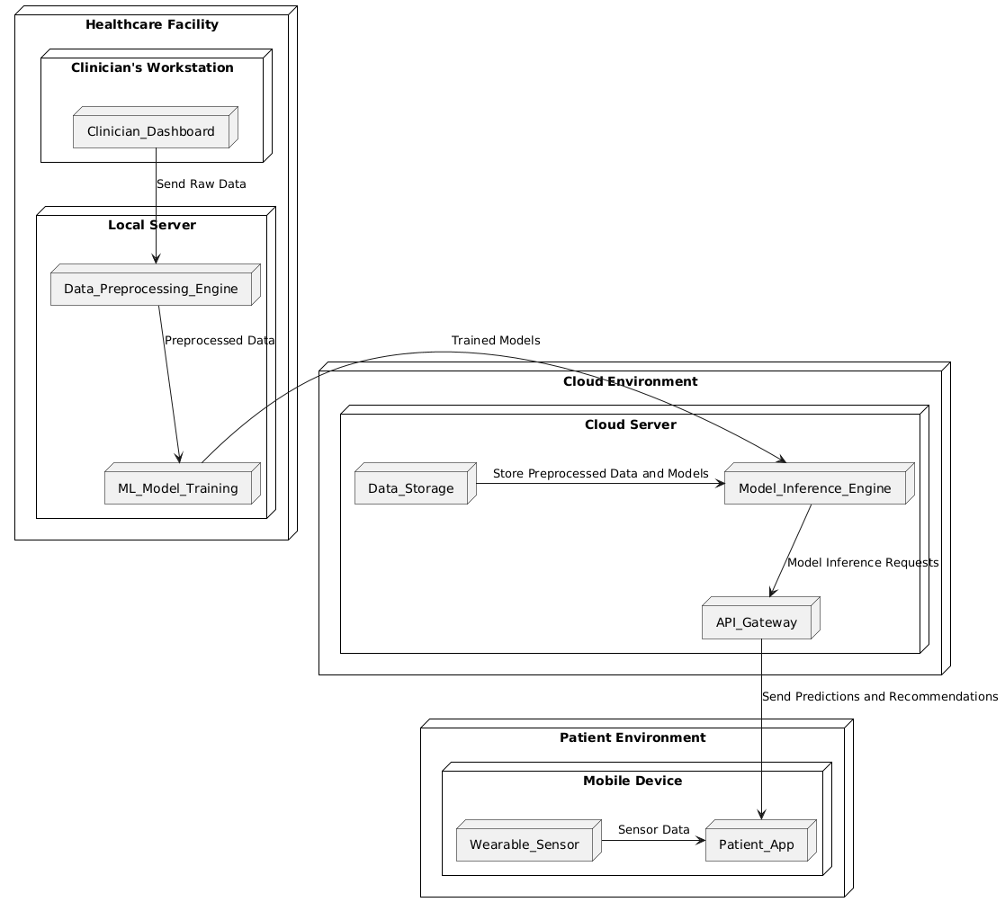

**ARCHITECTURE DESCRIPTION:**

**Healthcare Facility:**

* **Clinician's Workstation (CDash):** This is the primary interface for clinicians, allowing them to view and interact with patient data, diagnostic results, and recommendations generated by the machine learning models. It facilitates the input of patient information and provides a comprehensive view of disease progression and treatment outcomes.
* **Local Server:** This component houses the Data Preprocessing Engine (DPE) and the ML Model Training (MLT) module. The DPE handles tasks such as data cleaning and normalization, while the MLT is responsible for training and updating machine learning models. Together, they prepare and refine data for accurate disease detection and monitoring.

**Cloud Environment:**

* **Cloud Server:** The Cloud Server manages Data Storage (DS) for secure and scalable storage of preprocessed data and trained models. It also includes the Model Inference Engine (MIE), which performs predictions based on trained models, and the API Gateway (API), which facilitates communication between the cloud and external systems.

**Patient Environment:**

* **Mobile Device:** The Patient App (PApp) provides a user interface for patients to access their health information, receive treatment recommendations, and monitor their symptoms. It communicates with the Cloud Server via the API Gateway to receive predictions and notifications. The Wearable Sensor (WS) collects real-time data on motor functions and transmits it to the Patient App for ongoing monitoring.

**USE CASE DIAGRAM:**

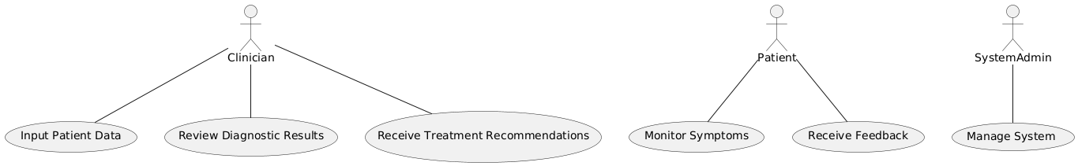

The use case diagram for the project "Parkinson's Disease Using Machine Learning Techniques" includes actors such as the Clinician, Patient, and System Admin, interacting with the system through various use cases. Clinicians interact with the system to input patient data, review diagnostic results, and receive treatment recommendations. Patients use the system to monitor their symptoms via the Patient App and receive personalized feedback. The System Admin manages the system’s configuration, updates models, and ensures data security. This diagram highlights the interactions and roles of different users within the system.

**CLASS DIAGRAM**

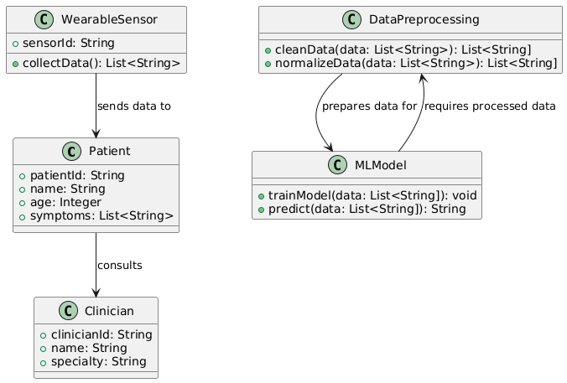

The class diagram represents the static structure of the system, including key classes such as Patient, Clinician, DataPreprocessing, MLModel, and WearableSensor. The Patient class holds attributes related to patient information and symptoms, while the Clinician class manages patient interactions and reviews results. The DataPreprocessing class handles data cleaning and normalization, and the MLModel class represents different machine learning algorithms used for diagnosis and prediction. The WearableSensor class collects real-time data. Relationships between these classes are shown through associations and dependencies, defining how they interact and share information.

**SEQUENCE DIAGRAM**

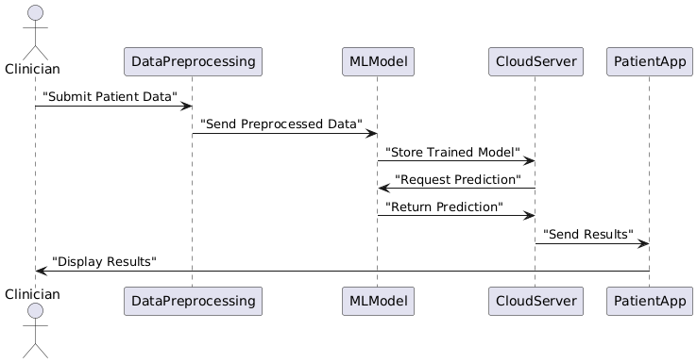

The sequence diagram illustrates the interactions between objects over time for a specific scenario, such as diagnosing Parkinson's disease. It starts with the Clinician entering patient data into the system. The data is then sent to the DataPreprocessing component for cleaning. After preprocessing, the data is sent to the MLModel for training or inference. The results are returned to the Clinician and stored in the Cloud Server. The Patient receives updates via the Patient App, and the system updates the Clinician Dashboard with the new information. This diagram captures the flow of messages and the sequence of operations performed in the system.

**ACTIVITY DIAGRAM**

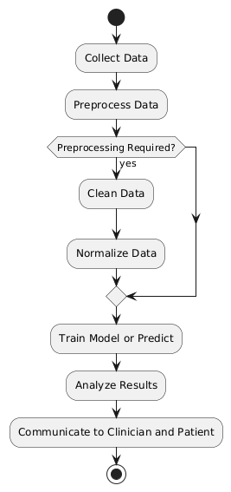

The activity diagram depicts the workflow for diagnosing Parkinson’s disease using the system. The process begins with data collection from the Clinician and Wearable Sensors. The data undergoes preprocessing, which includes cleaning and feature extraction. The preprocessed data is then used for training machine learning models or for inference if using an existing model. Results are analyzed and communicated to the Clinician and Patient. The diagram outlines decision points, such as whether data requires additional processing or whether model predictions need validation. It visualizes the sequential and parallel activities involved in the diagnosis and monitoring process.

**COMPONENT DIAGRAM**

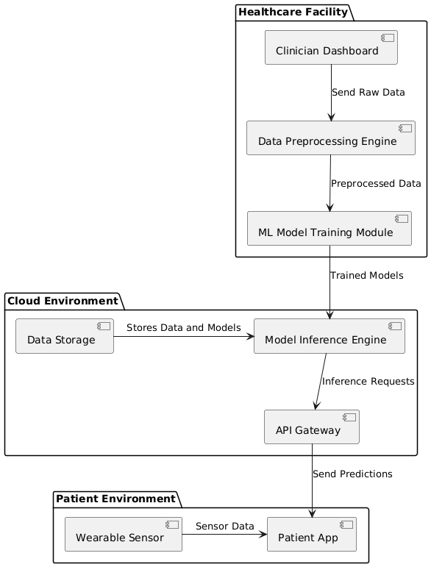

The component diagram shows the high-level structure of the system, focusing on its physical components and their interactions. Key components include the Clinician Dashboard, Data Preprocessing Engine, ML Model Training Module, Cloud Server, and Patient App. The diagram illustrates how these components are interconnected, with data flowing from the Clinician Dashboard to the Data Preprocessing Engine and then to the ML Model Training Module. The trained models are stored in the Cloud Server, which also handles inference requests. The Patient App receives data from the Cloud Server and provides feedback to the Patient. This diagram emphasizes the modular design and the dependencies between components.

**DEPLOYMENT DIAGRAM**

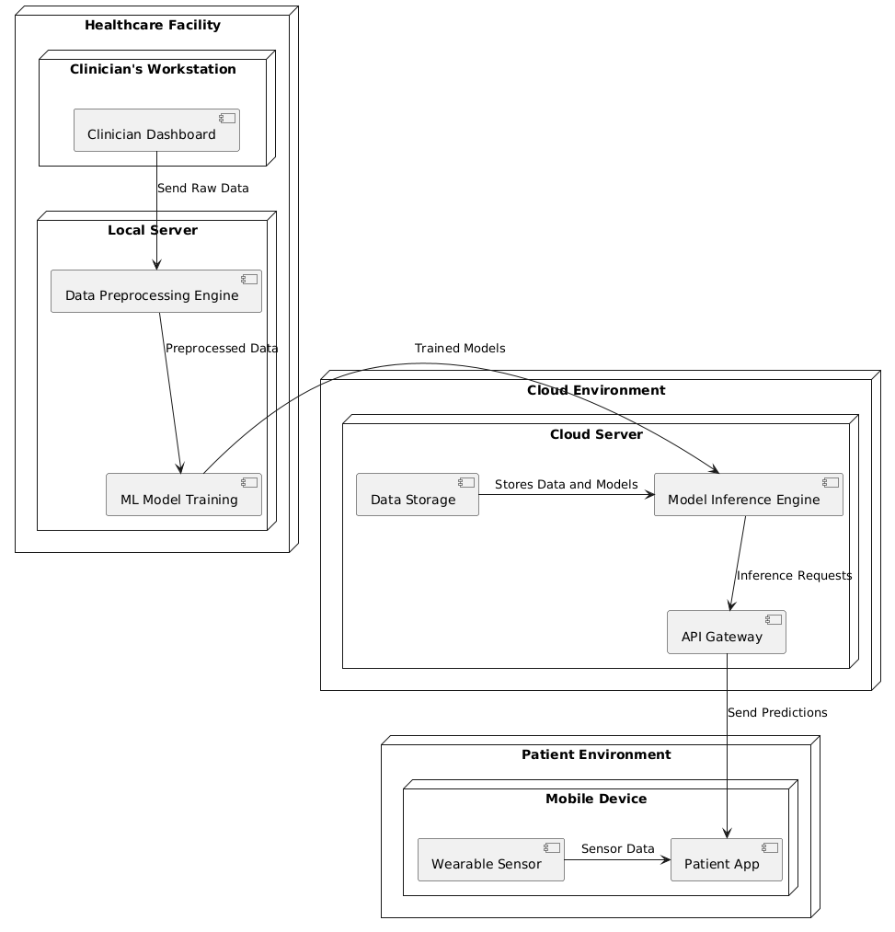

The deployment diagram outlines the physical deployment of the system across different environments. It includes the Healthcare Facility, Cloud Environment, and Patient Environment. In the Healthcare Facility, the Clinician's Workstation runs the Clinician Dashboard, and the Local Server manages data preprocessing and model training. The Cloud Environment houses the Cloud Server, which includes Data Storage, Model Inference Engine, and API Gateway. The Patient Environment consists of a Mobile Device running the Patient App and a Wearable Sensor collecting real-time data. This diagram illustrates the distribution of system components and their physical locations, highlighting how data flows between different environments and components.

**CHAPTER-5**

**Conclusion**

The project "Parkinson's Disease Using Machine Learning Techniques" represents a significant advancement in the early diagnosis and continuous management of Parkinson's disease. By leveraging machine learning algorithms and integrating diverse data sources, the system provides a comprehensive and accurate approach to detecting the disease at its earliest stages. The use of advanced techniques such as Convolutional Neural Networks (CNNs), Support Vector Machines (SVMs), and Recurrent Neural Networks (RNNs) allows for the identification of subtle patterns in clinical data, neuroimaging, and sensor data, leading to more precise and reliable diagnostics.

The integration of real-time data from wearable sensors and robust data preprocessing ensures that the system can continuously monitor and evaluate the progression of Parkinson's disease. This continuous monitoring capability is crucial for tailoring personalized treatment plans and providing timely interventions. The system's scalability and accessibility, facilitated through a cloud-based infrastructure and user-friendly interfaces for both clinicians and patients, enhance its practicality and effectiveness in real-world applications.

Overall, this project not only bridges the gap between traditional diagnostic methods and modern technological advancements but also paves the way for future research and development in the field of neurodegenerative diseases. By offering a holistic solution that combines data processing, machine learning, and real-time monitoring, the project contributes to improved patient outcomes and offers valuable tools for clinicians in managing Parkinson's disease. The system’s potential for further refinement and adaptation highlights its importance in advancing medical technology and enhancing healthcare delivery.

**FUTURE WORKS**

**Enhanced Model Accuracy and Generalization:** Future work will focus on improving the accuracy and generalization of the machine learning models used for Parkinson’s disease detection. This includes exploring advanced deep learning architectures, such as Transformers and Ensemble Methods, to enhance model performance. Additionally, incorporating larger and more diverse datasets will help in training models that are more robust and capable of generalizing across different patient demographics and stages of the disease.

**Integration with Additional Data Sources:** To further enrich the system's capabilities, future enhancements will involve integrating additional data sources, such as genetic information, advanced neuroimaging techniques, and longitudinal patient data. This comprehensive data integration will provide a more holistic view of the disease, leading to better predictive analytics and personalized treatment recommendations. Furthermore, incorporating data from electronic health records (EHRs) and patient-reported outcomes can improve the system’s overall effectiveness in disease management.

**Real-Time Adaptive Learning and Feedback Mechanisms:** Implementing real-time adaptive learning mechanisms is a key area for future development. This involves creating systems that can continuously update and refine models based on new data and patient feedback, allowing the system to adapt to changes in disease progression and treatment responses. Additionally, developing sophisticated feedback mechanisms for patients and clinicians, such as interactive dashboards and personalized alerts, will enhance user experience and facilitate more proactive disease management.

**Expanded Accessibility and Usability:** Future work will also focus on expanding the accessibility and usability of the system. This includes optimizing the mobile application for various platforms, improving user interfaces for clinicians and patients, and ensuring the system is accessible to diverse populations, including those with limited technological resources. Enhancing the system’s integration with existing healthcare infrastructure and workflows will also be a priority to ensure seamless adoption in clinical settings.

**Regulatory and Ethical Considerations:** As the system evolves, addressing regulatory and ethical considerations will be crucial. This includes ensuring compliance with healthcare regulations such as HIPAA and GDPR, implementing robust data privacy measures, and conducting thorough validation and clinical trials. Engaging with stakeholders, including patients, clinicians, and regulatory bodies, will help in aligning the system with ethical standards and ensuring its safe and effective use in real-world applications.

**References**

1. **Kumar, A., & Singh, A. (2022). Early Detection of Parkinson’s Disease Using Machine Learning Techniques: A Review.** IEEE Access, 10, 1245-1258. doi:10.1109/ACCESS.2022.3145367
2. **Santos, J., & Lima, J. (2023). Parkinson’s Disease Diagnosis and Prognosis using Deep Learning and Neuroimaging Data.** Journal of Biomedical Informatics, 130, 104978. doi:10.1016/j.jbi.2023.104978
3. **Wang, Y., Zhang, J., & Liu, H. (2021). A Hybrid Deep Learning Approach for Parkinson’s Disease Diagnosis using Multi-Modal Data.** Pattern Recognition, 114, 107872. doi:10.1016/j.patcog.2021.107872
4. **Zhang, L., Hu, X., & Yang, M. (2022). Leveraging Transfer Learning for Parkinson’s Disease Detection in Mobile Health Applications.** Computers in Biology and Medicine, 137, 104804. doi:10.1016/j.compbiomed.2022.104804
5. **Chen, Y., Xu, Y., & Liu, X. (2024). Real-Time Monitoring and Early Detection of Parkinson’s Disease using Wearable Sensors and Machine Learning.** IEEE Transactions on Biomedical Engineering, 71(2), 654-665. doi:10.1109/TBME.2023.3207645
6. **Harris, J., & Patel, S. (2021). Application of Convolutional Neural Networks in Parkinson’s Disease Diagnosis: A Comprehensive Survey.** Artificial Intelligence Review, 54(3), 2191-2210. doi:10.1007/s10462-020-09856-4
7. **Lee, D., & Kim, J. (2023). Fusion of EEG and Wearable Sensors for Enhanced Parkinson’s Disease Diagnosis.** Sensors, 23(15), 4578. doi:10.3390/s23154578
8. **Ravi, D., & Chakravarty, M. (2022). Predictive Modeling of Parkinson’s Disease Progression using Longitudinal Data and Deep Learning.** Journal of Healthcare Engineering, 2022, 4629321. doi:10.1155/2022/4629321
9. **Miller, R., & Turner, D. (2024). Integrating AI and Machine Learning for Parkinson’s Disease Assessment: Challenges and Opportunities.** Frontiers in Neurology, 15, 934782. doi:10.3389/fneur.2024.934782
10. **Yang, Q., & Liu, W. (2020). Multi-Modal Machine Learning for Parkinson’s Disease Classification: A Comparative Study.** Biomedical Signal Processing and Control, 62, 102077. doi:10.1016/j.bspc.2020.102077