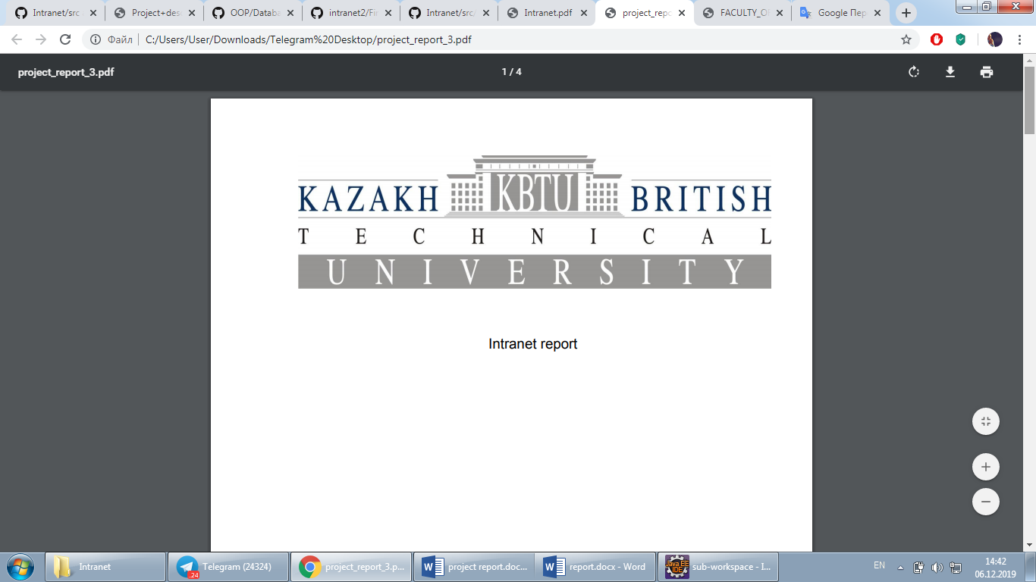

Intranet System

Prepared by: Nurmukhambet Assylanbek

Netullina Nuraiym

Oraz Sanzhar

Ratbek Sanzhar

Checked by: Duisek Bermagambet

Almaty, 2019

**Table of Contents**

Introduction…………………………………………………………………………………………………………………………….2

Main part…………………………………………………………………………………………………………………………………2

Diagrams…………..………………………………………………………………………………………………………….2

Data Storing…………..……………………………………………………………………………………………………..3

Examples…………..………………………………………………………………………………………………………….4

Conclusion…………..…………………………………………………………………………………………………………………..4

**Introduction**

In this project, we created our own student management system based on KBTU Intranet. In the creation of our intranet, our goal was to simplify the connection between users of the intranet as much as possible. The application was created in the object-oriented Java language and was originally planned to be protected as long as authentications, serializations and deserializations are used.

**Main part**

**Diagrams**

Our team has created two types of UML diagrams relative to our internal network. The first diagram is a Use-Case diagram that is understandable to all people. The second is the Class Diagram, which has all the attributes for encoding, such as fields, methods, etc. For creation, we used the TopCoder UML tool.

**Use-Case Diagram:**

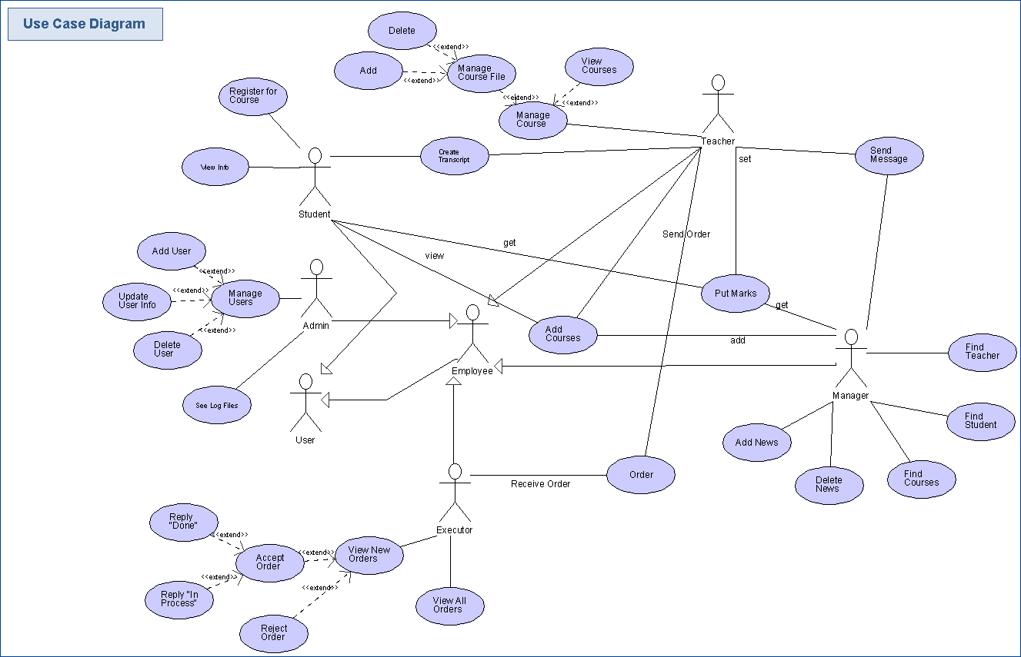

**Class Diagram:**

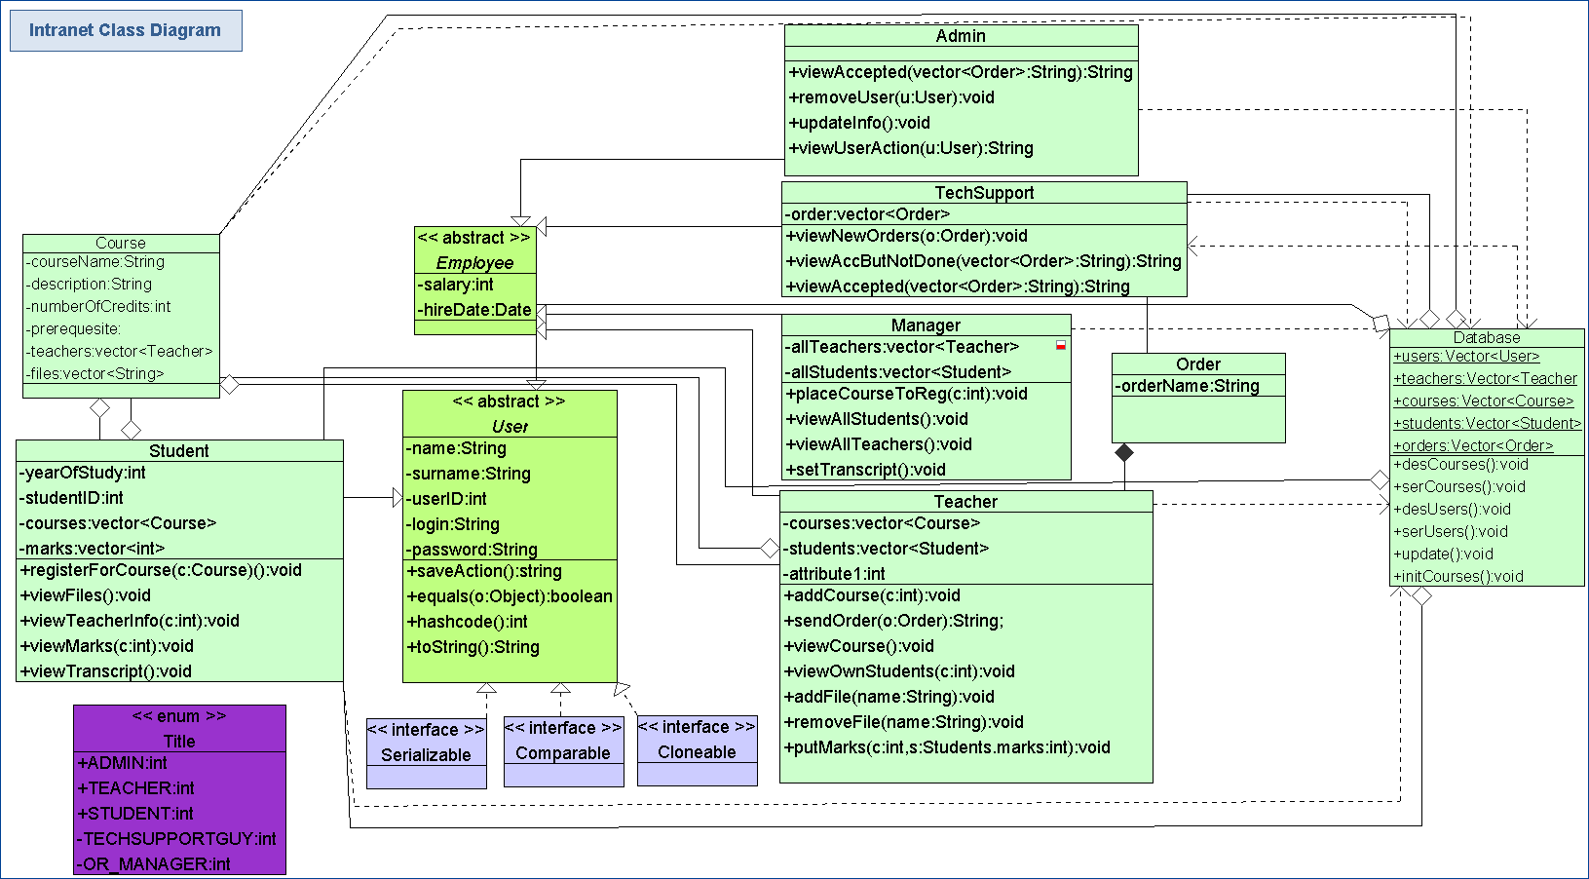

Generally, the class diagrams are widely used in the modeling of object-oriented systems because they are the only UML diagrams, which can be mapped directly with object-oriented languages. Our Class diagram describes the attributes and operations of a class and also the constraints imposed on the system.

**Data storing**

As the main part of the project we created a class named Database, which has private static collections as ArrayLists and Vectors. Every time the application runs we use Database by deserializing to fill collections with saved information and each time the application ends serialization occurs.

As long as serialization occurs, database will save all the information contained in all vectors as teachers, students, courses, users.

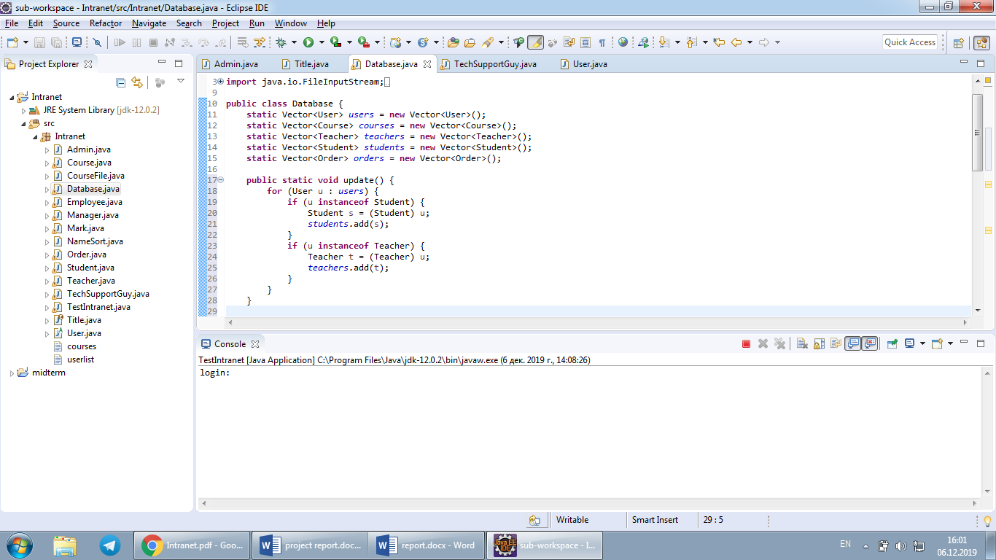



How it works is shown in the next example:

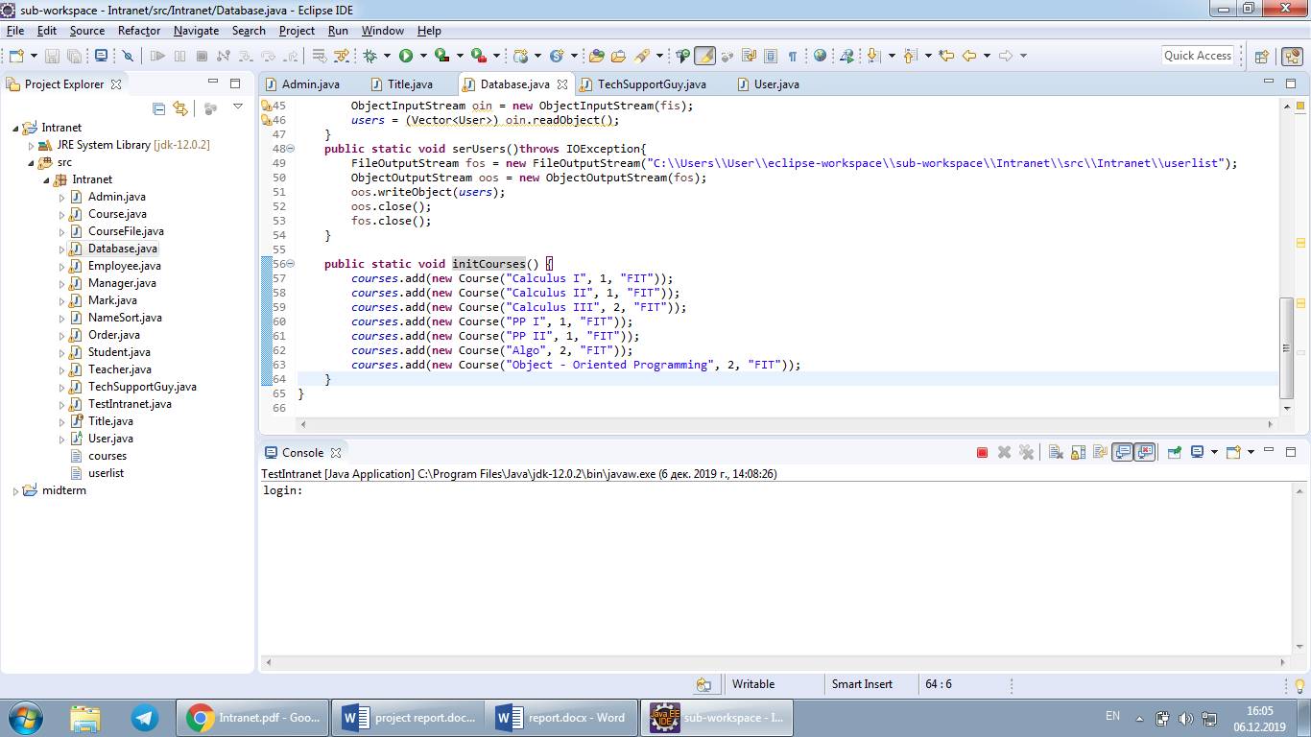

**Examples**

Here is shown another example of OOP approach in our Intranet system. Using this part of class code student can see for which courses he/she can register (e.g. what courses are available for him). Registration will be completed only if the year of study and specialty corresponds to the course. Also the course’s status should be true, which means opened by OR Manager to register by students.

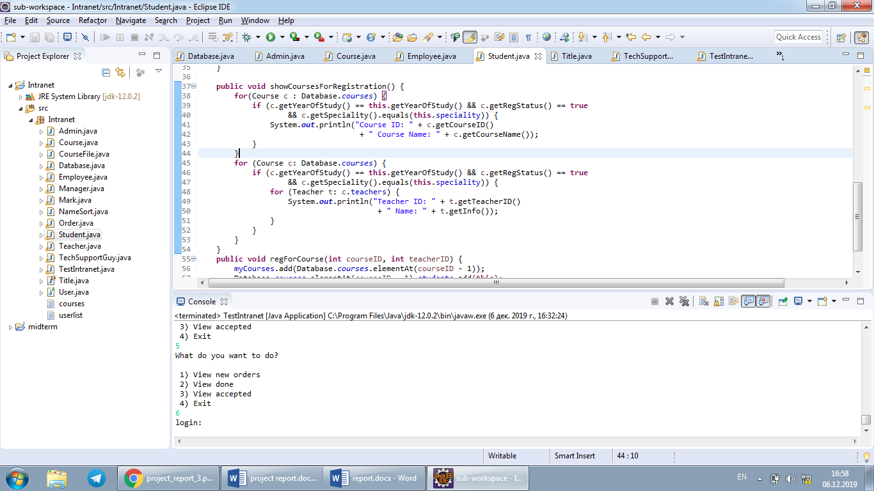

Also as one of the complicated parts of the project we can consider a making of tester class. In test class we used objects/methods of all existing classes and it was easy to make mistakes on associating them and making logical connection.

For example, here is shown a part of code of adding a new student and teacher accounts to the intranet being admin:

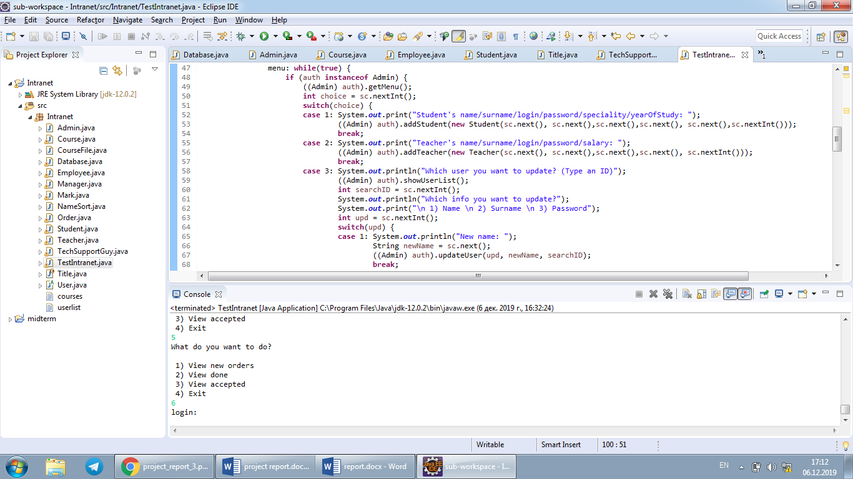

**Conclusion**

To conclude, I want to say that our intranet system has a good logical connection similar to KBTU system. But also it requires a lot of additions marks and news. Since this project was completed in 3 weeks, we can conclude that OOP designing really helps reduce coding time.