**Amaliy mashg’ulot**

**Mavzu: Murakkab so‘rovlar yaratish. TOP, LIMIT yoki ROWNUM**

**Ishdan** **maqsad:** Berilgan predmet soha ma`lumotlar bazasidan foydalanib TOP, LIMIT yoki ROWNUM lardan foydalanishni o`rganish.

**Masalani** **qo`yilishi:** Predmet soha ma`lumotlar bazasi shakllantirilgandan so`ng undan unumli foydalanishni tashkil etish maqsadida TOP, LIMIT yoki ROWNUM lar orqali so`rovlar yaratish.

**Uslubiy** **ko`rsatmalar**: SQL LIMIT va SQL TOP operatorlarining vazifasi belgilangan satrlarni chaqirishdan iborat. SQL TOP operatori MS SQLServerda ishlaydi**,** SQL LIMIT operatori esa MySQLda va **Oracle** da ROWNUM operatori ishlaydi ularnig vazifasi bir hil.

**SQL Server / MS Access Syntax:**

SELECT TOP number|*percent* column_name(s)  
FROM table_nameWHERE condition;

**MySQL Syntax:**

SELECT column_name(s)  
FROM table_nameWHERE condition  
LIMIT number;

**Oracle Syntax:**

SELECT column_name(s)  
FROM table_name  
WHERE ROWNUM <= number;

### Misol. MS SQL Serverda ishlash

SELECT TOP 3 * FROM Customers;

### Misol. SQL da ishlash

SELECT * FROM Customers  
LIMIT 3;

### Misol. **Oracleda ishlash**

SELECT * FROM Customers  
WHERE ROWNUM <= 3;

**Ishni bajarish tartibi**

Avvalgi bajargan korpus nomli jadvalni chaqirib olamiz.

SELECT * FROM **korpus;**

1. **So`rov: SELECT * FROM  korpus LIMIT 3;**

Buyrug`ini kiritamiz natijada birinchi uchta satr hosil bo`ladi

**Natija:**

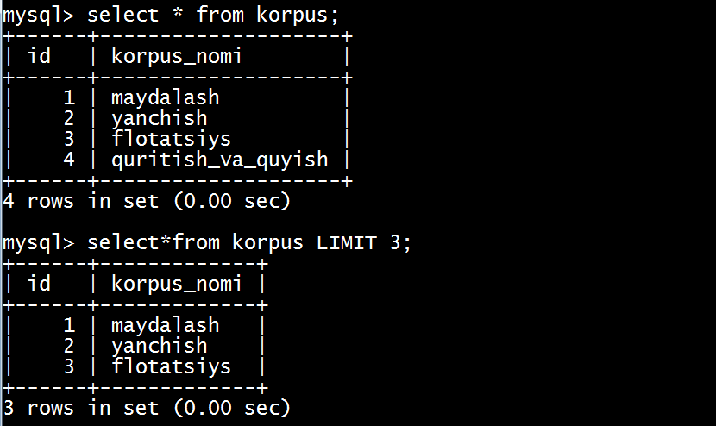

**13.1 – rasm. Limit** operatori orqali 3 ta qatorni ekranga chiqarish

1. **So`rov: Select * korpus_nomi FROM korpus LIMIT  2,3;**

Buyrug`ini yozamiz, natijada 2, 3 satrlar hosil bo`ladi.

**Natija:**

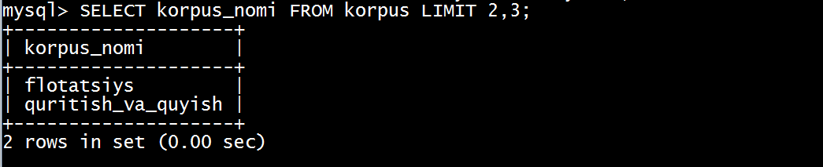

**13.2 – rasm. Limit** operatori orqali 2,3 qatorni ekranga chiqarish

1. **So`rov: SELECT *  korpus_nomi FROM korpus**

**ORDER BY korpus_nomi DESC LIMIT  2,3;**

**Natija:**

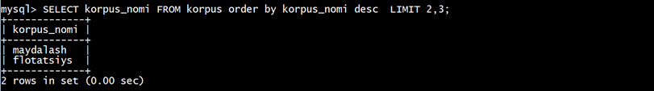

**13.3 rasm**

**Xulosa va foydalanilgan adabiyotlar keltiriladi**