|  |
| --- |
| University Domination |
| User Manual |
| *By Unlucky* |

# Overview:

In this top-down, turn-based strategy game you lead one of the college gangs and battle rival gangs to control the University of York. The campus has been divided into many territories and the aim of the game is to capture all of these territories or eliminate all other rival gangs.

# Gameplay:

During the game, players take turns to make various decisions and moves. In each turn, a player allocates new gang members to the sectors they own and then has the option to attack enemy sectors and move gang members between friendly sectors.

During a turn, all new gang members must be assigned to sectors, however, you have the option to not attack or move gang members.

# Allocating Gang Members:

Allocation of new gang members occurs at the start of every turn cycle. When it is a player’s turn to allocate, the ‘Gang Members Left’ label shows them the number of new gang members that have been assigned to their gang.

To allocate gang members:

1. Left-click on a sector that you own.
2. Type in the number of gang members you wish to allocate to the selected sector.
3. Once this is done, click the ‘Allocate’ button.

1. 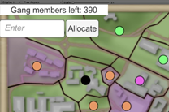 2. 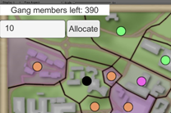 3. 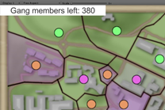

# Combat:

Attacks can only occur during the attacking phase of a turn. The outcome of an attack is based on the attack and defence scores of the attacking/defending sectors involved. The players can increase their attack/defence score by playing the slider minigame.

To initiate an attack:

1. Left-click on a sector that you own.
2. Left-click on an adjacent sector that has been highlighted in red.

1. 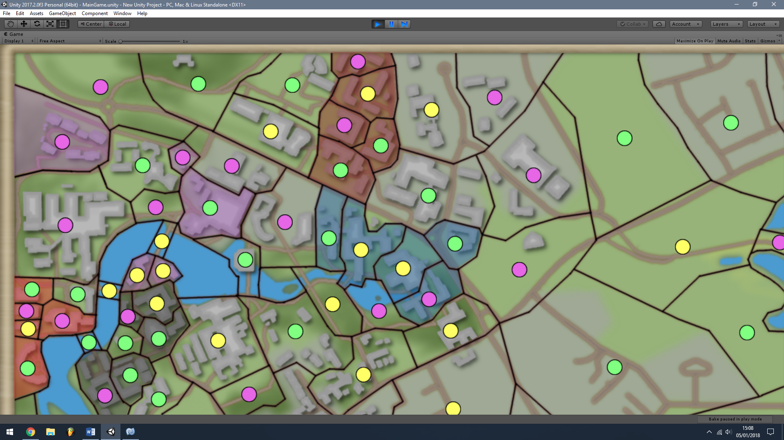 2. 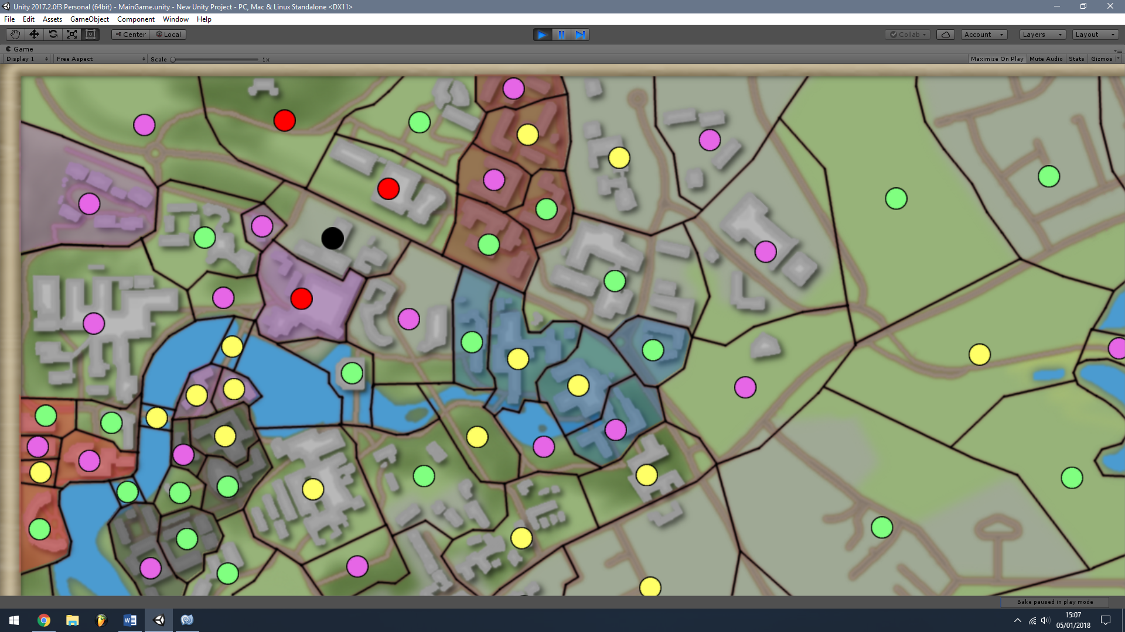

During an attack:

* Once you have initiated an attack, the slider minigame will be shown.
* The aim of the minigame is to press the stop button when the marker is as close to the middle as possible.
* The attacker plays the slider minigame first, followed by the defender.

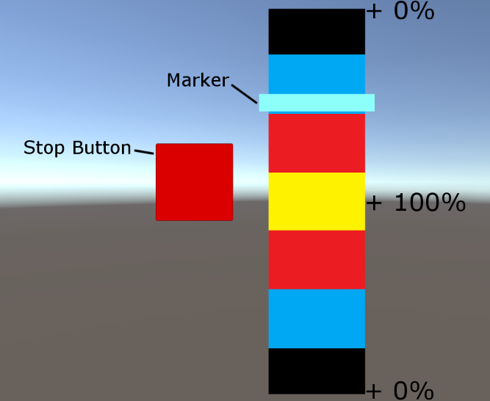

# Controls:

Left mouse button - select a sector / activate button.

Right mouse button - deselect current selection.

Cursor position - camera movement.