**User Manual:**

Contents:

Getting started: 2

The Objective of the Game: 3

The Basic Game Elements: 3

Playing the Game: 4

Taking Turns: 4

Conflicts: 5

PVC mini-game: 6

# 

# Getting started:

Run the executable file (UniversityDomination.exe) to load the menu.

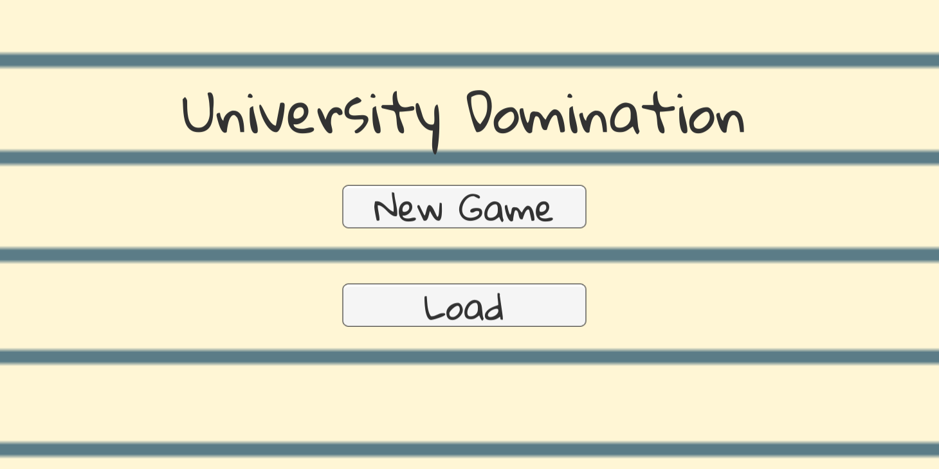

Figure 1: Starting menu shown when first launching the game

Upon launching the game you will enter a menu (Fig. 1). From here you will have the option to start a **new game** or **load** a saved game. The load button will only appear if there is already a saved game to load and it will load the last game you saved.

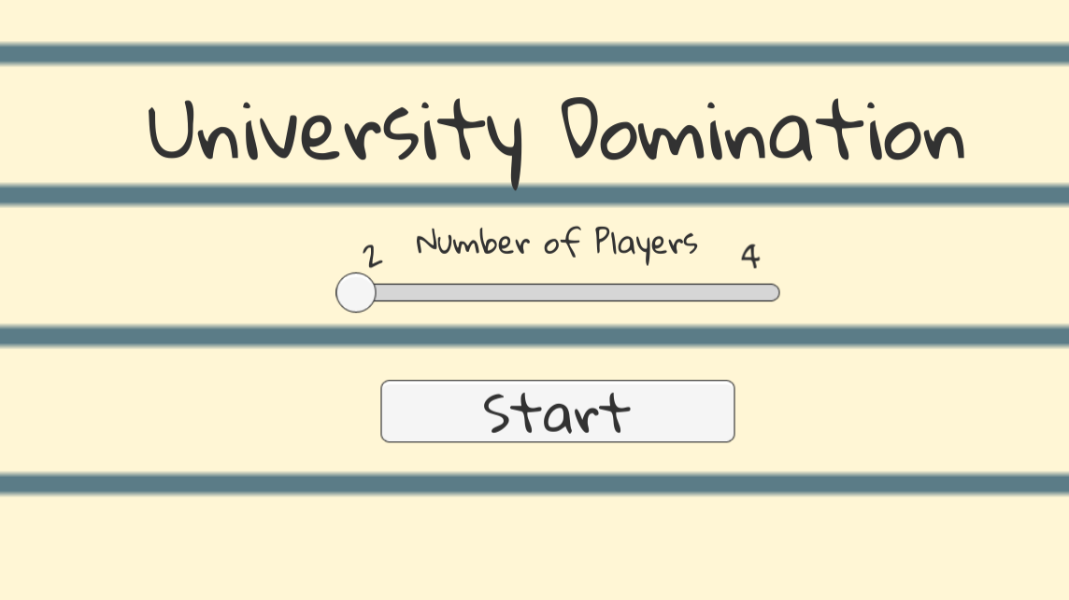

Figure 2: Number of players slider selection

Pressing the new game button will present a slider (Fig. 2) allowing the selection of how many human players (between 2 and 4) will be participating in the game. As there will always be 4 players the remaining spaces will be filled by computer controlled players.

Whilst in game, pressing the escape key will bring up the pause menu screen (Fig. 3). In this menu you have the option to either resume the game by pressing continue or to save the game to load it at a later point.

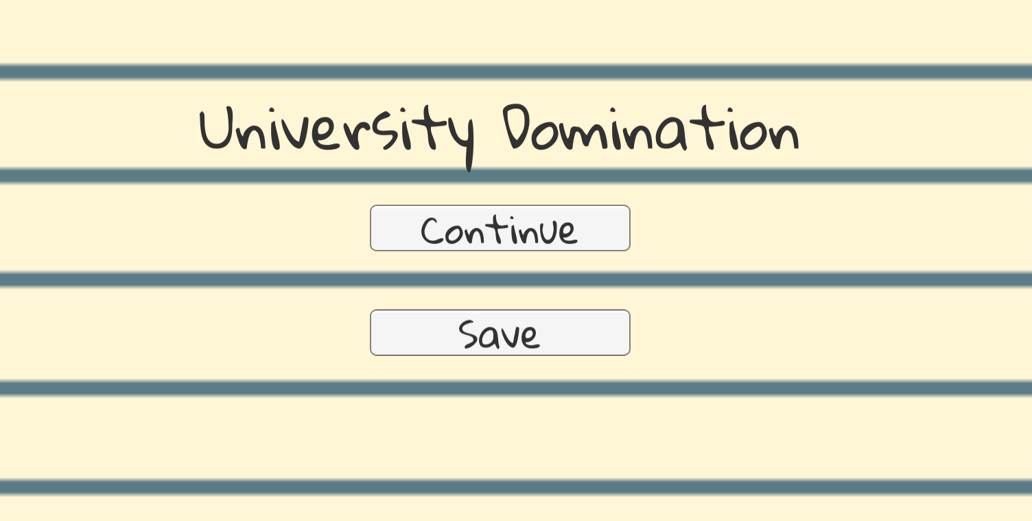

Figure 3: The pause menu shown during the game

# The Objective of the Game:

In order to win, you must be the last player standing. Eliminate other players by capturing their sectors and destroying their units.

# The Basic Game Elements:

To understand the game, you must be familiar with the following game elements:

*The Map* - The map is divided into 32 sectors, 4 of which are landmarks (Fig. 4). A sector may be owned by at most 1 player, and it may contain at most 1 unit.

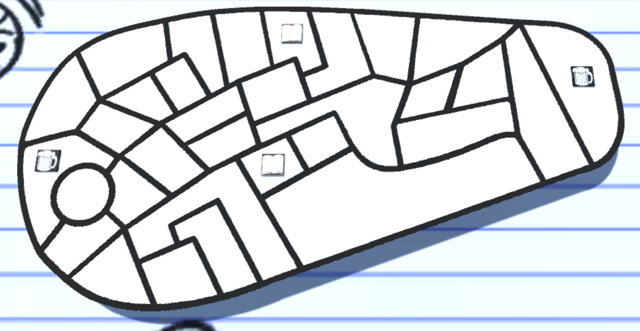

Figure 4: An image of the map including the placement of landmarks.

*Landmarks* - A landmark is a special kind of sector. If a player owns a landmark, a new unit will spawn at the landmark at the start of the player’s turn, assuming there is not a unit already on the landmark. In addition, each landmark is associated with a specific type of resource (Fig. 5), and the player who owns the landmark also owns 2 of the landmark’s associated resource.



Figure 5: The icons displayed on landmarks that identify its resource type: Beer (left) or Knowledge (right).

*Units* - Units are a player’s instrument with which to capture sectors and eliminate other players. New units spawn at Level 1, and may progress up to Level 5. Each time a unit successfully captures a sector, its level increases by 1. A unit’s level determines its overall strength - a higher-level unit is more likely to win conflicts with other units.

*The Pro-Vice-Chancellor -* The Pro-Vice-Chancellor (PVC) will spawn in a random sector at the start of the game that is not controlled by any player. The PVC will be hidden in this sector until a player captures. At this point the PVC mini-game will start and the player will be rewarded with bonus resources according to how well they played. When this sector is captured by another player, they will get a chance to play the mini-game and the bonus resources of the original owner will be lost.

Resources - There are two types of resources: Beer and Knowledge. Beer boosts a player’s offensive power, while Knowledge boosts a player’s defensive power.

# Playing the Game:

When the game starts, each player owns one landmark and one Level 1 unit which is situated on that landmark. Which player owns which landmark is determined randomly. Players then take turns moving their units and starting conflicts with other players. A player is considered eliminated when they have no units left AND they do not own any landmarks. The game ends when only one player is not eliminated, and that player is the winner.

# Taking Turns:

At the start of a player’s turn, new units are spawned at any landmarks the player owns, assuming that there is not a unit already on the landmark. During their turn, the player may make up to 2 move actions, moving one of their units into a sector adjacent to the sector it currently occupies.

To move a unit, first select the unit you wish to move by clicking on it, or on the sector it occupies. This will highlight the sectors adjacent to the one the selected unit occupies, indicating the possible sectors it can move into. Click on the sector you would like to move the selected unit into, and the move action will be resolved in one of three ways:

1. If you move the unit into an unoccupied sector (i.e. one that does not already contain a unit), then the unit moves into that sector unimpeded. If the sector belonged to a different player prior to the move, the unit captures the sector, and the unit’s level increases by 1 if it is not already at the maximum level (i.e. Level 5).
2. If you move the unit into an occupied sector (i.e. one that already contains a unit), and you own the unit occupying the sector, then the two units swap places.
3. If you move the unit into an occupied sector, and the unit occupying the sector is owned by a different player, then a conflict occurs. Conflicts are described in more detail in a later section.

* A player’s turn ends either after a conflict is resolved, or after they make 2 move actions, whichever comes first. It is then the next player’s turn. The player may also choose to pass the turn by pressing the pass turn button in the bottom left (Fig. 6)

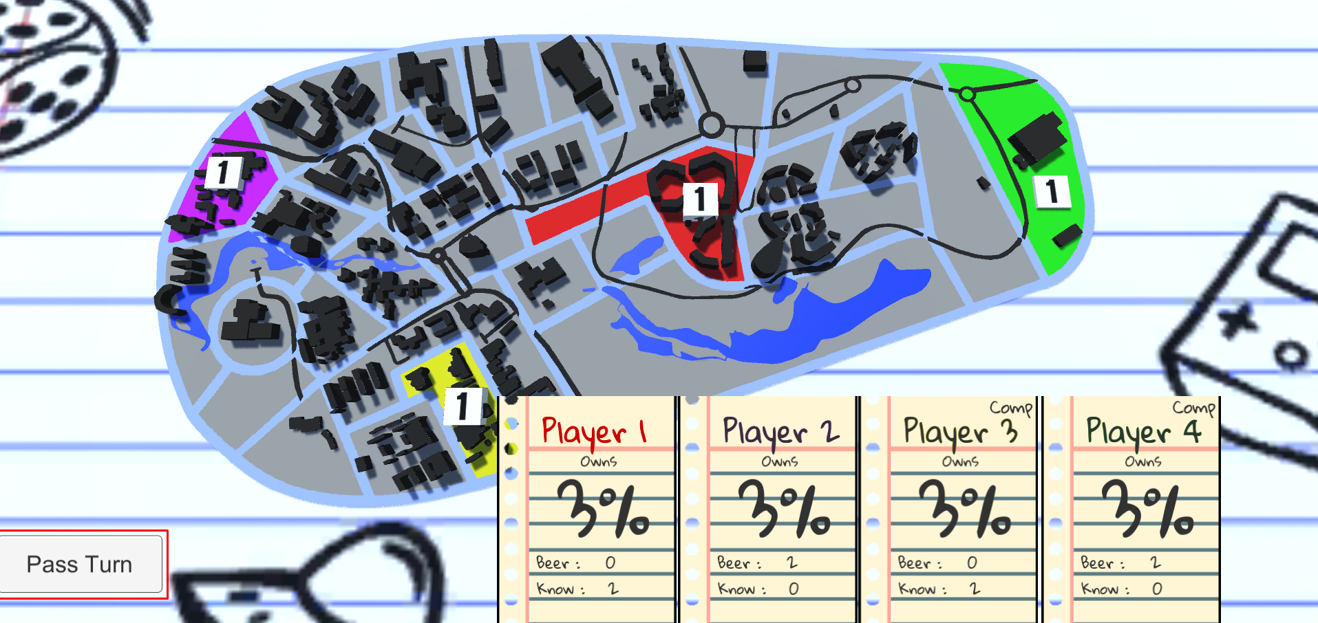

Figure 6: The pass turn button (highlighted in a red box in the bottom left of the screen)

# Conflicts:

A conflict occurs when a unit owned by one player (the attacking player) attempts to move into a sector occupied by a unit owned by another player (the defending player). The outcome of a conflict depends on two major factors: the respective levels of the units involved in the conflict and the amount of resources owned by the players involved in the conflict.

Higher-level units are generally stronger than lower-level units. The higher a unit’s level is compared to its opponent, the better its chances are at winning the conflict.

The different types of resources, Beer and Knowledge, boost a player’s chance to win a conflict depending on if the player is attacking or defending. Having more Beer increases a player’s chance of winning if they are attacking, and having more Knowledge increases a player’s chance of winning if they are defending.

Although unit levels and resource amounts can stack the odds in favour of one player, the outcome of the conflict is rarely certain - even a player at a severe disadvantage in a conflict can be victorious if luck is on their side.

Once a conflict is resolved, the losing unit is destroyed. If the attacking unit was the winner, then it moves into the sector previously occupied by the defending unit. If the defending unit was the winner, it remains in its sector.

# PVC mini-game:

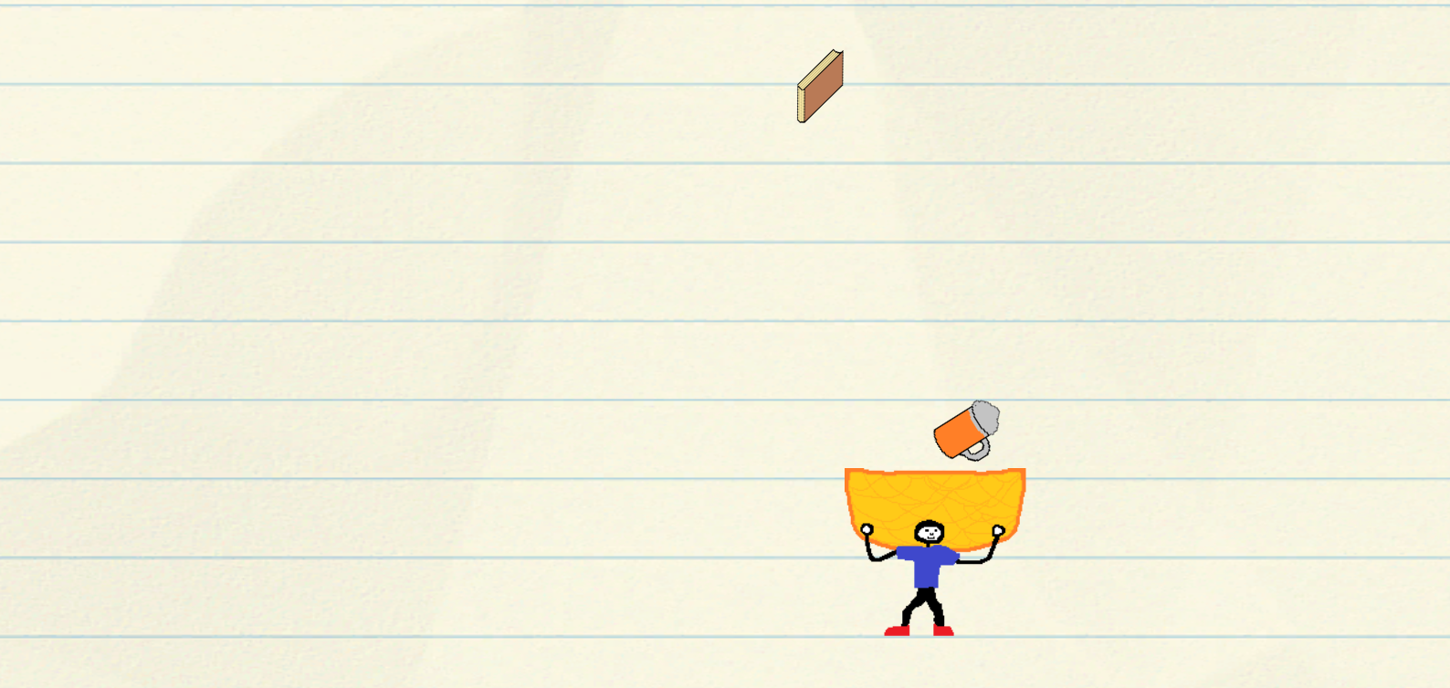

When playing the PVC mini-game you can move the character by pressing the left and right arrow keys. The objective is to catch as many beers (attack) and books (knowledge/defense) while avoiding bins, which will subtract from your score.

The game will end after 20 twenty objects have fallen. Then for every 2 Beers and Books the owner of the sector will get one attack and defense bonus.

Once someone else takes over the sector the bonus will be subtracted from the old owner and added to the new owner.