|  |
| --- |
| University Domination |
| User Manual |
|  |

**User Manual**

**The Object of the Game:**

In order to win, you must be the last player standing. Eliminate other players by capturing their territory and destroying their units.

**The Basic Game Elements:**

To understand the game, you must be familiar with the following game elements:

*Main Menu* - The main menu consists of a series of buttons, each with the following purposes:

1. New Game: Starts a new game
2. Load Game: Loads a previous save of the game, allowing you to continue a game that is unfinished
3. Options: Enters the options menu
4. Exit Game: Closes the game

*The Map* - The map is divided into 32 sectors, 4 of which are landmarks (Fig. 1). A sector may be owned by at most 1 player, and it may contain at most 1 unit.

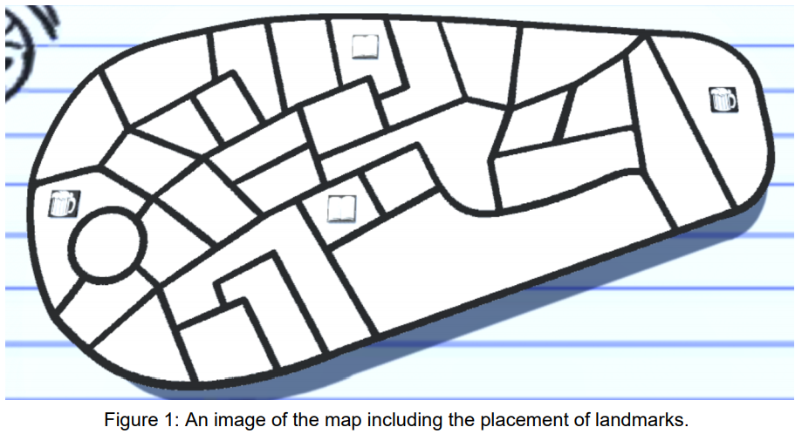

*Landmarks* - A landmark is a special kind of sector. If a player owns a landmark, a new unit will spawn at the landmark at the start of the player’s turn, assuming there is not a unit already on the landmark. In addition, each landmark is associated with a specific type of resource (Fig. 2), and the player who owns the landmark also owns 2 of the landmark’s associated resource.

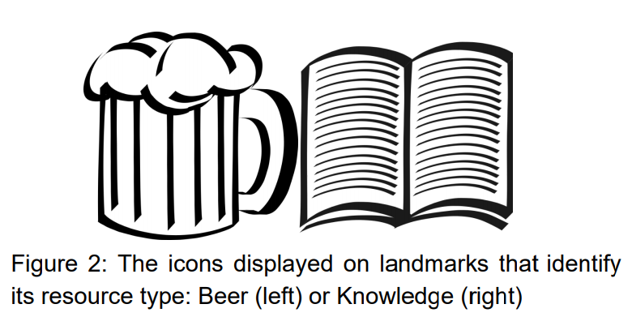

*Units* - Units are a player's instrument with which to capture sectors and eliminate other players. New units spawn at Level 1 and may progress up to Level 5. Each time a unit successfully captures a sector, its level increases by 1. A unit's level determines its overall strength - a higher-level unit is more likely to win conflicts with other units.

When a unit reaches level-5, it becomes a Postgraduate Unit. This is a special kind of unit that can teleport to any sector you own.

*Resources* - There are two types of resources: Beer and Knowledge. Beer boosts a player’s offensive power, while Knowledge boosts a player’s defensive power.

*Punishment Cards-* There are four types of card (Fig. 3): Fresher’s Flu, Killer Hangover, Nothing and Strike, each of which have a unique effect and for more information see the “Punishment Card” section below.

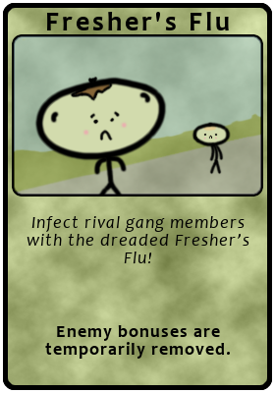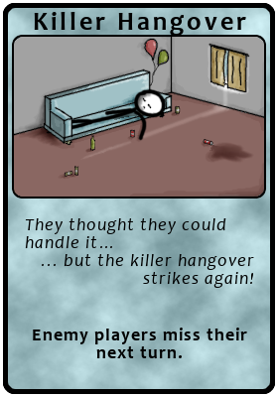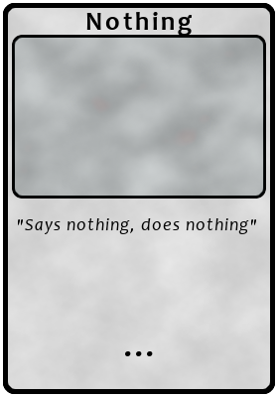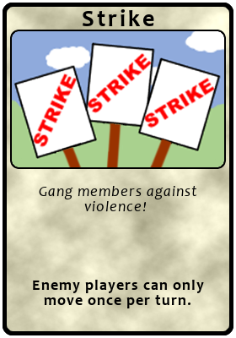

Figure 3: Images showing the four types of card.

**Starting the Game**: Run the executable file (University.Domination.exe) to start the default 4-player game.

**Playing the Game**: When the game starts, each player owns one landmark that contains a single level-1 unit, and the ownership of these landmarks are determined randomly. Players then take turns moving their units and starting conflicts with other players.

A player is considered eliminated when they have no units left AND they do not own any landmarks. The game ends when only one player is not eliminated, and that player is the winner.

**Taking Turns**: At the start of a player’s turn, new units are spawned at any landmarks the player owns, assuming that there is not a unit already on the landmark. During their turn, the player may make up to 2 move actions, moving one of their units into a sector adjacent to the sector it currently occupies.

To move a unit, first select the unit you wish to move by clicking on it, or on the sector it occupies. This will highlight the sectors adjacent to the one the selected unit occupies, indicating the possible sectors it can move into. Click on the sector you would like to move the selected unit into, and the move action will be resolved in one of three ways:

1. If you move the unit into an unoccupied sector (i.e. one that does not already contain a unit), then the unit moves into that sector unimpeded. If the sector belonged to a different player prior to the move, the unit captures the sector, and the unit’s level increases by 1 if it is not already at the maximum level (i.e. Level 5).
2. If you move the unit into an occupied sector (i.e. one that already contains a unit), and you own the unit occupying the sector, then the two units swap places.
3. If you move the unit into an occupied sector, and the unit occupying the sector is owned by a different player, then a conflict occurs. Conflicts are described in more detail in a later section.

A player’s turn ends either after a conflict is resolved, or after they make 2 move actions, whichever comes first. It is then the next player’s turn.

**Conflicts**:

A conflict occurs when a unit owned by one player (the attacking player) attempts to move into a sector occupied by a unit owned by another player (the defending player). The outcome of a conflict depends on two major factors: the respective levels of the units involved in the conflict and the amount of resources owned by the players involved in the conflict.

Higher-level units are generally stronger than lower-level units. The higher a unit’s level is compared to its opponent, the better its chances are at winning the conflict.

The different types of resources, Beer and Knowledge, boost a player’s chance to win a conflict depending on if the player is attacking or defending. Having more Beer increases a player’s chance of winning if they are attacking, and having more Knowledge increases a player’s chance of winning if they are defending.

Although unit levels and resource amounts can stack the odds in favour of one player, the outcome of the conflict is rarely certain - even a player at a severe disadvantage in a conflict can be victorious if luck is on their side.

Once a conflict is resolved, the losing unit is destroyed. If the attacking unit was the winner, then it moves into the sector previously occupied by the defending unit. If the defending unit was the winner, it remains in its sector.

**The Mini-Game:**

The mini-game (Fig. 4) begins by a player clicking on the Vice Chancellor icon is clicked, whilst the also control the sector that the icon is inside. The mini game is called “Vice-Chancellor Dress up”. To beat the mini-game, you must choose the right set of clothes for him to wear. You get 3 chances to guess. Upon beating the mini-game, you will receive a bonus!

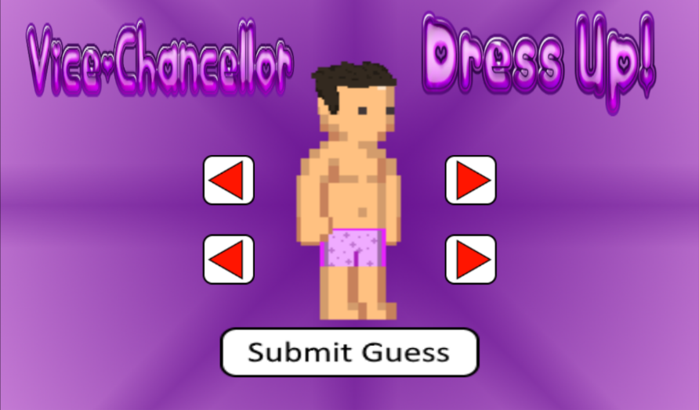

Figure. 4: Vice-Chancellor Dress up mini-game

**Saving and Loading:**

During the game at any point there is an “options” button in the top-right of the screen which allows you to save your game to continue playing later on. Once you have a save file from the main menu you can go into options and then choose to load your previously saved game instead of starting a new game.

**Punishment Cards:**

*Getting Cards*

At the start of your turn, a random punishment card is given to you. These cards are placed in your card deck, which can be viewed by clicking the “Punishment Cards” button (Fig. 5) at the beginning of your turn.

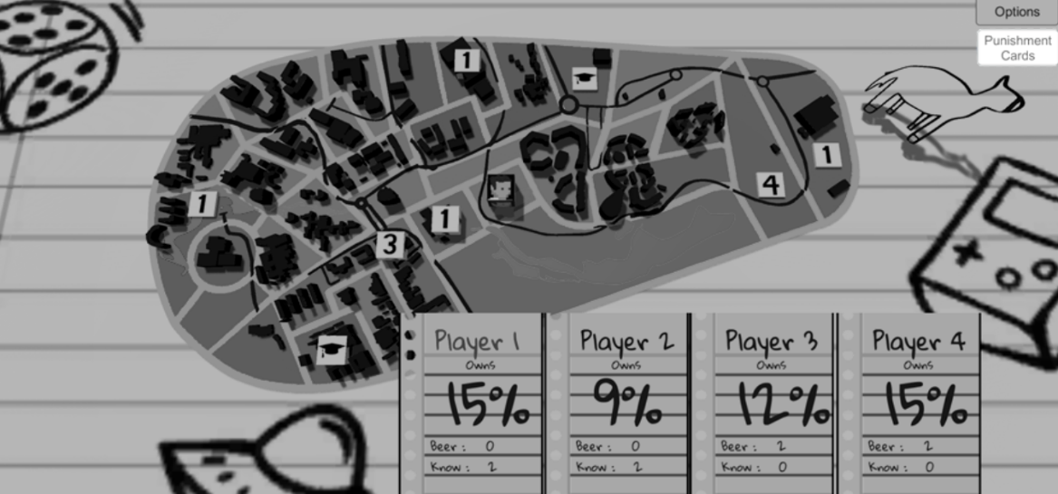

Figure 5: Screenshot of the game, highlighting the punishment card button.

*Playing Cards*

Punishment cards can only be played at the start of your turn. To do this, first open your punishment card deck (Fig.5), and then click on the punishment card you wish to play.

However, you cannot activate punishment cards that are currently in use or their cooldown has not expired, these cards appear faded in the deck (Fig.6). Once you play a punishment card, your turn ends.

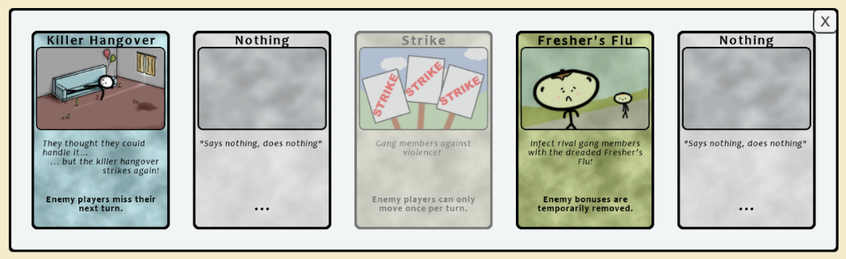

Figure 6: The punishment card deck (the Strike card is deactivated).

*Types of Card*

|  |  |  |  |
| --- | --- | --- | --- |
| **Type** | **Image** | **Effect** | **Duration**  (Turn Cycles) |
| Nothing | Nothing.png | This card has no effect. | 1 |
| Strike | Strike.png | When activated, the enemy players will only be able to move once per turn. | 3 |
| Killer Hangover | KillerHangover.png | This card makes enemy players miss their turn. This card **does not** end your turn when activated. | 2 |
| Fresher’s Flu | FreshersFlu.png | When activated, this card will infect enemy gang members with fresher’s flu.  The card will remove all enemy beer and knowledge bonuses.  *Any bonuses gained from the PVC minigame while this card is active, will be removed when it is deactivated.* | 2 |

Table 1: Table summarising all of the punishment card effects.