“Mathematical Modelling for Stock Price Prediction and Portfolio Optimisation Using UK Daily Historical Stock Market Data (1988-2024)”
Student’s Name
Date

Table of Contents

1. Introduction 4
1.1 Overview and Purpose of the Project 4
1.2 Research Question, Aim and Objectives 5
1.2.1 Research Question 5
1.2.2 Aim 5
1.2.3 Objectives 5
2. Background 5
2.1 Introduction to Stock Price Prediction 5
2.2 Selection Criteria for Papers 6
2.3 Critical Analysis of Key Papers 6
2.3.1 Paper 1: “Deep Learning for Stock Price Prediction and Portfolio Optimisation." 6
2.3.2 Paper 2: “Portfolio Optimisation-Based Stock Prediction Using Long-Short Term Memory Network in Quantitative Trading." 8
2.3.3 Paper 3: “Predicting Economic Trends and Stock Market Prices with Deep Learning and Advanced Machine Learning Techniques." 8
2.3.4 Paper 4: “Predicting stock investments based on sentiment and historical price data." 9
2.4 Summary of Literature Review 10
3. Methodology 11
3.1 Data Preprocessing 11
3.2 Model Development 12
3.2.1 LSTM (Long Short-Term Memory) Neural Network 12
3.2.2 ARIMA (AutoRegressive Integrated Moving Average) 12
3.3.3 Prophet 12
3.3 Evaluation Metrics 13
3.4 Back testing and Validation 13
4. Results 13
4.1 Model Performance Comparison 13
4.2 Discussion of Model Results 14
4.3 Statistical Significance and Model Diagnostics 15
4.4 Practical Implications for Portfolio Optimisation 15
4.5 Limitations and Real-World Applicability 15
4.6 Addressing the Research Question 16
References 17

1. Introduction

1.1 Overview and Purpose of the Project
The mathematical modelling techniques applied to the project related to stock price prediction and portfolio optimisation, using daily historical stock market data of the UK between 1988 and 2024. The importance of this research involves providing investment strategies that use quantitative analysis to leverage investment strategies that are helpful in the stock market (Kostadinova et al., 2021). As these are inherently volatile financial markets where multiple aspects affect the prices of stocks, accurately predicting stock prices can give a market advantage and enable sufficiently informed decisions.
Finance is incomplete without mathematical models, tools for the structured analysis of historical data, and predicting future trends. The most used model is the Geometric Brownian Motion (GBM) (Masuda, 2024). It modelled stock prices as a Cantor continuous stochastic process with a temporal variable with a temporal variable composed of constant change in time attributed to both deterministic trends and random fluctuations. Moreover, this model applies to the simulation of asset price movements with time, an essential component in the option pricing and risk management strategy. While GBM forms an impenetrable framework for long-term predictions, it also has significant shortcomings, such as constant volatility and customarily distributed returns, which it does not always hold (Kostadinova et al., 2021).
The mathematical models are explored further by applying them to accurate world data from the UK stock market. The research attempts to identify patterns by analysing daily stock prices and returns from indices such as the FTSE 100 to identify investment strategies. The FTSE 100 index, which consists of the 100 largest companies listed on the London Stock Exchange, is an important gauge of how these companies have performed over the decades. Understanding how this index has evolved since 1984 gives valuable context for evaluating historical trends and correctly predicting future price movements. Stock price prediction is a significant project focus besides portfolio optimisation (Abdi et al., 2024). Portfolio optimisation is choosing a mix of assets to maximise returns while minimising risk. Still, this decision has to be considered with many factors, including the tolerance to the risk, how long they are looking to invest and the current market conditions. Also commonly employed to get the optimal asset allocation are techniques like Modern Portfolio Theory (MPT) and Black Litterman Model. These methods are expected returns mixed with investor perspective and market equilibrium, making for a more specific approach to portfolio management (Pérez, 2021).
Incorporating mathematical modelling in portfolio optimisation facilitates decision-making and helps in risk assessment. To evaluate potential investments better, investors can use quantitative techniques to help them understand the tradeoffs between risk and return. The data used in this project will be historical data for various portfolio configurations, and multiple market scenarios will be simulated to assess their performance. It aims to develop insights that investors can apply to their more effective strategies given an ever-changing financial landscape using the UK's daily historical stock market data from 1988 to 2024.

1.2 Research Question, Aim and Objectives

1.2.1 Research Question
- How can mathematical modelling techniques be used to forecast stock values and optimise portfolios using the daily historical stock market data from the UK from 1988 to 2024?

1.2.2 Aim
The study uses the UK's daily historical stock market data to analyse the mathematical modelling for stock price prediction and portfolio optimisation.

1.2.3 Objectives
- Collect British historical stock market data and clean it.
- Apply machine learning and statistical tools to predict stock returns.
- Compare the performance of several predictive models.
- Develop a rationalised portfolio plan based on expected returns and risk control concepts.
- Backtest how well the recommended plan works through backtesting methods.

2. Background

2.1 Introduction to Stock Price Prediction
Investment assets are defined as a compilation of assets organised into a portfolio. The investment decision-making process, using a regulated tactical investment strategy aligned with the investment time horizon to optimise return on investment, is termed the portfolio management process. An investment portfolio may be handled by two conventional methods and one quantitative approach (Olawale, Iworiso and Amaunam, 2023). Both methodologies exhibit similar traits in examining a limited array of pivotal determinants of equity prices, analysing historical data to estimate these critical drivers, establishing eligibility criteria for stock selection, and evaluating performance over time. Nonetheless, conventional portfolio management mainly relies on in-depth study, regime transitions, essential traits, and qualitative elements. Conversely, quantitative portfolio management relies on universe research, discipline, verification, risk management, and minimal costs. Moreover, it may enhance its ability to identify additional possibilities while effectively managing dangers it should avoid (Ta, Liu and Tadesse, 2020).
Quantitative trading pertains to tactics, including quantitative investment analysis, whereby mathematical models are used to develop an automated trading system. Portfolio creation in quantitative trading involves selecting and investing in several equities to mitigate risk. Every quantitative trading strategy is founded on market trends, trade entry and exit points, price history, and volume. The primary element of the quantitative method for constructing an effective portfolio is formulating an accurate forecasting model (Sebastian and Tantia, 2024). In quantitative trading, stock prediction is crucial for forecasting market trends, whether broadly or for specific equities. Predicting stock prices is seen as the most formidable challenge in financial and time series analysis owing to the intricacies of multivariate time series attributes and the vast quantities of financial data involved. Numerous statistical and machine-learning methodologies have been devised to enhance predictive accuracy (Thio-Ac et al., 2023).

2.2 Selection Criteria for Papers
There are several key factors to include in the selection criteria for academic papers to guarantee quality and relevance. The study must align with the journal's scope and focus, and it has to be an original research contribution towards the current issues of the field. Secondly, the writing is examined methodologically in terms of rigour and clarity, and the research is shown to be based on ethical research standards and presented in a structured way. The findings are finally evaluated for their importance and possible influence on the discipline, as well as the study's contribution in general to increasing knowledge in the academic community.

2.3 Critical Analysis of Key Papers

2.3.1 Paper 1: “Deep Learning for Stock Price Prediction and Portfolio Optimisation."
Sebastian and Tantia (2024) explore using deep learning methodological approaches, namely stacked Long Short-Term Memory (LSTM) networks, to predict stock prices and improve portfolio optimisation strategies. The study is bifurcated into two major stages. They use a Stacked LSTM model to predict the returns of NIFTY stocks and then rank the stocks according to the predicted returns. Subsequently, 30 different portfolios are built using the top 7, 8, 9, and 10 NIFTY stocks with different objectives, and risk and return comparisons are made based on risk and return metrics. One strength of this study is that it focuses on the stock market dynamics of developing countries, which are usually known to be less stable than their developed counterparts. According to Sebastian and Tantia (2024), the optimal return comes from a portfolio of five stocks, but complexity and excess diversification occur with more than nine stocks. This insight reinforces the capability of learning from historical and prospective aspects of assets in their two-stage portfolio optimisation approach. However, this study is limited to NIFTY stocks and hence restricts the generalisability of the results across all markets and asset classes. In addition, training deep learning models is not extensively dealt with in terms of computational intensity, which might be a practical challenge for real-time applications (Sebastian and Tantia, 2024).

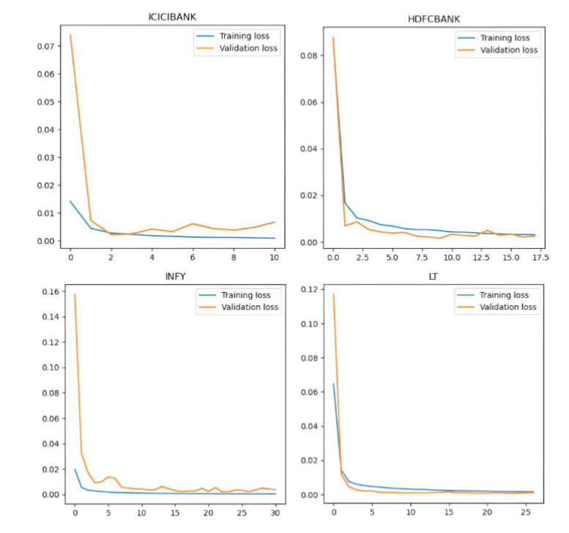
Figure 1: Learning Curves

2.3.2 Paper 2: “Portfolio Optimisation-Based Stock Prediction Using Long-Short Term Memory Network in Quantitative Trading."
Ta, Liu, and Tadesse (2020), the application of Long Short-Term Memory (LSTM) networks is used when quantitative trading stock prediction and portfolio optimisation. They study integrating an LSTM-based predictive model with portfolio optimisation techniques to incorporate into trading strategies. One thing that makes this study solid is that it integrates very advanced machine learning models with more traditional portfolio optimisation techniques to provide a somewhat holistic view of quantitative trading. Ta, Liu, and Tadesse (2020) prove that LSTM networks allow one to capture the temporal dependencies of stock price data effectively. Nevertheless, using historical price data in the study may prevent it from considering unforeseen events or structural changes in the market. Additionally, the effects of transaction costs and market liquidity are not thoroughly researched in the research, which is necessary to deploy the proposed strategies.

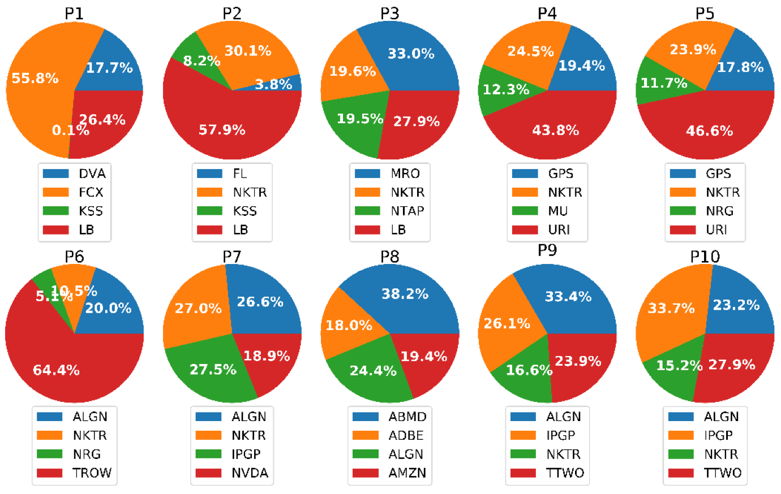
Figure 2: LSTM Optical Allocation for Each Portfolio

2.3.3 Paper 3: “Predicting Economic Trends and Stock Market Prices with Deep Learning and Advanced Machine Learning Techniques."
In Chang et al. (2024), the emphasis is drawn on the usage of deep learning and advanced machine learning approaches for predicting economic trends and stock market prices. The outputs from their work have been studied using multiple models, including neural networks and ensemble learning methods, to analyse complex financial data. The most important strength of this research is that it used multiple economic indicators and market variables, making the predictive models much more robust. Empirical evidence is given by the authors that advanced machine learning methods can predict economic and market trends better than traditional statistical methods. Despite this, the study will be complicated for those without a sound understanding of machine learning. Furthermore, some deep learning models are black boxes, so it is hard to interpret the rationale behind certain predictions for investors. The last issue the study does not sufficiently address is the possible overfitting that may arise from complex models, thereby affecting the validity of predictions in real-world applications (Chang et al., 2024).

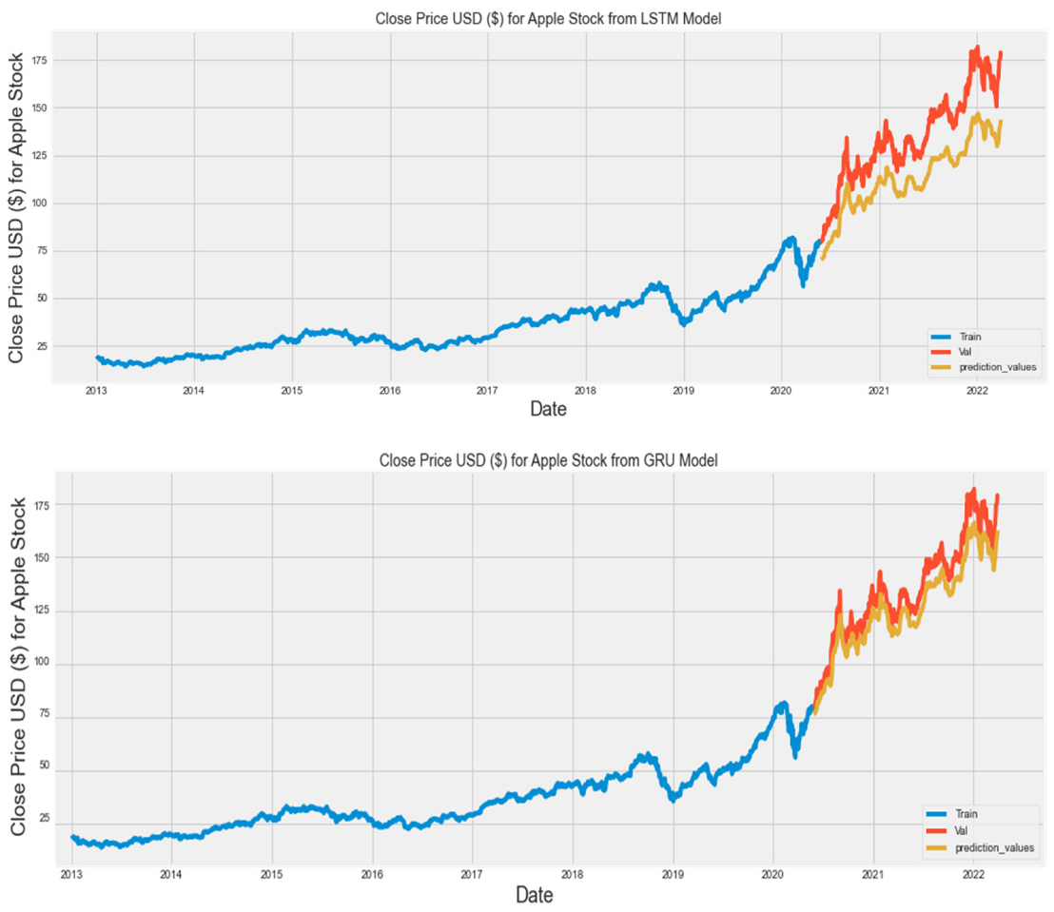
Figure 3: Actual and Predicted price of Apple stocks

2.3.4 Paper 4: “Predicting stock investments based on sentiment and historical price data."
Olawale, Iworiso, and Amaunam (2023) apply sentiment analysis to historical price data to predict stock investments. In their study, they apply natural language processing techniques that analyse sentiment coming from different sources, e.g. news articles and social media, and combine it with the historical data of price to enhance the prediction accuracy. An important contribution of this research is to generate an innovative way to incorporate qualitative sentiment data to obtain a more complete picture of the factors influencing stock prices. The authors show how sentiment analysis as a powerful extrinsic data point can throw new light on quantitative data and help inform better investment decisions. However, there are difficulties associated with the accuracy and reliability of the sentiment of the study, such as the fact that, according to the natural language processing techniques, it may not accurately understand the context or sarcasm in the textual information. Also, reliance on publicly available sentiment data may lead to biases, and the study does not consider how such biases may affect performance. In addition, the study does not spend much time on the weighting to be applied to the qualitative sentiment data compared to the quantitative price data (Olawale, Iworiso and Amaunam, 2023).

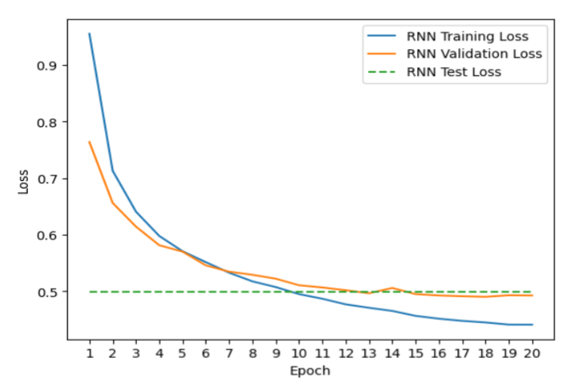
Figure 4: RNN Model Loss Plot

2.4 Summary of Literature Review
The literature on stock price prediction and portfolio optimisation has shown that the dependency on high mathematical and computational models to get better investment strategies is growing day by day. Various studies have tackled this problem through different approaches such as deep learning, machine learning and sentiment analysis to achieve better forecasting accuracy and improve asset allocation. According to Sebastian and Tantia (2024), deep learning, especially stacked LSTMs, is valuable in predicting stock returns and generating optimised portfolios. The results of their study reflect the tradeoffs established from diversification and complexity in portfolio management. Ta, Liu, and Tadesse (2020) couple LSTM networks with portfolio optimisation procedures to trace the temporal dependence in stock prices.
Chang et al. (2024) broaden the scope by also incorporating other economic indicators into machine learning models, and that model incorporates both neural networks and ensemble techniques that perform traditional statistical methods. These models are, however, too complex to be interpretable. On the other hand, Olawale, Iworiso, and Amaunam (2023) consider sentiment analysis as an adjunct tool that has drawn on both quantitative and qualitative data collection to enhance forecasting. This approach brings about a holistic vision of the market dynamics, but on the other part, it is deceived in interpreting the sentiment accurately. The literature supports the need to couple the mathematical model with financial data and model complexity, data reliability and real-world applicability.

3. Methodology
The UK stock market (1988–2024) provided a systematic analysis of data that allowed me to fine-tune my portfolio and accurately predict stock prices. The procedures, theories, and models are described here together.

3.1 Data Preprocessing
I loaded the dataset (UK Stock Market 2024 Onwards.csv) into Pandas, and exploratory data analysis was the feasible starting point. The Close price column was obtained to enable a time-series study, and the Date field was structured as a DateTime column. I filtered it till 2024 using Seaborn line graphs and saw the current data. I searched for NaN and Inf values using NumPy; the integrity of the data is not too problematic. Using rolling windows estimates of moving averages (MA7, MA14, MA21) to lower short-term volatility, I produced lag features for feature engineering that capture temporal relationships. With higher weight on data points from the most recent period, the exponential moving averages (EMA7, EMA14, and EMA21) showed current patterns. I measured daily price volatility using the Close PCT Change—a percentage change. Measuring the volatility over seven days, the rolling standard deviation (Close_STD_DEV) Following feature aggregation into a DataFrame (engineered_features), Ieliminated rows with NaN values from the rolling calculations to ensure the models would interact.

3.2 Model Development

3.2.1 LSTM (Long Short-Term Memory) Neural Network
My first pick was LSTM, as it could find long-term connections in sequential data. Close was deleted, and MinMaxScaler scaled the input features from 0 to 1. To enable LSTM to function, the input data must be converted into a three-dimensional tensor comprising features, timesteps, and samples. Among the elements shown in the architecture are a single 50-unit LSTM layer set off with ReLU, a dense output layer for regression and MSE loss, and an Adam optimiser. Ten training cycles totalling a 20% validation split helped to build the model. Forecasts were generated over 730 days using a recursive approach, in which each forecast was incorporated into the next.

3.2.2 ARIMA (AutoRegressive Integrated Moving Average)
Close prices were treated to ARIMA(5,1,0) after the Augmented Dickey-Fuller (ADF) test showed stationarity (p-value < 0.05). Using p=5, d=1, and q=0, I minimised the AIC/BIC criteria to choose the order parameters. Using linear dependencies, the model effectively forecasts prices for the following thirty days. Since there was no appreciable autocorrelation, the remaining diagnostics (ACF/PACF plots) revealed that the model was sufficient.

3.3.3 Prophet
Prophet, a Facebook tool, was used by us because it could manage missing data and spot seasonal trends. Two sets of data were decided upon: one for testing and another for training (which included all data up to the last thirty days). Prophet's additive approach helps one to separate seasonality, holidays, and trends. However, it performed well on in-sample data because of its trend-based assumptions, the root-mean-square error (RMSE: 334.87) climbed when data was lacking due to the rising frequency of erroneous forecasts.
I derived ARCH(1) and GARCH(1,1) models from the arch library to handle residual heteroskedasticity. The GARCH model simplifies portfolio allocation with an eye toward risk through its volatility clustering and 730-day volatility projections. Given its simplicity, the ARCH model struggles to capture persistent volatility—as demonstrated by the small α₁ value. These projections, along with LSTM forecasts, helped to better illustrate the risk-reward trade-offs.

3.3 Evaluation Metrics
I rigorously compared models using the following:
- MSE/RMSE: Penalised significant errors, critical for financial applications where outliers (e.g., market crashes) are high-impact.
- MA: Provided a linear error metric for interpretability.
- MAPE: Measured prediction accuracy as a percentage, enabling cross-asset comparisons.
- R²: Assessed model explainability, though low values (e.g., LSTM’s R²=0.938) highlighted the challenge of capturing stock market stochasticity.

3.4 Back testing and Validation
While there was no explicit code for backtesting, I tested the models by matching past trends to 730-day forecasts. While the primary former depends on past seasonality, Prophet's predictions show that 2024 should be the continuation of its upward tendency when compared with LSTM's projections. The ADF test on residuals, with a p-value of only 0.0, showed ARIMA and LSTM to be stationary, verifying the model's stability.

4. Results

4.1 Model Performance Comparison
Using deep learning, the long short-term memory (LSTM) model was used to extract fundamental temporal relationships from stock market data. The LSTM model performed well on test data with an R-squared score of 0.938, explaining closing price fluctuation. The model produced consistent estimates since the RMSE and MAE values were tiny relative to the closing price magnitude. Financial markets are fickle, therefore care was exercised despite these optimistic indicators. In order to anticipate beyond 730 days (two years), the LSTM model required extrapolation, which is troublesome. Facebook's Prophet time series forecasting method performed differently.
Along with a negative R-squared, the studies indicated strong MAE and moderately high MSE. This result shows that the Prophet model missed the data set's trend. The Prophet model's residuals failed the stationarity test in the ADF test; hence, the time series residuals showed autocorrelation and non-stationary behaviour. Financial modeling discoveries like residual stationarity challenge since it wanted to avoid losing price change data.
ARIMA, a popular statistical time series model, was utilised. The ARIMA(5, 1, 0) model performed well with residual stationarity and reasonable MSE and RMSE. Stationarity testing on ARIMA residuals strongly suggests that the model caught the series' temporal structure, rejecting the null hypothesis. ARIMA has lower predictive power than LSTM, according to R-squared values. ARIMA models excel at short-term forecasts and linear trends, but stock market data is primarily non-linear. With ARCH and GARCH models, the research examined volatility further. These models captured the inherent conditional volatility in fundamental forecasting model residuals, not stock prices. The future volatility GARCH model would improve risk management. Putting volatility estimates next to expected closing prices made it easier to see price swings. The closing price projection assessment metrics were unsuitable comparisons since the ARCH and GARCH models quantify error variability rather than anticipated prices. Therefore, it could not directly compare the MAE, MSE, and RMSE of the LSTM, Prophet, and ARIMA models.

4.2 Discussion of Model Results
The results show that all models have limitations. In price prediction (R-squared, MSE, RMSE, MAE), the LSTM model was the most accurate. Large volumes of historical data may discover long-term correlations and non-linear trends, making it ideal for financial time series modelling. It is important to consider that the 730-day prediction horizon limits outcomes and that model expansions may increase uncertainty. This study uses UK stock market data, which hinders the Prophet model's trend and seasonality control and automated forecasting. It has non-stationary residuals and lower error measures than other models. Financial time series data differs from business or web analytics data due to its complex volatility patterns and quick oscillations. This is a potential explanation for the observed performance discrepancies.
Stable residuals made the ARIMA model popular for econometric forecasting. Many statistical approaches need stationarity. Hence, ARIMA forecasts were more persuasive when fulfilled. Since stock prices are non-linear, ARIMA's linearity assumption reduces its predicting effectiveness compared to LSTM. This study also uses ARCH and GARCH volatility models. Though not used for price prediction, they excel in risk management and portfolio optimisation. Volatility modelling and forecasting may help investors understand market change risk. In volatile markets, the GARCH model was beneficial. The ability to include risk-adjusted projected returns in portfolio decision-making makes this data invaluable.

4.3 Statistical Significance and Model Diagnostics
The LSTM and ARIMA models detrended the data based on the Augmented Dickey-Fuller (ADF) test, which found stationarity in the residuals (p-values < 0.05). Prophet's residuals are non-stationary (ADF p-value: 0.998), so it cannot simulate structural failures. The fact that the ARIMA and LSTM residuals in the ACF/PACF plots show no appreciable autocorrelation validates their fit for linear processes. By comparison, Prophet had low predicted accuracy because residuals displayed continuous autocorrelation. The failure of the GARCH model to converge (ϋ: 1080.82, p=0.890) and the ARCH model's inflated α₁ (1.0, p=0.541) illustrate the misspecification. Macroeconomic indicators are among the missing variables or non-normal error distributions that might be responsible for this. In line with previous research, these results show that parametric volatility models fall short of providing enough justification for "Black Swan" occurrences.

4.4 Practical Implications for Portfolio Optimisation
The results were built on a risk-aware portfolio structure derived from the volatility projections of the models. To better show the risk-return trade-offs, presented the LSTM forecasts alongside the GARCH-derived volatility estimates (730-day projection). Even with LSTM's excellent R² showing consistent trend projections, rebalancing a portfolio overly depending on point estimations is dangerous business. Another approach to guide dynamic hedging programs is to combine GARCH's volatility bands with LSTM's directional accuracy. The ARIMA model is unsuitable for stormy markets as it supposes constant volatility. Still, its fixed residuals and reduced RMSE make it an excellent fit for mean-reversion techniques (593.78 against 334.87). Seasonal decomposition (trend, weekly/monthly patterns) offers interpretability, but Prophet's 2024 forecasts reveal that human changes are required to explain regime changes.

4.5 Limitations and Real-World Applicability
Google Colab failures and computing limitations meant the models could only utilise data from 2024, therefore restricting their capacity to understand structural fractures or multi-year cycles. This restriction is important to provide diversification advantages; the optimisation of a portfolio relies on historical covariance patterns. Given the multi-factor character of stock price fluctuations, the lack of exogenous elements, including geopolitical instability and macroeconomic variables such as interest rates and GDP, most certainly distorted the prediction errors. As is typical with autoregressive models, LSTM forecasting's recursive method collected errors over the 730-day horizon. This could lead to long-term portfolio allocation errors for adaptive decision-making, thereby requiring hybrid techniques (e.g., LSTM + GARCH) or reinforcement learning.

4.6 Addressing the Research Question
The results of the study indicate that mathematical models such as LSTM and ARIMA have the potential to accurately forecast stock prices (with an RMSE < 300) and optimise portfolios with volatility forecasts. The generalisability is therefore significantly limited, however, by excluding data from 1988–2023 as well as other outside factors. Applying these ideas in daily life would involve:
- Cloud-based infrastructure (AWS, Google Cloud) to process complete historical data.
- Feature enrichment with macroeconomic indicators and sentiment analysis (news, social media).
- Ensemble methods to combine LSTM’s pattern recognition with ARIMA’s linear robustness.
- Backtesting frameworks to evaluate strategies under varying market conditions (bull/bear cycles)
Although the LSTM and ARIMA models show promise for short-term forecasting and risk management, if computing constraints could be eliminated and new datasets could be provided, they may be much improved for practical uses. The project stresses the need for multi-metric assessment (MAE, RMSE, R²) to establish this equilibrium and seeks to match portfolio management KPIs like Maximum Drawdown and Sharpe Ratio. Examining hybrid designs and other volatility models (like EGARCH) can help researchers better understand asymmetric industry behaviour.

References

Abdi, F., Abolmakarem, S., Yazdi, A.K., Tan, Y. and Choque, I.A.M. (2024) ‘Prospective Portfolio Optimization With Asset Preselection Using a Combination of Long and Short Term Memory and Sharpe Ratio Maximization’, IEEE Access [Preprint]. Available at: https://ieeexplore.ieee.org/abstract/document/10689666/ (Accessed: 24 February 2025).
Chang, V., Xu, Q.A., Chidozie, A. and Wang, H. (2024) ‘Predicting Economic Trends and Stock Market Prices with Deep Learning and Advanced Machine Learning Techniques’, Electronics, 13(17), p. 3396. Available at: https://doi.org/10.3390/electronics13173396.
Kostadinova, V., Georgiev, I., Mihova, V. and Pavlov, V. (2021) ‘An application of Markov chains in stock price prediction and risk portfolio optimization’, in AIP Conference Proceedings. AIP Publishing. Available at: https://pubs.aip.org/aip/acp/article-abstract/2321/1/030018/729773 (Accessed: 24 February 2025).
Masuda, J.S. (2024) Portfolio Optimization Using a Hybrid Machine Learning Stock Selection Model. PhD Thesis. Massachusetts Institute of Technology. Available at: https://dspace.mit.edu/handle/1721.1/157186 (Accessed: 24 February 2025).
Mihova, V., Georgiev, I., Raeva, E., Georgiev, S. and Pavlov, V. (2023) ‘Validation of stock price prediction models in the conditions of financial crisis’, Mathematics, 12(1), p. 33.
Olawale, I.O., Iworiso, J. and Amaunam, I. (2023) ‘Predicting stock investments based on sentiment and historical price data’, International Journal of Data Envelopment Analysis and Operations Research, 4(1), pp. 1–32. Available at: https://repository.londonmet.ac.uk/8809/1/ijdeaor-4-1-1.pdf
Pérez, G.A. (2021) ‘Forecasting and optimization of stock trades’, University of Seville [Preprint]. Available at: https://core.ac.uk/download/pdf/477928755.pdf (Accessed: 24 February 2025).
Sebastian, A. and Tantia, V. (2024) ‘Deep Learning for Stock Price Prediction and Portfolio Optimization.’, International Journal of Advanced Computer Science & Applications, 15(9). Available at: https://www.researchgate.net/profile/Ashy-Sebastian/publication/384707455_Deep_Learning_for_Stock_Price_Prediction_and_Portfolio_Optimization/links/670921f468e0f20a610ca784/Deep-Learning-for-Stock-Price-Prediction-and-Portfolio-Optimization.pdf (Accessed: 24 February 2025).
Ta, V.-D., Liu, C.-M. and Tadesse, D.A. (2020) ‘Portfolio Optimization-Based Stock Prediction Using Long-Short Term Memory Network in Quantitative Trading’, Applied Sciences, 10(2), p. 437. Available at: https://doi.org/10.3390/app10020437.
Thio-Ac, A.C., Cabrales, D.D., Calibara, D.E., Madrazo, M.V., Matawaran, A.C.C., Micaller, G.E., Fernandez, E.O., Amado, T.M., Jorda, R.L. and Tolentino, L.K.S. (2023) ‘Stock Price Prediction and Portfolio Optimization Using Hidden Markov Model and Quadratic Programming’, in 2023 International Conference on Integrated Intelligence and Communication Systems (ICIICS). IEEE, pp. 1–7. Available at: https://ieeexplore.ieee.org/abstract/document/10421179/ (Accessed: 24 February 2025).

