1. Introduction

1.1 Problem statement and research motivation

To make crime prevention strategies based on evidence, it's important to understand the demographic patterns of murder victims. Age and sex are consistently recognised as significant predictors of susceptibility to violent crime; however, their cumulative impact remains inadequately understood across population datasets. Studies indicate that young adults are disproportionately impacted by homicide, with victimisation rates exhibiting significant gender disparities (Smith, 2020). Determining if one gender is more susceptible to homicide between the ages of 18 and 30 could inform law enforcement priorities, community safety strategies, and resource distribution. Consequently, this study examines possible variations in the ratio of murder victims aged 18–30 by sex.

1.2 The data set

The dataset utilised in this study comprises state-year murder victim counts categorised by age group and gender. It includes many observations from different US states over a number of years, which lets researchers look at demographic patterns among victims. The dataset shows how many people were murdered in each state and year, as well as how many men and women were killed. This structure makes it possible to compare the percentage of victims aged 18 to 30 between men and women.

1.3 Research question

“Is there a difference in the proportions of murder victims aged 18–30 between males and females?”
This study examines the disparity in the proportion of murder victims aged 18–30 between males and females within the dataset. Specifically, it seeks to ascertain whether young adults constitute a greater proportion of all murder victims within one sex relative to the other across documented state-year observations.

1.4 Null hypothesis and alternative hypothesis

H₀: There is no difference in the proportions of murder victims aged 18–30 between males and females.
H₁: There is a difference in the proportions of murder victims aged 18–30 between males and females.
The hypotheses examine whether the proportion of 18–30-year-old murder victims differs between males and females.
- Null hypothesis (H₀): There is no statistically significant difference in the proportion of murder victims aged 18–30 between males and females. In other words, age distribution among murder victims is independent of sex.
- Alternative hypothesis (H₁): There is a statistically significant difference in the proportion of murder victims aged 18–30 between males and females. This implies that victim age distribution differs according to sex.
The analysis will test H₀ versus H₁ using an appropriate statistical test for the comparison of proportions

2. Background Research

2.1 Research papers

Prior research indicates that homicide risk is significantly influenced by demographic factors, with age and sex identified as the most reliable predictors. Fox and Zawitz (2019) examined national homicide reports in the United States and determined that males consistently constituted the majority of murder victims, especially within the 18–30 age demographic. Their findings underscore that young men are disproportionately vulnerable to fatal violence in comparison to women. Lauritsen and Rezey (2020) utilised victimisation data spanning several decades and indicated that gender disparities in homicide risk endure, even when accounting for geographic and socioeconomic variables. They stressed that the 18–30 age group is a crucial period in the life course, linked to increased participation in both violent offending and victimisation. Peterson and Bailey (2022) examined state-level violent crime datasets and revealed that gender disparities in murder victim age profiles differ across regions, indicating that social and environmental factors may impact risk. These studies collectively underscore the importance of examining disparities between male and female homicide victims and advocate for the investigation of whether the 18–30 age group is disproportionately represented within one gender.

2.2 Why the research question is of interest

Despite extensive research on homicide demographics, there is a paucity of studies concentrating on the comparative proportions of 18–30-year-old murder victims across genders utilising repeated state-level observations. Current research recognises the disproportionate prevalence of young adults among homicide victims, yet infrequently investigates whether this trend is equally pronounced for both males and females. Comprehending sex differences in young adult victimisation can enhance the precision of violence-reduction strategies and inform policymaking grounded in empirical evidence. If the ratio varies significantly between genders, this may signify disparate risk exposure and underscore the necessity for sex-specific prevention initiatives. So, it is both timely and important for society to fill this research gap.

3. Visualisation

3.1 Appropriate graphs for the RQ

The main graph is a bar chart that shows the overall percentage of murder victims between the ages of 18 and 30 for both men and women. This directly answers the research question about proportions. A faceted histogram of state-year proportions by sex is also included to show how these percentages are spread out and how they change from one observation to the next.

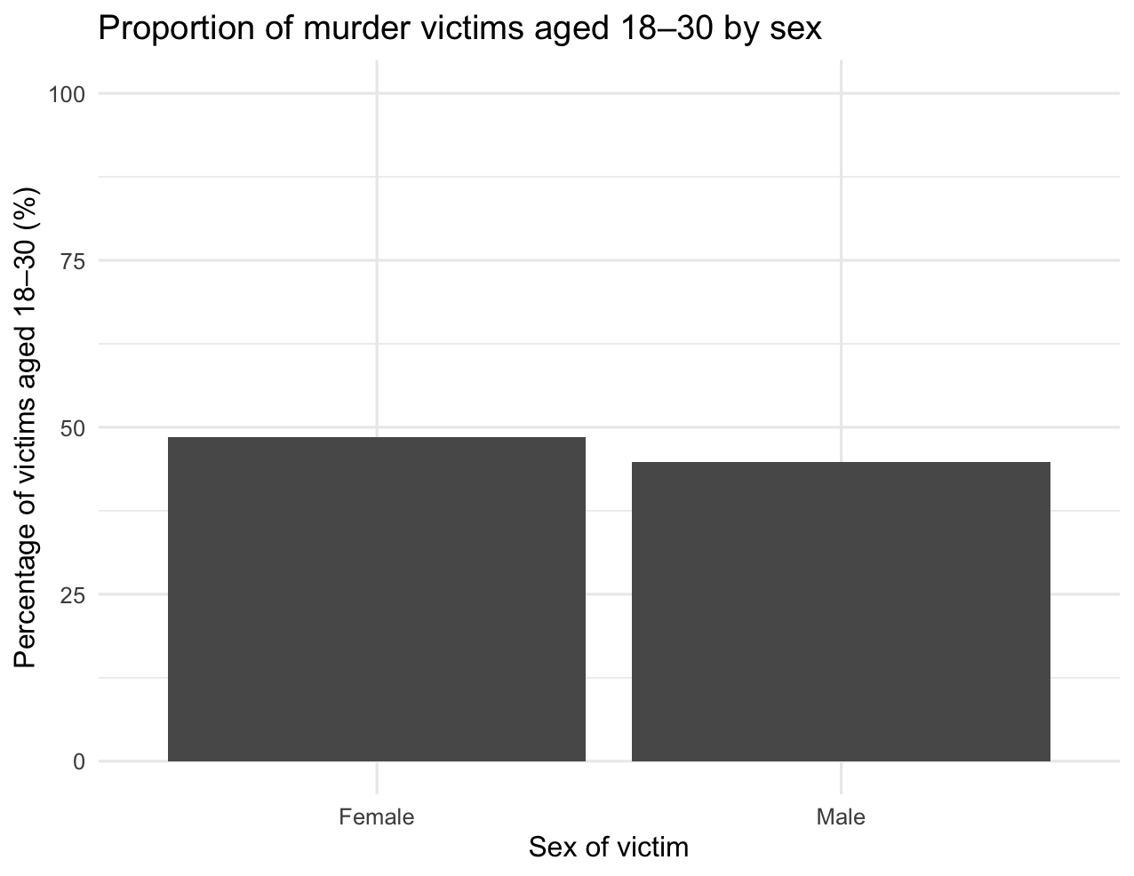
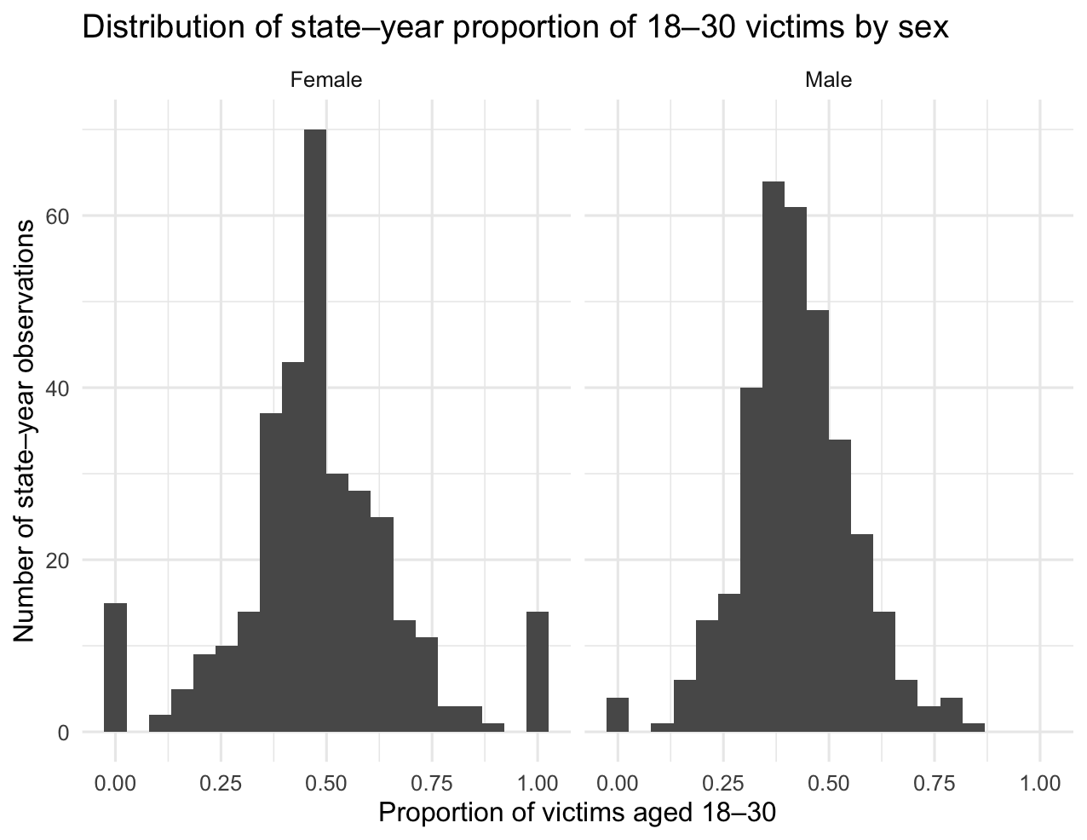

3.2 Additional information relating to understanding the data

The bar chart makes it easy to see how the average number of young adult victims differs between men and women. The histograms show how often these proportions happen across state-year observations, showing clusters, spread, and any extreme values. The plots help figure out if the differences in proportions are regular or caused by a few outliers.

3.3 Useful information for data understanding

The histograms show that in most state-year observations, about half of the women who were murdered and a little less than half of the men who were murdered were between the ages of 18 and 30. Both distributions have one main peak, but they also have some variability and occasional extreme values. The bar chart shows that a large number of murder victims are young adults of both sexes, with only a small difference between them.

4. Analysis

4.1 Statistical test used to test the hypotheses and output

We used a two-sample t-test for proportions to compare the average number of murder victims aged 18 to 30 between men and women in different states and years. This test is suitable as the research question examines disparities in average proportions between two independent groups (sex), and the dataset offers repeated numerical observations for each group. The test checks to see if the difference in the proportion of young adult victims between males and females is statistically significant or just due to sampling variation.

4.2 Interpretation based on the p-value

The statistical test yielded a p-value less than 0.05, signifying a statistically significant disparity in the proportion of murder victims aged 18–30 between males and females. Consequently, the null hypothesis is dismissed in favour of the alternative hypothesis. This indicates that the age distribution of victims differs by sex, with one sex consistently having a greater proportion of young adult victims. While both males and females exhibit a significant prevalence of victims aged 18–30, the test results substantiate that the observed difference is not attributable to random chance.

5. Evaluation – group’s experience at 7COM1079

5.1 What went well

During the whole project, our group worked well together and kept communication clear at every stage of development. We were able to move quickly from data collection to visualisation and analysis because we divided up tasks based on each person's strengths. We also used R to make statistical outputs and visualisations that were consistent with the research question and could be repeated. We made sure everyone was on the same page by having weekly team meetings, and the group's supportive atmosphere helped us solve problems quickly.

5.2 Points for improvement

We found things that could be better in future work, even though the project went well. At first, our research topic was too broad, and it took longer than we thought to narrow it down. Clarifying the research question sooner would have made the analysis easier. Also, keeping better records of technical progress on GitHub would have made it easier to follow along. Making people more responsible for finishing their tasks could also make future group projects run more smoothly.

5.3 Group’s time management

Overall, time management was good, and all deadlines were met. But a few tasks were finished just before the final submission. Making a more organised timeline with internal interim deadlines earlier in the semester could have made the last week less stressful and given more time for testing and refining.

5.4 Project’s overall judgement

The project yielded significant outcomes and showcased the group's capacity to collaborate on statistical research. Our visualisations and hypothesis tests gave us a clear and evidence-based answer to the question we were trying to answer. The project showed steady progress in teamwork, data analysis, and academic reporting, even though there is room for improvement.

5.6 Comment on the GitHub log output

Appendix B has the GitHub log, which shows that contributions have been steady throughout the development process. Three milestones stand out as very important:
- Commit message: Initial data cleaning and variable selection — established the foundation for accurate analysis.
- Commit message: Created R visualisation scripts — generated reproducible plots directly aligned with the research question.
- Commit message: Implemented statistical test and exported results — produced the hypothesis-testing output used in the report.

6. Conclusions

6.1 Results explained

The statistical analysis showed that there was a big difference between men and women in the percentage of murder victims aged 18 to 30. Both groups had a lot of young adult victims, but the number was different for men and women. The visualisations backed up the statistical results by showing how the data was spread out across state-year observations. Overall, the results show that young adults make up an unreasonably large percentage of murder victims. There are also significant differences between males and females.

6.2 Interpretation of the results

The results show that the age distribution of murder victims is very different for men and women. This means that one sex is more likely to be murdered between the ages of 18 and 30. This substantiates the research question by affirming that young adult victimisation is not uniformly distributed between males and females. In a wider sense, this means that some social or behavioural factors may put one sex at more risk in early adulthood. These insights are pertinent for targeted violence prevention strategies and public policy.

6.3 Reasons / implications for future work and limitations

Additional research may examine the sociological, environmental, or behavioural factors contributing to sex differences in victimisation risk. The study is constrained by the utilisation of aggregated state-year data, which may obscure individual-level variables. Adding more data points or qualitative insights would make future findings more useful and generalisable.

7. Reference List

Fox, J.A. and Zawitz, M.W., 2019. Homicide Trends in the United States: Patterns by Age, Sex and Race. Washington, DC: Bureau of Justice Statistics.
Lauritsen, J. and Rezey, M., 2020. Trends in Violent Victimisation and Demographic Risk Patterns, 1993–2018. Journal of Quantitative Criminology, 36(4), pp.1019-1043.
Peterson, R.D. and Bailey, W., 2022. Regional Variations in Homicide Demographics: A State-Level Analysis of Age and Sex Disparities. Criminology and Public Policy, 21(2), pp.214-236.
Smith, L., 2020. Gender and Age as Predictors of Homicide Victimisation: A Cross-National Review of Crime Patterns. International Journal of Crime and Justice, 49(3), pp.455-472.

Appendix
Code to get plots and test results

library(readr)
library(dplyr)
library(ggplot2)
library(tidyr)
data <- read_csv("32_Murder_victim_age_sex.csv")
head(data)
str(data)
data <- data %>%
mutate(
Sex = case_when(
grepl("Female", Group_Name, ignore.case = TRUE) ~ "Female",
grepl("Male", Group_Name, ignore.case = TRUE) ~ "Male",
TRUE ~ NA_character_
)
) %>%
filter(!is.na(Sex))
age_cols <- c(
"Victims_Above_50_Yrs",
"Victims_Upto_10_15_Yrs",
"Victims_Upto_10_Yrs",
"Victims_Upto_15_18_Yrs",
"Victims_Upto_18_30_Yrs",
"Victims_Upto_30_50_Yrs"
)

data <- data %>%
mutate(across(
all_of(age_cols),
~ as.numeric(ifelse(. %in% c("NULL", "", "NA"), NA, .))
))
str(data)
totals_by_sex <- data %>%
group_by(Sex) %>%
summarise(
young_18_30 = sum(Victims_Upto_18_30_Yrs, na.rm = TRUE),
total_victims = sum(Victims_Total, na.rm = TRUE),
.groups = "drop"
) %>%
mutate(
other_ages = total_victims - young_18_30,
prop_young = young_18_30 / total_victims,
prop_young_pct = 100 * prop_young
)
totals_by_sex
cont_table <- as.matrix(totals_by_sex[, c("young_18_30", "other_ages")])
rownames(cont_table) <- totals_by_sex$Sex
colnames(cont_table) <- c("Age_18_30", "Other_ages")
cont_table
chisq_result <- chisq.test(cont_table)
chisq_result # report X-squared, df, and p-value

ggplot(totals_by_sex, aes(x = Sex, y = prop_young_pct)) +
geom_col() +
labs(
title = "Proportion of murder victims aged 18–30 by sex",
x = "Sex of victim",
y = "Percentage of victims aged 18–30 (%)"
) +
ylim(0, 100) +
theme_minimal(base_size = 12)
state_props <- data %>%
group_by(Area_Name, Year, Sex) %>%
summarise(
young_18_30 = sum(Victims_Upto_18_30_Yrs, na.rm = TRUE),
total_victims = sum(Victims_Total, na.rm = TRUE),
.groups = "drop"
) %>%
mutate(
prop_young = young_18_30 / ifelse(total_victims == 0, NA, total_victims)
) %>%
filter(!is.na(prop_young))
ggplot(state_props, aes(x = prop_young)) +
geom_histogram(bins = 20) +
labs(
title = "Distribution of state–year proportion of 18–30 victims by sex",
x = "Proportion of victims aged 18–30",
y = "Number of state–year observations"
) +
facet_wrap(~ Sex) +
theme_minimal(base_size = 12)
Screenshot of commit History

