Ping and Traceroute Homework 2 Report
my_ping.py and my_traceroute.py — Performing basic ping and traceroute actions
Name: Abdul Aleem Shaik Gadda
Course / Section: CSCI 651
Date: 09 October 2026
Helper file(s) used: utils.py

1. Introduction
The programs, my_ping.py and my_traceroute.py, are command-line network tools built on Python’s standard socket library that reimplement the standard ping and traceroute utilities with macOS-style output. The program my_ping.py sends ICMP echo request packets over a raw socket, matches each echo reply by identifier and sequence number, and prints per-packet round-trip times along with a closing summary of packet loss and min/avg/max/stddev statistics. The program my_traceroute.py sends probes with an increasing TTL, reads the ICMP time exceeded and port unreachable replies, and prints each hop’s address and round-trip times, with optional reverse-DNS lookups, a configurable number of probes per hop, and a summary of unanswered probes. Both share a helper module, utils.py, which provides the Internet checksum, ICMP packet construction, and IP header parsing. They require root privileges to open raw sockets and are run from the command line, with additional runs using the -c, -i, -s, and -t options for ping and the -n, -q, and -S options for traceroute to verify packet matching, timeout handling, and output formatting.

2. Output of the Program for different flags used with my_ping.py
The screenshots below show the program my_ping.py running with different flags.

2.1 No flag
Command used: sudo python3 my_ping.py google.com
Output from Program:
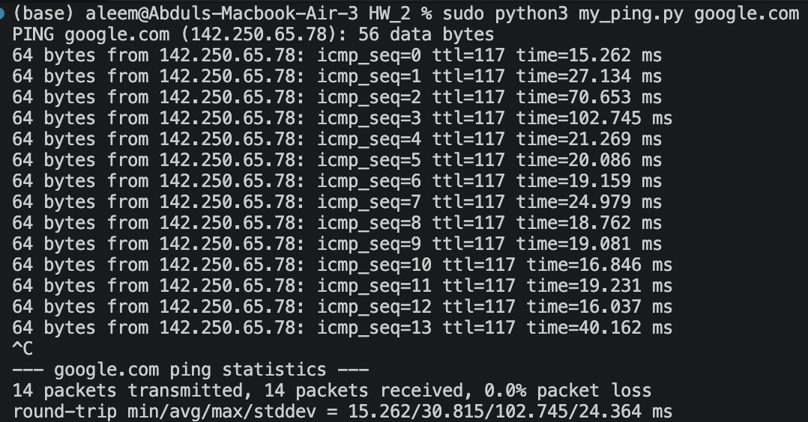
We can see from the figure that my_ping successfully sends and receives ICMP echo packets identified by the last 16 bits of the process ID. Press Ctrl-C on the keyboard to raise an interrupt.

2.2 -c flag used for count
Command used: sudo python3 my_ping.py -c 4 google.com
Output from Program:
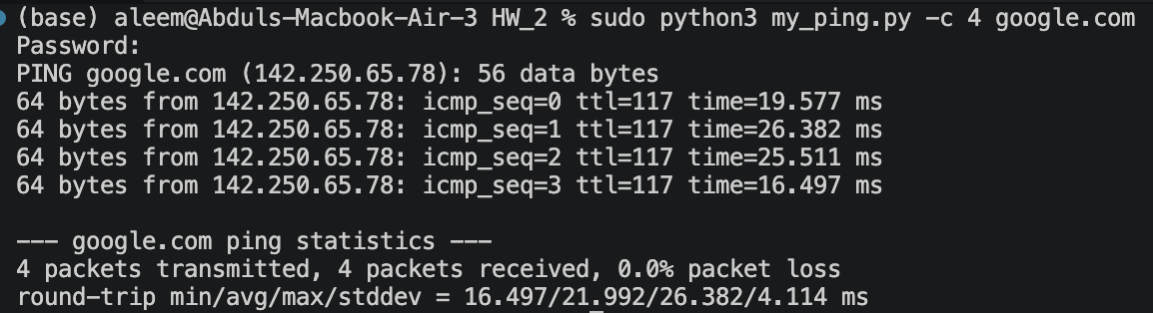
We can see that the -c flag limits the number of ICMP packets requested and received based on the numerical count provided.

2.3 -The t flag is used for timeout, and -i flag is used for waiting time between each request sent
Command used: sudo python3 my_ping.py -t 5 google.com
Command used: sudo python3 my_ping.py -i 2 google.com
Command used: sudo python3 my_ping.py -t 10 -i 2 google.com
Output from Program for flag t
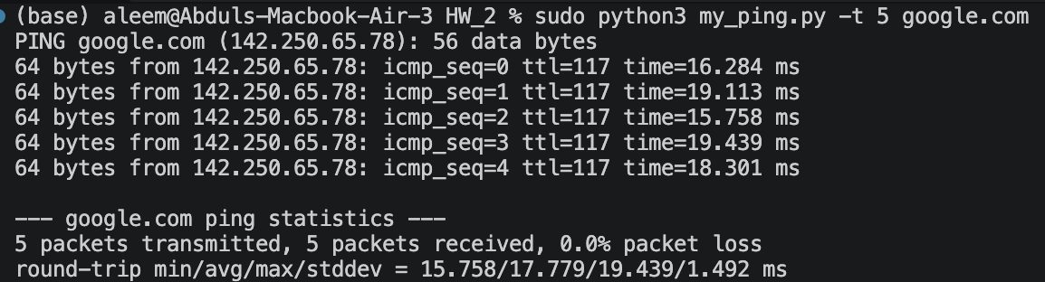
Output from Program for flag i
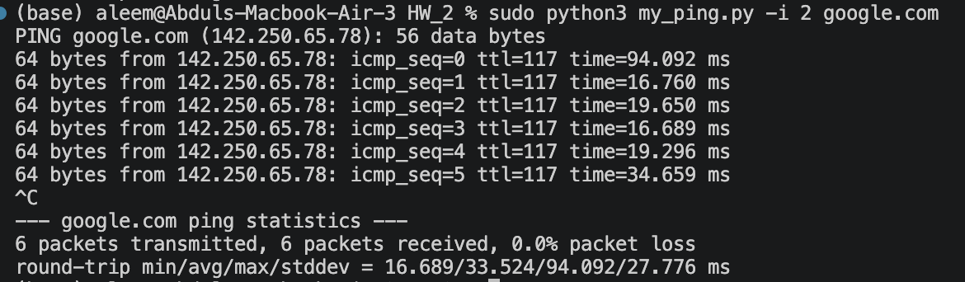

Output from Program for flag t and i
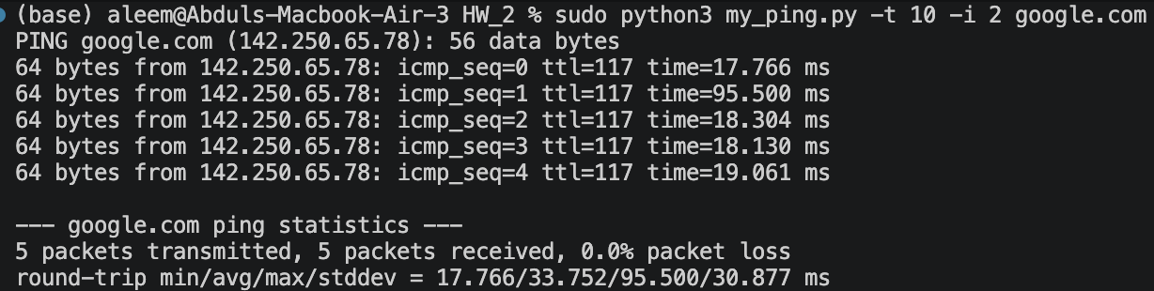
We can see from the pictures that the flag “t” represents the timeout; for example, if t is set to 5 seconds, the packets are transmitted for 5 seconds before the program exits. The default interval between packets of my_ping is 1 second, so we can see 5 packets over 5 seconds. If we use the “i” flag, the interval between packets is set to the specified number of seconds. But the program keeps streaming continuously until a keyboard interrupt is raised.

Combining both the flags has a clear representation that, if the timeout is set to 10 seconds, and the interval time is set to 2 seconds, then the number of packets transmitted and received ideally should be 10/2 = 5, and we can see from the output that clearly there are only 5 packets transmitted by combining both the flags.

2.4 -s flag for packet size

Command used: sudo python3 my_ping.py -c 3 -s 128 google.com
Output from Program:
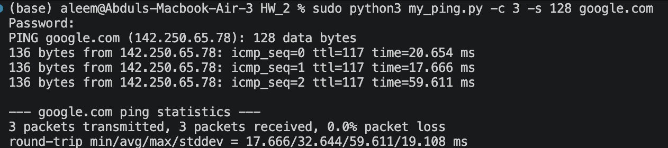
We can see from the picture that the 3 packets are carrying a data payload of 128 bytes, while my_ping shows 136 bytes because the 8 bytes of ICMP header information are added when the packet is constructed. Thus, my_ping reports a total of s+8 bytes.

2.5 What if the hostname is not found or unreachable?

Command used: sudo python3 my_ping.py -c 5 0.0.0.0 (unreachable host)
Command used: sudo python3 my_ping.py -c 5 googlerit.com (host that does not exist)

Output from Program for unreachable host
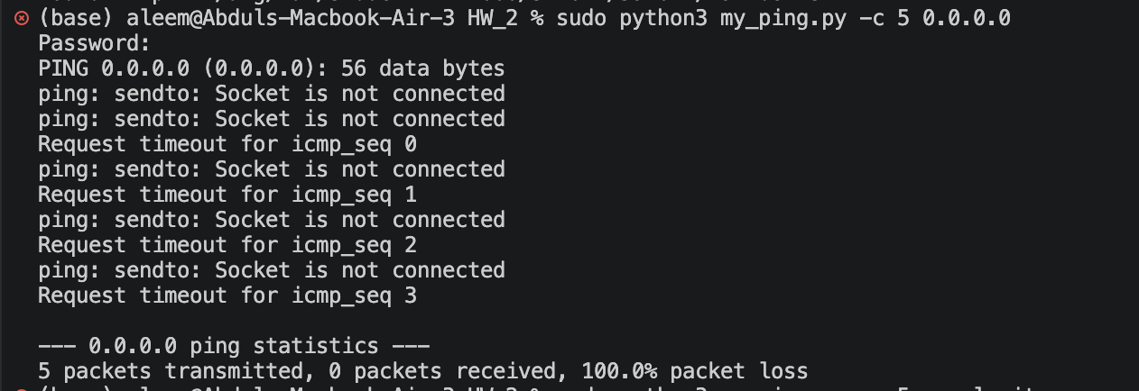
Output from Program for unknown host
We can see from the pictures that if the host is unreachable, my_ping returns an error that says “Socket is not connected,” whereas if the host is unknown or does not exist, it prints “Unknown host.”

3. Output of the Program for different flags used with my_traceroute.py
The screenshots below show the implementation of the program my_traceroute.py with different flags.

3.1 No flag
Command used: sudo python3 my_traceroute.py google.com

Output from Program:
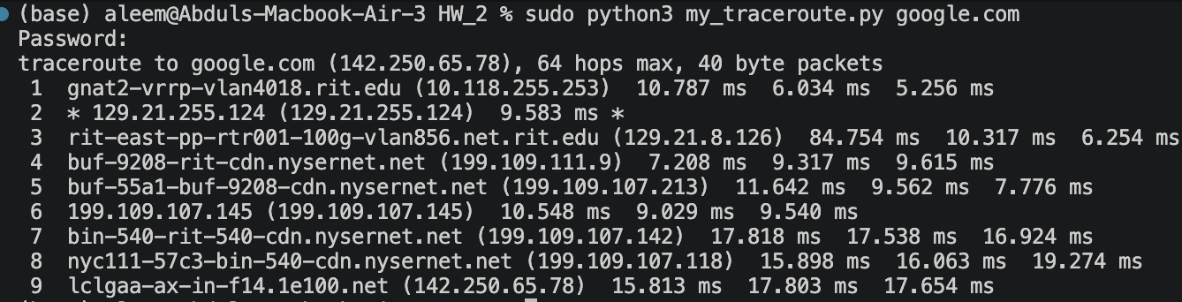
We can see that the my_traceroute.py maps out the number of hops that a packet takes before it reaches the destination IP address.

3.2 -n flag

Command used: sudo python3 my_traceroute.py -n google.com
Output from Program:
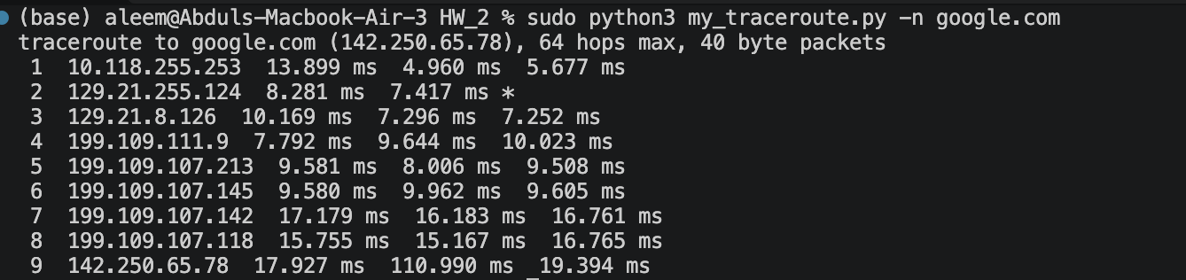
We can see from the picture that the -n flag successfully prints hop addresses numerically rather than symbolically.

3.3 -q flag

Command used: sudo python3 my_traceroute.py -q 1 google.com
Output from Program:
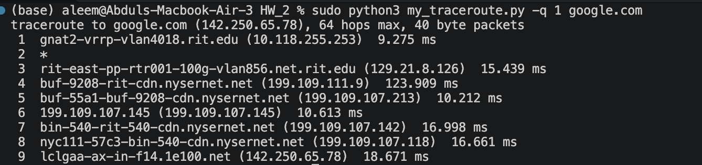
We can see from the picture that the -q flag successfully sets the number of probes per TTL to n queries.

3.4 -S flag

Command used: sudo python3 my_traceroute.py -S google.com
Output from Program:
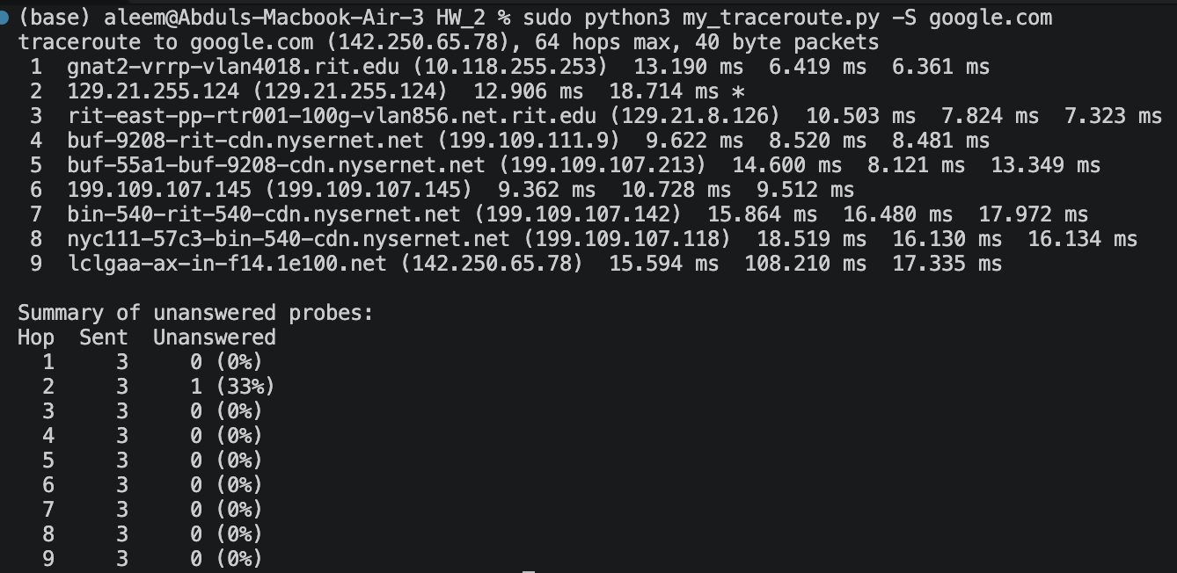
We can see from the picture that the -S (uppercase only) flag successfully prints a summary of how many probes were not answered for each hop.

3.5 What if the hostname is not found or unreachable?

Command used: sudo python3 my_traceroute.py 0.0.0.0 (unreachable host)
Command used: sudo python3 my_traceroute.py googlerit.com (host that does not exist)
Output from Program for unreachable host
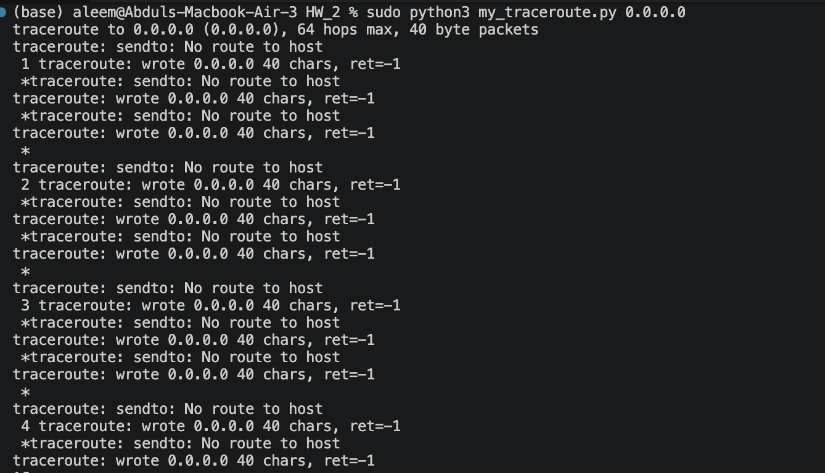
Output from Program for unknown host
We can see from the pictures that if the host is unreachable, my_traceroute returns an error: “No route to host,” whereas if the host is unknown or does not exist, it prints “Name or Service not Known.”

When using my_traceroute on an unreachable host, the program must be terminated with Ctrl-C so it does not keep waiting until 64 hops (the default maximum) have been tested.

4. Limitations

The programs my_ping and my_traceroute offer basic functionality similar to the native network utilities ping and traceroute.

4.1 my_ping

The my_ping program has some limitations compared to the native ping utility.

- The native ping utility has native timeout and reply-handling behavior, whereas my_ping has a hard-coded minimum wait of 1 second per reply.
- Native ping supports the -m flag to set the Time to Live (TTL) of packets before they reach the destination address; my_ping does not support this functionality.

4.2 my_traceroute

The my_traceroute program has some limitations compared to the native traceroute utility.

- The hardcoded timeout for the probe is 3 seconds, whereas in the native traceroute, it is configurable with the -w flag.
- Native traceroute also supports flags to filter source addresses, destination ports, maximum TTL, TCP protocol, whereas my_traceroute defaults to UDP probes.

5. Conclusion

The my_ping program reports packet loss and round-trip times. At the same time, the my_traceroute tool identifies intermediate routers by increasing the TTL and receiving ICMP responses, with options to control probes and display results.

