Reliable Data Transfer Homework 3 Report
rdt.py, client.py, server.py, simulator.py— Performing basic reliable data transfer using client and server roles, along with a simulator to corrupt and lose packets.
Name: Abdul Aleem Shaik Gadda
Course / Section: CSCI 651
Date: 23 October 2026
Helper file(s) used: rdt.py
Main script(s) used: client.py, server.py and simulator.py

1. Introduction
The programs rdt.py, simulator.py, server.py, and client.py are command-line tools built on Python’s standard socket library that implement reliable data transfer over UDP, together with a file transfer application. The program rdt.py implements a selective-repeat protocol that assigns each packet a sequence number and a CRC-32 checksum, and confirms delivery with ACKs that carry both cumulative and selective values. It retransmits unacknowledged packets using a per-packet timer, reorders and deduplicates packets at the receiver, and maintains a sliding window of packets in flight, pausing between transmissions to maintain a low sending rate. The program simulator.py acts as a UDP relay between the client and the server, randomly dropping, corrupting, duplicating, delaying, and reordering packets according to configurable probabilities, and logs the outcome of every packet with a closing summary. The programs server.py and client.py use the protocol to upload, download, and list files, verifying each transfer end-to-end with a SHA-256 hash. All four files must be in the same folder, since the other three import rdt.py, and they are run from the command line, with additional runs using the --loss, --corrupt, --reorder and --duplicate options for the simulator and the --interval, --timeout and --window options for the client and server to verify packet recovery, timeout handling and output formatting.

2. Usage
Note: To run the rdt over UDP, all four scripts should be in the same folder. Also, grant these scripts read and write permissions, as they will handle local directory creation and file transfers.
Please open 3 terminal sessions before you try to send or receive data to the server (local server, do not try this over the internet).
Terminal 1: Initiate the server. Starting the server creates a directory that serves as a database for storing data (files, in this case). Thus, please make sure to give it the necessary permissions with chmod (Linux). -v flags exist for verbose, always recommend it to keep it on for the log.
Command : python3 server.py --port 9000 --interval 20 -v
Outcome: Creates a default directory named server_files within the directory where you are running the script from. Using the --root flag selects the specified directory as the server database. Recommended to go by default instead of using root for the convenience of observing the data transfer. The default interval is 0.02 seconds between each packet, but if using “interval 20” on both server and client makes the interval rate limited to ~410 bits/sec (below the limit of 500 bits/sec)
Terminal 2: Initiate the simulator. Starting the simulator opens a UDP relay on its own port (8000 by default) that sits between the client and the server and forwards every packet to the server’s port (9000 by default). It does not create any files or directories, so no chmod is needed, but it must be started after the server and before the client. Each impairment is set with its own option (--loss, --corrupt, --reorder, --duplicate) as a probability between 0 and 1. The client must then connect to the simulator’s port (8000) rather than the server’s, otherwise its packets bypass the simulator. Press Ctrl-C when the transfer is finished to stop the simulator and print a summary of the number of packets received, delivered unchanged, dropped, corrupted, duplicated, and delayed.
Command: python3 simulator.py --listen-port 8000 --server-port 9000 --loss 0.1 --corrupt 0.05 --reorder 0.2 --duplicate 0.05 --seed 3 -v
Outcome: Opens a simulated relay port that acts as a bridge between client and server, controlling packet loss and other impairments. Seeding helps to reproduce the impaired behavior on that specific packet, making it reproducible. Use -v, recommended to observe the packet impairments.
Before Terminal 3, let’s create a test file :
Command: python3 -c "import os; open('test_small.bin','wb').write(os.urandom(1000))";
Output: A file named “test_small.bin” of size 1KB is created to observe the time it takes to send the small file over a rate of ~400 bits/sec. However, it is recommended to create a 20KB file, as the MSS is 1 KB, to observe significant impairments. Apart from the slow transfer, we will also observe a few impairments using the test_large.bin (20 KB).
Terminal 3: Run the client. The client connects to the simulator’s port (8000), not the server’s (9000), so its packets pass through the simulator. If you send several files in a row, run the command once per file, and each run opens a new connection that the simulator marks with a New data transfer banner. Add -v to see each timeout and retransmission (timeout, retransmit seq=N) and the protocol statistics at the end.
Command: python3 client.py --port 9000 --interval 20 put test.bin
Output: The file is downloaded to the server_files folder.

3 Impairments

3.1 Slow transfer

Server Command: python3 server.py --port 9000 --interval 20 -v

Simulator Command: python3 simulator.py --listen-port 8000 --server-port 9000 -v

Client command: python3 client.py --port 8000 --interval 20 put test_small.bin

Output:

Server

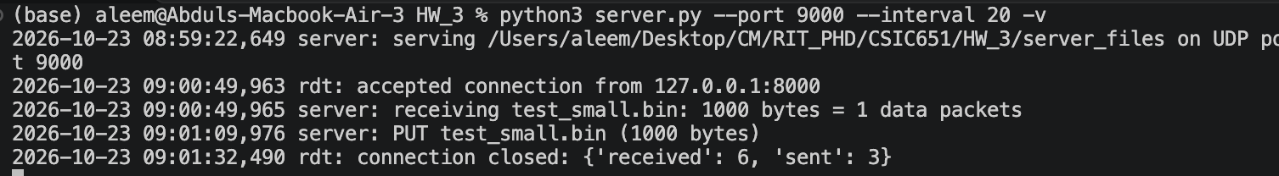

Simulator:

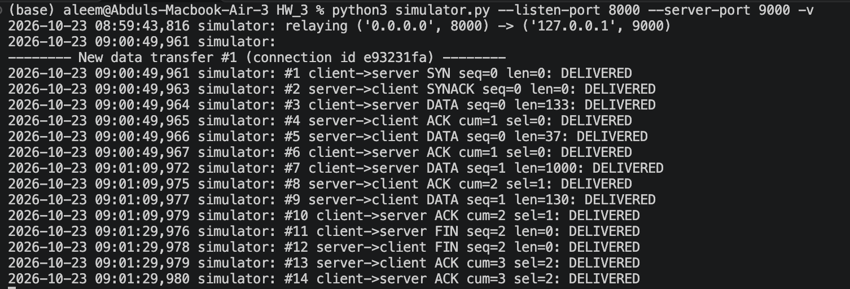

Client

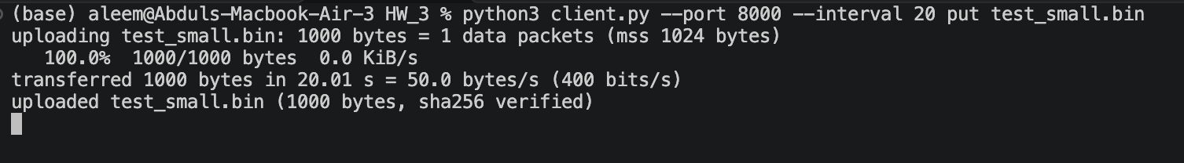

We can see that the transfer is complete and receive an acknowledgment at the end. It also shows the actual transfer rate, which was 400 bits/s.

3.2 Packet Corruption

This will be tested on the 20KB file to observe multiple packets being corrupted.

Server Command: python3 server.py --port 9000 -v

Simulator Command: python3 simulator.py --listen-port 8000 --server-port 9000 --corrupt 0.2 -v

Client command: python3 client.py --port 8000 put test_large.bin

Server

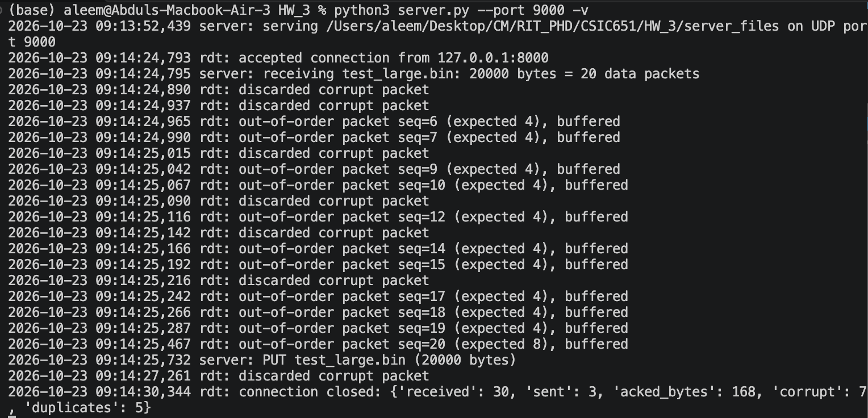

Client

Simulator:

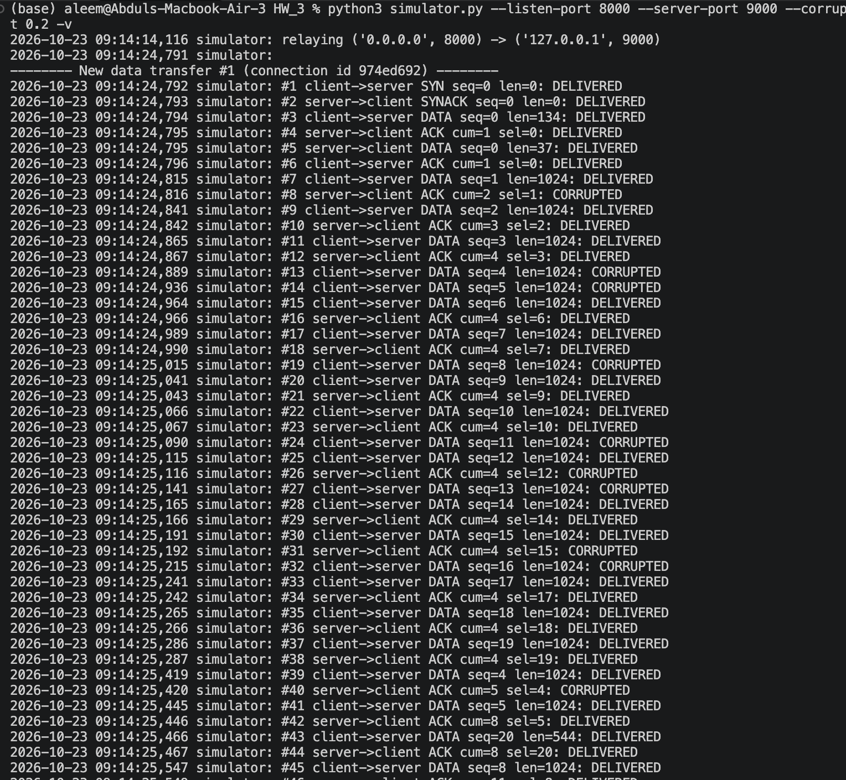

We can see that in the simulator, lines #13 and #14, data packets were corrupted, which were retransmitted by the client in #39 and #49, this shows that the protocol was able to handle packet corruption.

3.3 Packet Loss
This will be tested on the 20KB file to observe multiple packets being corrupted.

Server Command: python3 server.py --port 9000 -v

Simulator Command: python3 simulator.py --listen-port 8000 --server-port 9000 --loss 0.2 -v

Client command: python3 client.py --port 8000 put test_large.bin

Server

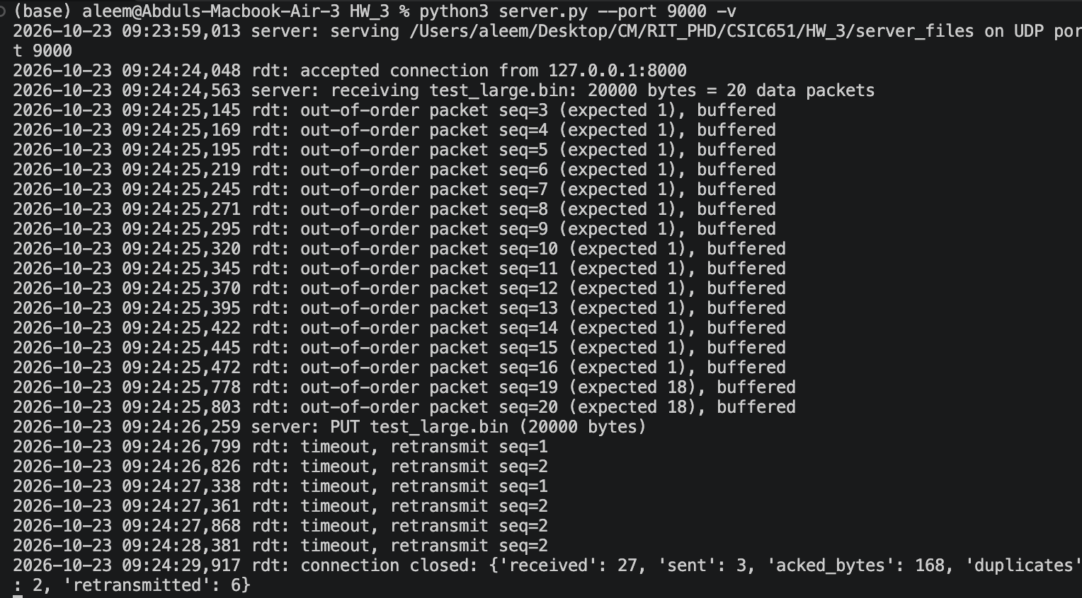

Client

Simulator
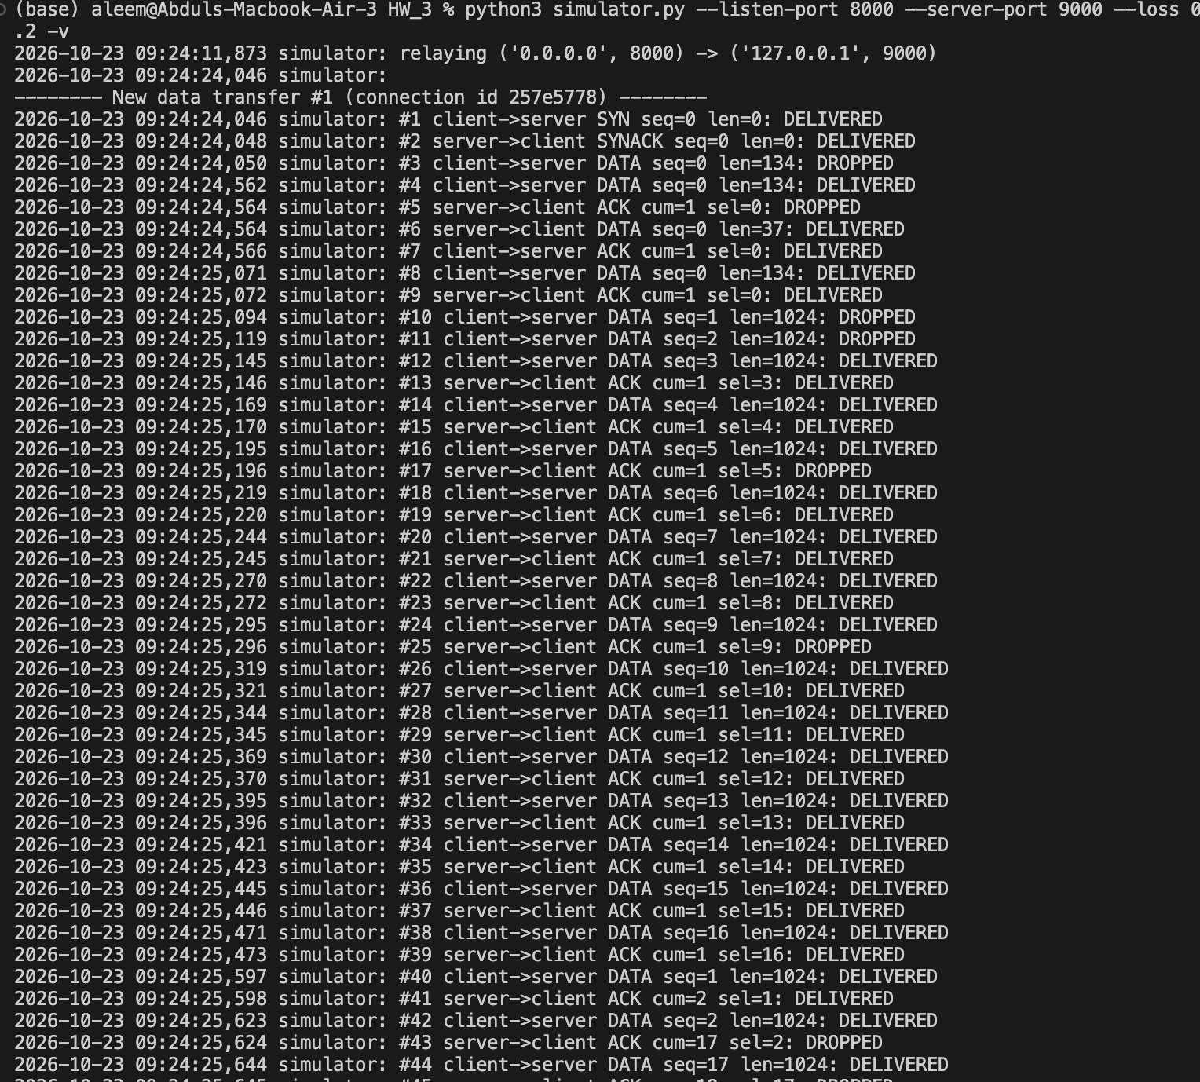
We can see from the simulator that the data packets in lines #10 and #11 were dropped (lost) and retransmitted to the server, as were the packets in lines #40 and #42. This shows that the protocol was able to handle the packet loss.

3.4 Re-ordered Packets
This will be tested on the 20KB file to observe multiple packets being corrupted.

Server Command: python3 server.py --port 9000 -v

Simulator Command: python3 simulator.py --listen-port 8000 --server-port 9000 --reorder 0.2 --seed 3 -v

Client command: python3 client.py --port 8000 put test_large.bin

Server

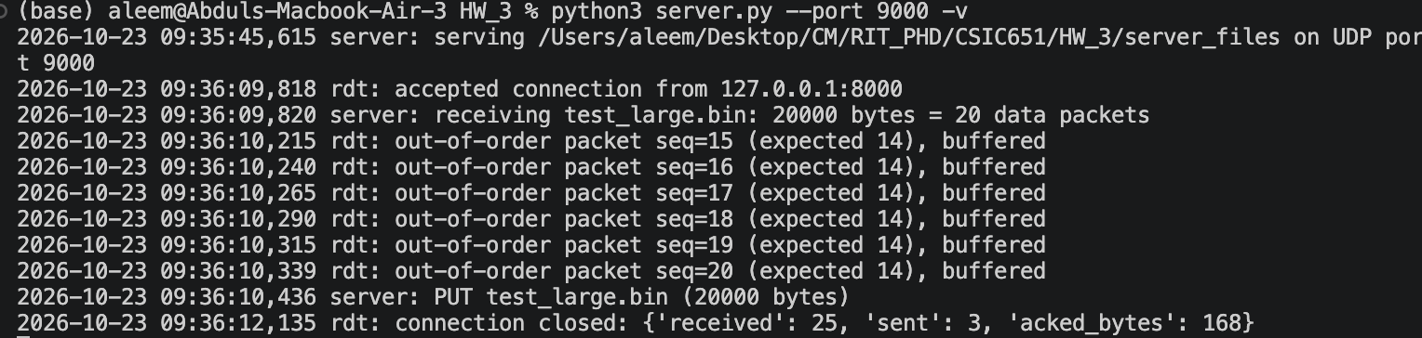
Client

Simulator
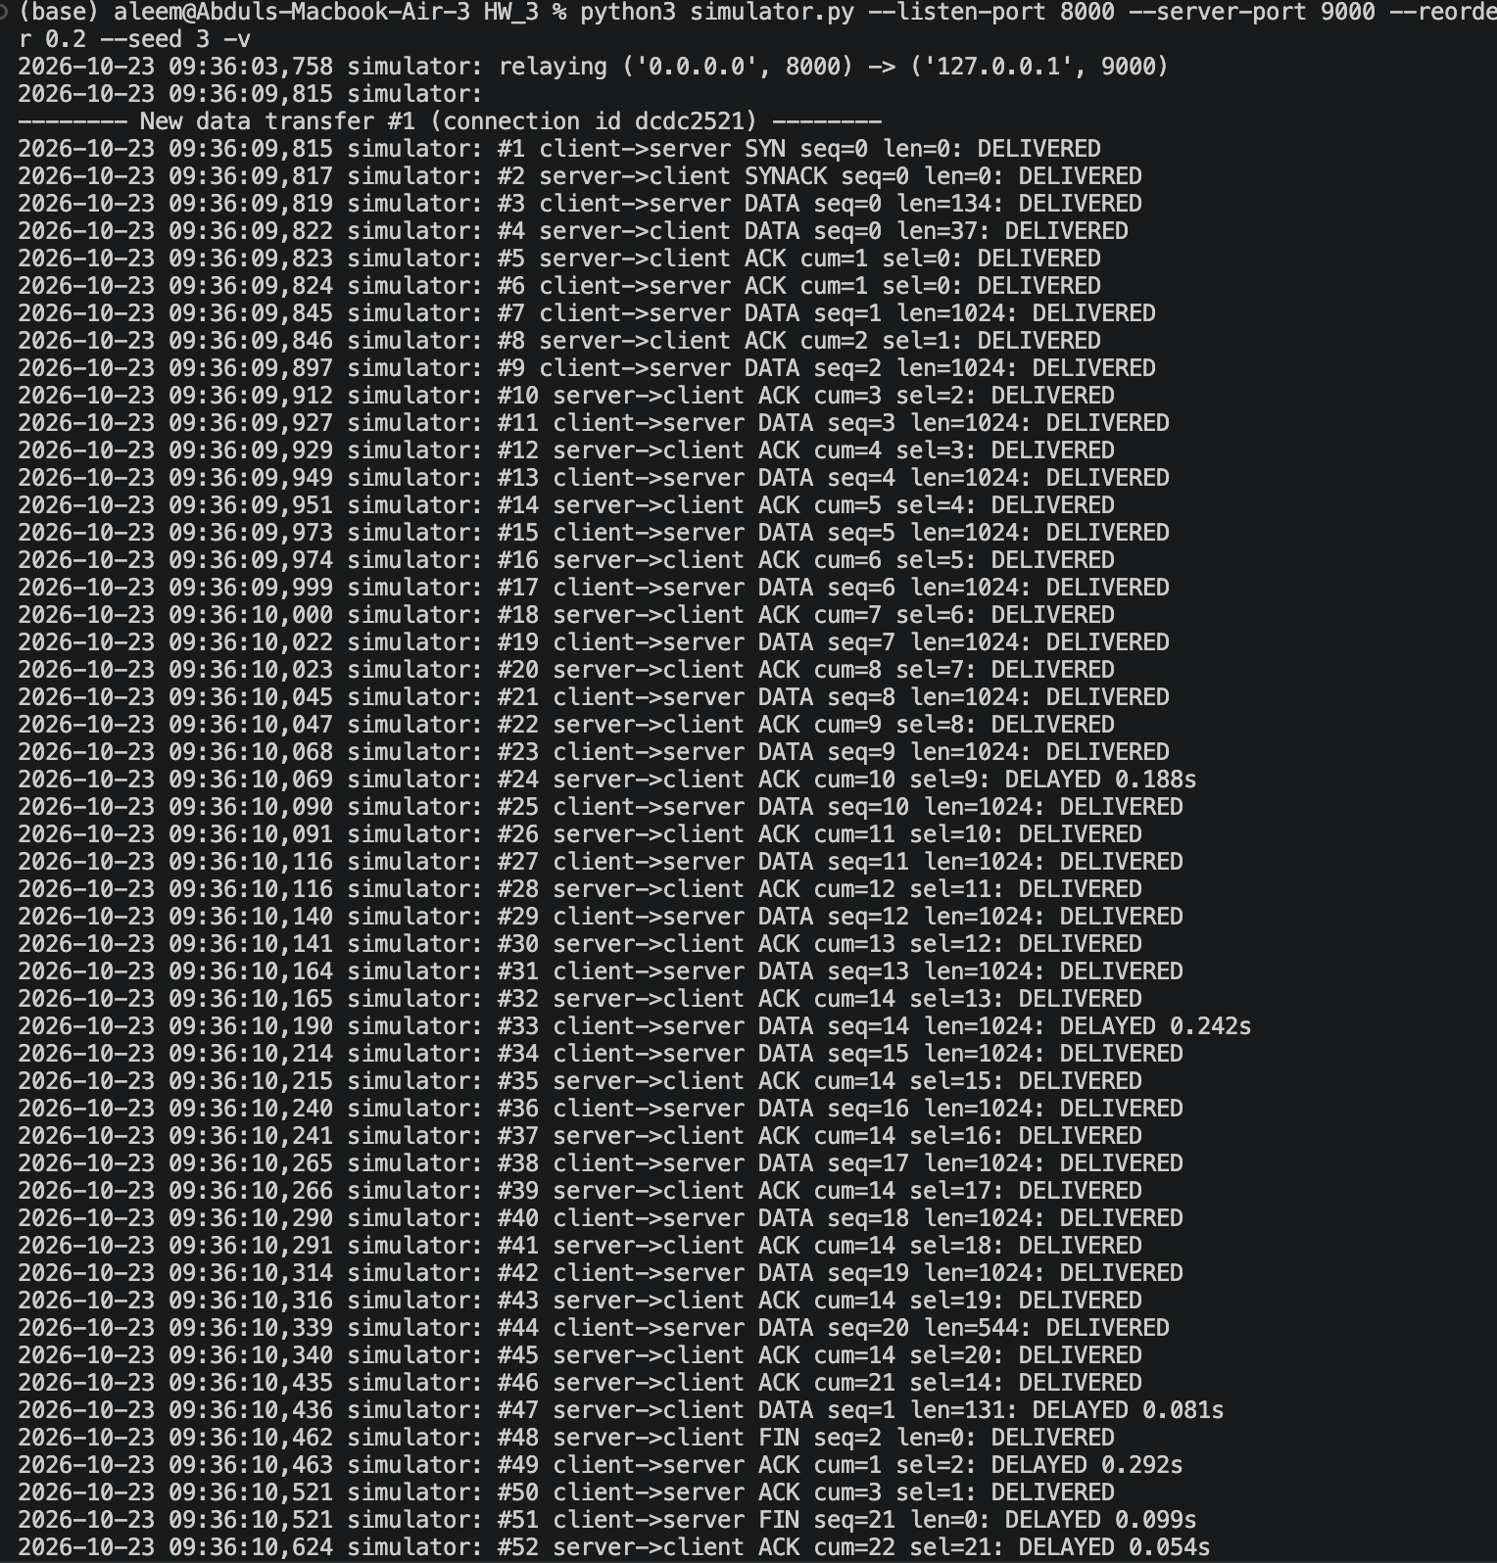
We can see in line #33 that the data packet was delayed (intentionally reordered to let other packets go first). Then, the server keeps the cumulative status at 14 (waiting for the 14 packet). Once it receives the 14th packet, it sends an ACK (#46) and updates its cumulative value for the next packet to be received (21).

3.5 Successful Writing and downloading data from the server_files

Client

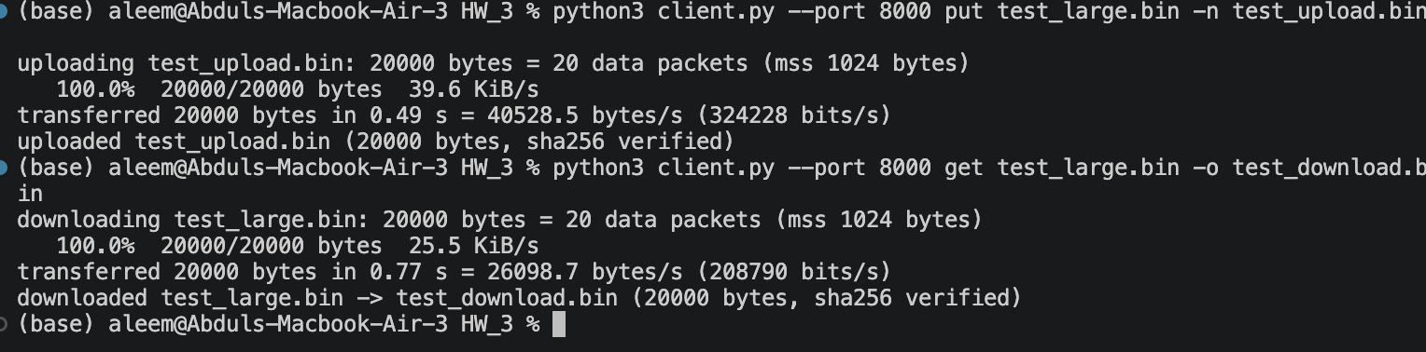

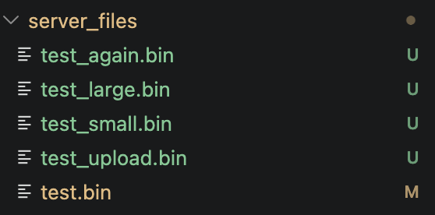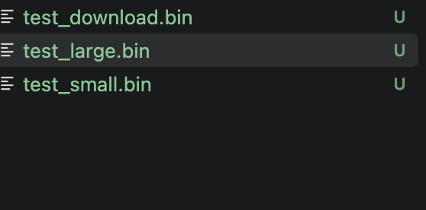

We can see that the uploads and downloads are successful.

4. Limitations
The built protocol indeed comes with a few limitations such as
- The server and the simulator handle one client at a time.
- IPv4 only.
- The retransmission timeout is fixed, not adaptive.
- No congestion control implemented.
- No authentication or file size limit on the server.

5. Conclusion
In this project, a reliable data transfer protocol was developed on top of UDP and used to implement a file transfer client and server. The protocol (rdt.py) uses a selective-repeat design with sequence numbers, CRC-32 integrity checks, cumulative and selective acknowledgments, per-packet retransmission timers, a sliding window, and a paced sending rate, so a service that normally gives no delivery guarantee now delivers data in complete and in-order form. The network simulator (simulator.py) lets us test it under controlled conditions by dropping, corrupting, duplicating, and reordering packets, and its per-packet log shows each event next to the protocol’s response: corrupted packets were discarded by the checksum, lost packets were retransmitted after a timeout, and out-of-order packets were buffered until the missing ones arrived. In every test, the uploaded and downloaded files matched their SHA-256 hashes, even at loss, corruption, and duplication rates far higher than a real network would show. The cost of that unreliability appeared as extra retransmissions and longer transfer times, which the client’s statistics and the speed it reports on acknowledged data made measurable.

