Reactive and hybrid agents

a) Describe two key difficulties with constructing agents based on classical deductive/symbolic reasoning agent architectures.

**One problem with using classical symbolic reasoning agents is the transduction problem. The transduction problem is the problem of translating the real world into an accurate, adequate symbolic description in time for that description to be useful e.g. vision, speech, understanding, learning.**

**Another problem with using classical deductive/symbolic agents is the representation/reasoning problem. The representation/reasoning problem is the problem of how to symbolically represent information about complex real world entities and processes, and how to get agents to reason with this information in time for the results to be useful.**

b) Brooks’ subsumption architecture attempts to avoid altogether explicit

representations and explicit reasoning in decision making. Explain how it

achieves this.

**Brookes subsumption architecture attempts to avoid explicit representations and explicit reasoning in decision making by having task accomplishing behaviours. The action the agent makes depends on the current situation. In the original architecture behaviours were implemented as finite state machines. Multiple behaviours can be fired at the same time to keep up with changing environment. In order to correctly choose the right behaviour the Subsumption hierarchy is used. The Subsumption hierarchy has behaviours organized in layers. Lower layer behaviours inhibit higher level ones. E.g. “Avoid obstacles” lower layer (higher priority) than “drive to goal”.**

c) The following diagram illustrates the key subsystems of the

TOURINGMACHINES agent architecture: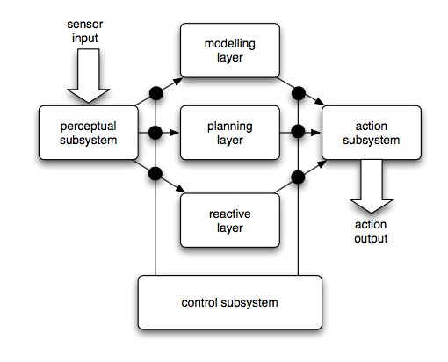

Describe the overall operation of the architecture, making sure you explain how the three decision layers achieve the goal of providing both reactive and proactive behaviour.

**The touring machine uses horizontal layer architecture. Each layer continually produces suggestions for what action the agent should perform. The planning layer is used for long term behaviours such as day to day behaviours. The planning layer chooses sub plans out of the plan library. The modelling layer keeps and modifies the environmental model e.g. represents facts about environment including other agents. The modelling layer is also used to select new goals for the planning layer. The control subsystem exercises control e.g. by suppressing information input to certain layers (censorship) in order to prevent the triggering of certain actions.**

# Communication and ontologies

1. Give two advantages of using an ontology in a multi-agent system.

**Some advantages of using an ontology within a multi-agent system are:**

* **Allows agents written by different developers to communicate**
* **Integrates with JADE**
* **Makes domain knowledge explicit**
* **Allows for automated reasoning (e.g. Infer properties)**

1. It is often recommended to reuse ontologies where possible. Discuss the advantages and disadvantages of this.

* **One advantage of reusing ontologies is that it will save development time for agents if an existing one is used.**
* **Another advantage is that other developers who use your ontology already and are familiar with it won’t have adapt or change their agents in order to communicate with your agents.**
* **A disadvantage of reusing Difficulty customising existing ontologies for a new application.**
* **Ontologies may be expressed in different languages.**
* **Different applications within a domain focus on different areas.**
* **Need to motivate domain experts to create them in the first place.**

1. State the meaning of the following in FIPA SL:
   * Predicates

**Predicates are a logical formula that can be assigned a truth value. For example if agent I informs agent j that the price of a theoretical good good 2 is 150.**

* + Concepts
  + Agent actions

**An agent action is anything that has to be performed by an agent. For example if agent I was to request agent j (robot) to deliver a parcel. The agent action sent in the message would instruct the receiving agent what action to perform and any other information it needs to complete the action.**

1. Consider the following ACL message:

(inform

:sender (agent-identifier :name i)

:receiver (set (agent-identifier :name j))

:content ((price good2 150))

:language fipa-sl

:ontology SET10111-pc-auction

)

Identify the following in the message:

* + The FIPA performative

**Inform**

* + The predicate

**Pricegood2 150**

* + The content language

**FIPA SL**

1. Write an ACL message in which agent i asks agent j to move box 17 to location

12. Be sure to show the FIPA performative, sender, receiver, and content fields. You should use FIPA SL syntax for the content field.

(request

:sender (agent-identifier :name i)

:receiver (set (agent-identifier :name j))

:content ((action (agent-identifier :name j) (deliver box017 (loc 12)))

:language fipa-sl

:ontology robotic-assistant :reply-with order567 )

# Working together

1. “The CONTRACT NET protocol takes inspiration from the way in which contracts are put out to tender in human organisations.” With reference to the way in which the CONTRACT NET works, and the key issues that must be addressed in implementing it, explain what you understand by this statement.

**The CONTRACT NET protocol is made up of 4 key stages. Problem recognition in which the agent realises that it has a problem and requires assistance from another agent. Just like how when someone leaves a job or the job cannot be done by the individual or company alone. The next stage is task announcement in which the agent sends out an announcement to other agents with a specification of the job that must be completed. It must encode a description of the task itself, any constraints and any meta-task information. In the case of human organisations a job listing would be posted. The third stage is the bidding stage in which agents who received the message about the contract decide whether or not they want to take on the task. To do this the agent must determine whether or not it is capable of completing the task and any quality constraints and price information if relevant. The real world equivalent of this is applicants applying for the job. The fourth and final stage is awarding and expediting the contract. Agent that sent the initial announcement must decide which agent to award the contract to. The result of this process is communicated to all agents who submitted a bid. This is equivalent to informing all interviewees whether or not they were successful in getting the contract. May involve generating further manager contractor relationships called sub contracts which repeats the same process again for the job.**

**Difficulties of implementing the CONTRACT NET include:**

* **Before sub problems can be distributed in the first place, problem decomposition must take place which is computationally taxing.**
* **Communication between agents is fairly slow and produces overhead.**
* **Problems must have the right amount of granularity to allow them to be decomposed into sub problems to be announced to other agents.**
* **The recognition stage is not explicitly covered, meaning it can be difficult for the agent to realise in the first place that the job or part of it needs to be offered as a contract.**

1. Explain how the CONTRACT NET protocol may be implemented in terms of the FIPA agent communication language.

**The CONTRACT NET protocol could be implemented in FIPA communication by way of sending an inform performative message as an announcement to other agents informing them that the contract is open to bids. Agents would have a simple behaviour to “listen” for jobs that they could bid on. If they decide to bid they would send an inform performative message to the announcing agent. After a set time period the announcing agent would pick which agent to offer the job to based on logic written into the agent to help it decide which bidder is best suited for the contract. Once a decision has been made the announcing agent would send another message to all agents with its choice. Lastly a request performative message would be sent to the winning agent detailing the job to be performed as an agent action along with any other details the agent will need to effectively carry out the job.**

# Game theory

1. Define the prisoner’s dilemma, and in particular explain why it is a “dilemma”.

**The prisoners dilemma is**

1. Define the notion of Nash equilibrium, and identify and explain the single Nash equilibrium in the prisoner’s dilemma.
2. Consider the following payoff matrix:

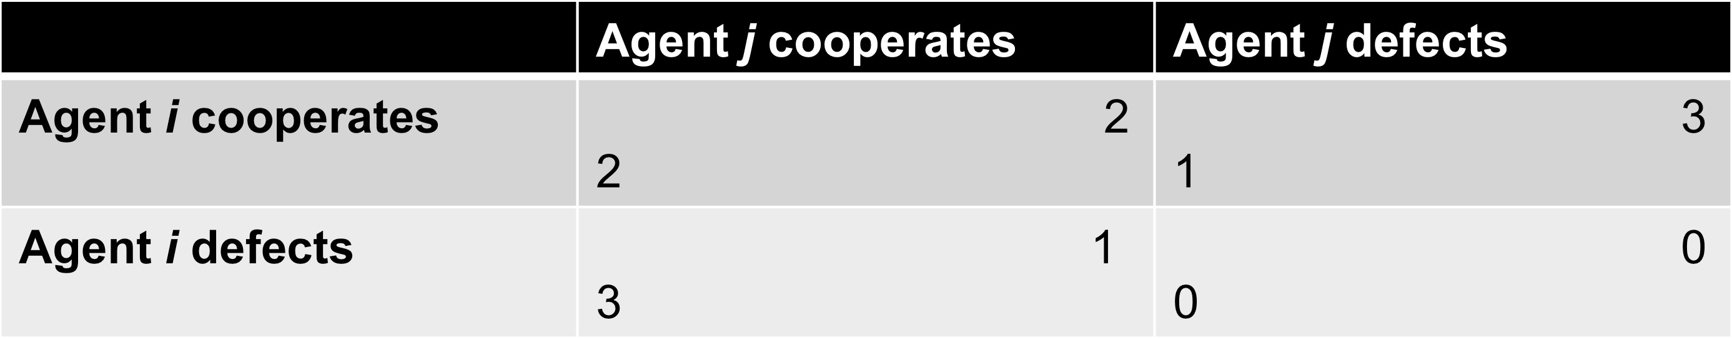

State which outcomes maximise social welfare, and explain under what circumstances we would be interested in social welfare.

1. Explain how the game in c) is different from a Prisoner’s Dilemma.

# Agent-based modelling

1. Discuss the benefits of agent-based modelling compared to traditional analytical modelling.
2. Discuss the disadvantages of agent-based modelling compared to traditional analytical modelling.
3. Describe an example of an agent-based model used to address a question in economics.