**MINI PROJECT**

**(2020-2021)**

# Cloud-Based E-book Website

# SYNOPSIS



**Institute of Engineering & Technology**

**Team Members**

Priyansh Agrawal (181500510)

Krishan (181500328)

Ashutosh Kumar(181500149)

Ankit Kumar (181500097)

Nitin Goyal (181500432)

## Supervised By

**Mrs. Harvinder Kaur Mam**

**Department of Computer Engineering & Applications**

**Name / Title of the project:**

Cloud Based E-book Website

**General Introduction of Topic:**

A website where you can download ebooks.Ebooks can be download online in your browser

requiring no extra cost,At any time,anywhere you can download or study.

**Area of Computer Science:**

E-learning. it is a learning system based on formalised teaching but with the help of electronic

resources is known as E-learning.

**Requirements:**

***Hardware:-***

* Processor: i3 or above
* RAM: 4 GB or above
* Disc space: 20 GB (3 GB for database files + enough GB for shared documents, individual)

***Software:-***

* Visual Studio Code as IDE
* OPERATING SYSTEM: Windows
* FRONT-END: HTML, CSS, JAVASCRIPT.
* BACK-END: Python

**Problem Definition:**

A person who want to read book but unable to go in library,He/She can easily use ebook website without

any problem in your mobile phones or laptop or computer

**Objectives of the project:**

In this project,.The aim of ebook website is simplify and enhance the overall learning experience,

Digital books make the learning process more interactive and engaging. E-books can be easily

accessible,these are cloud based means it is fast,secure and no problem of storage.

**Testing technologies to be used:**

* Functionality Testing
* Usability testing
* Database Testing
* Compatibility testing
* Performance Testing
* Security testing
* Crowd Testing

**Methodology (including a summary of the project):**

* Create a front page for the website i.e Title and links, Tables to store ebooks, Login and Signup forms.
* Database to store Ebooks i.e Ebook stored in Cloud Storage and easily download.
* Designing of Website i.e JS use for layout and design and Font color,size of pages done by CSS.
* Backend of Website i.e Python creates interfaces,Javascript join pages by dynamic functionality.
* Authentication for Website i.e Login and Signup forms created by HTML,Store Credential in backend database.
* Building links in Websites i.e Deep links, Hyperlink infringe.
* Service Page and Privacy Policy i.e User Agreements, FAQ, About us..

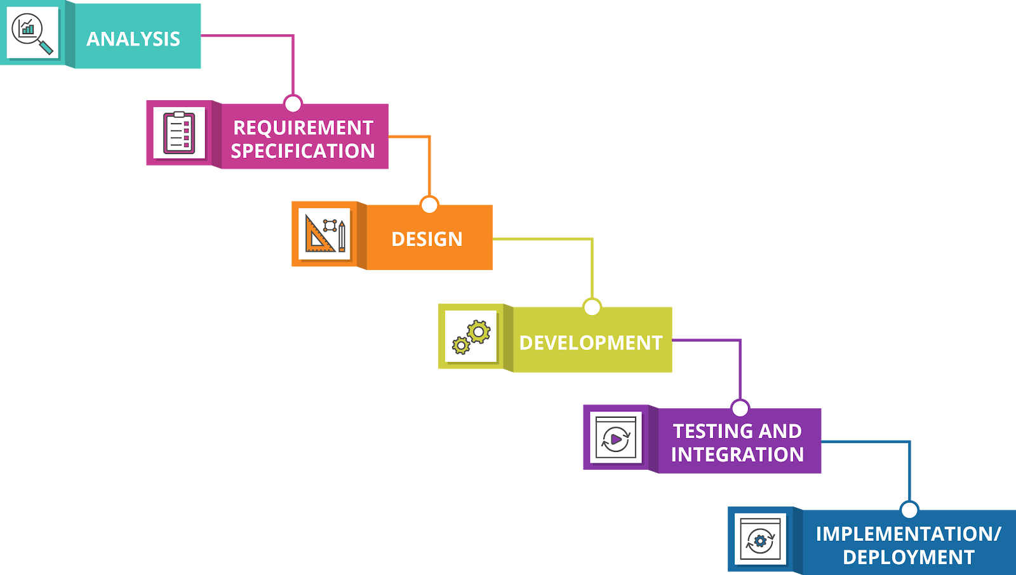

**Administrator:**

Login, Add or Delete Category, Add or delete book.

**Conclusion:**

We made a website where ebooks are available for all time,Anyone can use this website whenever required.

**References:**

[**https://www.learn-html.org/**](https://www.learn-html.org/)

[**https://www.w3schools.com/html**](https://www.w3schools.com/html)

[**https://en.wikipedia.org/wiki/HTML**](https://en.wikipedia.org/wiki/HTML)

[**https://www.python.org/**](https://www.python.org/)