Ashish Subedi

INFSCI 1570 – Network and Web Data Tech

Assignment 1

9/30/25

I made an informative website about the Porsche 911 GT3RS. Porsche is my favorite car brand when it comes to super cars and sports cars, so that is why I wanted to make my website Porsche related. The website goes over the basics of the car across the different webpages. The website covers the engine, the brakes, the aerodynamics, and a little about the history of Porsche and the 911.

The engine webpage compares the GT3 and the GT3RS to see similarities and differences between the two engines. The brakes webpage covers the two options available to customers looking to buy a GT3RS. The aerodynamics webpage talks about three fundamental designs of the GT3RS that keep is planted to the ground as it speeds around a track. And finally, the history webpage covers some of the history of Porsche and how the 911 has fared against the test of time.

For HTML elements, I used image elements, paragraph elements, semantic elements like article and section, button elements, a table, an unordered list, and more. I used these elements to try to have a consistent look across the webpages. I didn’t want the webpages to be too text heavy. It was supposed to be more visual so readers could appreciate the design of the car.

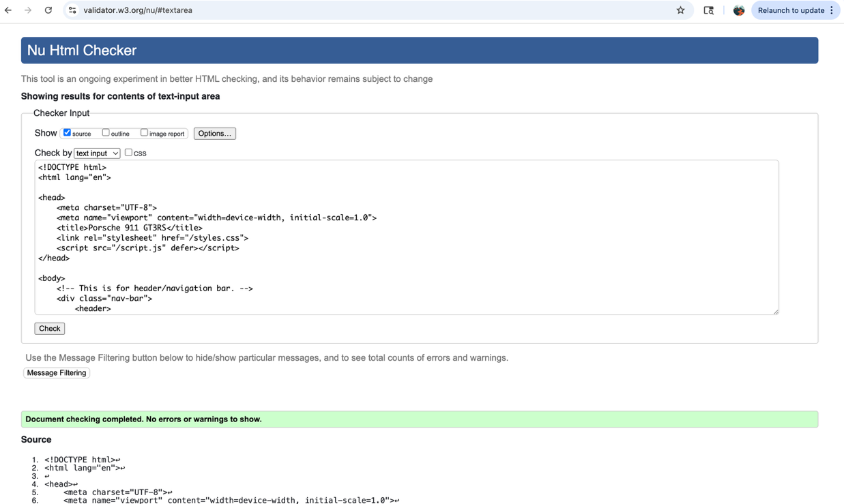

I didn’t copy the link for my validation because the link kept taking me back to the homepage of the validator, so I took a screenshot of my validation instead.

For CSS styles, I mainly changed the font family, size, and weight of the text. I tried to center and resize images so that they fit the page appropriately. I used a mix of class declarations, id declarations, and tag declarations. I also changed the color of certain elements to stick with the red, black, and white theme.

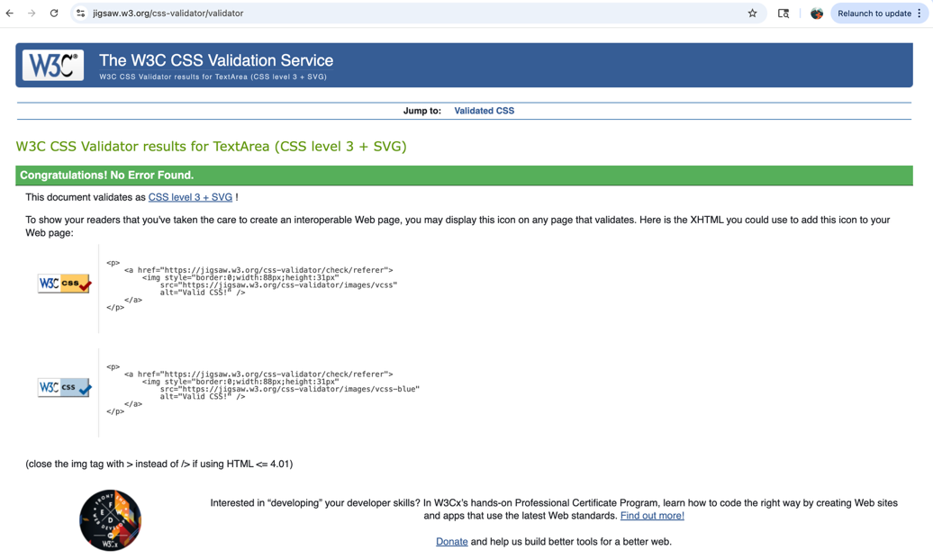

Same as the HTML validator, I just inserted a screenshot because the link just took me back to the homepage.

For JavaScript elements I added two buttons. I added a button to the bottom of the home page that hides an image when you click it, and I added a second button on the engine page that changes the background color of the webpage. I changed the look of the buttons to match the theme of the website as well. I also checked to make sure there were no errors in the web inspector for both buttons.

**Additional Information**

I used W3 schools and our in-class Code Pen activities for help on any issue I had while coding. For information about the car itself, I used sources like Porsche’s website on the GT3RS and YouTube videos about the GT3RS like from Carwow’s channel. I got the images of the cars from Google Search, and the links to the images are in the HTML anchor tag elements.