**系統程式設計**

**Lab4 File Attributes**

**學號:410430049**

**姓名:王子銜**

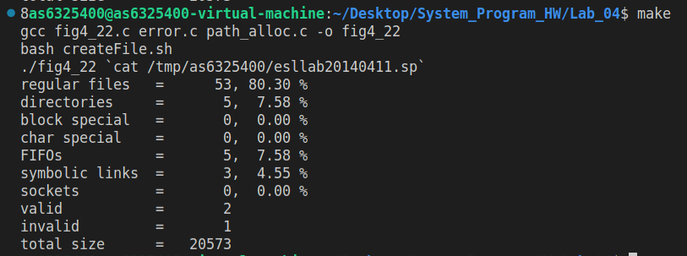

結果圖

1. **How do you modify fig4_22.c?**

**新增程式碼在76,77行的位置(如下圖)**

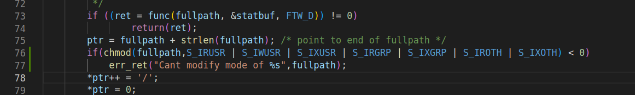

**新增判斷validlink或者invalidlink在110-111行**



**新增記記算大小在100行**



1. **The count of the various types of files?**

regular files = 53, 80.30 %

directories = 5, 7.58 %

block special = 0, 0.00 %

char special = 0, 0.00 %

FIFOs = 5, 7.58 %

symbolic links = 3, 4.55 %

sockets = 0, 0.00 %

1. **The count of total files size?**

**Total size = 20573**

1. **(Bonus) The count of valid and invalid link?**

**Valid link = 2**

**Invalid link = 1**

數據皆來自上方圖