**系統程式設計**

**Lab8 Race condition**

**學號:410430049**

**姓名:王子銜**

1. **How did you implement the processes?  
   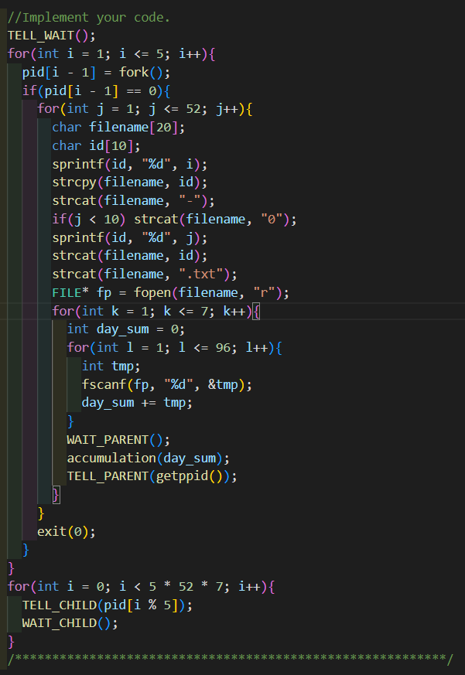**
2. **How did you update the file "sum.txt"?  
   不斷的去讀檔，同時用rewind清掉原本檔案裡的東西，最後再寫檔寫回去**
3. **How did you solve the race condition?  
   在每次進行accumulate()前，先等待父程序，最後由父程序統一給指令進行分配。  
   **
4. **What is the average daily power consumption over the 5 years? (daily means for one day)  
   Please attach screenshot !**

