Create a Story Using Generative AI
Name: ____________________ Class: ______ No. ______
AI tools used: ChatGPT (text) / Canva AI (illustrations)

1. My Prompts
Prompt 1 (first try)
Write a story about Hansel and Gretel with survival skills.
Result: The story was short and very simple. There was no conversation, and the survival skills were not clear.
Prompt 2 (added details)
Write a fairy tale based on "Hansel and Gretel."
In this version, Hansel and Gretel have survival skills.
They use these skills to get home safely.
The story is for Japanese high school students learning English.
Up to 500 words. More than 3 paragraphs. Include conversation.
Result: The story became longer and had conversation. However, some words were too difficult, and the survival skills were not used in an interesting way.
Prompt 3 (final prompt)
[Context] You are a children's story writer. Retell the fairy tale
"Hansel and Gretel." In this version, the brother and sister have
survival skills: making fire, building a shelter, using a compass,
and checking which food is safe to eat.
[Purpose] Show that staying calm and thinking carefully can save you.
[Target audience] Japanese high school students learning English (CEFR A2-B1).
[Format] Start with "Once upon a time." Use more than 3 paragraphs.
Include conversation between Hansel, Gretel, and the old woman.
Give the children two "survival rules" that they say in the story.
[Framework] Up to 500 words. Use simple vocabulary and short sentences.
Make the ending happy, and do not include violent scenes.
Finally, suggest a title for the story.
Result: The story was easy to read, had a clear message, and each survival skill was important for the plot.

2. What Made the Difference
- Context: When I listed the exact survival skills, the AI used them in the story.
- Target audience: When I wrote "CEFR A2-B1," the vocabulary became easier.
- Purpose: Adding a message ("stay calm and think carefully") made the ending stronger.
- Format and framework: Word limits, paragraphs, and "survival rules" gave the story a clear structure.
I learned that a good prompt should be clear, specific, and relevant. The more information I gave, the closer the result was to what I wanted.

3. Illustration Prompts
Picture 1: A colorful children's picture book illustration in soft watercolor
style: Hansel (a boy with a small backpack) and Gretel (a girl holding a
compass) walking through a deep green forest. Hansel is dropping small
white stones on the path. No text.

Picture 2: The same style. Hansel and Gretel at night beside a small
campfire next to a shelter made of branches and leaves. In the background,
a house made of candy and cookies glows between the trees. No text.

4. Title and Story
Title: Hansel and Gretel: The Forest Survival Team
Once upon a time, a boy named Hansel and his sister Gretel lived at the edge of a big, dark forest. Their family was very poor, but the children loved learning about nature. Every weekend, they practiced how to make a fire, find clean water, and read the stars.
One night, Hansel heard their stepmother talking. "There is not enough food. Tomorrow, we will leave the children in the forest," she said. Hansel was shocked, but he did not panic. He quietly filled his pockets with white stones. The next morning, as the family walked into the forest, he dropped the stones one by one.
"Why do you keep looking back?" asked their father.
"I'm just looking at the birds," Hansel answered.
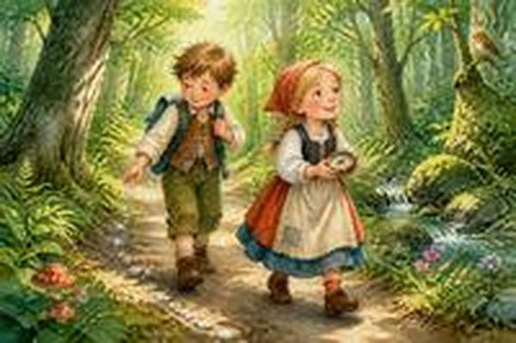
Hansel drops white stones on the path.
When night came, the children were alone. Gretel was scared, but Hansel smiled. "Don't worry. Survival rule number one: stay calm." Together, they collected dry branches and built a small shelter. Gretel made a fire with two sticks. "Let's rest here tonight," she said. "Tomorrow morning, the stones will show us the way home."
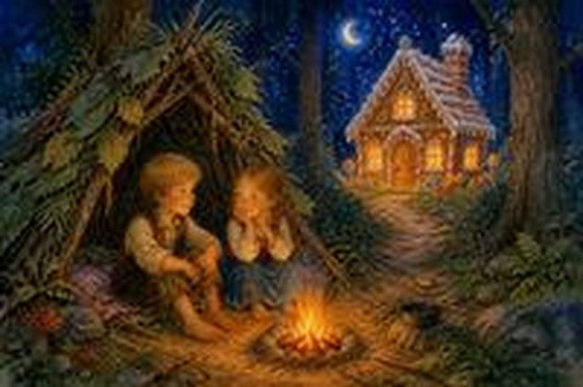
The children build a shelter and see a strange candy house.
In the morning, however, they saw something strange. Between the trees stood a house made of cake, cookies, and candy. Hansel's stomach made a loud noise. "Food!" he shouted, and he started to run.
"Wait!" Gretel said. "Survival rule number two: never eat something if you don't know what it is. And who builds a candy house in the middle of a forest?"
Just then, the door opened, and an old woman came out. "Come in, my dears. I have lots of sweets for you," she said with a strange smile.
Gretel looked carefully. There was a big iron cage behind the house. "No, thank you," she said politely. "We have our own food." She showed the woman some berries and nuts. "These are safe. I checked them in my plant book."
The old woman became angry and tried to grab Hansel's arm. But Hansel was ready. He threw a handful of sand into the air, and while the woman was rubbing her eyes, the children ran into the trees. Gretel took out her compass. "Our house is to the east. Follow me!" They ran and ran until they found their white stones again.
At last, they arrived home. Their father hugged them with tears in his eyes. "I'm so sorry. I will never leave you again," he said. From that day on, the family worked together, and Hansel and Gretel taught everyone in the village how to survive in the forest. People called them "The Forest Survival Team."

