Important policies that you cannot ignore

Please schedule a meeting with **Zaeem Asif** directly if you don’t understand any of the following points. Please read it carefully as you are directly responsible for the following.

# Clients and intellectual property:

1. The source code that we write for our clients is their property and you can never use it or upload it anywhere. Never use amazon keys, password or any of the company material for your personal use or redistribution.
2. No monitoring on laptops. In your absence, anyone is allowed to use it. Do not share any personal family data, facebook /linkedin profile or CodingCops’ official email.
3. You have no direct relationship with clients, you are never supposed to add them on social media,facebook, twitter, linkedIn or anywhere.
4. You can never approach any of our existing or previous clients directly anywhere directly or indirectly.
5. It’s your legal and moral responsibility to keep our trade secrets confidential.

# Slack:

1. You should be available on slack unless you have real reasons for not doing that.
2. Please be responsive in slack as well.
3. Only use the 3 characters of your name on slack such as “zae” for zaeem unless we have two ppl with same name like Hassan Ahmad and Hassan mehmood. In that case, please use 4.
4. Please only use code/sudo names in slack chats with clients. Never use real names as clients can see your personal messages on slack too. Same for client’s company gmails, they can see your activities.
5. While using gmail and slack, they can also see where did you access their company gmail and slack and how many devices you are logged in and from where, so don’t use client’s slack on your personal mobile unless you are an SSE or Team lead.
6. Teamleads, please make sure to see your members git commits and they should not be sending any messages to clients directly without you reading them first. Please avoid any grammatical, spelling or punctuation mistakes.

# Upwork meter rules:

1. Please make sure that no wrong snapshot is uploaded; it’s your responsibility to

make sure that NO wrong snapshots are uploaded. Delete the snapshot immediately if it happens. Wrong snapshots include the snapshots of personal windows other than work related including Facebook, messengers, emails and any such thing that is not related to work and your code name.

1. Every project has a code name and **story**, please keep that story.
2. Your laptop camera should be tapped while running upwork meter.
3. Never login to 2 different upwork profiles from the same computer.
4. Never login to same profile from 2 different computers.
5. If you are using your meter on a new system, make sure to uninstall the previously installed upwork app.
6. If you are logging in on upwork.com on a new system, make sure to delete the previous cookies before logging in.
7. Never access any account from home OR using your personal computer. Everything mentioned above is extremely important and no one except you is responsible to follow the clear guidelines.

# Google Document access rules:

Do not **request access** to any Google document. There is a good chance that you are requesting access from the wrong email address and not the one through which you were supposed to. For example, your code name is Abdul and you were supposed to open the document your email address [devabdul@gmail.com](mailto:devabdul@gmail.com) but you might be logged in using abc@devsinc/CodingCops.com. This could be a blunder, which may cost us business loss, so never do that and always be careful about google docs.

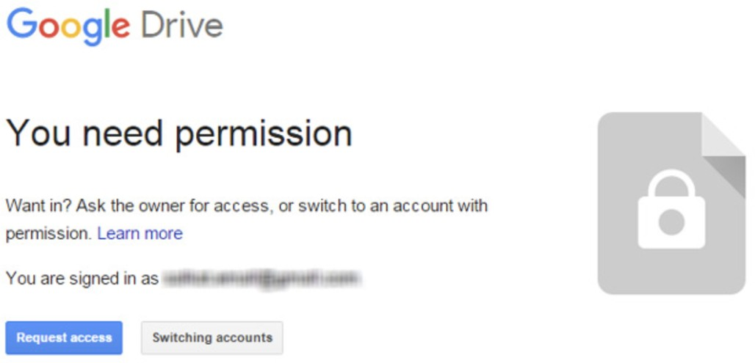

**GIT commits** Make sure that your git commits are from your code name. Always got to github.com or bitbucket.com to check your commits are from correct code name. Always

make sure to use the respective commands before committing any code.

**config** --**global** user.name "Usman Asif"

**config** --**global** user.email “[mail.usmanasif@gmail.com](mailto:mail.usmanasif@gmail.com)”



# Deployment Rules

1. Before doing any deployments on servers, it’s your responsibility to make sure that the server backup including the database backup is there. Always talk to your team lead if you are not sure.
2. Do not run any migrations in any server without immediate database backup.



# Slack Rules:

1. If you read any message from slack that you believe your team lead should read as well. Always make sure to make it unread or paste it in official slack so that everyone can read it.

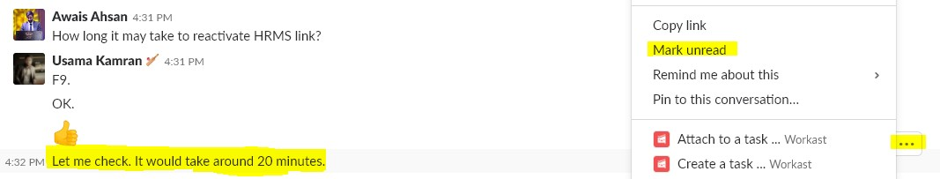

1. Do not directly reply to clients if you are not senior enough OR haven’t been permitted by your team lead explicitly.

# Client Communication 1-to-1

1. The last reply should be from us. (emojis and chat abbreviations are not considered as replies i.e. AOA, LOL, ROLF, gr8, f9 & OK never use capital letters in chat)
2. A reply is better than emoji
3. Don't leave communication in the middle
4. If you have replied to some code red or critical issue then make sure that you will

add some update in the channel within every 30 minutes max for better visibility.

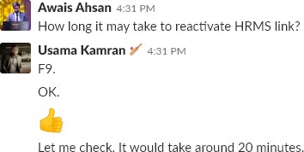

1. 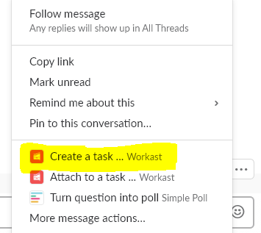If you did ask a question then please do add a note or task and follow up on that next day. If you didn’t receive any reply (you can make a task using workast or reminder of slack)
2. Read client emails at time and respond accordingly. Do not forget to respond. While you respond, you should make sure that the concerned person such as Zaeem or any other lead working with you should know that. Please share the email subject with that person.
3. Understand the context of the messages and reply after the understanding.
4. If you have to post stand-up on daily basis please remember to do so as clients count it as how much dedicated you are towards his work.

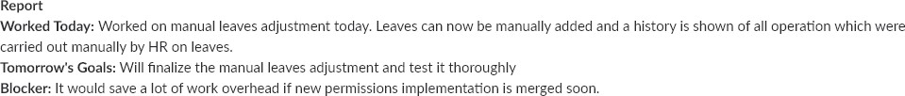

1. Sync client calendar notification so that you may know about meeting time and you should not do conversation at that time (shadow vs face)
2. If you are in verbal communication please take care of the followings:
   1. Good internet connection.
   2. View behind, should seem professional
   3. Try to be as fluent as you can be, in English
   4. Do some reading that will help you in it.
3. People Solution on chrome:

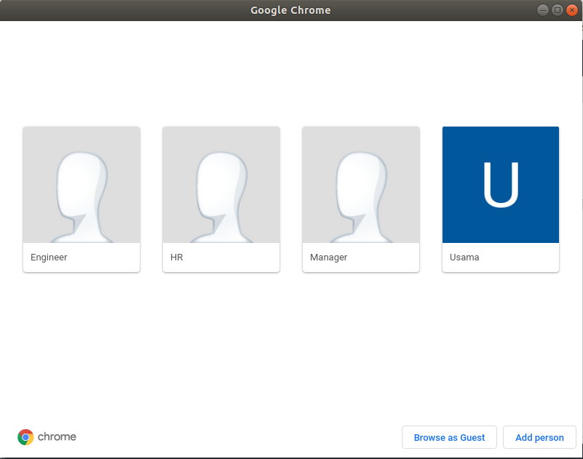

1. No email will be sent to the client without the approval of PM/Lead.
2. Clients should be blocked on social media like Facebook & LinkedIn. E.g

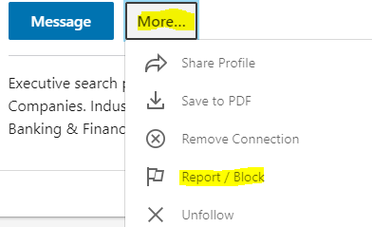

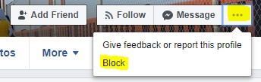

1. Do not share personal cell number with clients
2. In case if it is required, get approval from Zaeem Asif (CodingCops)
3. Before sharing number with client make these changes:
   1. Change your WhatsApp name to Project Name
   2. Change WhatsApp picture and place project logo/name.

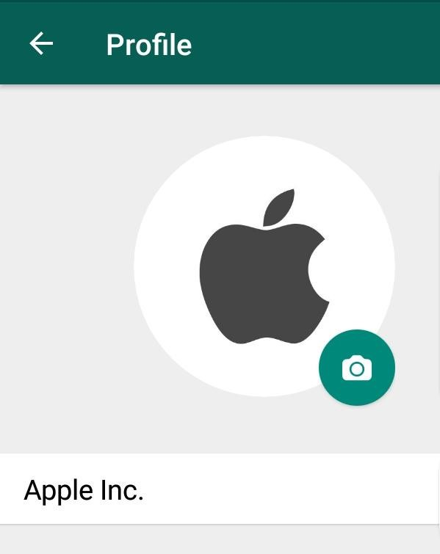

1. Chat/Comment:

Try to elaborate issue in your own words



Do not make such mistakes. At Least read carefully before sending.

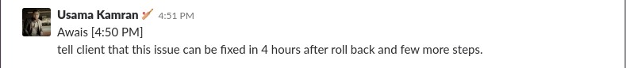

1. No personal email id should be used for testing. Never use it in the code even for test. Only use either [devzaeem.asif@gmail.com](mailto:devzaeem.asif@gmail.com) Or the sudo name’s email id.

Bad Example: (never ever do that)

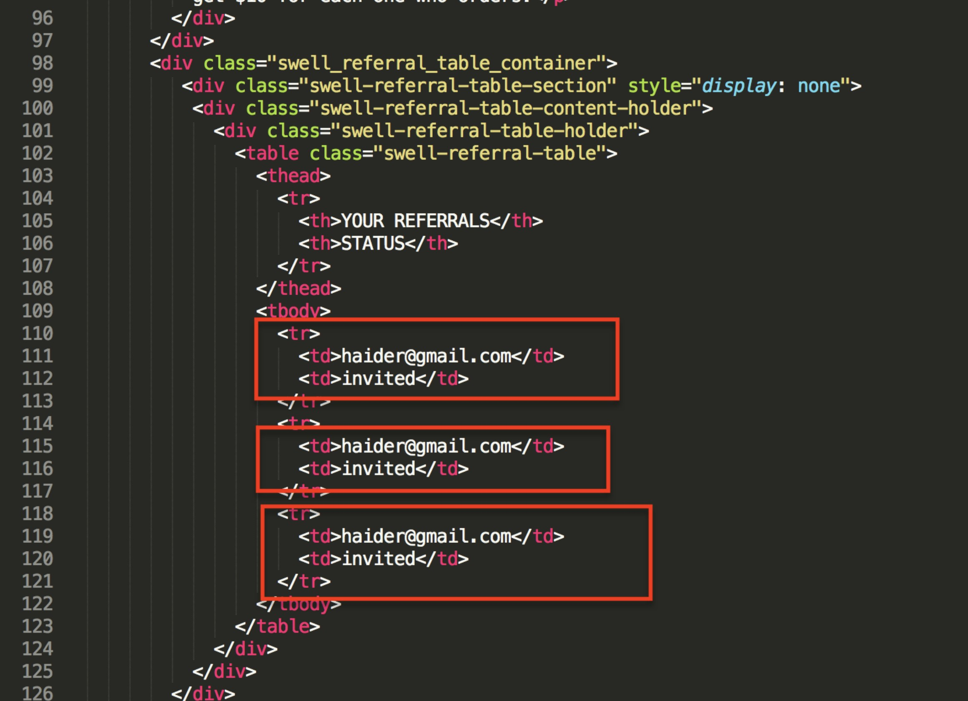

-Multiple devices are login at same email ID.

1. Test Project

Please do not copy paste the test project.

# Loom:

Loom is pretty popular these days but what we should be aware of is that when

take a look at a Loom - the owner gets an email notification on who watched it along with the email address. So please either open all the loom links in cognito OR please make sure to watch the video with a project specific email address.

# Hardware Usage:

1. Charging cables to remain within the premises. Never take your laptops home without the permission of your leads.
2. Take good care of your laptops and other hardware items assigned to you. Oily keyboards, dirty screen, scratch laptop bodies shows bad/careless attitude and that may affect the level of trust that we have on you.
3. Sports equipment like table tennis should not be used for putting up the tea mugs.
4. No eating in the hall on the 1st floor, only eat in the dining room.
5. Take care of lights and acs when not used.
6. Washroom lids should be crystal dry as you come out.
7. Commod tissue papers issue. Only throw them in the basket.

# Personal hygiene:

We don’t like people who have embarrassing hygiene issues and it may reflect in a bad review as well.

All members are expected to maintain a professional, neat and clean appearance at all times. Please take a bath daily before coming to office, brush your teeth properly and wear clean clothes. For meetings with customers, men should wear dress shirts, trousers and shoes. Please note that personal hygiene is one of the most important things in CodingCops. Please make sure to have clean clothes, socks and other items. Please make sure to brush your teeth, keep your nails clean and use perfume/deodorant to keep the body odor away and it will make it easy for other people to work with you and vice versa.

# Internet Usage:

1. Please do not download any kinds of torrent using official Internet policy. It’s strongly prohibited and will be considered highly unethical, and we do not expect our people to be unethical.
2. Do not use our Internet facility to download movies, watching recreational videos on YouTube OR live streaming.
3. To avoid wasting bandwidth, there is an option in smartphones, which disallow applications like Facebook to keep downloading the contents even when running in the background. It’s called “Background App Refresh” Please disable that option on your mobile. I have shown the snapshot on iPhone mobile above.

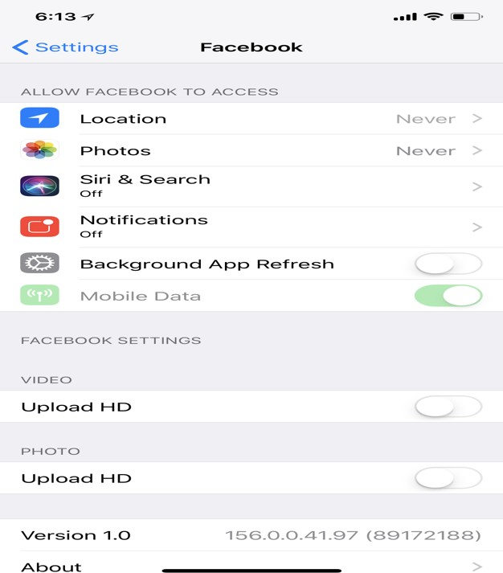

1. Sometimes, people request that they need bandwidth on a certain channel. It’s your moral responsibility to immediately switch from that line.

# Leave Rules

Please apply for leaves well within time. All leaves have to be pre-approved except emergency leaves or sick leaves. It’s your responsibility to get a leave approved first by your immediate team leads and then senior management and then on the day of the leave share on general channel one day earlier than the leave date. For a leave of 2 days or less, it has to be approved at-least 2 **\*business days** days earlier. For any leave consisting of more than 2 working days, it must be approved at least 2 \***business weeks** earlier. Any leave more than 5 working days has to be approved at least 45 days earlier. Other than casual and sick leaves, we also have extraordinary leaves, which we usually approve of, based on the extraordinary circumstances. Please note that applying for a leave doesn’t guarantee the approval, it has to be approved by the senior lead first. Any leave can be rejected as well or can be converted to a day swap. Generally, most of the leaves following the guidelines above get approved.

# Safeguarding company Information and Property:

In the course of your work, you will have access to information about company operations. Some of this is legal, medically, or personally privileged and/or confidential.

Discretion and the maintenance of confidentiality are expected of all employees.

You are asked to be careful to turn out the lights. Equipment breakdowns should be reported to your supervisor. Members are not to remove equipment, office supplies, or other company property from the office without proper authorization. All lost, stolen, or missing items should be reported to the Administration. **Please note that outside the premises of your office area, if you take the company belongings such as the laptop, test devices like the iPad, cameras on anything. You yourself will be responsible for any mishap such as laptop snatching, camera damage or any other kind of damage.**