WEB ACCESSIBILITY OBSERVATORY REPORT: GENERAL STATE ADMINISTRATION
[fecha]

Índice
1.Introducción 6
1.1. Antecedentes 6
2.Objetivos del estudio 8
3.Resultados Globales 9
3.1.Distribución del Nivel de adecuación estimado global 10
3.2.Distribución de la Situación de cumplimiento estimada global 11
3.3.Comparación de la Conformidad de las verificaciones 12
3.3.1.Nivel de Adecuación A 13
3.3.2.Nivel de adecuación AA 15
3.4.Comparación de la Puntuación media de verificación 16
3.4.1.Nivel de adecuación A 17
3.4.2.Nivel de adecuación AA 19
3.5.Comparación de Modalidad por Verificación 20
3.5.1.Nivel de adecuación A 21
3.5.2.Nivel de adecuación AA 23
3.6.Comparación del nivel de adecuación estimado por segmento 24
3.7.Comparación de la situación de cumplimiento estimada por segmento 25
3.8.Comparación de la Puntuación media de los sitios web por segmento y nivel de adecuación 26
3.9.Comparación del Nivel de adecuación estimado por complejidad 28
3.10.Comparación de la Situación de cumplimiento estimada por complejidad 29
3.11.Comparación de la Puntuación media de los sitios web por complejidad y nivel de adecuación 30
3.12.Comparación de la Puntuación media por aspectos 32
4.EVOLUCIÓN DE RESULTADOS 35
5.TÉRMINOS GLOBALES 36
5.1.Evolución del Nivel de adecuación estimado 37
5.2.Evolución del Nivel de cimplimiento estimado 38
5.3.Evolución de la Puntuación Media del Observatorio 39
5.4.Evolución de la Puntuación Media por Verificacion 40
5.4.1.Nivel de Accesibilidad I 41
5.4.2.Nivel de Accesibilidad II 44
5.5.Evolución de la conformidad por Verificacion 46
5.5.1.Nivel de Accesibilidad I 47
5.5.2.Nivel de Accesibilidad II 50
5.6.Evolución de la Puntuación Media por Aspecto 52
6.TÉRMINOS FIJOS 54
6.1.Evolución del Nivel de adecuación estimado 55
6.2.Evolución del Nivel de cimplimiento estimado 56
6.3.Evolución de la Puntuación Media del Observatorio 57
6.4.Evolución de la Puntuación Media por Verificacion 58
6.4.1.Nivel de Accesibilidad I 59
6.4.2.Nivel de Accesibilidad II 62
6.5.Evolución de la conformidad por Verificacion 64
6.5.1.Nivel de Accesibilidad I 65
6.5.2.Nivel de Accesibilidad II 68
6.6.Evolución de la Puntuación Media por Aspecto 70
7.Evolución por segmentos 72
8.Conclusiones del estudio 73
8.1.Resultados globales 73
8.2.Resultados por segmentos 74
8.2.1.Segmento Principales 74
8.2.2.Segmento Organismos 74
8.2.3.Segmento Temáticos 74
8.2.4.Segmento Otros 74
8.2.5.Segmento Sedes 74
8.3.Evolución de resultados 75
ANEXO I: Metodología del Observatorio 76

- INTRODUCTION
The Web Accessibility Observatory aims to help public administrations comply with accessibility requirements. the implementation of the regular iterations of the Web Accessibility Observatory makes it possible to ascertain the degree of compliance with web accessibility principles, how they evolve over time, as well as the main issues to be resolved. This makes it possible to draw conclusions and appropriate action plans to support organisations to achieve the following objective: ensure an optimal level of compliance in a sustainable manner over time.
The various iterations of the Observatory are carried out according to the Web Accessibility Observatory’s own methodology, which is described as an annex in this document and is used by the Spanish state for the simplified follow-up, allowing for a review of the degree of compliance on web-accessibility.
This methodology has been approved within the ICT Directorate Committee of the AGE and the Sectoral Commission for Electronic Administration with the participation of the Spanish Federation of Municipalities and Provinces (FEMP) and the Conference of Rectors of the Spanish University.

1.1. BACKGROUND
The Secretariat-General for Digital Administration, attached to the Ministry of Territorial Policy and Civil Service, through the Secretariat of the State Civil Service, has as its functions the promotion of the Digital Administration through studies and the design and technical implementation of policy programmes, cooperation with other public administrations, and the development and dissemination of common tools and services necessary for this purpose.
It shall also evaluate the action taken and make any necessary recommendations within the framework of the guidelines to be established by the Commission for ICT Strategy and the Commission for the Sectoral Commission on Electronic eGovernment, to which it will provide technical support.
The Web Accessibility Observatory initiative was launched in 2010 by providing services based on standard UNE 139803: 2004 (WCAG 1.0). In 2014, the services of the observatory were updated to use the standard 139803: 2012 (WCAG 2.0). And since 2020, the Observatory services have been updated on the basis of the Spanish standard UNE-EN 301549: 2019 “Accessibility requirements for ICT products and services”, which is the Spanish translation of standard EN 301 549 V2.1.2 (2018-08). Accessibility requirements for ICT products and services “, harmonised standard declared by the European Commission in Implementing Decision 2018/2048/EU . These rules are in line with WCAG 2.1 WCAG to W3C
- objectives of the study
The purpose of this study is to ascertain the current situation and developments regarding the accessibility of central government websites, from the websites of the ministries, to smaller websites and websites.
It offers a wide range of graphs and tables which collect results from this last iteration of the Observatory (overall results, results by segment and by complexity) as well as the evolution of the results in the latest iterations.
From among all the data generated in iteration based on the methodology of the Observatory, the statistics that have been considered the most interesting in defining the current situation and the evolution of accessibility have been generated in this report.
- GLOBAL RESULTS
The implementation of a iteration for the Observatory generates a wealth of information for each website analysed.
by analysing and aggregating these data, overall results are obtained which, thanks to the generation of several graphs, clearly provide an overview of the current state of accessibility of the websites analysed in the study.

  - distribution of the overall estimated level of adequacy
As a first overall objective, the aim is to ascertain the estimated compliance with web accessibility standards by the websites analysed. It then shows the overall distribution of websites according to the estimated level of adequacy: Not valid, A or AA.
Overall estimated level
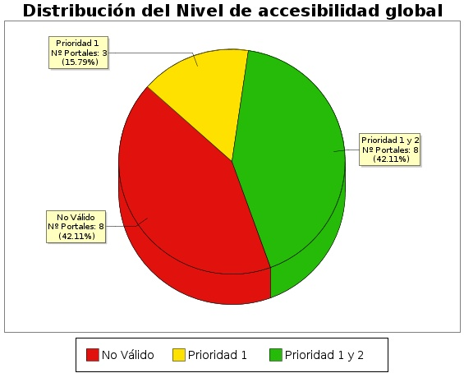

Estimated level of adequacy | Percentage of websites | Number of websites
AA | -41.t1.b2- | -41.t1.c2-
A | -41.t1.b3- | -41.t1.c3-
Not valid | -41.t1.b4- | -41.t1.c4-

3.2. overall estimated compliance status
The following graph shows the distribution of websites according to the estimated compliance status set out in the observatory methodology: not partially compliant or fully compliant.
Overall estimated compliance status

Estimated compliance status | Percentage of websites | Number of websites
Full compliance | -4c1.t1.b2- | -4c1.t1.c2-
Partially conforme | -4c1.t1.b3- | -4c1.t1.c3-
Disagreed | -4c1.t1.b4- | -4c1.t1.c4-
  - comparison of verifications compliance
From a technical point of view, the Observatory has been planned as a review of accessibility verifications organised in two large groups according to the levels of adequacy established in WCAG 2,1: verifications of level A and adequacy level AA verifications.
Moreover, for each website the conformity of each verification with the values of: It does not apply, in a satisfactory or compliant manner.
The following graph presents in a comprehensive manner the compliance of each verification by aggregating the results of all the websites analysed, in the first place for the adequacy level checks A and then for the level AA adequacy verifications.
The X axis of the graphs represents each of the verifications analysed at an adequacy level, and on axis Y is the conformity of the verification (as an aggregation of the results of all the websites analysed).
    - Level of alignment A
Conformity of verification. Adequacy Level A
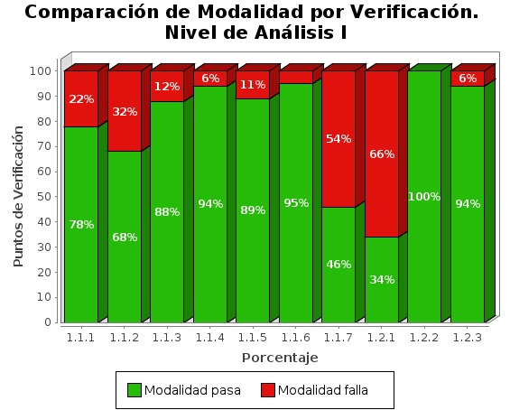

Verification | Compliant | Non compliant | Not applicable
1.1 Text alternatives | -451c.t1.b2- | -451c.t1.c2- | -451c.t1.d2-
1.2 Use of headers | -451c.t1.b3- | -451c.t1.c3- | -451c.t1.d3-
1.3 Use of lists | -451c.t1.b4- | -451c.t1.c4- | -451c.t1.d4-
1.4 Data tables | -451c.t1.b5- | -451c.t1.c5- | -451c.t1.d5-
1.5 Structural grouping | -451c.t1.b6- | -451c.t1.c6- | -451c.t1.d6-
1.6 content separation and presentation | -451c.t1.b7- | -451c.t1.c7- | -451c.t1.d7-
1.7 Main language identification | -451c.t1.b8- | -451c.t1.c8- | -451c.t1.d8-
1.8 Navigation with Javascript accessible and user control | -451c.t1.b9- | -451c.t1.c9- | -451c.t1.d9-
1.9 Forms and labels | -451c.t1.b10- | -451c.t1.c10- | -451c.t1.d10-
1.10 Forms and Structure | -451c.t1.b11- | -451c.t1.c11- | -451c.t1.d11-
1.11 Page Title and Frameworks | -451c.t1.b12- | -451c.t1.c12- | -451c.t1.d12-
1.12 descriptive links | -451c.t1.b13- | -451c.t1.c13- | -451c.t1.d13-
1.13 Context changes | -451c.t1.b14- | -451c.t1.c14- | -451c.t1.d14-
1.14 Compatibility | -451c.t1.b15- | -451c.t1.c15- | -451c.t1.d15-
    - Adequacy level AA
A comparison of verification compliance. Level AA
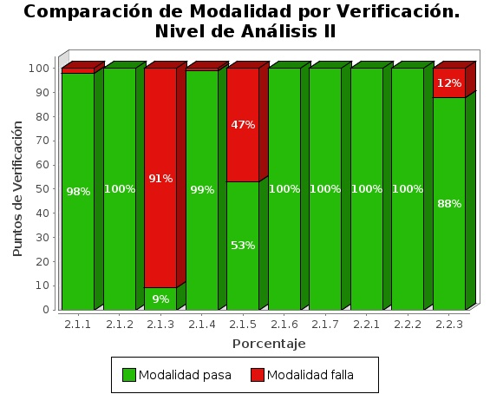

Verification | Compliant | Non compliant | Not applicable
2.1 Identification of language changes | -452c.t1.b2- | -452c.t1.c2- | -452c.t1.d2-
2.2 Sufficient device | -452c.t1.b3- | -452c.t1.c3- | -452c.t1.d3-
2.3 Accessibility Section | -452c.t1.b4- | -452c.t1.c4- | -452c.t1.d4-
2.4 Multiple navigation waterways | -452c.t1.b5- | -452c.t1.c5- | -452c.t1.d5-
2.5 keyboard Foo | -452c.t1.b6- | -452c.t1.c6- | -452c.t1.d6-
2.6 consisting of | -452c.t1.b7- | -452c.t1.c7- | -452c.t1.d7-
  - Average verification score compared

The average score for each verification is then aggregated by aggregating the results of all the analysed pages, in the first place for the adequacy level A verifications and then for the level AA adequacy verifications.
The X axis of the graphs represents each of the verifications analysed at a level of adequacy, and the Y axis presents the Overall Average Score Score (PMV) by aggregating the results of all pages analysed. Those tests with a lower score are those with the highest accessibility problems and for which improvement efforts will have to be concentrated.
    - Adequacy Level A
Average verification score. Adequacy Level A
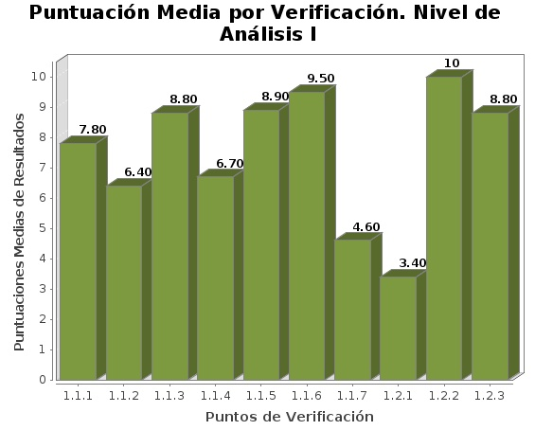

Verification | Average score
1.1 Text alternatives | -441.t1.b2-
1.2 Use of headers | -441.t1.b3-
1.3 Use of lists | -441.t1.b4-
1.4 Data tables | -441.t1.b5-
1.5 Structural grouping | -441.t1.b6-
1.6 content separation and presentation | -441.t1.b7-
1.7 Main language identification | -441.t1.b8-
1.8 Navigation with Javascript accessible and user control | -441.t1.b9-
1.9 Forms and labels | -441.t1.b10-
1.10 Forms and Structure | -441.t1.b11-
1.11 Page Title and Frameworks | -441.t1.b12-
1.12 descriptive links | -441.t1.b13-
1.13 Context changes | -441.t1.b14-
1.14 Compatibility | -441.t1.b15-
    - Adequacy level AA
Average score per verification. Adequacy level AA
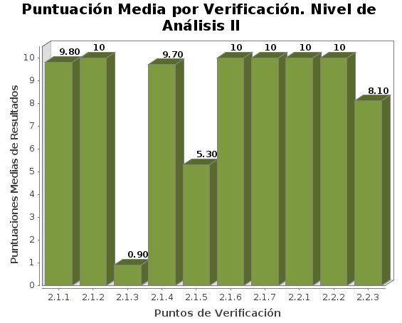

Verification | Average score
2.1 Identification of language changes | -442.t1.b2-
2.2 Sufficient device | -442.t1.b3-
2.3 Accessibility Section | -442.t1.b4-
2.4 Multiple navigation waterways | -442.t1.b5-
2.5 keyboard Foo | -442.t1.b6-
2.6 consisting of | -442.t1.b7-
  - comparison of Modality to Verification
The following graphs present in a comprehensive manner the Modality of each verification (Pasa or Falla) by adding the results of all the analysed web pages, in the first place for the adequacy level verifications A and then for the level AA adequacy verifications.
The X axis of the graphs represents each of the verifications analysed at an adequacy level, and on the Y-axis is presented by stack bars the percentage of Pasa and Fula modality pages (as an aggregation of the results of all the analysed pages).
    - Adequacy Level A
Comparison of Modality to Verification. Adequacy Level A

Verification | Percentage Pass | Percentage Fails
1.1 Text alternatives | -451.t1.b2- | -451.t1.c2-
1.2 Use of headers | -451.t1.b3- | -451.t1.c3-
1.3 Use of lists | -451.t1.b4- | -451.t1.c4-
1.4 Data tables | -451.t1.b5- | -451.t1.c5-
1.5 Structural grouping | -451.t1.b6- | -451.t1.c6-
1.6 content separation and presentation | -451.t1.b7- | -451.t1.c7-
1.7 Main language identification | -451.t1.b8- | -451.t1.c8-
1.8 Navigation with Javascript accessible and user control | -451.t1.b9- | -451.t1.c9-
1.9 Forms and labels | -451.t1.b10- | -451.t1.c10-
1.10 Forms and Structure | -451.t1.b11- | -451.t1.c11-
1.11 Page Title and Frameworks | -451.t1.b12- | -451.t1.c12-
1.12 descriptive links | -451.t1.b13- | -451.t1.c13-
1.13 Context changes | -451.t1.b14- | -451.t1.c14-
1.14 Compatibility | -451.t1.b15- | -451.t1.c15-
    - Adequacy level AA
Comparison of Modality to Verification. Adequacy level AA

Verification | Percentage Pass | Percentage Fails
2.1 Identification of language changes | -452.t1.b2- | -452.t1.c2-
2.2 Sufficient device | -452.t1.b3- | -452.t1.c3-
2.3 Accessibility Section | -452.t1.b4- | -452.t1.c4-
2.4 Multiple navigation waterways | -452.t1.b5- | -452.t1.c5-
2.5 keyboard Foo | -452.t1.b6- | -452.t1.c6-
2.6 consisting of | -452.t1.b7- | -452.t1.c7-

  - comparison of the level of adequacy estimated by segment
As has been shown above, the overall estimated level of adequacy at the level of the observatory is set out below, the estimated level of suitability for each of the segments analysed in the observatory can be easily compared to the different segments.
The X axis represents the segments in which the observatory sample is divided, and the axis Y shows by stack rods, the percentage of websites with estimated levels not valid, A or AA for each of the segments.
Level of adequacy estimated by segment
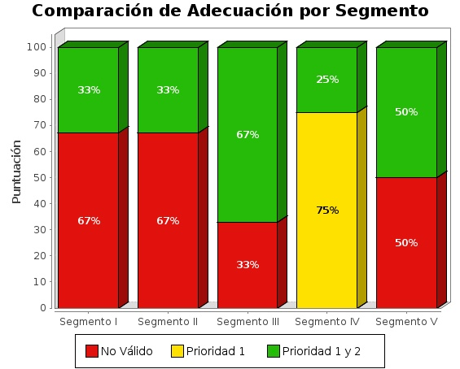

--tablassegmento--

  - comparison of compliance status estimated by segment
As has been shown above, the overall estimated compliance status at the level of the overall observatory is presented below, the estimated compliance status for each of the segments analysed in the observatory can be easily compared to the different segments.
The X axis represents the segments in which the observatory is divided, and the axis Y shows by stack rods, the percentage of non-compliant websites, Partly conform or fully compliant for each of the segments.
Compliance rate by segment
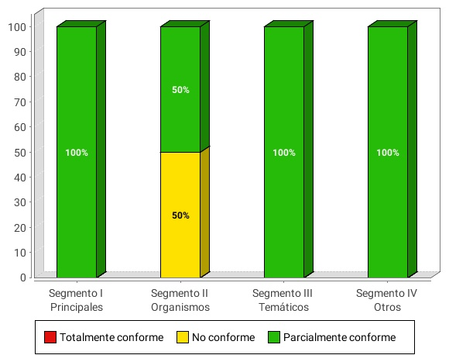

--tablascumplimientosegmento--
  - comparison of average score of websites per segment and level of adequacy
This section shows the average scores obtained by websites belonging to a segment and level of adequacy.
The graph is distributed in such a way that axis X shows the segments in which the observatory’s sample is divided, including for each of them a slash for each level of alignment (not valid, A, AA). The Y axis represents the average score obtained by the websites for each segment and the level of adequacy, which is obtained from the scores of all websites (PMSW) of a given segment and level of adequacy.
The average scores represent how many accessibility checks are properly met. High averages indicate that many accessibility checks are met. However, high averages do not ensure a high level of adequacy. The level of adequacy is related to the level of adequacy of the verifications that are met. If problems are concentrated on fitness level checks, the level of adequacy is not valid, although the average scores may be high.
Average score of the websites per segment and estimated level of adequacy
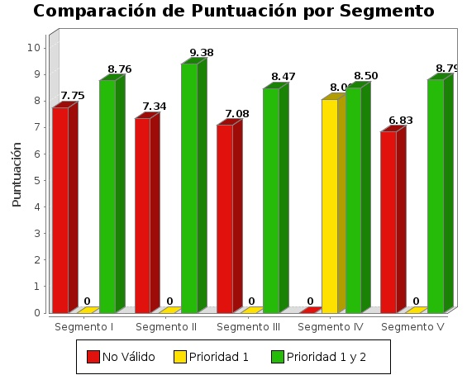

--tablaspuntuacionsegmento--
  - comparison of the level of adequacy estimated by complexity
As the overall estimated level of adequacy has been shown above, the overall estimated level of adequacy at the level of the observatory is set out below, depending on the complexity of the websites analysed, so as to make it possible to compare and draw conclusions on whether the estimated level of adequacy achieved is linked to the complexity of the website.
The X axis represents the Complexity of the websites (Lower, Media and Alta) and the axis Y shows by stack rods, the percentage of websites with estimated level of adequacy Not valid, A or AA for each complexity.
Level of adequacy estimated by complexity
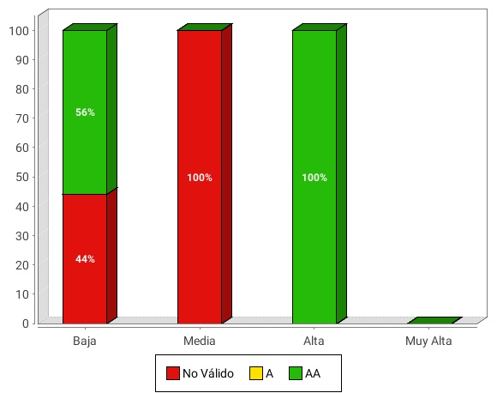

--tablascomplejidad--
  - comparison of the compliance status estimated to be complex
As the overall estimated compliance status has been shown above, the compliance status is then estimated on the basis of the complexity of the websites analysed, so as to make it possible to compare and draw conclusions on whether the compliance status reached is linked to the complexity of the website.
The X axis represents the Complexity of the websites (Lower, Media and Alta) and the Y axis by stack bars, the percentage of websites with estimated compliance status, Partly under or totally compliant for each complexity.
Compliance status estimated to be complex
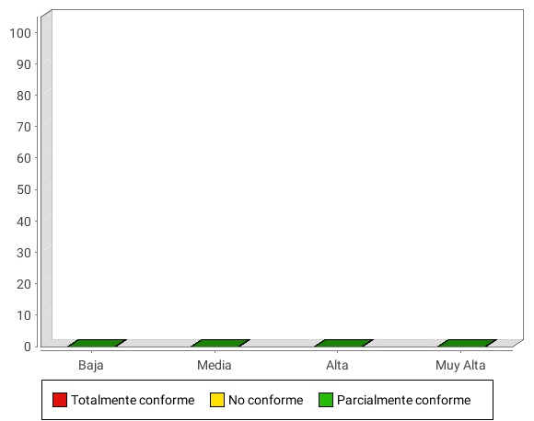

--tablascumplimientocomplejidad--
  - comparison websites’ average score due to complexity and level of adequacy
This section shows the average scores obtained by all websites at a level of adequacy and complexity.
The graph is distributed in such a way that the ‘X’ axis shows the complex of the websites (lower, medium or high), including for each of them a bar per level of adequacy (not valid, A, AA). The Y axis represents the average score obtained by the websites for each complexity and adequacy level, which is obtained from the Medias scores (PMS) on all websites of a certain level of complexity and suitability.
The average scores represent how many accessibility checks are properly met. High averages indicate that many accessibility checks are met. However, high averages do not ensure a high level of adequacy. The level of adequacy is linked to the level of adequacy of the verifications that are being met. If problems are concentrated on fitness level checks, the level of adequacy is not valid, although the average scores may be high.
Average score of websites due to complexity and level of adequacy

--tablaspuntuacioncomplejidad--
  - Average score per item comparison
Below are the results of the Media (PMA) score obtained for the cluster by aspects of the different verification points of the methodology.
Average score because of appearance
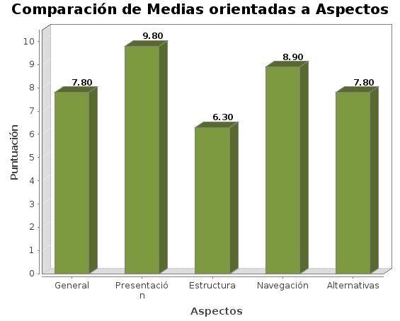

Appearance | Average score
General | -46.t1.b2-
Presentation | -46.t1.b3-
Structure | -46.t1.b4-
Navigation | -46.t1.b5-
Alternatives | -46.t1.b6-

--categorysection--

--complexitysection--
- PERFORMANCE DEVELOPMENT
The Web Accessibility Observatory aims to serve as a tool to effectively monitor the level of accessibility of public websites. It is therefore vital to analyse and compare the results obtained over time in the various observatories, so that their trend can be observed.
To this end, a large number of developments are provided, making it possible to know both on a global basis and more specifically the results obtained in the observatories carried out so far. These graphs show the evolution of both the overall rating of the observatory and the levels of adequacy, the score for each verification, or the score for the accessibility aspects.
in this way, the charts of developments allow for a quick observation of which accessibility issues are being improved, as well as those where an additional effort should be made in order to achieve appropriate results.
- Global terms
The Web Accessibility Observatory aims to serve as a tool to effectively monitor the level of accessibility of public websites. It is therefore vital to analyse and compare the results obtained over time in the various observatories, so that their trend can be observed.
To this end, a large number of developments are provided, making it possible to know both on a global basis and more specifically the results obtained in the observatories carried out so far. These graphs show the evolution of both the overall rating of the observatory and the levels of adequacy, the score for each verification, or the score for the accessibility aspects.
In this way, the charts of developments allow for a quick observation of which accessibility issues are being improved, as well as those where an additional effort should be made in order to achieve appropriate results.
  - evolution of the estimated level of adequacy
The following graphs show how the portals were distributed at the three levels of conformity defined by the observatory: Priority 1 and Priority 2 (optimum), Priority 1 and Partial.
The ideal trend would be to observe in this evolution that the percentage of Priority 1 and Priority 2 is always on the increase, as well as with Priority 1, while the Parcial level should decrease towards the maximum possible of 0.
Evolution of conformity level
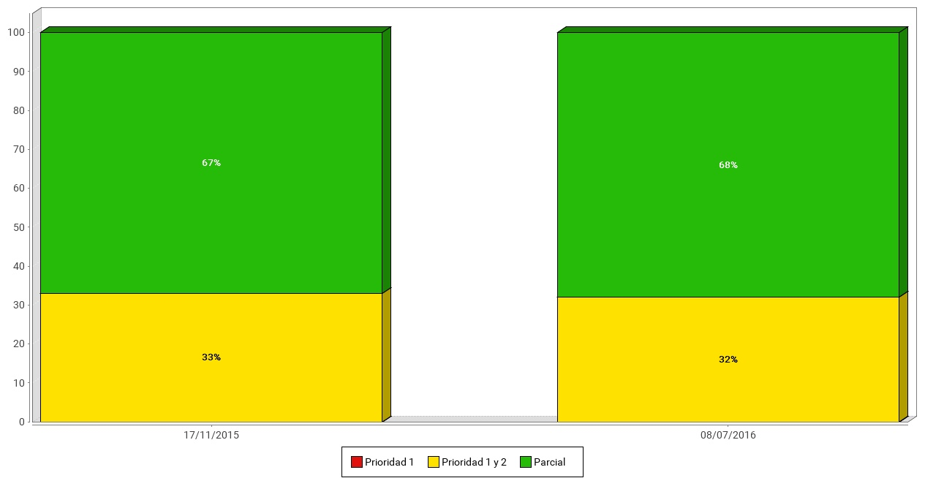

 | -eg.t1.1.a2- | -eg.t1.1.a3- | -eg.t1.1.a4- | -eg.t1.1.a5- | -eg.t1.1.a6- | -eg.t1.1.a7-
AA | -eg.t1.1.b2- | -eg.t1.1.b3- | -eg.t1.1.b4- | -eg.t1.1.b5- | -eg.t1.1.b6- | -eg.t1.1.b7-
A | -eg.t1.2.b2- | -eg.t1.2.b3- | -eg.t1.2.b4- | -eg.t1.2.b5- | -eg.t1.2.b6- | -eg.t1.2.b7-
Not valid | -eg.t1.3.b2- | -eg.t1.3.b3- | -eg.t1.3.b4- | -eg.t1.3.b5- | -eg.t1.3.b6- | -eg.t1.3.b7-

  - evolution of the estimated level of completeness
The following graphs show how the portals were distributed at the three levels of conformity defined by the observatory: Priority 1 and Priority 2 (optimum), Priority 1 and Partial.
The ideal trend would be to observe in this evolution that the percentage of Priority 1 and Priority 2 is always on the increase, as well as with Priority 1, while the Parcial level should decrease towards the maximum possible of 0.
Evolution of the level of compliance

 | -eg.t2.1.a2- | -eg.t2.1.a3- | -eg.t2.1.a4- | -eg.t2.1.a5- | -eg.t2.1.a6- | -eg.t2.1.a7-
Fully compliant | -eg.t2.1.b2- | -eg.t2.1.b3- | -eg.t2.1.b4- | -eg.t2.1.b5- | -eg.t2.1.b6- | -eg.t2.1.b7-
Partially compliant | -eg.t2.2.b2- | -eg.t2.2.b3- | -eg.t2.2.b4- | -eg.t2.2.b5- | -eg.t2.2.b6- | -eg.t2.2.b7-
Not compliant | -eg.t2.3.b2- | -eg.t2.3.b3- | -eg.t2.3.b4- | -eg.t2.3.b5- | -eg.t2.3.b6- | -eg.t2.3.b7-

  - evolution of the Centre’s Average Score
The following graph shows the score reached by the various observatories carried out so far. This is often a small variation, but it makes it possible to see whether the accessibility of the State’s central government websites tends to improve or deteriorate in time.
Evolution of the Centre’s Average Score
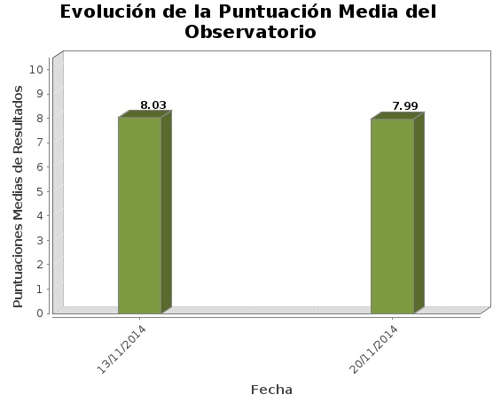

Date | Average score
-eg.t3.a2- | -eg.t3.b2-
-eg.t3.a3- | -eg.t3.b3-
-eg.t3.a4- | -eg.t3.b4-
-eg.t3.a5- | -eg.t3.b5-
-eg.t3.a6- | -eg.t3.b6-

  - Evolution of Media Score
In the following sections, the variation suffered by Media Scoring of the observatory’s 20 verifications.
By means of these graphs, a conclusion can be reached rapidly on which accessibility requirements are being improved, as well as those where the problems identified have been increasing, and so that efforts can be targeted more easily.
    - Level of Accessibility A
Evolution of the score by verification level of accessibility A
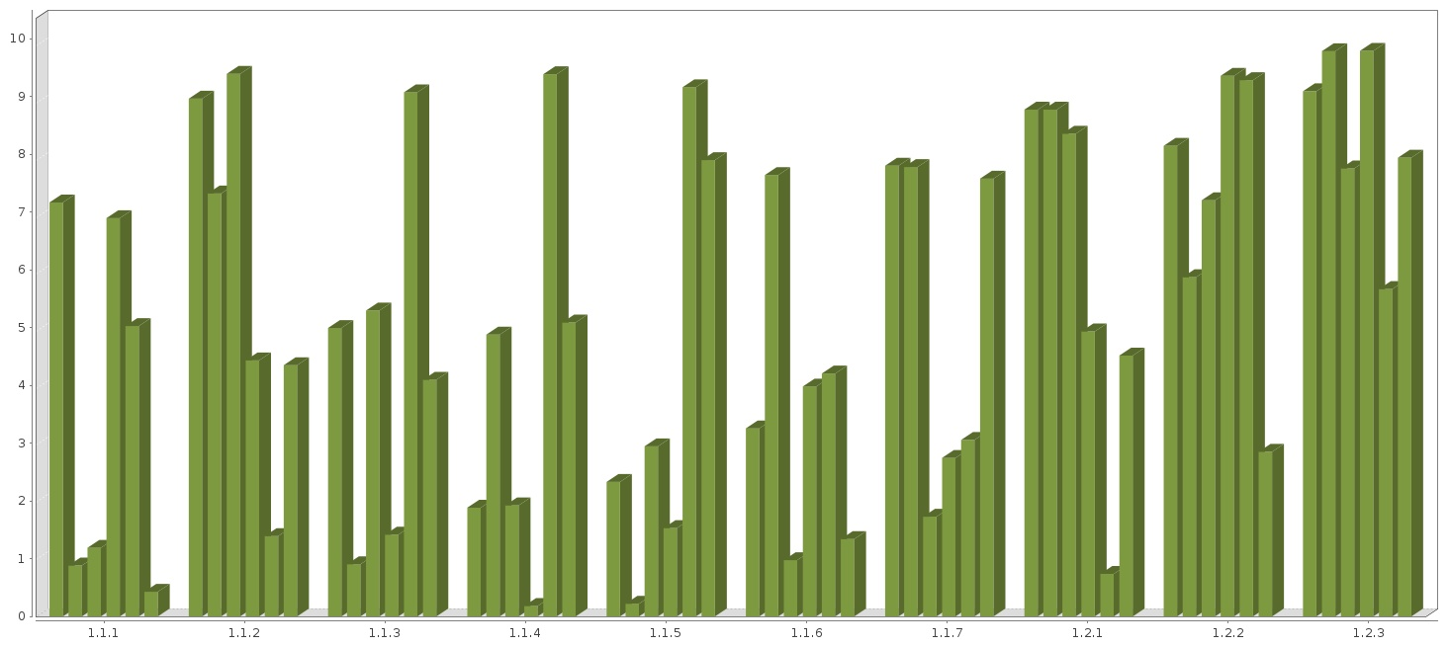

 | 1st Bar | 2nd Bar | 3rd Bar | 4th Bar | 5th Bar | 6th Bar
Observatory date | -eg.t4.1.a2- | -eg.t4.1.a3- | -eg.t4.1.a4- | -eg.t4.1.a5- | -eg.t4.1.a6- | -eg.t4.1.a7-

Evolution of the score by verification level of accessibility A
 | 1st Bar | 2nd Bar | 3rd Bar | 4th Bar | 5th Bar | 6th Bar
Observatory date | -eg.t4.1.a2- | -eg.t4.1.a3- | -eg.t4.1.a4- | -eg.t4.1.a5- | -eg.t4.1.a6- | -eg.t4.1.a7-

Evolution of the score by verification level of accessibility A
 | -eg.t4.1.a2- | -eg.t4.1.a3- | -eg.t4.1.a4- | -eg.t4.1.a5- | -eg.t4.1.a6- | -eg.t4.1.a7-
1.1 Text alternatives | -eg.t4.1.b2- | -eg.t4.1.b3- | -eg.t4.1.b4- | -eg.t4.1.b5- | -eg.t4.1.b6- | -eg.t4.1.b7-
1.2 Use of headers | -eg.t4.2.b2- | -eg.t4.2.b3- | -eg.t4.2.b4- | -eg.t4.2.b5- | -eg.t4.2.b6- | -eg.t4.2.b7-
1.3 Use of lists | -eg.t4.3.b2- | -eg.t4.3.b3- | -eg.t4.3.b4- | -eg.t4.3.b5- | -eg.t4.3.b6- | -eg.t4.3.b7-
1.4 Data tables | -eg.t4.4.b2- | -eg.t4.4.b3- | -eg.t4.4.b4- | -eg.t4.4.b5- | -eg.t4.4.b6- | -eg.t4.4.b7-
1.5 Structural grouping | -eg.t4.5.b2- | -eg.t4.5.b3- | -eg.t4.5.b4- | -eg.t4.5.b5- | -eg.t4.5.b6- | -eg.t4.5.b7-
1.1.6 content separation and presentation | -eg.t4.6.b2- | -eg.t4.6.b3- | -eg.t4.6.b4- | -eg.t4.6.b5- | -eg.t4.6.b6- | -eg.t4.6.b7-
1.7 Main language identification | -eg.t4.7.b2- | -eg.t4.7.b3- | -eg.t4.7.b4- | -eg.t4.7.b5- | -eg.t4.7.b6- | -eg.t4.7.b7-
1.8 Navigation with Javascript accessible and user control | -eg.t4.8.b2- | -eg.t4.8.b3- | -eg.t4.8.b4- | -eg.t4.8.b5- | -eg.t4.8.b6- | -eg.t4.8.b7-
1.9 Forms and labels | -eg.t4.9.b2- | -eg.t4.9.b3- | -eg.t4.9.b4- | -eg.t4.9.b5- | -eg.t4.9.b6- | -eg.t4.9.b7-
1.10 Forms and Structure | -eg.t4.10.b2- | -eg.t4.10.b3- | -eg.t4.10.b4- | -eg.t4.10.b5- | -eg.t4.10.b6- | -eg.t4.10.b7-
1.11 Page Title and Frameworks | -eg.t4.11.b2- | -eg.t4.11.b3- | -eg.t4.11.b4- | -eg.t4.11.b5- | -eg.t4.11.b6- | -eg.t4.11.b7-
1.12 descriptive links | -eg.t4.12.b2- | -eg.t4.12.b3- | -eg.t4.12.b4- | -eg.t4.12.b5- | -eg.t4.12.b6- | -eg.t4.12.b7-
1.13 Context changes | -eg.t4.13.b2- | -eg.t4.13.b3- | -eg.t4.13.b4- | -eg.t4.13.b5- | -eg.t4.13.b6- | -eg.t4.13.b7-
1.14 Compatibility | -eg.t4.14.b2- | -eg.t4.14.b3- | -eg.t4.14.b4- | -eg.t4.14.b5- | -eg.t4.14.b6- | -eg.t4.14.b7-

    - Level of accessibility AA
Evolution of the score by verification level of accessibility AA
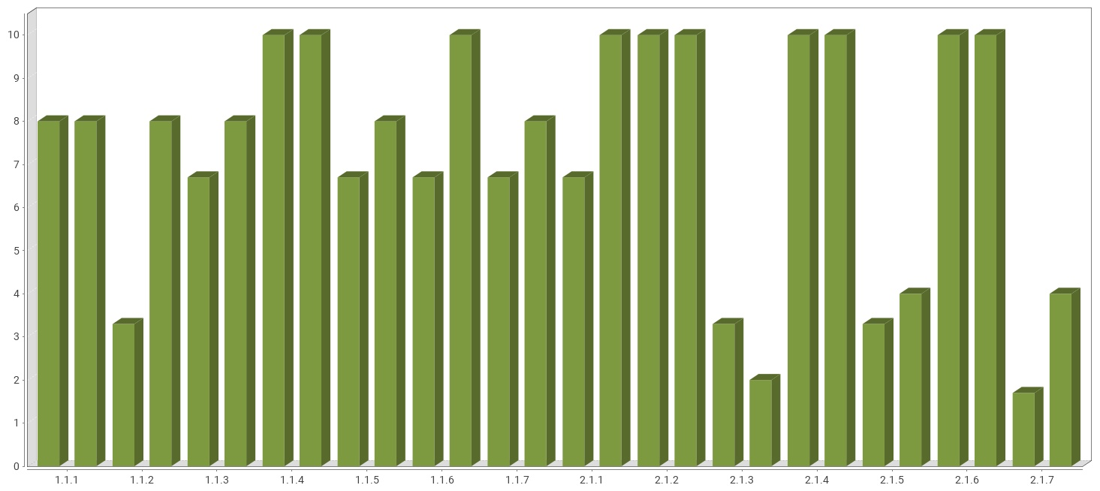
 | 1st Bar | 2nd Bar | 3rd Bar | 4th Bar | 5th Bar | 6th Bar
Observatory date | -eg.t4.21.a2- | -eg.t4.21.a3- | -eg.t4.21.a4- | -eg.t4.21.a5- | -eg.t4.21.a6- | -eg.t4.21.a7-

Evolution of the score by verification level of accessibility AA
 | -eg.t4.21.a2- | -eg.t4.21.a3- | -eg.t4.21.a4- | -eg.t4.21.a5- | -eg.t4.21.a6- | -eg.t4.21.a7-
2.1 Identification of language changes | -eg.t4.21.b2- | -eg.t4.21.b3- | -eg.t4.21.b4- | -eg.t4.21.b5- | -eg.t4.21.b6- | -eg.t4.21.b7-
2.2 Sufficient device | -eg.t4.22.b2- | -eg.t4.22.b3- | -eg.t4.22.b4- | -eg.t4.22.b5- | -eg.t4.22.b6- | -eg.t4.22.b7-
2.3 Accessibility Section | -eg.t4.23.b2- | -eg.t4.23.b3- | -eg.t4.23.b4- | -eg.t4.23.b5- | -eg.t4.23.b6- | -eg.t4.23.b7-
2.4 Multiple navigation waterways | -eg.t4.24.b2- | -eg.t4.24.b3- | -eg.t4.24.b4- | -eg.t4.24.b5- | -eg.t4.24.b6- | -eg.t4.24.b7-
2.5 keyboard Foo | -eg.t4.25.b2- | -eg.t4.25.b3- | -eg.t4.25.b4- | -eg.t4.25.b5- | -eg.t4.25.b6- | -eg.t4.25.b7-
2.6 consisting of | -eg.t4.26.b2- | -eg.t4.26.b3- | -eg.t4.26.b4- | -eg.t4.26.b5- | -eg.t4.26.b6- | -eg.t4.26.b7-

  - compliance evolution by verification
In the following sections, the variation suffered by Media Scoring of the observatory’s 20 verifications.
By means of these graphs, a conclusion can be reached rapidly on which accessibility requirements are being improved, as well as those where the problems identified have been increasing, and so that efforts can be targeted more easily.
    - Level of accesibility A
Evolution of conformity assessment by level of level of accessibility A

 | 1st Bar | 2nd Bar | 3rd Bar | 4th Bar | 5th Bar | 6th Bar
Observatory date | -eg.t5.1.a2- | -eg.t5.1.a3- | -eg.t5.1.a4- | -eg.t5.1.a5- | -eg.t5.1.a6- | -eg.t5.1.a7-

Evolution of conformity assessment by level of level of accessibility A
 | 1st Bar | 2nd Bar | 3rd Bar | 4th Bar | 5th Bar | 6th Bar
date | -eg.t5.1.a2- | -eg.t5.1.a3- | -eg.t5.1.a4- | -eg.t5.1.a5- | -eg.t5.1.a6- | -eg.t5.1.a7-

Evolución de la Conformidad Verificación Nivel de Accesibilidad I
 | -eg.t5.1.a2- | -eg.t5.1.a3- | -eg.t5.1.a4- | -eg.t5.1.a5- | -eg.t5.1.a6- | -eg.t5.1.a7-
1.1 Text alternatives | -eg.t5.1.b2- | -eg.t5.1.b3- | -eg.t5.1.b4- | -eg.t5.1.b5- | -eg.t5.1.b6- | -eg.t5.1.b7-
1.2 Use of headers | -eg.t5.2.b2- | -eg.t5.2.b3- | -eg.t5.2.b4- | -eg.t5.2.b5- | -eg.t5.2.b6- | -eg.t5.2.b7-
1.3 Use of lists | -eg.t5.3.b2- | -eg.t5.3.b3- | -eg.t5.3.b4- | -eg.t5.3.b5- | -eg.t5.3.b6- | -eg.t5.3.b7-
1.4 Data tables | -eg.t5.4.b2- | -eg.t5.4.b3- | -eg.t5.4.b4- | -eg.t5.4.b5- | -eg.t5.4.b6- | -eg.t5.4.b7-
1.5 Structural grouping | -eg.t5.5.b2- | -eg.t5.5.b3- | -eg.t5.5.b4- | -eg.t5.5.b5- | -eg.t5.5.b6- | -eg.t5.5.b7-
1.1.6 content separation and presentation | -eg.t5.6.b2- | -eg.t5.6.b3- | -eg.t5.6.b4- | -eg.t5.6.b5- | -eg.t5.6.b6- | -eg.t5.6.b7-
1.7 Main language identification | -eg.t5.7.b2- | -eg.t5.7.b3- | -eg.t5.7.b4- | -eg.t5.7.b5- | -eg.t5.7.b6- | -eg.t5.7.b7-
1.8 Navigation with Javascript accessible and user control | -eg.t5.8.b2- | -eg.t5.8.b3- | -eg.t5.8.b4- | -eg.t5.8.b5- | -eg.t5.8.b6- | -eg.t5.8.b7-
1.9 Forms and labels | -eg.t5.9.b2- | -eg.t5.9.b3- | -eg.t5.9.b4- | -eg.t5.9.b5- | -eg.t5.9.b6- | -eg.t5.9.b7-
1.10 Forms and Structure | -eg.t5.10.b2- | -eg.t5.10.b3- | -eg.t5.10.b4- | -eg.t5.10.b5- | -eg.t5.10.b6- | -eg.t5.10.b7-
1.11 Page Title and Frameworks | -eg.t5.11.b2- | -eg.t5.11.b3- | -eg.t5.11.b4- | -eg.t5.11.b5- | -eg.t5.11.b6- | -eg.t5.11.b7-
1.12 descriptive links | -eg.t5.12.b2- | -eg.t5.12.b3- | -eg.t5.12.b4- | -eg.t5.12.b5- | -eg.t5.12.b6- | -eg.t5.12.b7-
1.13 Context changes | -eg.t5.13.b2- | -eg.t5.13.b3- | -eg.t5.13.b4- | -eg.t5.13.b5- | -eg.t5.13.b6- | -eg.t5.13.b7-
1.14 Compatibility | -eg.t5.14.b2- | -eg.t5.14.b3- | -eg.t5.14.b4- | -eg.t5.14.b5- | -eg.t5.14.b6- | -eg.t5.14.b7-

    - Level of accesibility AA
Evolution of conformity assessment by level of level of accessibility AA
 | 1ª Barra | 2ª Barra | 3ª Barra | 4ª Barra | 5ª Barra | 6ª Barra
Fecha observatorio | -eg.t5.21.a2- | -eg.t5.21.a3- | -eg.t5.21.a4- | -eg.t5.21.a5- | -eg.t5.21.a6- | -eg.t5.21.a7-

Evolution of conformity assessment by level of level of accessibility II
 | -eg.t5.21.a2- | -eg.t5.21.a3- | -eg.t5.21.a4- | -eg.t5.21.a5- | -eg.t5.21.a6- | -eg.t5.21.a7-
2.1 Identification of language changes | -eg.t5.21.b2- | -eg.t5.21.b3- | -eg.t5.21.b4- | -eg.t5.21.b5- | -eg.t5.21.b6- | -eg.t5.21.b7-
2.2 Sufficient device | -eg.t5.22.b2- | -eg.t5.22.b3- | -eg.t5.22.b4- | -eg.t5.22.b5- | -eg.t5.22.b6- | -eg.t5.22.b7-
2.3 Accessibility Section | -eg.t5.23.b2- | -eg.t5.23.b3- | -eg.t5.23.b4- | -eg.t5.23.b5- | -eg.t5.23.b6- | -eg.t5.23.b7-
2.4 Multiple navigation waterways | -eg.t5.24.b2- | -eg.t5.24.b3- | -eg.t5.24.b4- | -eg.t5.24.b5- | -eg.t5.24.b6- | -eg.t5.24.b7-
2.5 keyboard Foo | -eg.t5.25.b2- | -eg.t5.25.b3- | -eg.t5.25.b4- | -eg.t5.25.b5- | -eg.t5.25.b6- | -eg.t5.25.b7-
2.6 consisting of | -eg.t5.26.b2- | -eg.t5.26.b3- | -eg.t5.26.b4- | -eg.t5.26.b5- | -eg.t5.26.b6- | -eg.t5.26.b7-

  - Evolution of the score in terms of appearance
Finally, the results of the Media score obtained for the various aspects of accessibility in which the Observatory’s 20 verifications have been classified are presented.
This also provides information on the areas where further work is being carried out: those directly linked to accessibility (Alternative for example), standards issues (such as Presentation for example), or those related also to web usability issues as those of the navigation aspect.
Evolution of the score in terms of appearance
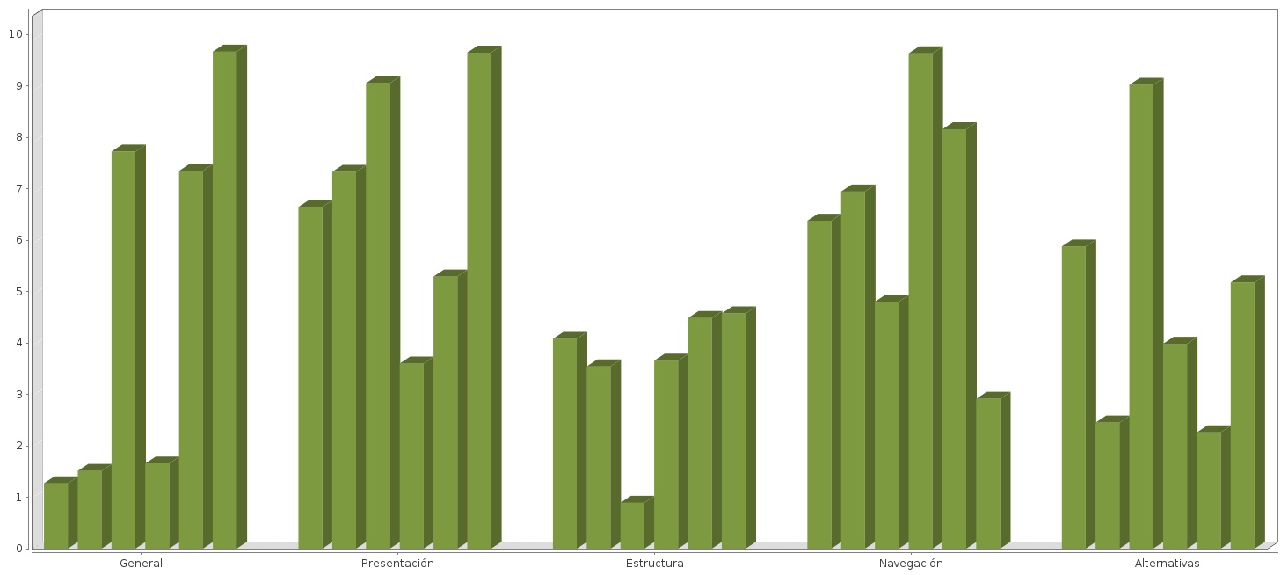

 | -1025.t1.a2- | -1025.t1.a3- | -1025.t1.a4- | -1025.t1.a5- | -1025.t1.a6- | -1025.t1.a7-
General | -1025.t1.b2- | -1025.t1.b3- | -1025.t1.b4- | -1025.t1.b5- | -1025.t1.b6- | -1025.t1.b7-
Presentation | -1026.t1.b2- | -1026.t1.b3- | -1026.t1.b4- | -1026.t1.b5- | -1026.t1.b6- | -1026.t1.b7-
Structure | -1027.t1.b2- | -1027.t1.b3- | -1027.t1.b4- | -1027.t1.b5- | -1027.t1.b6- | -1027.t1.b7-
Navigation | -1028.t1.b2- | -1028.t1.b3- | -1028.t1.b4- | -1028.t1.b5- | -1028.t1.b6- | -1028.t1.b7-
Alternatives | -1029.t1.b2- | -1029.t1.b3- | -1029.t1.b4- | -1029.t1.b5- | -1029.t1.b6- | -1029.t1.b7-

- FIXED TERMS
The Web Accessibility Observatory aims to serve as a tool for the effective delivery of the level of accessibility of public websites. It is therefore vital to analyse and compare the results obtained over time in the various observatories, so that their trend can be observed.
To this end, a large number of developments are provided, making it possible to know both on a global basis and more specifically the results obtained in the observatories carried out so far. These graphs show the evolution of both the overall rating of the observatory and the levels of adequacy, the score for each verification, or the score for the accessibility aspects.
In this way, the charts of developments allow for a quick observation of which accessibility issues are being improved, as well as those where an additional effort should be made in order to achieve appropriate results.
  - evolution of the estimated level of adequacy
The following graphs show how the portals were distributed at the three levels of conformity defined by the observatory: Priority 1 and Priority 2 (optimum), Priority 1 and Partial.
The ideal trend would be to observe in this evolution that the percentage of Priority 1 and Priority 2 is always on the increase, as well as with Priority 1, while the Parcial level should decrease towards the maximum possible of 0.
Evolution of conformity level

 | -ef.t1.1.a2- | -ef.t1.1.a3- | -ef.t1.1.a4- | -ef.t1.1.a5- | -ef.t1.1.a6- | -ef.t1.1.a7-
AA | -ef.t1.1.b2- | -ef.t1.1.b3- | -ef.t1.1.b4- | -ef.t1.1.b5- | -ef.t1.1.b6- | -ef.t1.1.b7-
A | -ef.t1.2.b2- | -ef.t1.2.b3- | -ef.t1.2.b4- | -ef.t1.2.b5- | -ef.t1.2.b6- | -ef.t1.2.b7-
Not valid | -ef.t1.3.b2- | -ef.t1.3.b3- | -ef.t1.3.b4- | -ef.t1.3.b5- | -ef.t1.3.b6- | -ef.t1.3.b7-

  - evolution of the estimated level of completeness
The following graphs show how the portals were distributed at the three levels of conformity defined by the observatory: Priority 1 and Priority 2 (optimum), Priority 1 and Partial.
The ideal trend would be to observe in this evolution that the percentage of Priority 1 and Priority 2 is always on the increase, as well as with Priority 1, while the Parcial level should decrease towards the maximum possible of 0.
Evolución del Nivel de Cumplimiento

 | -ef.t2.1.a2- | -ef.t2.1.a3- | -ef.t2.1.a4- | -ef.t2.1.a5- | -ef.t2.1.a6- | -ef.t2.1.a7-
Totalmente Conforme | -ef.t2.1.b2- | -ef.t2.1.b3- | -ef.t2.1.b4- | -ef.t2.1.b5- | -ef.t2.1.b6- | -ef.t2.1.b7-
Parcialmente Conforme | -ef.t2.2.b2- | -ef.t2.2.b3- | -ef.t2.2.b4- | -ef.t2.2.b5- | -ef.t2.2.b6- | -ef.t2.2.b7-
No conforme | -ef.t2.3.b2- | -ef.t2.3.b3- | -ef.t2.3.b4- | -ef.t2.3.b5- | -ef.t2.3.b6- | -ef.t2.3.b7-

  - evolution of the Centre’s Average Score
The following graph shows the score reached by the various observatories carried out so far. This is often a small variation, but it makes it possible to see whether the accessibility of the State’s central government websites tends to improve or deteriorate in time.
Evolución de la Puntuación Media del Observatorio

Date | Average score
-ef.t3.a2- | -ef.t3.b2-
-ef.t3.a3- | -ef.t3.b3-
-ef.t3.a4- | -ef.t3.b4-
-ef.t3.a5- | -ef.t3.b5-
-ef.t3.a6- | -ef.t3.b6-

  - Evolution of Media Score
In the following sections, the variation suffered by Media Scoring of the observatory’s 20 verifications.
By means of these graphs, a conclusion can be reached rapidly on which accessibility requirements are being improved, as well as those where the problems identified have been increasing, and so that efforts can be targeted more easily.
    - Nivel de Accesibilidad I
Evolución de la Puntuación Media por Verificación Nivel de Accesibilidad I

 | 1ª Barra | 2ª Barra | 3ª Barra | 4ª Barra | 5ª Barra | 6ª Barra
Fecha observatorio | -ef.t4.1.a2- | -ef.t4.1.a3- | -ef.t4.1.a4- | -ef.t4.1.a5- | -ef.t4.1.a6- | -ef.t4.1.a7-

Evolución de la Puntuación Media por Verificación Nivel de Accesibilidad I
 | 1ª Barra | 2ª Barra | 3ª Barra | 4ª Barra | 5ª Barra | 6ª Barra
Fecha observatorio | -ef.t4.1.a2- | -ef.t4.1.a3- | -ef.t4.1.a4- | -ef.t4.1.a5- | -ef.t4.1.a6- | -ef.t4.1.a7-

Evolución de la Puntuación Media por Verificación Nivel de Accesibilidad I
 | -ef.t4.1.a2- | -ef.t4.1.a3- | -ef.t4.1.a4- | -ef.t4.1.a5- | -ef.t4.1.a6- | -ef.t4.1.a7-
1.1 Existencia de alternativas textuales | -ef.t4.1.b2- | -ef.t4.1.b3- | -ef.t4.1.b4- | -ef.t4.1.b5- | -ef.t4.1.b6- | -ef.t4.1.b7-
1.2 Uso de encabezados | -ef.t4.2.b2- | -ef.t4.2.b3- | -ef.t4.2.b4- | -ef.t4.2.b5- | -ef.t4.2.b6- | -ef.t4.2.b7-
1.3 Uso de listas | -ef.t4.3.b2- | -ef.t4.3.b3- | -ef.t4.3.b4- | -ef.t4.3.b5- | -ef.t4.3.b6- | -ef.t4.3.b7-
1.4 Tablas de datos | -ef.t4.4.b2- | -ef.t4.4.b3- | -ef.t4.4.b4- | -ef.t4.4.b5- | -ef.t4.4.b6- | -ef.t4.4.b7-
1.5 Agrupación estructural | -ef.t4.5.b2- | -ef.t4.5.b3- | -ef.t4.5.b4- | -ef.t4.5.b5- | -ef.t4.5.b6- | -ef.t4.5.b7-
1.1.6 Separación de contenido y presentación | -ef.t4.6.b2- | -ef.t4.6.b3- | -ef.t4.6.b4- | -ef.t4.6.b5- | -ef.t4.6.b6- | -ef.t4.6.b7-
1.7 Identificación del idioma principal | -ef.t4.7.b2- | -ef.t4.7.b3- | -ef.t4.7.b4- | -ef.t4.7.b5- | -ef.t4.7.b6- | -ef.t4.7.b7-
1.8 Navefación con Javascript accesible y Control de usuario | -ef.t4.8.b2- | -ef.t4.8.b3- | -ef.t4.8.b4- | -ef.t4.8.b5- | -ef.t4.8.b6- | -ef.t4.8.b7-
1.9 Formularios y etiquetas | -ef.t4.9.b2- | -ef.t4.9.b3- | -ef.t4.9.b4- | -ef.t4.9.b5- | -ef.t4.9.b6- | -ef.t4.9.b7-
1.10 Formularios y estructura | -ef.t4.10.b2- | -ef.t4.10.b3- | -ef.t4.10.b4- | -ef.t4.10.b5- | -ef.t4.10.b6- | -ef.t4.10.b7-
1.11 Título de página y de marcos | -ef.t4.11.b2- | -ef.t4.11.b3- | -ef.t4.11.b4- | -ef.t4.11.b5- | -ef.t4.11.b6- | -ef.t4.11.b7-
1.12 Enlaces descriptivos | -ef.t4.12.b2- | -ef.t4.12.b3- | -ef.t4.12.b4- | -ef.t4.12.b5- | -ef.t4.12.b6- | -ef.t4.12.b7-
1.13 Cambios de contexto | -ef.t4.13.b2- | -ef.t4.13.b3- | -ef.t4.13.b4- | -ef.t4.13.b5- | -ef.t4.13.b6- | -ef.t4.13.b7-
1.14 Compatibilidad | -ef.t4.14.b2- | -ef.t4.14.b3- | -ef.t4.14.b4- | -ef.t4.14.b5- | -ef.t4.14.b6- | -ef.t4.14.b7-

    - Nivel de Accesibilidad II
Evolución de la Puntuación Media por Verificación Nivel de Accesibilidad II
 | 1ª Barra | 2ª Barra | 3ª Barra | 4ª Barra | 5ª Barra | 6ª Barra
Fecha observatorio | -ef.t4.21.a2- | -ef.t4.21.a3- | -ef.t4.21.a4- | -ef.t4.21.a5- | -ef.t4.21.a6- | -ef.t4.21.a7-

Evolución de la Puntuación Media por Verificación Nivel de Accesibilidad II
 | -ef.t4.21.a2- | -ef.t4.21.a3- | -ef.t4.21.a4- | -ef.t4.21.a5- | -ef.t4.21.a6- | -ef.t4.21.a7-
2.1 Identificación de los cambios de idioma | -ef.t4.21.b2- | -ef.t4.21.b3- | -ef.t4.21.b4- | -ef.t4.21.b5- | -ef.t4.21.b6- | -ef.t4.21.b7-
2.2 Contraste suficiente | -ef.t4.22.b2- | -ef.t4.22.b3- | -ef.t4.22.b4- | -ef.t4.22.b5- | -ef.t4.22.b6- | -ef.t4.22.b7-
2.3 Sección de accesibilidad | -ef.t4.23.b2- | -ef.t4.23.b3- | -ef.t4.23.b4- | -ef.t4.23.b5- | -ef.t4.23.b6- | -ef.t4.23.b7-
2.4 Múltiples vías de navefación | -ef.t4.24.b2- | -ef.t4.24.b3- | -ef.t4.24.b4- | -ef.t4.24.b5- | -ef.t4.24.b6- | -ef.t4.24.b7-
2.5 Foco del teclado | -ef.t4.25.b2- | -ef.t4.25.b3- | -ef.t4.25.b4- | -ef.t4.25.b5- | -ef.t4.25.b6- | -ef.t4.25.b7-
2.6 Navefación consistente | -ef.t4.26.b2- | -ef.t4.26.b3- | -ef.t4.26.b4- | -ef.t4.26.b5- | -ef.t4.26.b6- | -ef.t4.26.b7-

  - Evolución de la conformidad por Verificacion
En los apartados siguientes se presenta la variación sufrida por la Puntuación Media de las veinte verificaciones del observatorio.
Mediante estas gráficas se puede obtener de forma rápida una conclusión sobre en qué requisitos de accesibilidad se está mejorando, así como aquellos en los que los problemas detectados han ido en aumento, y de esa forma poder focalizar los esfuerzos más fácilmente.
    - Nivel de Accesibilidad I
Evolución de la Conformidad por Verificación Nivel de Accesibilidad I

 | 1ª Barra | 2ª Barra | 3ª Barra | 4ª Barra | 5ª Barra | 6ª Barra
Fecha observatorio | -ef.t5.1.a2- | -ef.t5.1.a3- | -ef.t5.1.a4- | -ef.t5.1.a5- | -ef.t5.1.a6- | -ef.t5.1.a7-

Evolución de la Conformidad por Verificación Nivel de Accesibilidad I
 | 1ª Barra | 2ª Barra | 3ª Barra | 4ª Barra | 5ª Barra | 6ª Barra
Fecha observatorio | -ef.t5.1.a2- | -ef.t5.1.a3- | -ef.t5.1.a4- | -ef.t5.1.a5- | -ef.t5.1.a6- | -ef.t5.1.a7-

Evolución de la Conformidad Verificación Nivel de Accesibilidad I
 | -ef.t5.1.a2- | -ef.t5.1.a3- | -ef.t5.1.a4- | -ef.t5.1.a5- | -ef.t5.1.a6- | -ef.t5.1.a7-
1.1 Existencia de alternativas textuales | -ef.t5.1.b2- | -ef.t5.1.b3- | -ef.t5.1.b4- | -ef.t5.1.b5- | -ef.t5.1.b6- | -ef.t5.1.b7-
1.2 Uso de encabezados | -ef.t5.2.b2- | -ef.t5.2.b3- | -ef.t5.2.b4- | -ef.t5.2.b5- | -ef.t5.2.b6- | -ef.t5.2.b7-
1.3 Uso de listas | -ef.t5.3.b2- | -ef.t5.3.b3- | -ef.t5.3.b4- | -ef.t5.3.b5- | -ef.t5.3.b6- | -ef.t5.3.b7-
1.4 Tablas de datos | -ef.t5.4.b2- | -ef.t5.4.b3- | -ef.t5.4.b4- | -ef.t5.4.b5- | -ef.t5.4.b6- | -ef.t5.4.b7-
1.5 Agrupación estructural | -ef.t5.5.b2- | -ef.t5.5.b3- | -ef.t5.5.b4- | -ef.t5.5.b5- | -ef.t5.5.b6- | -ef.t5.5.b7-
1.1.6 Separación de contenido y presentación | -ef.t5.6.b2- | -ef.t5.6.b3- | -ef.t5.6.b4- | -ef.t5.6.b5- | -ef.t5.6.b6- | -ef.t5.6.b7-
1.7 Identificación del idioma principal | -ef.t5.7.b2- | -ef.t5.7.b3- | -ef.t5.7.b4- | -ef.t5.7.b5- | -ef.t5.7.b6- | -ef.t5.7.b7-
1.8 Navefación con Javascript accesible y Control de usuario | -ef.t5.8.b2- | -ef.t5.8.b3- | -ef.t5.8.b4- | -ef.t5.8.b5- | -ef.t5.8.b6- | -ef.t5.8.b7-
1.9 Formularios y etiquetas | -ef.t5.9.b2- | -ef.t5.9.b3- | -ef.t5.9.b4- | -ef.t5.9.b5- | -ef.t5.9.b6- | -ef.t5.9.b7-
1.10 Formularios y estructura | -ef.t5.10.b2- | -ef.t5.10.b3- | -ef.t5.10.b4- | -ef.t5.10.b5- | -ef.t5.10.b6- | -ef.t5.10.b7-
1.11 Título de página y de marcos | -ef.t5.11.b2- | -ef.t5.11.b3- | -ef.t5.11.b4- | -ef.t5.11.b5- | -ef.t5.11.b6- | -ef.t5.11.b7-
1.12 Enlaces descriptivos | -ef.t5.12.b2- | -ef.t5.12.b3- | -ef.t5.12.b4- | -ef.t5.12.b5- | -ef.t5.12.b6- | -ef.t5.12.b7-
1.13 Cambios de contexto | -ef.t5.13.b2- | -ef.t5.13.b3- | -ef.t5.13.b4- | -ef.t5.13.b5- | -ef.t5.13.b6- | -ef.t5.13.b7-
1.14 Compatibilidad | -ef.t5.14.b2- | -ef.t5.14.b3- | -ef.t5.14.b4- | -ef.t5.14.b5- | -ef.t5.14.b6- | -ef.t5.14.b7-

    - Nivel de Accesibilidad II
Evolución de la Conformidad por Verificación Nivel de Accesibilidad II
 | 1ª Barra | 2ª Barra | 3ª Barra | 4ª Barra | 5ª Barra | 6ª Barra
Fecha observatorio | -ef.t5.21.a2- | -ef.t5.21.a3- | -ef.t5.21.a4- | -ef.t5.21.a5- | -ef.t5.21.a6- | -ef.t5.21.a7-

Evolución de la Conformidad por Verificación Nivel de Accesibilidad II
 | -ef.t5.21.a2- | -ef.t5.21.a3- | -ef.t5.21.a4- | -ef.t5.21.a5- | -ef.t5.21.a6- | -ef.t5.21.a7-
2.1 Identificación de los cambios de idioma | -ef.t5.21.b2- | -ef.t5.21.b3- | -ef.t5.21.b4- | -ef.t5.21.b5- | -ef.t5.21.b6- | -ef.t5.21.b7-
2.2 Contraste suficiente | -ef.t5.22.b2- | -ef.t5.22.b3- | -ef.t5.22.b4- | -ef.t5.22.b5- | -ef.t5.22.b6- | -ef.t5.22.b7-
2.3 Sección de accesibilidad | -ef.t5.23.b2- | -ef.t5.23.b3- | -ef.t5.23.b4- | -ef.t5.23.b5- | -ef.t5.23.b6- | -ef.t5.23.b7-
2.4 Múltiples vías de navefación | -ef.t5.24.b2- | -ef.t5.24.b3- | -ef.t5.24.b4- | -ef.t5.24.b5- | -ef.t5.24.b6- | -ef.t5.24.b7-
2.5 Foco del teclado | -ef.t5.25.b2- | -ef.t5.25.b3- | -ef.t5.25.b4- | -ef.t5.25.b5- | -ef.t5.25.b6- | -ef.t5.25.b7-
2.6 Navefación consistente | -ef.t5.26.b2- | -ef.t5.26.b3- | -ef.t5.26.b4- | -ef.t5.26.b5- | -ef.t5.26.b6- | -ef.t5.26.b7-

  - Evolución de la Puntuación Media por Aspecto
Por último, se presentan los resultados de Puntuación Media obtenidos por los distintos aspectos de accesibilidad en que se han clasificado las veinte verificaciones del observatorio.
De esta forma se obtiene también información sobre en qué áreas se está trabajando más: aquellas directamente relacionadas con la accesibilidad (Alternativas por ejemplo), cuestiones de estándares (aspecto Presentación por ejemplo), o las relacionadas también con cuestiones de usabilidad de la web como las del aspecto Navefación.
Evolución de la Puntuación Media por Aspecto

 | -1025.t1.a2- | -1025.t1.a3- | -1025.t1.a4- | -1025.t1.a5- | -1025.t1.a6- | -1025.t1.a7-
General | -1025.t1.b2- | -1025.t1.b3- | -1025.t1.b4- | -1025.t1.b5- | -1025.t1.b6- | -1025.t1.b7-
Presentación | -1026.t1.b2- | -1026.t1.b3- | -1026.t1.b4- | -1026.t1.b5- | -1026.t1.b6- | -1026.t1.b7-
Estructura | -1027.t1.b2- | -1027.t1.b3- | -1027.t1.b4- | -1027.t1.b5- | -1027.t1.b6- | -1027.t1.b7-
Navefación | -1028.t1.b2- | -1028.t1.b3- | -1028.t1.b4- | -1028.t1.b5- | -1028.t1.b6- | -1028.t1.b7-
Alternativas | -1029.t1.b2- | -1029.t1.b3- | -1029.t1.b4- | -1029.t1.b5- | -1029.t1.b6- | -1029.t1.b7-

- Evolución por segmentos
A continuación se muestra información de evolución agrupada para cada segmento analizado en este observatorio
evolutionsegmentsection
- Conclusiones del estudio
  - Resultados globales
-111.text-
  - Resultados por segmentos
A continuación se muestran las conclusiones obtenidas del análisis de los resultados por segmentos.
    - Segmento Principales
-1121.text-
    - Segmento Organismos
-1122.text-
    - Segmento Temáticos
-1123.text-
    - Segmento Otros
-1124.text-
    - Segmento Sedes
-1125.text-
  - Evolución de resultados

ANEXO I: Metodología del Observatorio
Se puede consultar la metodología del observatorio en http://administracionelectronica.gob.es/PAe/accesibilidad/metodologiaUNE-EN2019v2

http://administracionelectronica.gob.es/PAe/accesibilidad/une-en-301549-2019.pdf
https://www.etsi.org/deliver/etsi_en/301500_301599/301549/02.01.02_60/en_301549v020102p.pdf
https://eur-lex.europa.eu/legal-content/ES/TXT/?uri=uriserv:OJ.L_.2018.327.01.0084.01.SPA&toc=OJ:L:2018:327:TOC

