Alaine M. Sabigan

Screen Number 1

Home Page (index)

Alaine M. Sabigan

Screen Number 2

About

Alaine M. Sabigan

Screen Number 3

Courses

Alaine M. Sabigan

Screen Number 4

Gallery

Alaine M. Sabigan

Screen Number 5

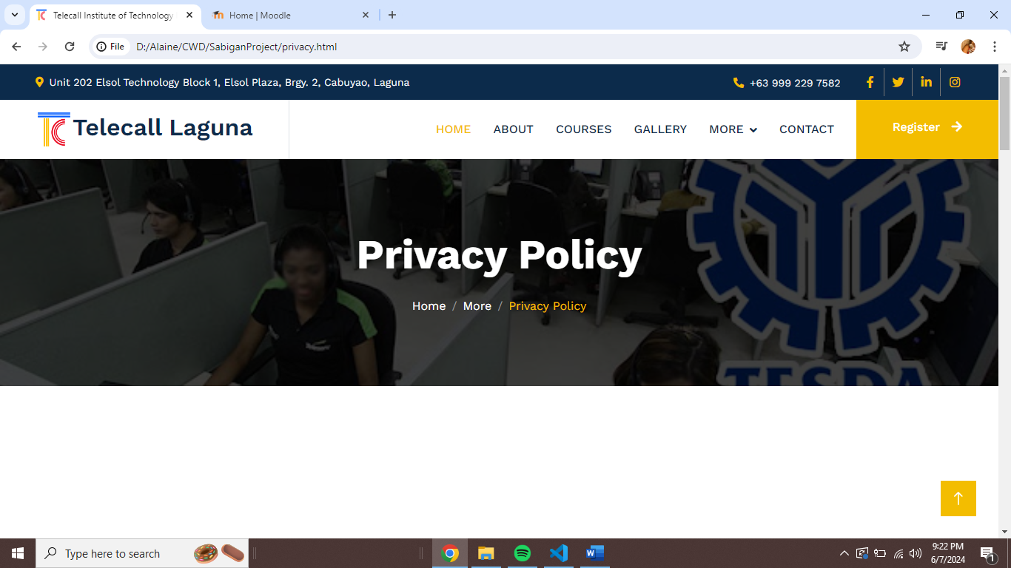More/Privacy Policy

Alaine M. Sabigan

Screen Number 6

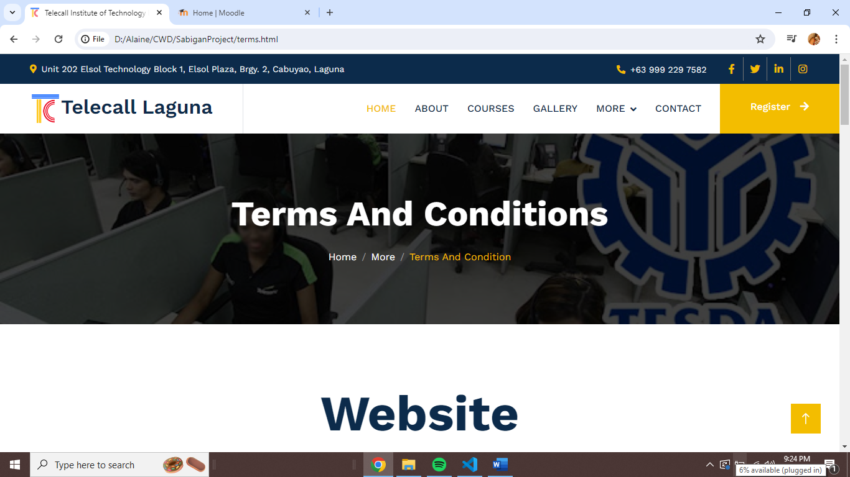More/ Terms and Condition

Alaine M. Sabigan

Screen Number 7

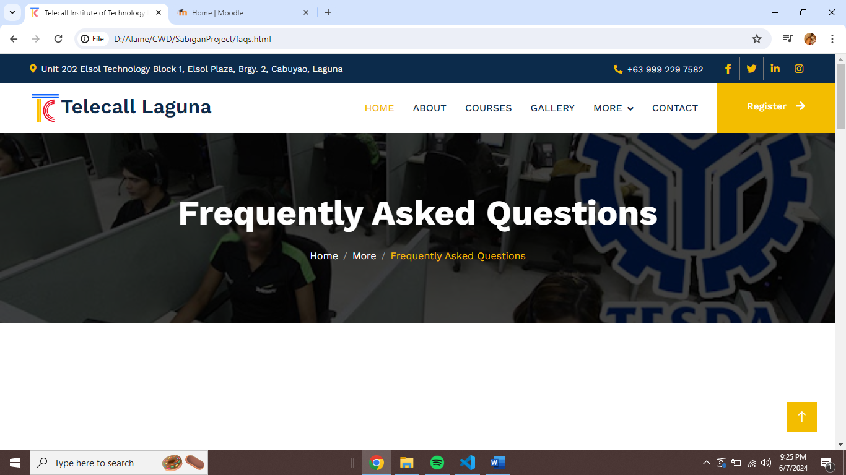More/ FAQs and Help

Alaine M. Sabigan

Screen Number 8

Contact

Alaine M. Sabigan

Screen Number 9

Register

