Normals
On the heels of a new annual heat record set in 2022 — the latest in a string of record-setting years — average ocean surface temperatures around the globe have spiked since early March. Excluding polar regions, they are about two-tenths of a degree Celsius warmer than scientists have ever observed at this time of year via satellite data.
The Washington Post, April 28, 2023

Problem to Solve
How do we know whether ocean temperatures are lower or higher than “normal”? What’s a “normal” temperature? Turns out that scientists have developed a metric called a “Climate Normal.” A Climate Normal characterizes aspects of earth’s climate—its long-term weather—over a span of 30 years. One important metric is ocean temperature.
In a database called normals.db, using a table called normals, explore some of the most recent Climate Normal data to understand what makes a normal ocean temperature around the world.

Schema
The data in normals.db can be visualized as shown:
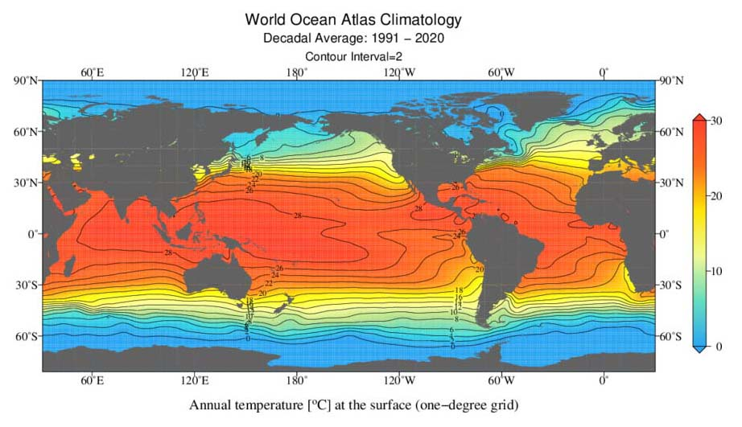

Notice that the earth is divided into a grid of coordinates—points that can identify most any location on earth. Each coordinate is a combination of latitude and longitude. And notice how each coordinate over an ocean has some normal ocean surface temperature associated with it!
In normals.db you’ll find a single table of coordinates, normals. In the normals table, you’ll find the following columns:
- id, which uniquely identifies each row (coordinate) in the table
- latitude, which is the degree of latitude (expressed in decimal format) for the coordinate
- longitude, which is the degree of longitude (expressed in decimal format) for the coordinate
- 0m, which is the normal ocean surface temperature (i.e., the normal temperature at 0 meters of depth), in degrees Celsius, at the coordinate
- 5m, which is the normal ocean temperature at 5 meters of depth, in degrees Celsius, at the coordinate
- 10m, which is the normal ocean temperature at 10 meters of depth, in degrees Celsius, at the coordinate
And observations continue until 5500m, or 5500 meters of depth, for some coordinates!

Specification
For each of the following questions, you should write a single SQL query that outputs the results specified by each problem. Your response must take the form of a single SQL query. You should not assume anything about the ids of any particular observations: your queries should be accurate even if the id of any particular observation were different. Finally, each query should return only the data necessary to answer the question.
- In 1.sql, write a SQL query to find the normal ocean surface temperature in the Gulf of Maine, off the coast of Massachusetts. To find this temperature, look at the data associated with 42.5° of latitude and -69.5° of longitude.
  - Recall that you can find the normal ocean surface temperature in the 0m column, which stands for 0 meters of depth!
- In 2.sql, write a SQL query to find the normal temperature of the deepest sensor near the Gulf of Maine, at the same coordinate above.
  - The deepest sensor records temperatures at 225 meters of depth, so you can find this data in the 225m column.
- In 3.sql, choose a location of your own and write a SQL query to find the normal temperature at 0 meters, 100 meters, and 200 meters. You might find Google Earth helpful if you’d like to find some coordinates to use!
- In 4.sql, write a SQL query to find the lowest normal ocean surface temperature.
- In 5.sql, write a SQL query to find the highest normal ocean surface temperature.
- In 6.sql, write a SQL query to return all normal ocean temperatures at 50m of depth, as well as their respective degrees of latitude and longitude, within the Arabian Sea. Include latitude, longitude, and temperature columns. For simplicity, assume the Arabian Sea is encased in the following four coordinates:
  - 20° of latitude, 55° of longitude
  - 20° of latitude, 75° of longitude
  - 0° of latitude, 55° degrees of longitude
  - 0° of latitude, 75° degrees of longitude
- In 7.sql, write a SQL query to find the average ocean surface temperature, rounded to two decimal places, along the equator. Call the resulting column “Average Equator Ocean Surface Temperature”.
  - The equator’s ocean surface temperatures can be found at all longitudes between the latitudes -0.5° and 0.5°, inclusive.
- In 8.sql, write a SQL query to find the 10 locations with the lowest normal ocean surface temperature, sorted coldest to warmest. If two locations have the same normal ocean surface temperature, sort by latitude, smallest to largest. Include latitude, longitude, and surface temperature columns.
- In 9.sql, write a SQL query to find the 10 locations with the highest normal ocean surface temperature, sorted warmest to coldest. If two locations have the same normal ocean surface temperature, sort by latitude, smallest to largest. Include latitude, longitude, and surface temperature columns.
- There are 180 whole degrees of latitude. In 10.sql, write a SQL query to determine how many points of latitude we have at least one data point for. (Why might we not have data points for all latitudes?)

