**Election Campaign**

**I have assumed that I have been hired by Mitch McConnell for the upcoming Presidential elections, to help him identify opportunities for support using the election data I found that there are 96 candidates from 22 different parties, who would be contesting in the elections with him.**

Query:

*create table new_table as*

*SELECT Distinct(c1.CAND_ID),c1.CAND_NAME,c1.CAND_ELECTION_YR, c1.CAND_PTY_AFFILIATION FROM candidate c1 where CAND_ELECTION_YR = 2020;*

Explanation: The above mentioned query creates a table having information of the candidates who would be fighting upcoming 2020 elections. Information consists of Candidate Name,Candidate ID, Candidate affiliated parties.

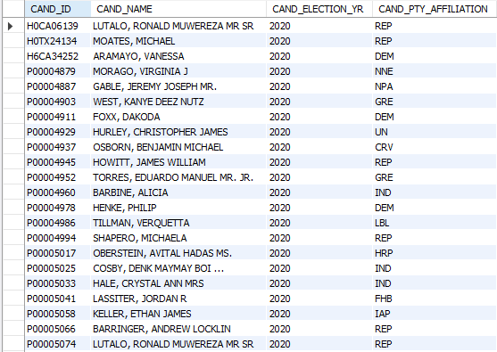

Query:

*SELECT count(Distinct(CAND_PTY_AFFILIATION)) as Number_of_states FROM candidate where CAND_ELECTION_YR = 2020*;

Explanation:The above mentioned query gives the number of states from which candidates would be contesting for 2020 elections



**To get information specifically about 'MCCONNELL, MITCH' following query was used :**

*SELECT * FROM CANDIDATE WHERE CAND_NAME= 'MCCONNELL, MITCH'*



**Using this query we found that candidate ID for 'MCCONNELL, MITCH' was 'S2KY00012'**

**He is associated with 14 political committees and belongs to the Republican party.**

**Query:**

*select COUNT(*) from committee2candidate where CAND_ID='S2KY00012'*



**The committees are:**

**Query**

*Select * from committee2candidate where CAND_ID='S2KY00012'*

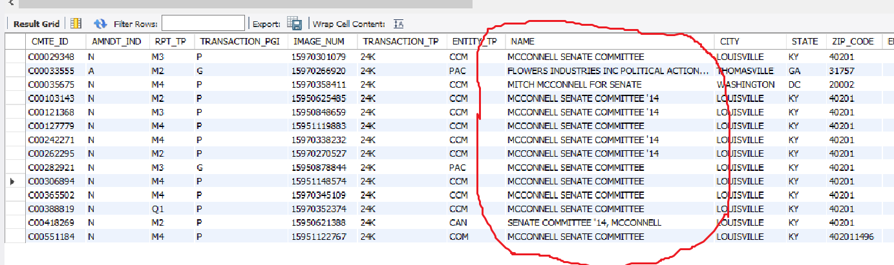

**These committees have currently contributed $24,100 towards his candidature (From states of Kentucky, Georgia and Washington DC )**

**Query:**

*Select sum(TRANSACTION_AMT) from committee2candidate where CAND_ID='S2KY00012'*



**From transactions it was observed that :**

1. **Major contribution of 26600 is from state of Kentucky ( Louisville ). This makes sense, as he is contesting from this state.**

**Query:**

*Select SUM(TRANSACTION_AMT) from committee2candidate where CAND_ID='S2KY00012' and STATE = 'KY'*

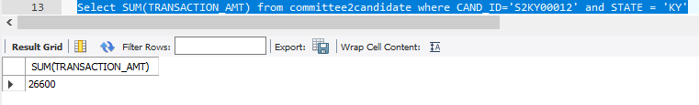

1. Washington DC contributed **$2500** to the committees.

**Query:**

*Select SUM(TRANSACTION_AMT) from committee2candidate where CAND_ID='S2KY00012' and STATE = 'DC’*

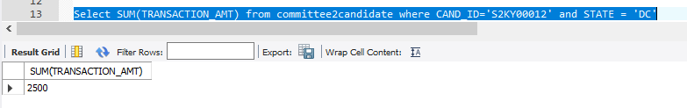

1. The transaction balance for Georgia (Thomasville) was, however ‘ **- $5000 ‘.**

**Query:**

*Select SUM(TRANSACTION_AMT) from committee2candidate where CAND_ID='S2KY00012' and STATE = 'GA’*

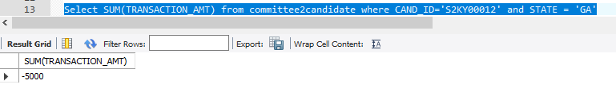

**“This indicates that MITCH MCCONNELL must invest significant resources to the state of Georgia to increase his overall committee contributions**.”

**The 14 committees also received $29,158 from the people of Maryland.**

**Query:**

*select SUM(c2.TRANSACTION_AMT) from committee2candidate c1 INNER JOIN marylandcontributions c2 on c1.CMTE_ID=c2.CMTE_ID where CAND_ID='S2KY00012'*

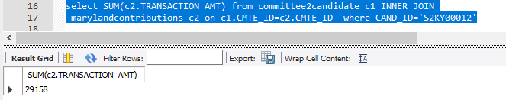

**Which were :**

**Query:**

*select c1.CMTE_ID,c1.NAME,c2.TRANSACTION_AMT from committee2candidate c1 INNER JOIN*

*marylandcontributions c2 on c1.CMTE_ID=c2.CMTE_ID where CAND_ID='S2KY00012'*

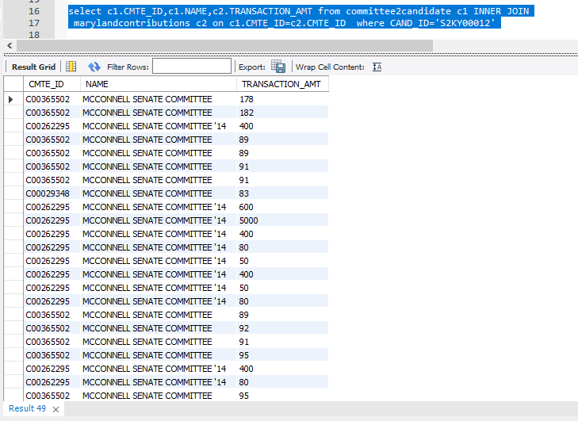

**So total contributions from 14 committees is $ 53,258 (26600+29158)**

**The data also indicates that the maximum contribution of $25,0012 was for Ted Cruze via single committee “Cruze for President” during the 2016 Presidential elections. This contribution comes from the state of Texas.**

**Query:**

*Select CMTE* *select CMTE_ID,NAME,TRANSACTION_AMT,STATE from committee2candidate order by TRANSACTION_AMT Desc;*

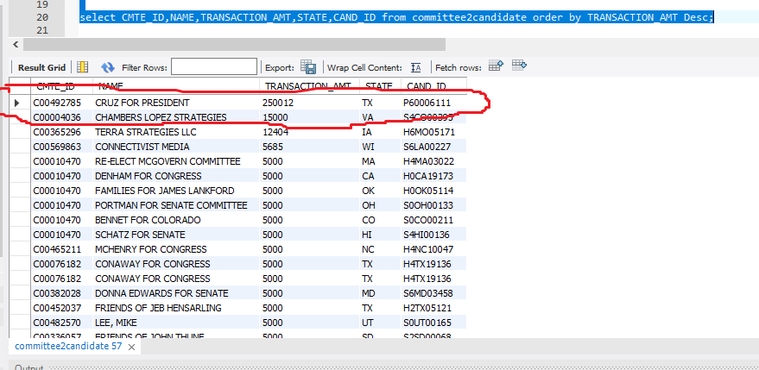

**Explanation: The above mentioned query gives the list of committee ID’s ,transaction amounts they received, from which state they received and for which candidate id tey received that amount.**

**To verify that the amount was for” TED Cruze “ we verified using candidate ID “P60006111” which we got from the above query**

**Query:**

*SELECT * FROM CANDIDATE WHERE CAND_ID=' P60006111’;*

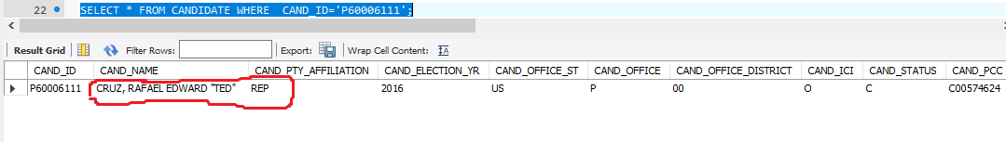

Next, we look at the state-wise contribution to political committees supporting the Republican candidates prior to 2020 elections.

**Query:**

*create table abhi1 as*

*SELECT c1.CAND_NAME,c1.CAND_PTY_AFFILIATION,c1.CAND_ELECTION_YR,c2.NAME,c2.CMTE_ID,c2.STATE,*

*c2.TRANSACTION_AMT FROM CANDIDATE c1 inner join committee2candidate c2 on c1.CAND_ID=c2.CAND_ID WHERE*

*c1.CAND_ELECTION_YR < 2020 AND c1.CAND_PTY_AFFILIATION='REP' ORDER BY c2.STATE;*

**Explanation: The above mentioned query provides data of candidates who contested for elections prior to 2020 along with the transaction amounts each of their committee received from various states.**

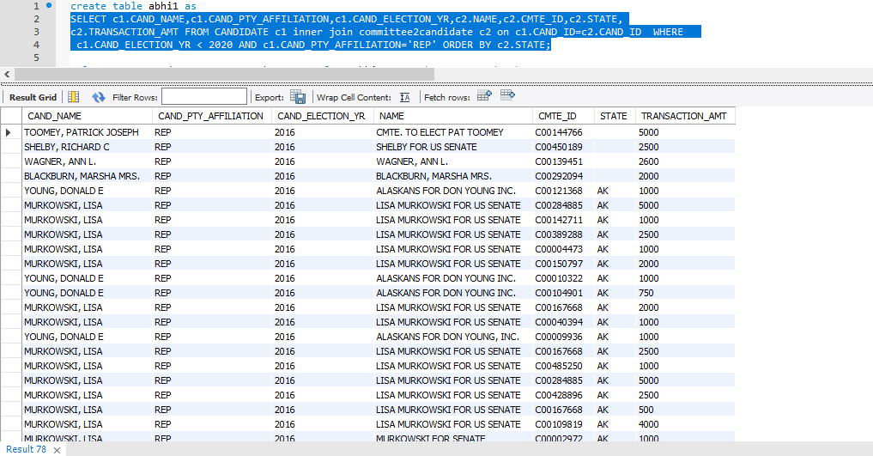

**Using the above created table we extract the total contributions received from each state towards the Republican party in all of the past elections present in the data.**

**Query:**

*select state,sum(TRANSACTION_AMT) as SUM1 from abhi1 group by state order by SUM1 DESC*

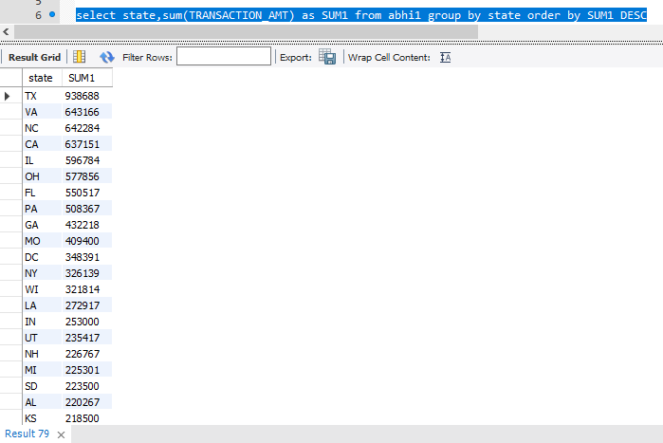

As we can see, the top 10 states that have contributed towards the Republican party are Texas, Virginia, North Carolina, California, Illinois, Ohio, Florida, Pennsylvania, Georgia and Missouri. Mitch McConnell must focus his efforts in these states to gain financial support for his campaign. Also, since Texas is the top contributor, he **MUST NOT** ignore this state. Ted Cruze being the top receiver of contributions in Texas, Mitch must pursue him for financial gains in Texas (This should not be difficult since Ted is not participating in the 2020 elections and hence, no conflict of interest).

**CONCLUSION:**

**Mitch McConnell is competing for the 2020 Presidential elections from the Republican party. He will be competing against 95 other candidates from various parties. He is associated with 14 major political committees, which have collectively contributed $53,258. The only state with a net outflow of $5000 is Georgia. It makes good sense to focus his resources in this state.**

**Previous election data has shown that Texas has been a top contributor to the Republican party, suggesting a strong electoral presence. Also, Ted Cruze being a top receiver(2016 electios) in this state implies building stronger relations with him to seal the votes and contributions from Texas.**

**The analysis also contains a list of states with their contributions to the Republican party. McConnell must use all his resources majorly in the top 10 states for contributions and votes.**

**ISSUES WITH THE DATA**

The biggest discrepancy in the data is the presence of candidates who supposedly compete in 2021. However, elections in America occur during the even years, and Presidential elections occur once in 4 years. Also, there are few empty datasets in the data which had to be taken in care of.

There is no metadata for the dataset given, which if given could help in enhancing the analysis to a greater extent.