|  |
| --- |
| Computational Biology -  Improved Estimators for Entropy and other Properties: A python implementation  Mohit Choudhary1, Rushil Sharma1, Sachin A1 , Shireen Nagdive 1  1Department of Computer Science, Stony Brook University  Abstract  **Motivation:** The original paper shows using MATLAB that a class of statistical properties of distributions, which includes such practically relevant properties as entropy, the number of distinct elements, and distance metrics between pairs of distributions, can be estimated given a sublinear sized sample. Specifically, given a sample consisting of independent draws from any distribution over at most k distinct elements, these properties can be estimated accurately using a sample of size O(k/ log k). We implement this in Python.  **Results:** The quick brown fox jumps over the lazy dog. The quick brown fox jumps over the lazy dog. The quick brown fox jumps over the lazy dog. The quick brown fox jumps over the lazy dog. The quick brown fox jumps over the lazy dog. The quick brown fox jumps over the lazy dog.   1. A project report (~5 pages in the above format).  This should follow the format of a normal research paper, with an introduction describing the motivation of the project and most relevant prior work, a methods section describing the work that your group has done and what you have achieved, a results section demonstrating the application of your method / tool and giving some results, and a conclusion discussing what remains to be done or what might be interesting future work.   **Availability:** Our code can be found at: http://www.github.com/  **Contact:** rushil.sharma@stonybrook.edu |

# Introduction

Many real–world machine learning and data analysis tasks face the challenge of accurately estimating various properties of the distribution based on a random sample. Many applications like text data (typically, no matter how large the corpus, where 30% of the observed vocabulary only occurs once), customer data (many customers or website users are only seen a small number of times), and the study of genetic mutations across a population incur the challenge of inferring properties of a distribution when a “too small” sample is encountered.

[1] have introduced a general and robust approach for using a sample to characterize the “unseen” portion of the distribution.

The quick brown fox jumps over the lazy dog. The quick brown fox jumps over the lazy dog. The quick brown fox jumps over the lazy dog. The quick brown fox jumps over the lazy dog. The quick brown fox jumps over the lazy dog. The quick brown fox jumps over the lazy dog. The quick brown fox jumps over the lazy dog. The quick brown fox jumps over the lazy dog. The quick brown fox jumps over the lazy dog. The quick brown fox jumps over the lazy dog. The quick brown fox jumps over the lazy dog. The quick brown fox jumps over the lazy dog. The quick brown fox jumps over the lazy dog. The quick brown fox jumps over the lazy dog. The quick brown fox jumps over the lazy dog. The quick brown fox jumps over the lazy dog. The quick brown fox jumps over the lazy dog. The quick brown fox jumps over the lazy dog. The quick brown fox jumps over the lazy dog. The quick brown fox jumps over the lazy dog. The quick brown fox jumps over the lazy dog. The quick brown fox jumps over the lazy dog. The quick brown fox jumps over the lazy dog. The quick brown fox jumps over the lazy dog. The quick brown fox jumps over the lazy dog. The quick brown fox jumpjumps over the lazy dog. The quick brown fox jumps over the lazy dog. The quick brown fox jumps over the lazy dog. The quick brown fox jumps over the lazy dog. The quick brown fox jumps over the lazy dog. The quick brown fox jumps over the lazy dog. The quick brown fox jumps over the lazy dog. The quick brown fox jumps over the lazy dog. The quick brown fox jumps over the lazy dog. The quick brown fox jumps over the lazy dog. The quick brown fox jumps over the lazy dog. The quick brown fox jumps over the lazy dog. The quick brown fox jumps over the lazy dog. The quick brown fox jumps over the lazy dog. The quick brown fox jumps over the lazy dog.

# Methods

We pose this problem of finding the simplest plausible histogram as a pair of linear programs. The first linear program will return a histogram h′ that minimizes the distance between its expected fingerprint and the observed fingerprint, where we penalize the discrepancy between Fi and E [F h′ ] in proportion to √i the inverse of the standard deviation of Fi, which we estimate as 1/ 1 + Fi, since Poisson distributions have variance equal to their expectation. The constraint that h′ corresponds to a histogram simply means that the total probability mass is 1, and all probability values are nonnegative. The second linear program will then find the histogram h′′ of minimal support size, subject to the constraint that the distance between its expected fingerprint, and the observed fingerprint, is not much worse than that of the histogram found by the first linear program.

To make the linear programs finite, we consider a fine mesh of values x1,...,xl ∈(0,1]that between them discretely approximate the potential support of the histogram. The variables of the linear program, h′1, . . . , h′l will correspond to the histogram values at these mesh points, with variable h′i representing the number of domain elements that occur with probability xi, namely h′(xi).

A minor complicating issue is that this approach is designed for the challenging “rare events” regime, where there are many domain elements each seen only a handful of times. By contrast if there is a domain element that occurs very frequently, say with probability 1/2, then the number of times it occurs will be concentrated about its expectation of n/2 (and the trivial empirical estimate will be accurate), though fingerprint Fn/2 will not be concentrated about its expectation, as it will take an integer value of either 0, 1 or 2. Hence we will split the fingerprint into the “easy” and “hard” portions, and use the empirical estimator for the easy portion, and our linear programming approach for the hard portion. The full algorithm is below:

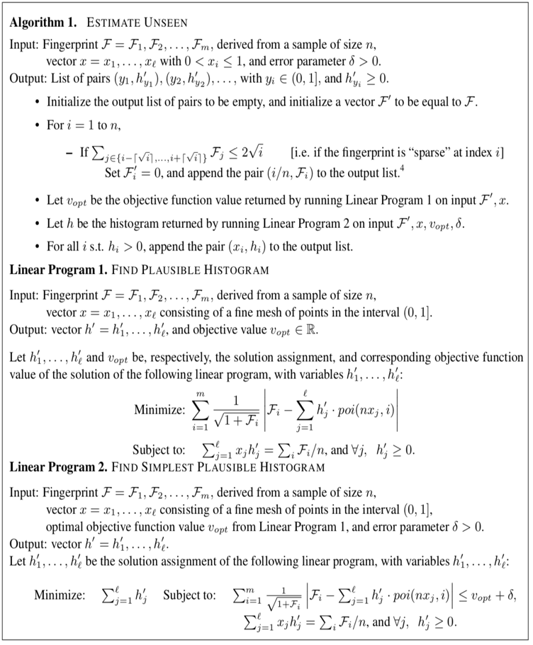

# Results

The quick brown fox jumps over the lazy dog. The quick brown fox jumps over the lazy dog. The quick brown fox jumps over the lazy dog. The quick brown fox jumps over the lazy dog. The quick brown fox jumps over the lazy dog. The quick brown fox jumps over the lazy dog. The quick brown fox jumps over the lazy dog. The quick brown fox jumps over the lazy dog. The quick brown fox jumps over the lazy dog. The quick brown fox jumps over the lazy dog. The quick brown fox jumps over the lazy dog. The quick brown fox jumps over the lazy dog. The quick brown fox jumps over the lazy dog. The quick brown fox jumps over the lazy dog. The quick brown fox jumps over the lazy dog. The quick brown fox jumps over the lazy dog. The quick brown fox jumps over the lazy dog. The quick brown fox jumps over the lazy dog. The quick brown fox jumps over the lazy dog. The quick brown fox jumps over the lazy dog. The quick brown fox jumps over the lazy dog. The quick brown fox jumps over the lazy dog. The quick brown fox jumps over the lazy dog. The quick brown fox jumps over the lazy dog. The quick brown fox jumps over the lazy dog.

## Data Structure This is Heading 2 style this is heading 2 style

The quick brown fox jumps over the lazy dog. The quick brown fox jumps over the lazy dog. The quick brown fox jumps over the lazy dog. The quick brown fox jumps over the lazy dog. The quick brown fox jumps over the lazy dog. The quick brown fox jumps over the lazy dog. The quick brown fox jumps over the lazy dog. The quick brown fox jumps over the lazy dog. The quick brown fox jumps over the lazy dog. The quick brown fox jumps over the lazy dog. The quick brown fox jumps over the lazy dog. The quick brown fox jumps over the lazy dog.

### 3.1.1 This is heading 3 style

The quick brown fox jumps over the lazy dog. The quick brown fox jumps over the lazy dog. The quick brown fox jumps over the lazy dog. The quick brown fox jumps over the lazy dog.

The quick brown fox jumps over the lazy dog. The quick brown fox jumps over the lazy dog.

The quick brown fox jumps over the lazy dog. The quick brown fox jumps over the lazy dog.

1. The quick brown fox jumps over the lazy dog.
2. The quick brown fox jumps over the lazy dog. The quick brown fox jumps over the lazy dog.
3. The quick brown fox jumps over the lazy dog. The quick brown fox jumps over the lazy dog.

The quick brown fox jumps over the lazy dog. The quick brown fox jumps over the lazy dog.

The quick brown fox jumps over the lazy dog. The quick brown fox jumps over the lazy dog. The quick brown fox jumps over the lazy dog. The quick brown fox jumps over the lazy dog. The quick brown fox jumps over the lazy dog. The quick brown fox jumps over the lazy dog. The quick brown fox jumps over the lazy dog. The quick brown fox jumps over the lazy dog. The quick brown fox jumps over the lazy dog. The quick brown fox jumps over the lazy dog. The quick brown fox jumps over the lazy dog. The quick brown fox jumps over the lazy dog. The quick brown fox jumps over the lazy dog. The quick brown fox jumps over the lazy dog. The quick brown fox jumps over the lazy dog. The quick brown fox jumps over the lazy dog. The quick brown fox jumps over the lazy dog. The quick brown fox jumps over the lazy dog. The quick brown fox jumps over the lazy dog.

The quick brown fox jumps over the lazy dog. The quick brown fox jumps over the lazy dog.

* The quick brown fox jumps over the lazy dog. The quick brown fox jumps over the lazy dog.
* The quick brown fox jumps over the lazy dog. The quick brown fox jumps over the lazy dog.
* The quick brown fox jumps over the lazy dog. The quick brown fox jumps over the lazy dog.

The quick brown fox jumps over the lazy dog. The quick brown fox jumps over the lazy dog.

The quick brown fox jumps over the lazy dog. The quick brown fox jumps over the lazy dog. The quick brown fox jumps over the lazy dog.

## Unnumbered list style

The quick brown fox jumps over the lazy dog. The quick brown fox jumps over the lazy dog. The quick brown fox jumps over the lazy dog.

The quick brown fox jumps over the lazy dog. The quick brown fox jumps over the lazy dog.

The quick brown fox jumps over the lazy dog. The quick brown fox jumps over the lazy dog.

The quick brown fox jumps over the lazy dog. The quick brown fox jumps over the lazy dog.

The quick brown fox jumps over the lazy dog. The quick brown fox jumps over the lazy dog.

The quick brown fox jumps over the lazy dog. The quick brown fox jumps over the lazy dog.

 (1)

The quick brown fox jumps over the lazy dog. The quick brown fox jumps over the lazy dog. The quick brown fox jumps over the lazy dog. The quick brown fox jumps over the lazy dog. The quick brown fox jumps over the lazy dog. The quick brown fox jumps over the lazy dog.

**Fig. 1. Relation between τ and *t*.** This example has only two continuous Steppers, S1 and S2.

The quick brown fox jumps over the lazy dog. The quick brown fox jumps over the lazy dog. The quick brown fox jumps over the lazy dog. The quick brown fox jumps over the lazy dog. The quick brown fox jumps over the lazy dog. The quick brown fox jumps over the lazy dog. The quick brown fox jumps over the lazy dog. The quick brown fox jumps over the lazy dog. The quick brown fox jumps over the lazy dog. The quick brown fox jumps over the lazy dog. The quick brown fox jumps over the lazy dog. The quick brown fox jumps over the lazy dog. The quick brown fox jumps over the lazy dog. The quick brown fox jumps over the lazy dog. The quick brown fox jumps over the lazy dog. The quick brown fox jumps over the lazy dog.

The quick brown fox jumps over the lazy dog. The quick brown fox jumps over the lazy dog. The quick brown fox jumps over the lazy dog. The quick brown fox jumps over the lazy dog. The quick brown fox jumps over the lazy dog. The quick brown fox jumps over the lazy dog. The quick brown fox jumps over the lazy dog. The quick brown fox jumps over the lazy dog. The quick brown fox jumps over the lazy dog. The quick brown fox jumps over the lazy dog. The quick brown fox jumps over the lazy dog. The quick brown fox jumps over the lazy dog. The quick brown fox jumps over the lazy dog. The quick brown fox jumps over the lazy dog. The quick brown fox jumps over the lazy dog. The quick brown fox jumps over the lazy dog.

The quick brown fox jumps over the lazy dog. The quick brown fox jumps over the lazy dog. The quick brown fox jumps over the lazy dog. The quick brown fox jumps over the lazy dog. The quick brown fox jumps over the lazy dog. The quick brown fox jumps over the lazy dog. The quick brown fox jumps over the lazy dog. The quick brown fox jumps over the lazy dog. The quick brown fox jumps over the lazy dog. The quick brown fox jumps over the lazy dog. The quick brown fox jumps over the lazy dog. The quick brown fox jumps over the lazy dog. The quick brown fox jumps over the lazy dog. The quick brown fox jumps over the lazy dog. The quick brown fox jumps over the lazy dog. The quick brown fox jumps over the lazy dog. The quick brown fox jumps over the lazy dog. The quick brown fox jumps over the lazy dog. The quick brown fox jumps over the lazy dog. The quick brown fox jumps over the lazy dog. The quick brown fox jumps over the lazy dog. The quick brown fox jumps over the lazy dog. The quick brown fox jumps over the lazy dog. The quick brown fox jumps over the lazy dog. The quick brown fox jumps over the lazy dog. The quick brown fox jumps over the lazy dog.

**Table 1.**Benchmark results of the cascade oscillators model

|  |  |  |  |  |
| --- | --- | --- | --- | --- |
| |S| | Predicted cost | Timing | Predicted speed | Speed |
| 1 | S219.20(100%) | 68m43s | 1.00 | 1.00 |
| 2 | 29.10+219.10(~50%) | 35m13s | 2.00 | 1.95 |
| 4 | 219.20(100%) | 68m43s | 1.00 | 1.00 |
| 10 | 29.10+219.10(~50%) | 35m13s | 2.00 | 1.95 |
| 20 | 219.20(100%) | 68m43s | 1.00 | 9.5 |

This is table foot note sample text This is table foot note sample text This is table foot note sample text

The quick brown fox jumps over the lazy dog. The quick brown fox jumps over the lazy dog. The quick brown fox jumps over the lazy dog. The quick brown fox jumps over the lazy dog. The quick brown fox jumps over the lazy dog. The quick brown fox jumps over the lazy dog. The quick brown fox jumps over the lazy dog. The quick brown fox jumps over the lazy dog.The quick brown fox jumps over the lazy dog. The quick brown fox jumps over the lazy dog. The quick brown fox jumps over the lazy dog. The quick brown fox jumps over the lazy dog. The quick brown fox jumps over the lazy dog. The quick brown fox jumps over the lazy dog.The quick brown fox jumps over the lazy dog.

Acknowledgements

The quick brown fox jumps over the lazy dog. The quick brown fox jumps over the lazy dog. The quick brown fox jumps over the lazy dog. The quick brown fox jumps over the lazy dog. The quick brown fox jumps over the lazy dog. The quick brown fox jumps over the lazy dog.

Funding

This work has been supported by the …..

*Conflict of Interest:* none declared.

References

Alexandrescu,A. (2001) Modern C++ Design: Generic Programming and Design Patterens Applied. Addision Wesley Professional, Boston.

Dormand,J.R. and Prince,P.J. (1980) A family of embedded Runge–Kutta formulae. *J. Comp. Appl. Math.*, **6**, 19–26.

Alexandrescu,A. (2001) *Modern C++ Design: Generic Programming and Design Patterens Applied.* Addision Wesley Professional, Boston.

Dormand,J.R. and Prince,P.J. (1980) A family of embedded Runge–Kutta formulae. *J. Comp. Appl. Math.*, **6**, 19–26.

Alexandrescu,A. (2001) *Modern C++ Design: Generic Programming and Design Patterens Applied.* Addision Wesley Professional, Boston.

Dormand,J.R. and Prince,P.J. (1980) A family of embedded Runge–Kutta formulae. *J. Comp. Appl. Math.*, **6**, 19–26.

Yoo,M.S. *et al*. (2003) Oxidative stress regulated genes in nigral dopaminergic neurnol cell: correlation with the known pathology in Parkinson’s disease. *Brain Res. Mol. Brain Res.*, **110**(Suppl. 1), 76–84.

Crenshaw, B.,III, and Jones, W.B.,Jr (2003) The future of clinical cancer management: one tumor, one chip. *Bioinformatics*, doi:10.1093/bioinformatics/btn000.

Auhtor,A.B. *et al.* (2000) Chapter title. In Smith, A.C. (ed.), *Book Title*, 2nd edn. Publisher, Location, Vol. 1, pp. ???–???.

Bardet, G. (1920) Sur un syndrome d’obesite infantile avec polydactylie et retinite pigmentaire (contribution a l’etude des formes cliniques de l’obesite hypophysaire). PhD Thesis, name of institution, Paris, France.