**Max30102:**

Max30102 is an integrated pulse oximetry and heart rate monitor biosensor module.It includes LEDs,photodetector,optical elements and low-noise electronics with ambient light rejection.

**Key Features**

* Heart-Rate Monitor and Pulse Oximeter Biosensor in LED Reflective Solution
* Tiny 5.6mm x 3.3mm x 1.55mm 14-Pin Optical Module
  + Integrated Cover Glass for Optimal, Robust Performance
* Ultra-Low Power Operation for Mobile Devices
  + Programmable Sample Rate and LED Current for Power Savings
  + Low-Power Heart-Rate Monitor (< 1mW)
  + Ultra-Low Shutdown Current (0.7µA, typ)
* Fast Data Output Capability
  + High Sample Rates
* Robust Motion Artifact Resilience
  + High SNR
* -40°C to +85°C Operating Temperature Range

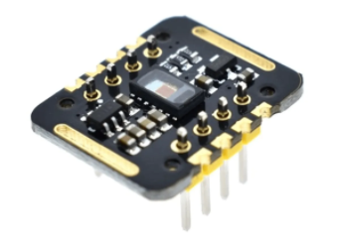

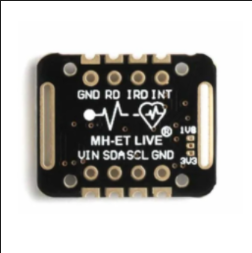

**Library for Arduino**

