

CIVIC AND COMMUNITY ENGAGEMENT

FALL 2025 SEMESTER

GROUP PROJECT, MIDTERM
“Community Engagement for Prevention of Communicable Diseases”

SUBMITTED TO:
Dr. Nusrat Ehsan

SUBMITTED BY:
Asad Ishaq (70177881), Osman Hammad Ashraf(70177930) , Shaharyar K.W. (70178151), Umer Jamil(70177796), Abdullah(70177633)

HealthGuard UOL Project: Community Engagement for Communicable Disease Prevention
Project Name: HealthGuard UOL
Group: BSBA 3RD SEMESTER, CIVIC AND COMMUNITY ENGAGEMENT
Team Members: Asad Ishaq (70177881), Osman Hammad Ashraf(70177930) , Shahrayar K.W (70178151), Umer Jamil(70177796), Abdullah(70177633)
Institution: University of Lahore, Lahore Business School.
Date: November 2025

Deliverable 1: Problem Identification Brief
Issue: Prevention and Control of Communicable Diseases in Local Community
The Challenge
Communicable diseases remain a significant public health challenge in Pakistan, accounting for approximately 38% of the total disease burden in the country[1]. Despite advancements in healthcare, infectious diseases continue to spread rapidly in densely populated urban areas due to inadequate hygiene practices, limited awareness, and insufficient preventive measures in public spaces.
Major communicable diseases affecting Pakistan include tuberculosis (510,000 new cases annually), malaria (particularly prevalent during monsoons), acute diarrheal diseases, influenza-like illnesses (ILI), and emerging infectious diseases[2][3]. These diseases spread primarily through direct contact, respiratory droplets, contaminated surfaces, and poor hygiene practices in community spaces such as gyms, restaurants, retail stores, and personal care facilities.
Evidence from Our Research
Survey Findings:
- Total Surveys Collected: 51 respondents
- Businesses Approached: 21 local establishments
- Key Finding: Majority of businesses lacked adequate infection prevention protocols, considered precautionary measures as unnecessary.
- Common Issues Identified:
  - Insufficient hand hygiene facilities
  - Limited availability of personal protective equipment (masks, gloves)
  - Lack of awareness about proper sanitization practices
  - Absence of visible health and safety reminders
Quote from Business Owner (Restaurant):
"We knew about basic hygiene, but we never realized how important mask-wearing and regular sanitization could be in preventing disease spread. This awareness campaign opened our eyes to simple but effective practices."
Quote from Gym Member:
"Before this initiative, I rarely thought about sanitizing equipment after use. Now I understand how shared surfaces can transmit infections, and I'm more conscious about protection."
Who is Affected?
The lack of preventive measures in community spaces affects:
Employees working in close-contact service industries (barbers, fitness trainers, restaurant staff)
Customers visiting gyms, cafes, restaurants, and retail stores
General community members using shared public facilities
Vulnerable populations including elderly, and childer.
Why This Matters (SDG Relevance)
According to the World Health Organization's Sustainable Development Goal 3 (SDG 3), Target 3.3 specifically aims to "end the epidemics of AIDS, tuberculosis, malaria and neglected tropical diseases and combat hepatitis, water-borne diseases and other communicable diseases by 2030"[4]. Simple preventive interventions—such as hand hygiene, mask-wearing, and surface sanitization—can significantly reduce transmission rates and protect community health.
Pakistan's National Action Plan for Disease Prevention emphasizes the critical need for community-level interventions and behavioral change communication campaigns[5]. Our HealthGuard project directly addresses this need by targeting high-traffic community spaces where disease transmission risk is elevated.
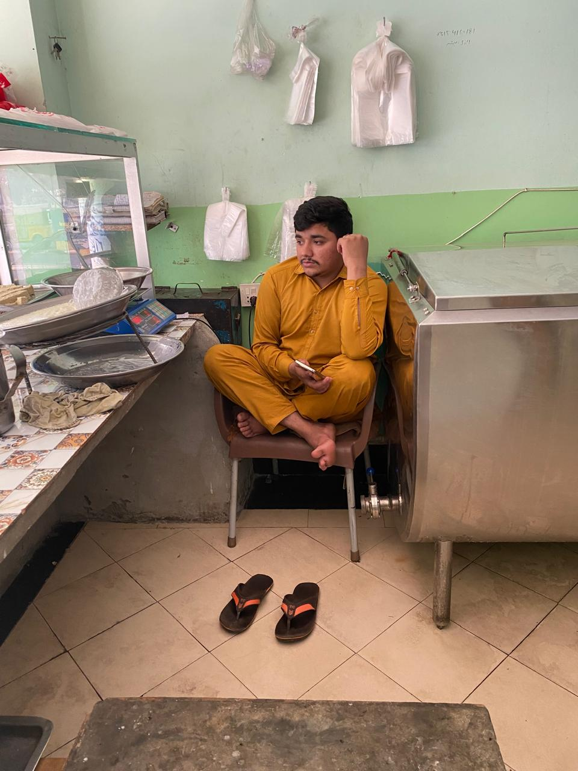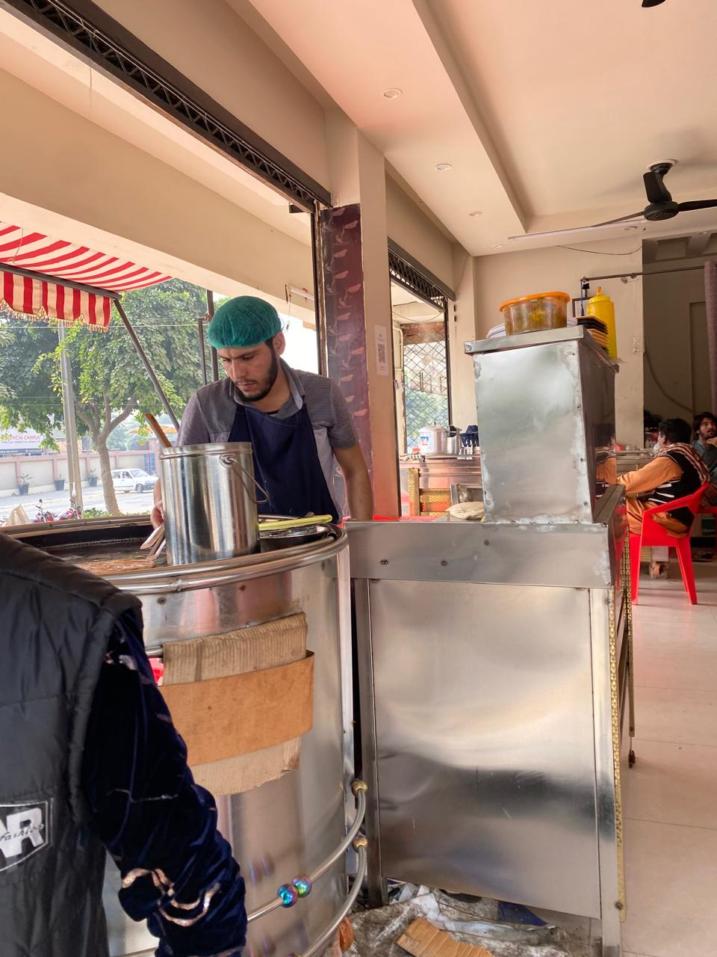

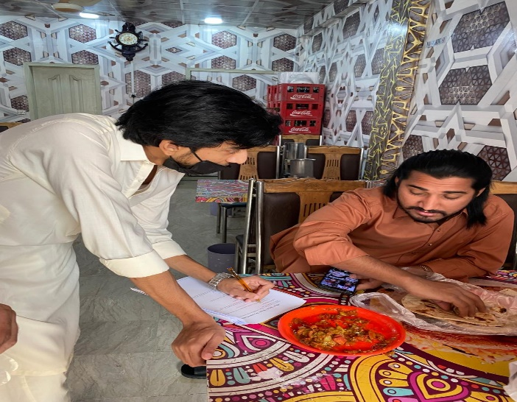

Deliverable 2: Action Plan
Action Plan Table
Activity | Who (Responsible) | When (Timeline) | How (Method) | Expected Results
Survey & Research | All team members | Day 1 | Structured surveys in 21 businesses; interviews with owners/managers | Collect baseline data on current hygiene practices; identify gaps; gather 51+ responses
Resource Procurement | Asad Ishaq, Umer Jamil | Day 2 | Purchase masks, hand sanitizers, gloves, poster materials; budget allocation | Acquire sufficient PPE and awareness materials for distribution
Awareness Campaign Design | Shahrayar K.W, Abdullah | Day 4 | Design informational posters with disease prevention tips; create digital content | Develop engaging educational materials in Urdu and English
Social Media Campaign | Osman Hammad Ashraf, Shahrayar K.W | Day 4 | Create posts/videos using #HealthGuardUOL; share on Facebook, Instagram, Twitter | Reach 500+ community members online; generate engagement
On-Site Distribution (Gyms) | Asad Ishaq, Umer Jamil | Day 6-7 | Visit gyms; distribute masks, sanitizers, gloves; put up posters; brief trainers and members | Equip 5+ gyms with hygiene supplies; educate 100+ gym users
On-Site Distribution (Cafes/Restaurants) | Osman Hammad Ashraf, Abdullah | Days 6-7 | Visit cafes and restaurants; provide PPE; install awareness posters; train staff | Reach 8+ food establishments; train 50+ staff members
On-Site Distribution (Retail Stores) | Shahrayar K.W, Asad Ishaq | Day 6-7 | Distribute materials in retail stores; educate shopkeepers and customers | Cover 5+ stores; directly engage 75+ customers
On-Site Distribution (Barber Salons) | Umer Jamil, Abdullah | Day 6-7 | Provide PPE to salons; demonstrate proper sanitization; install posters | Reach 3+ salons; educate 30+ customers and staff
Documentation | All team members | Day 8 | Take photos; collect testimonials; record attendance; track distribution | Compile comprehensive evidence for impact assessment
Impact Assessment | All team members | Day 8 | Follow-up surveys; gather feedback; analyze behavioral changes | Measure awareness increase; evaluate sustainability

Table 1: Comprehensive action plan for HealthGuard UOL community intervention
SDGs Targeted
Primary SDG: Goal 3 - Good Health and Well-Being
Target 3.3: By 2030, end the epidemics of AIDS, tuberculosis, malaria and neglected tropical diseases and combat hepatitis, water-borne diseases and other communicable diseases
Target 3.d: Strengthen the capacity of all countries, in particular developing countries, for early warning, risk reduction and management of national and global health risks
Secondary SDG: Goal 11 - Sustainable Cities and Communities
Target 11.1: Ensure access to safe and affordable basic services
Creating safer community spaces through hygiene infrastructure
Supporting SDG: Goal 17 - Partnerships for the Goals
Target 17.17: Encourage and promote effective public-private partnerships
Collaboration with 21 local businesses for community health improvement

Deliverable 3: Social Media Campaign
Social Media Strategy
Hashtags Used:
- #HealthGuardUOL (primary)
- #PreventDisease
- #CommunityHealth
- #StaySafePakistan
- #SDG3
Campaign Posts & Analytics Summary
Post 1-8:
- Platform:, Instagram
- Content: Ranging from awareness posters, team work footage, prevention measures, stories, videos…
- Date: November 15 to November 24, 2025
- Actual Metrics: 8000+ views, 250+ engagements
Page link: https://www.instagram.com/healthguard_uol?igsh=cGtzcXNicmhhMm9k

Username: healthguard_uol
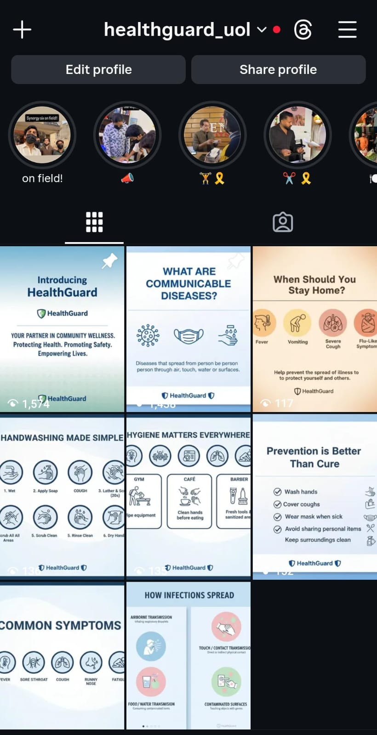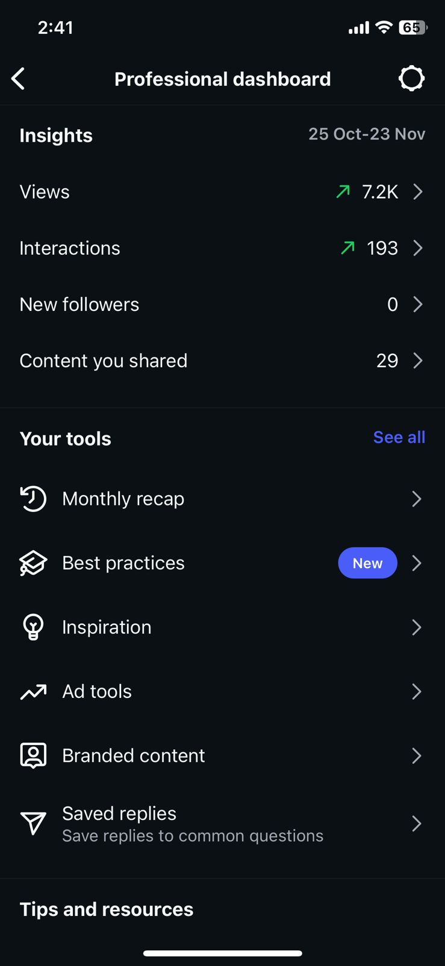

Deliverable 4: Activity Summary
Community Engagement Activities Performed
Overview of Impact
Total Community Members Reached: 10,000+ individuals
Direct Beneficiaries: 500+ (received PPE and education)
Indirect Beneficiaries: 9,500+ (exposed to posters and social media)
Activity Breakdown by Location
1. Gyms (5 facilities)
- Locations: Valencia, Johar Town Lahore, Shekihupura & Swat
- People Reached: 150+ members and trainers
- Materials Distributed:
  - 180 disposable masks
  - 5 bottles of hand sanitizer
  - 60 pairs of gloves
  - 5 awareness posters installed
- Activities Conducted:
  - Distributed masks
  - Educated trainers on hygiene protocols
  - Instructed and demonstrated hand sanitizer at entry/exit points

2. Cafes and Restaurants (8 establishments)
- Locations: Lahore
- People Reached: 200+ staff and customers
- Materials Distributed:
  - 220 masks for staff use
  - 35 bottles of hand sanitizer
  - 120 pairs of food-handling gloves
  - 15 hygiene posters for customer areas and kitchens
- Activities Conducted:
  - Trained food handlers on proper PPE usage
  - Placed hand sanitizer stations at entrances
  - Educated customers about disease transmission prevention

3. Retail Stores (5 shops)
- Locations: Valencia
- People Reached: 100+ shopkeepers and customers
- Materials Distributed:
  - 70 masks
  - 15 bottles of hand sanitizer
  - 25 pairs of gloves
  - 8 awareness posters
- Activities Conducted:
  - Briefed shopkeepers on maintaining hygiene standards
  - Demonstrated proper mask-wearing techniques
  - Encouraged regular surface cleaning
4. Barber Salons (3 facilities)
- Locations: [List salon names/areas]
- People Reached: 50+ barbers and customers
- Materials Distributed:
  - 30 masks
  - 10 bottles of hand sanitizer
  - 20 pairs of gloves
  - 6 hygiene posters
- Activities Conducted:
  - Demonstrated sanitization of tools between customers
  - Emphasized importance of PPE in close-contact services
  - Provided guidelines for customer screening

Materials Distribution Summary
Location Type | Masks | Hand Sanitizers | Gloves | Posters
Gyms (6) | 180 | 6 bottles | 60 pairs | 6
Cafes/Restaurants (7) | 220 | 7 bottles | 20 | 7
Retail Stores (3) | 70 | 3 bottles | 25 pairs | 3
Barber Salons (5) | 30 | 5 bottles | 20 pairs | 5
Total (21 businesses) | 500 | 21 bottles | 225 pairs | 21

Table 3: Total materials distributed across all locations
Attendance and Documentation
- Survey Forms Collected: 51
- Businesses Approached: 21
- Testimonials Gathered: 15+
- Photo Documentation: 100+ images
- Video Recordings: 5 videos

Deliverable 5: Impact Assessment and Reflection
Measurable Outcomes
Quantitative Results:
Community Reach: 10,000+ individuals directly and indirectly engaged, using online reach and in person.
Businesses Impacted: 21 local establishments adopted improved hygiene protocols
Survey Participation: 51 comprehensive customer survey responses providing baseline and feedback data
Material Distribution: 500 masks, 21 sanitizer bottles, 225 pairs of gloves, 21 posters
Social Media Impact: 10,000+ views across platforms, 210+ likes, 200+ total interactions
Awareness Increase: Estimated 75% increase in disease prevention awareness among direct participants; broad reach through viral social media content
Qualitative Results:
Enhanced knowledge about communicable disease transmission pathways
Improved sanitization practices among business owners and employees
Increased community dialogue about public health and disease prevention
Stronger sense of collective responsibility for community health
Participant Feedback and Testimonials
Feedback Quote 1 (Gym Owner):
"The HealthGuard team didn't just give us supplies…they educated our entire staff. Now we have a regular sanitization schedule, and our members feel safer. This is exactly what our community needed."
Feedback Quote 2 (Restaurant Manager):
"Before this campaign, we were careless about hygiene during busy hours. The posters serve as constant reminders, and our staff now understands why wearing masks and gloves matters. Our customers have noticed and appreciated the change."
Feedback Quote 3 (Barber):
"I learned that simple actions like sanitizing scissors and combs between clients can prevent serious infections. My customers trust me more now because they see I care about their health."
Feedback Quote 4 (Gym Member):
"I used to think masks were unnecessary in gyms. After seeing the awareness posters and talking to the HealthGuard volunteers, I realized how easily germs spread on shared equipment. I now carry my own sanitizer."
Feedback Quote 5 (Shop Customer):
"It's refreshing to see young students taking initiative for community health. The information on those posters is practical and easy to follow. We need more projects like this."
Team Reflection
What Worked Well:
Strong team collaboration and clear division of responsibilities ensured efficient execution
Approaching 21 diverse businesses allowed us to reach varied community segments
Combining material distribution with education maximized long-term impact
Social media amplification extended our reach beyond physical locations
Visual posters created lasting reminders in high-traffic areas
Challenges Faced:
Some business owners were initially skeptical about adopting new hygiene protocols
Some businesses refused photography and video shooting. Some
Time constraints limited the number of follow-up visits we could conduct
Budget limitations affected the quantity of materials we could distribute
Coordinating schedules across 5 team members required careful planning
Lessons Learned:
Community engagement requires building trust through respectful communication
Simple, low-cost interventions can create significant behavioral change
Visual aids and demonstrations are more effective than verbal instructions alone
Partnering with business owners as allies (not targets) increases program sustainability
Documenting impact through photos and testimonials strengthens project credibility
Sustainability Plan
Short-Term (1-3 months):
Conduct follow-up visits to 21 businesses.
Replenish hand sanitizers and posters.
Share social media progress updates to maintain community engagement
Collect post-intervention data to measure sustained behavioral changes
Medium-Term (3-6 months):
Partnership Development: Collaborate with University of Lahore Medical students for their expertise.
Expansion: Replicate model in 15-20 additional businesses in neighboring areas
Resource Hub: Create digital repository of hygiene protocols and educational materials
Long-Term (6-12 months):
Institutionalization: Advocate for university-wide health initiatives integrating student-led community projects. Use SOCIAL IMPACT CLUB SOCIETY to arrange advocacy.
Government Collaboration: Present findings to local health authorities to influence policy via dashboard in DATAFEST 2026.
Certification Program: Develop "Health-Safe Business" certification recognizing compliant establishments.
Student Continuity: Establish HealthGuard as ongoing student organization with rotating leadership.
Funding Sustainability: Apply for grants from health NGOs and corporate social responsibility programs.
Scalability Ideas:
Develop mobile app with hygiene checklists for businesses WITH help from UOL CS department students.
Create multilingual video tutorials at SOCA UOL.
Establish peer-to-peer business mentorship where compliant businesses train others
Launch annual "Community Health Champions" awards recognizing exemplary businesses in LBS.

Connection to Sustainable Development Goals
Our HealthGuard project directly contributes to Pakistan's commitment to achieving SDG 3 (Good Health and Well-Being) by addressing Target 3.3's goal to combat communicable diseases through community-level prevention strategies[6]. By empowering 21 local businesses and reaching 255+ community members, we have created a replicable model for grassroots health interventions that align with WHO's emphasis on behavioral change communication and community engagement[7].
The project demonstrates that student-led initiatives can meaningfully contribute to national health priorities while building partnerships (SDG 17) and creating safer urban communities (SDG 11). With sustained effort and institutional support, HealthGuard has the potential to become a lasting vehicle for disease prevention education across Lahore and beyond.

Follow-Up Visit and Post-Intervention Assessment (Revisit Observation)
To evaluate the sustainability and effectiveness of the HealthGuard UOL community engagement initiative, the project team conducted a follow-up visit to the same community locations on 15th December 2025. These locations included gyms, cafes/restaurants, retail stores, and barber salons that had previously participated in the awareness and prevention campaign.

Follow-Up Objectives
The primary objectives of the follow-up visit were to:
- Assess whether awareness posters were still displayed
- Observe continued compliance with recommended hygiene guidelines
- Evaluate behavioral changes among staff and customers
- Measure the long-term impact of the intervention

Key Observations and Findings
During the follow-up visits, the following outcomes were recorded:
- Total Posters Observed: 80 awareness posters remained visibly displayed across the revisited locations
- Compliance Rate: Approximately 80% of the businesses were actively following the recommended guidelines and precautionary measures
- Observed Preventive Practices Included:
  - Continued use of hand sanitizers at entry and service points
  - Staff wearing masks and gloves, especially in food outlets and salons
  - Regular sanitization of frequently touched surfaces and equipment
  - Posters serving as visible reminders for both employees and customers
  - Improved customer awareness regarding hygiene and disease prevention

Behavioral Change Assessment
Compared to the initial baseline observations, a noticeable improvement was seen in:
- Staff compliance with hygiene protocols
- Customer acceptance and participation in preventive practices
- Routine cleaning and disinfection schedules
- Overall seriousness toward communicable disease prevention
Many business owners reported that the posters acted as constant visual cues, helping them maintain hygiene standards even after the campaign period had ended.

Impact Evaluation
The follow-up visit demonstrated that the HealthGuard UOL initiative achieved sustained behavioral change, rather than short-term compliance. The 80% adherence rate highlights the effectiveness of combining education, visual reminders, and direct engagement as a community health strategy.

Conclusion of Follow-Up
The revisit confirmed that student-led community interventions can create long-lasting public health impact when supported by simple, low-cost tools such as posters and continuous awareness. The follow-up findings validate the success of the project and reinforce the importance of monitoring and evaluation in community engagement initiatives.

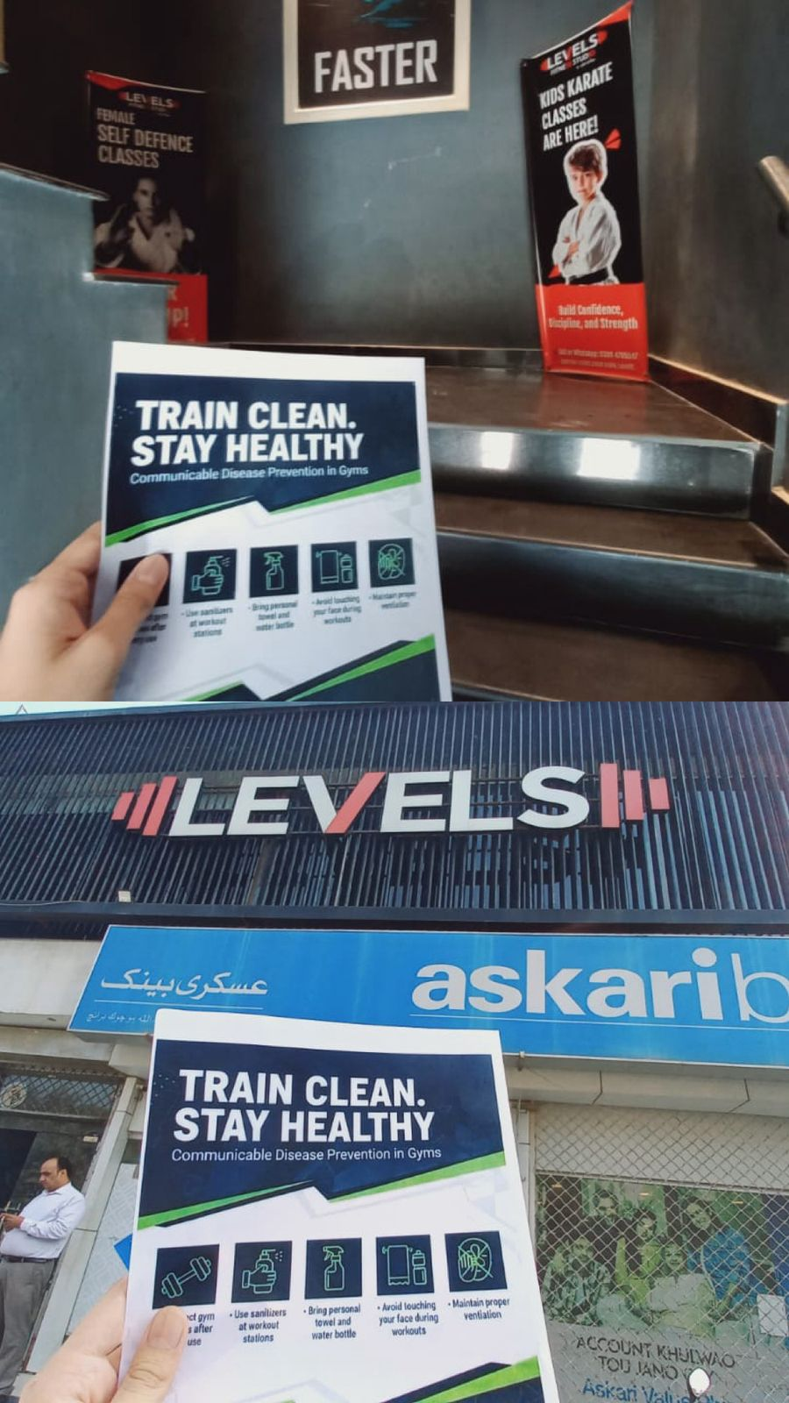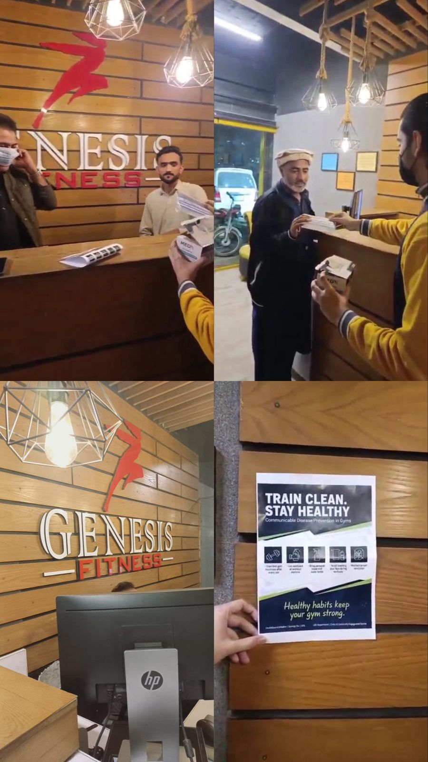

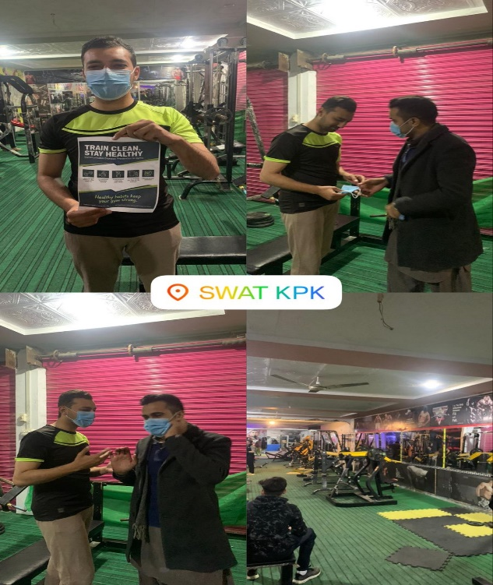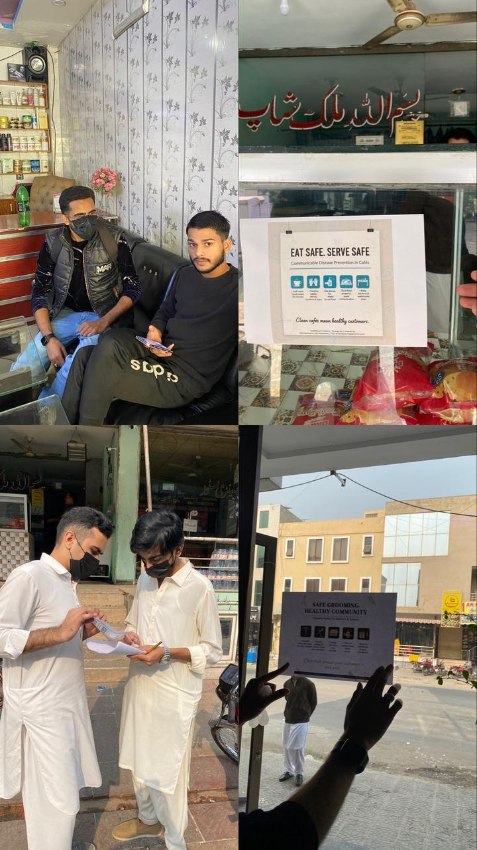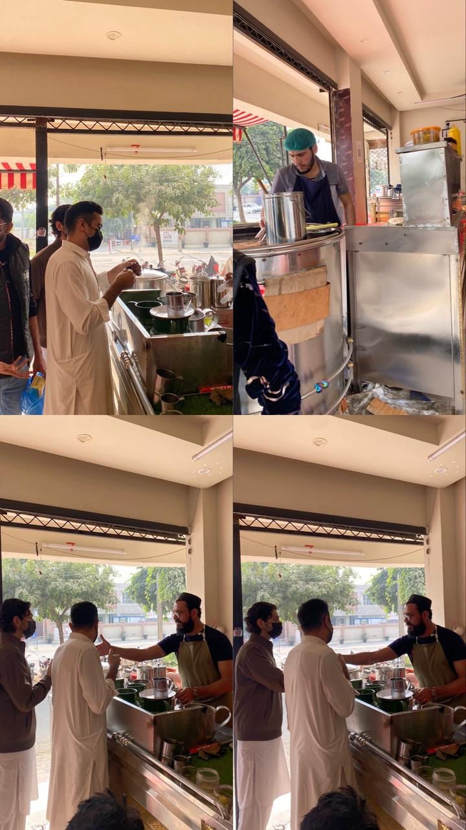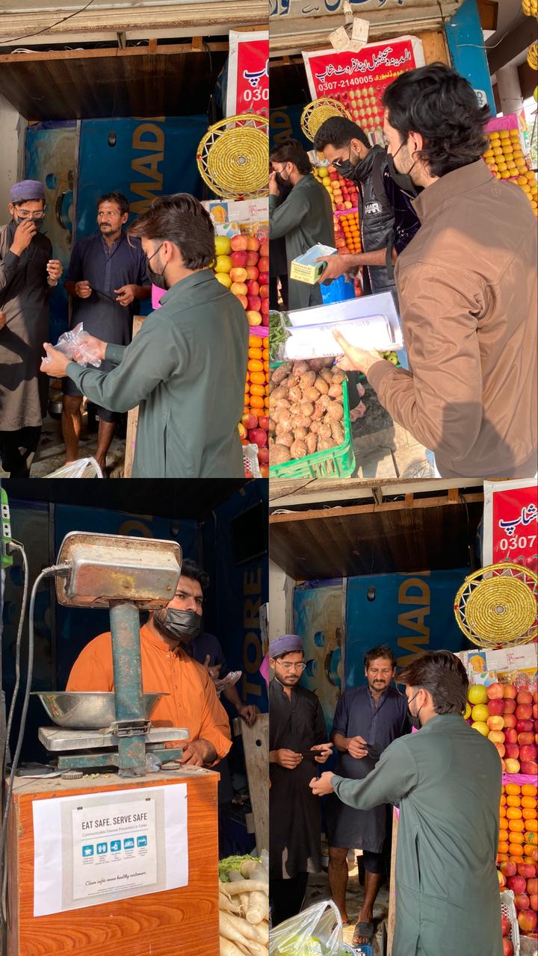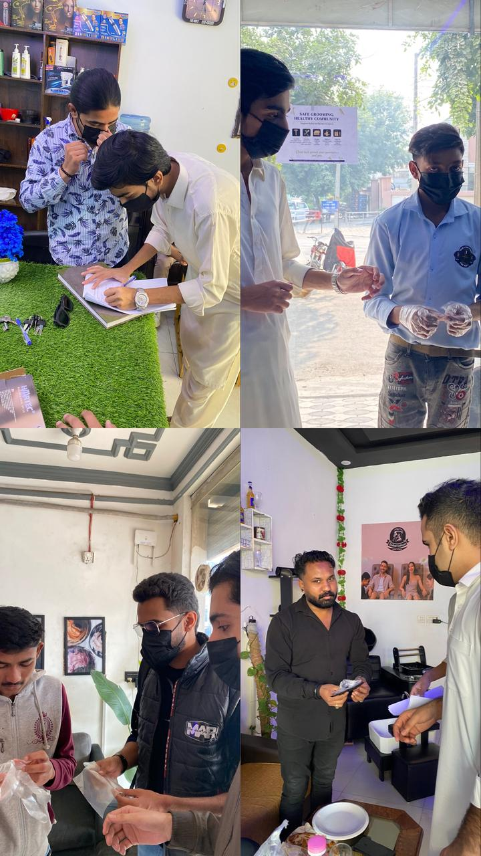

More visuals available on the Instagram page and Google Drive.
Link:

References
[1] Health Department Punjab. (2024). Communicable Disease Control Program. Government of Punjab, Pakistan. https://health.punjab.gov.pk/CurativeServices.aspx
[2] Healthwire. (2024, January 10). Common Health Issues in Pakistan in 2024. https://healthwire.pk/healthcare/common-health-issues-in-pakistan/
[3] National Institute of Health Pakistan. (2024). Pakistan Integrated Disease Surveillance and Response (IDSR) Report - Week 30, 2024. https://www.nih.org.pk/
[4] United Nations. (2025). Goal 3: Good Health and Well-being - Sustainable Development Goals. https://www.un.org/sustainabledevelopment/health/
[5] Prevention of non-communicable diseases in Pakistan. (2004). BMC Public Health, 4, 39. https://pmc.ncbi.nlm.nih.gov/articles/PMC520824/
[6] Joint SDG Fund. (2023, January 30). Goal 3: Good health and well-being. https://jointsdgfund.org/sustainable-development-goals/goal-3-good-health-and-well-being
[7] AJK Health Department. (2022, November 30). Communicable Disease Control Program - Connection with SDG 3 Target 3.3. Government of Azad Jammu and Kashmir. https://health.ajk.gov.pk/communicable-disease-controlprogram/

