# **Mawlana Bhashani Science and Technology University**



**A project On TIC – TAC –TOE GAME**

**Course Title : Software Development Project-1 and Industrial Tour**

**Course Code :** **CSE** - 2112

|  |  |
| --- | --- |
| Submitted By | Supervised by |
| Asaduzzaman SHUVO  ID : CE-15041  Session : 2014-15  Dept. of CSE, MBSTU | 1. **S. M. Delowar Hossain**   **Assistant Professor**  Dept. Of CSE, MBSTU  Tangail - 1902 |

# Index

1. Introduction Of My project
2. Gaming Rules
3. Winning condition
4. General Introduction Of My coding
5. Language
6. Coding Menu
7. Introduction Of Functions
8. References

# Introduction OF My project:

Tic-Tac-Toe is a very simple two player game. So only two players can play at a time. This game is also known as Noughts and Crosses or Xs and Os game. One player plays with X and the other player plays with O. In this game we have a board consisting of a 3X3 grid. The number of grids may be increased. In this mini-project a player can play with other players or with computer. To play with computer there are 3 levels.

1.Easy

2. Medium

3. Hard

Easy level are 1st stage. This level is very easy to win, medium level is harder to win than easy level .then comes hard level. This level is very difficult to win.

In this play a player can chose his option according to his/her will. He/she can play with multiplayer / with computer in different level. Or exit the Game at any moment.

* A 3x3 Tic-Tac-Toe looks like: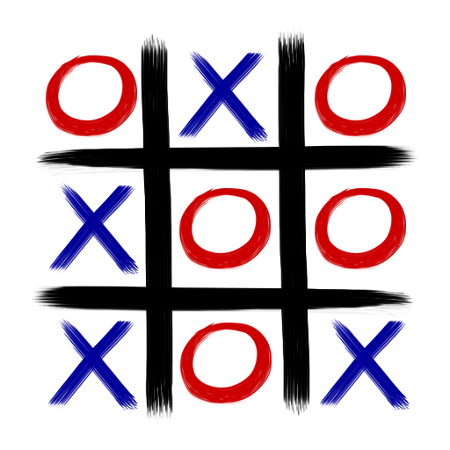

# Gaming Rules :

* Traditionally the first player plays with "X". So you can decide who wants to go "X" and who wants go with "O".
* Only one player can play at a time.
* If any of the players have filled a square then the other player and the same player cannot override that square.
* There are only two conditions that may be match will be draw or may be win.
* The player that succeeds in placing three respective mark (X or O) in a horizontal, vertical or diagonal row wins the game.

# Winning Condition

* Whoever places three respective marks (X or O) horizontally vertically or diagonally will be the winner.

# DIAGONAL WIN

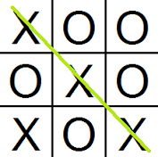 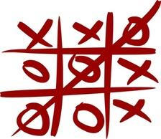

# Horizontally Win

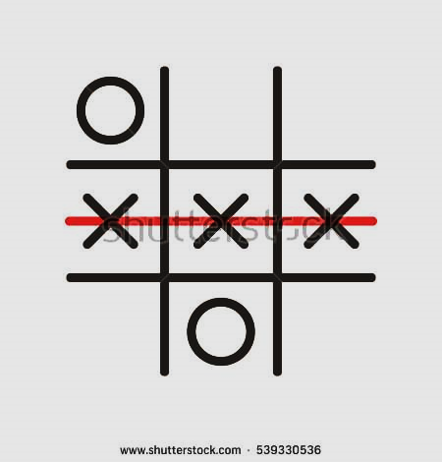

|  |
| --- |
|  |

# Vertically Win

# All Possible Win

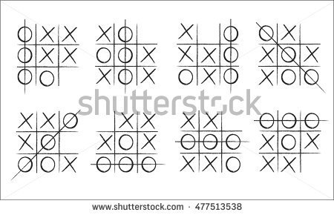

# My code introduction:

# LAGUAGE:

# I used c language to develop this mini-project.

# C Language:

C was originally developed by Dennis Ritchi between 1969 and 1973 at Bell Labs  and used to re-implement the Unix operating system. It has since become one of the most widely use programming languages of all time, with C compilers from various vendors available for the majority of existing computer architectures and operating systems. C has been standardized by the American National Standards Institute (ANSI) since 1989 (see ANSI C) and subsequently by the International Organization for Standardization (ISO).

# 

MENU:

* 1. Start The Game
  + - a. To Play With other players
    - b. To Play With Computer
* 2.Exit The Game
* 4. Gaming Rule

|  |
| --- |
| Multyplayer:  **1.Multy_play()**  **2. Board()**  **3. Checkwin()** |

|  |
| --- |
| **Basic Finction:**  **1.Gaming_Rule()**  **2.Introduction()**  **3.Drawing_board()**  **4.Start_play()** |
| With computer:  1. Game_on()  2. Initial()  3. Computer_Play()  4. Computer_Turn()  5. Computer_Turn1();  6. Computer_Turn2();  7. My_Turn()  8. Middle_check()  9. Computer_middle()  10. Computer_corner()  11. Computer_side()  12. My_turn_check() |

* Introduction() :

When we call this function this function tells us about tic-tac-toe game.

* Gaming_Rule() :

When we call this Function this function show us the simple gaming rules of tic-tac-toe. It’s a void function. Its retun nothing.

Drawing Board():

This function draw 3x3 grid for the game and further show us ours move and gaming present condition.

Start_play():

When we call start_play() function it will ask you a question, if you want to play with computer or your friend ? basically it’s the first step of the game .If you want to play with your friend you select Multiplayer option ,or if you want to play with computer you select play with computer option. Then the Game is on.

* Initial(): This Funtion initial the value of the 3x3 grid. Like ,

square[0][0]=‘1’

square[0][1]=‘2’

This function helps to re-initial the grid whenever needed. So if we play the game again and again without terminate the program this function helps a lot.

Computer_play(): when We call the function program start to play with computer.

Game_on():

When we call this function the game is on.

* My_turn(): Generally player start the game with ‘X’. Then the computer.
* My_turn_check(): when player want to select a particular Grid to implement its ‘X’, this function check if the move is valid or not. If the Grid is already taken then it’s a invalid move or it’s a valid move. this function decide its for the program.
* Computer_turn():

After player move computer pick his position .By this function computer pick best possible spot to win this game. And this function will only valid for hard level.

* Computer_turn1():

After player move computer pick his position .By this function computer pick best possible spot to win this game. And this function will only valid for Easy level.

* Computer_turn2():

After player move computer pick his position .By this function computer pick best possible spot to win this game. And this function will only valid for Medium level.

* Middle_check():

In this Function computer check all of the grid, and which grid is empty. If a grid is empty it’s take a move there and then check by this move if computer win or not. If computer win its return the position to move. If it does not win its then check if player will win if he/she move its next move. if yes its also return the position and choose the position for move.

* Computer_middle():

If middle check does not work it call the function first to pick a position. It gives this function priority over others. If middle position of the grid is empty its pick the position and return value.

* Computer_corner():

If middle position is not empty its choose corner position.

* Computer_side():

If Middle and Corner position are not empty its choose side position.

RESULT:

Win , lose or draw: in Game_on() finction this function decide which side has won. Computer or human. If player has won it will print it and vise-versa.

Multiplay funtions:

Multy_play():

In this function we start the two player tic-tac-toe game. In first attempt first player will start the game with ‘X’ and then second player will start with ‘o’.

The game will goes on until one player win or draw.

Initial():

it is also initial its grid before starting the game. If we want to play the game without exiting then this function will helps a lot.

Check_win():

This function will helps you to decide which player has won the game, or the game is draw.

Scoreboard:

* This function will show us which player wins how many times, and number of draws. Its generally works for two player games.

Exit:

* If player wants to exit the game it will select the option and terminate the game.

Some Screenshot Of The Game:

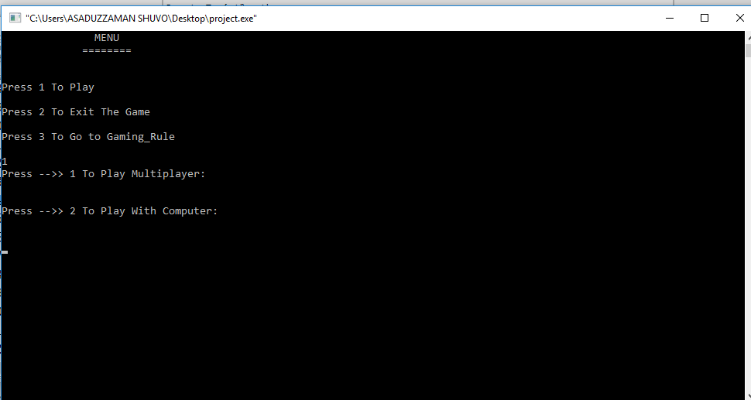

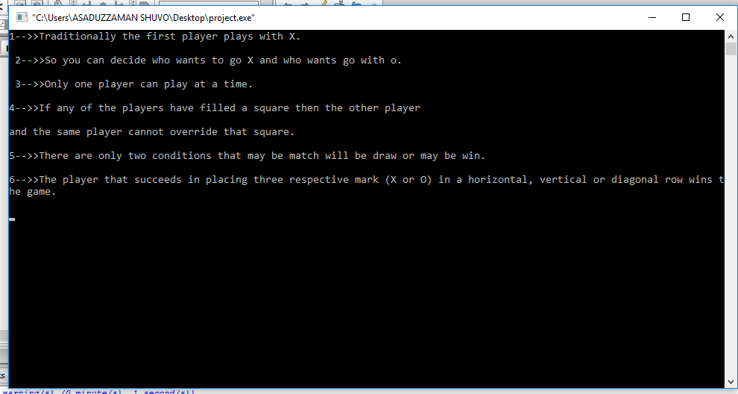

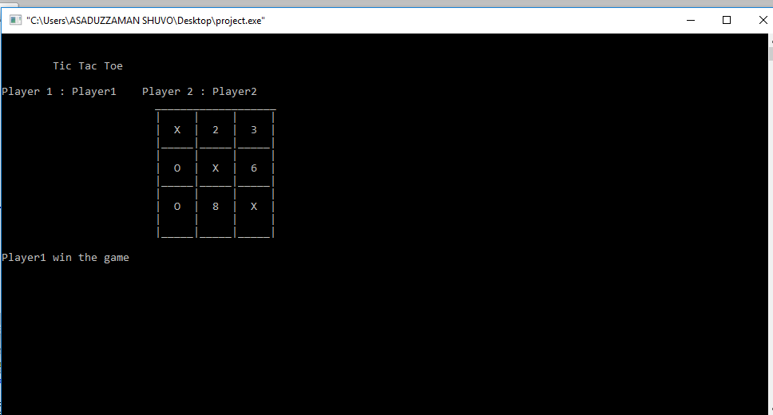

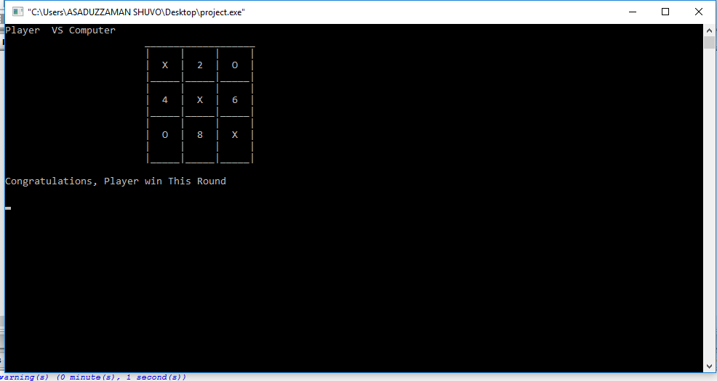

References :

### **Herbert Schildt Teach Yourself C**

### **Programming in ANSI C – Balagurusamy**