**Chor Bazzar Shopping**

**(CBS)**

**Session 2023 - 2027**

**Submitted by:**

Muhammad Asad 2023-CS-14

**Supervised by:**

Dr Muhammad Awais Hassan

**Course:**

CSC-102 Programming Fundamentals

Department of Computer Science

**University of Engineering and Technology**

**Lahore Pakistan**

Table of Contents

❖ About Chor bazar shopping (CBS): 4

I. Cheap and Convenient Shopping: 4

II. What it does: 4

❖ User Types In CBS: 4

i. Seller: 4

ii. User: 4

• Seller’s Functions: 5

• User’s Functions: 6

❖ Images From The Application 6

1. Seller’s Login Page: 6

2. Current Seller Menu: 7

3. User’s Login Page: 7

4. Current User Menus: 8

**Table of Figures**

Figure 1 6

Figure 2 7

Figure 3 7

Figure 4 8

### About Chor bazar shopping (CBS):

## Cheap and Convenient Banking:

The Chor Bazar Shopping application is designed for cheap and conventional shopping of clothes and goods available for every person.

## What it does:

It allows the seller to add products to their account, remove products, add and remove the copies if the original product so that it can be afforded as well as a well business can be started.

### User Types In CBS:

The chor bazar shopping provides different access to two types of users. First is seller and the second is buyer. Seller can sell their products and buyers can buy the products.

## Seller:

The seller can add products to the account and can sell their products on a platform and can remove a product or edit the number and type of products.

## Buyer:

The buyer can access to its account and can add products to the kart and can see the total bill and can remove products from the kart.

* + - **Functional Requirements Of CBS:**

Some of the functions that can be performed by the Seller and buyer in my Chor bazar shopping are under:

## Seller’s Functions:

|  |  |  |
| --- | --- | --- |
| **User Type** | **Functions** | **Action Performed** |
| **Admin/Manager** | Add New Product | Used to add new product in the application |
| View Products | Used to view the products in the application |
| Delete Products | Used to delete the product |
| Set Interest Rate | Used to set the interest rate |
| View Available products | Used to view products |
| Update Information | Allows to edit information for account |
| Reset Passwords | Used to reset the passwords |
| Give Aways | Allows to give free products to specific client |
| amount Calculator | Used to calculate the amount |
| Interest Calculator | Used to calculate the interest on money |

## Client’s Functions:

|  |  |  |
| --- | --- | --- |
| **Client/User** | Add products | Allows to add product to their kart |
| Remove products | Allows to remove product from their kart |
| Edit kart | Allows to edit kart |
| Apply for giveaways | Used to apply for |
| Request For Account removal | Allow user to apply to remove his account |
| View kart History | Allows the user to see his past products |
| View Products | Used to view all items |
| Modify Information | Allows to edit basic information |
| Apply for Change of Password | Used to Change Password |
| Freeze/Unfreeze karts | Used to Freeze/Unfreeze the karts |

### Images From The Application

## Seller’s Login Page:

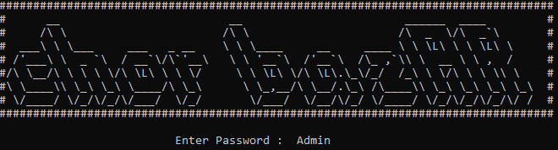

Figure 1

## Current Manager Menu:

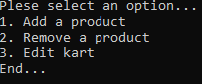

Figure 2

## Client’s Login Page:

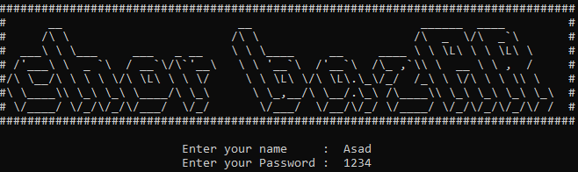

Figure 3

## Current Client Menus:

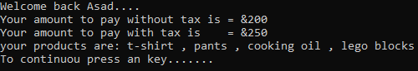

Figure 4