Filetypes
SMSD matches various filetypes, to see a list of supported types, run SMSD with "-h". At the end of the help, the list of types is shown, along with a description for each type. The type is a short identifier ('MOL', 'PDB', etc) that is used to tell SMSD what to expect. The query and the target files can have different types, for example:
./SMSD -Q MOL -q molfile.mol -T PDB -t pdbfile.pdb
Where the uppercase flags (-Q and -T) give the types, and the lowercase flags (-q and -t) give the filenames. For 'string' types - such as SMILEs - the filename will be the data itself:
./SMSD -Q SMI -q "CCC" -T PDB -t pdbfile.pdb
Note that, while the quotes may not always be necessary, they will prevent problems with more complex SMILEs.
Types can also be used with the output subgraph. There is a corresponding pair of -o/-O flags for the output filepath, and output filetype, respectively. So, to write the subgraph to a molfile, write:
./SMSD -Q SMI -q "CCC" -T PDB -t ATP.pdb -O MOL -o subgraph.mol
For convenience, the output filepath can be given as the special name "--", which means "write to stdout". This is a quick way to see the subgraph, especially, if the output filetype is SMI.
./SMSD -Q SMI -q "CCC" -T SMI -t "CCN" -O SMI -o --
This will just print "CC", as that is the common subgraph of these two smiles.
Images
To generate an image of the isomorphism, use the -g flag, like this:
./SMSD -Q MOL -q ADP.mol -T MOL -t ATP.mol -g
This will generate an image named "ADP_ATP.png" looking something like:
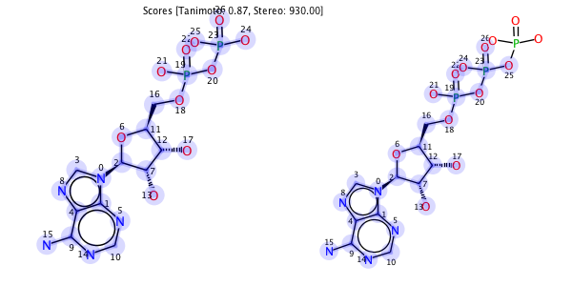
Clearly the name of the image is generated using the names of the query and target input files. If string format molecules are used, the string will be used; for example, "CCC_CCCC.png". The size of the image can be changed with the -d flag, like : -d 400x200 to create an image with a width of 400 and a height of 200.
Image options can also be passed at the command-line using the syntax "-Iopt=value". For example, "-IdrawAromaticCircles=true". To get a list of the options, along with their default values, just use the -I flag without any arguments.
N-MCS
To get the maximum common subgraph (MCS) of a set of molecules, provide only a target file, which must be a multi-file format such as SDF. As an example:
./SMSD -T SDF -t arom.sdf -N -g -z
This will produce a 'hub-wheel' image of the MCS that looks like:
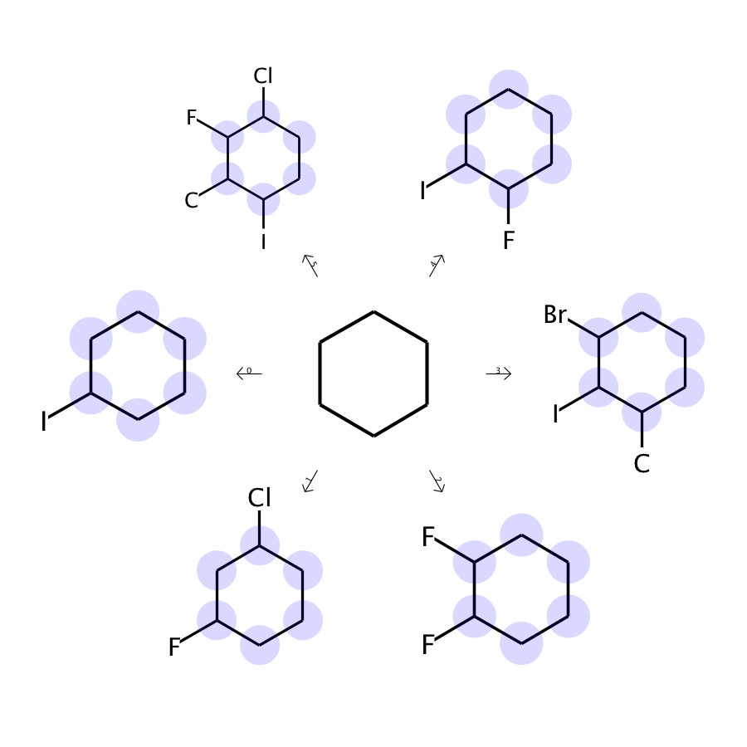
where the central (hub) molecule is the MCS of the molecules around the rim of the wheel.
Just use ./SMSD -I to list all the image options.
Usage and command line options:
-A | Appends output to existing files, else creates new files
-a | Add Hydrogen
-b | Match Bond types (Single, Double etc)
-d | Dimension of the image in pixels
-f | Default: 0, Stereo: 1, Stereo+Fragment: 2, Stereo+Fragment+Energy: 3
-g | create png of the mapping
-h,--help | Help page for command usage
-I | Image options
-m | Report all Mappings
-N | Do N-way MCS on the target SD file
-o | Output the substructure to a file
-O | Output type
-Q | Query type (MOL, SMI, etc)
-q | Query filename
-r | Remove Hydrogen
-s | SubStructure detection
-S | Add suffix to the files
-T | Target type (MOL, SMI, etc)
-t | Target filename
-z | Match Rings in the MCS/ Substructure search
Allowed types for single-molecules (query):
MOL | MDL V2000 format
ML2 | MOL2 Tripos format
PDB | Protein Databank Format
CML | Chemical Markup Language
SMI | SMILES string format
SIG | Signature string format
Allowed types for multiple-molecules (targets only):
SDF | SD file format
NOTE: Remove hydrogens before performing graph matching.

