Name of the Experiment: Classification of Contact Lenses data using Weka.

Number of Experiment: 01

Date of Performance: 2 July 2018

Date of Submission: 8 July 2018

1. ARFF Data Used: Vote

Attached at contact-lenses.arff

1. ZeroR classification Result:

(a)

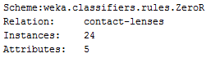

(b)



(c)

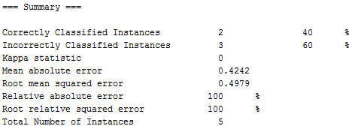

(d)

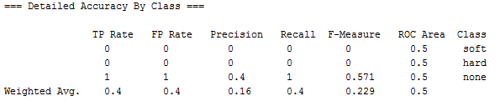

(e)

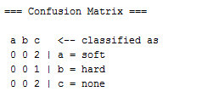

1. J48 Classification

(a)

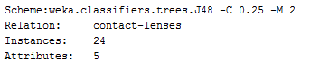

(b)



(c)

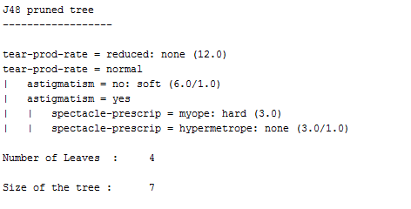

(d)

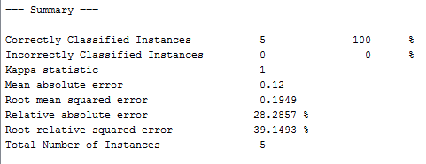

(e)

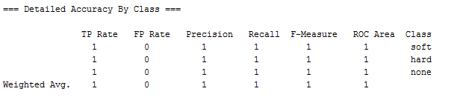

(f)

