**Lab report no: 01**

**Experiment Name:** Introduction to Networking Devices.

**Aim:** The aim of this lab is to study Networking Devices.

**Objectives:**

* To learn about networking devices.
* To introduce about networking devices.

**Description:** At first we should introduce about networking devices.it will help to work easily.

**Network interface cards:**

A NIC (network interface card) is a piece of computer hardware designed to allow computers to communicate over a computer network. It provides physical access to a networking medium and often provides a low-level addressing system through the use of MAC addresses. It allows users to connect to each other either by using cables or wirelessly. The NIC provides the transfer of data in  megabytes.

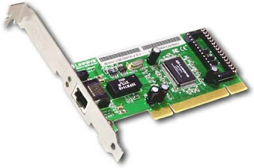

Fig: Network interface cards

**Repeaters:**

A repeater is an electronic device that receives a signal and retransmits it at a higher power level, or to the other side of an obstruction, so that the signal can cover longer distances without degradation. In most twisted pair ethernet configurations, repeaters are required for cable runs longer than 100 meters away from the computer.

http://1.bp.blogspot.com/-IGioj5gHBJI/UF6qPuRturI/AAAAAAAAAMk/pLqgA_jhbvQ/s320/re.png

Fig: Repeaters

**Hubs:**

A hub contains multiple ports. When a packet arrives at one port, it is copied to all the ports of the hub for transmission. In a hub, a frame is passed along or "broadcast" to every one of its ports. It doesn't matter that the frame is only destined for one port

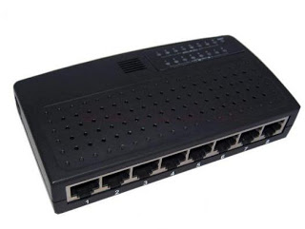

Fig: Hub

**Bridges:**

A network bridge connects multiple network segments at the data link layer (layer 2) of the OSI model. Bridges do not copy traffic to all ports, as hubs do, but learn which MAC addresses are reachable through specific ports. Once the bridge associates a port and an address, it will send traffic for that address only to that port. Bridges do send broadcasts to all ports except the one on which the broadcast was received.

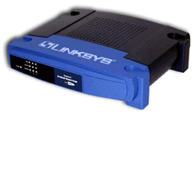

Fig: Bridges

**Switches:**

The switch is a relatively new network device that has replaced both hubs and bridges in LANs. A switch uses an internal address table to route incoming data frames via the port associated with their destination MAC address. Switches can be used to connect together a number of end-user devices such as workstations, or to interconnect multiple network segments. A switch that interconnects end-user devices is often called a workgroup switch. Switches provide dedicated full-duplex links for every possible pairing of ports, effectively giving each attached device its own network segment .This significantly reduces the number of intra-segment and inter-segment collisions.

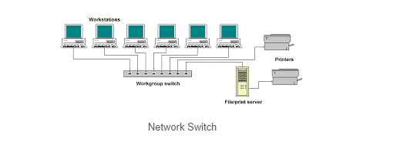

**Routers:**

Routers are networking devices that forward data packets between networks using headers and forwarding tables to determine the best path to forward the packets. A network environment that consists of several interconnected networks employing different network protocols and architectures requires a sophisticated device to manage the flow of traffic between these diverse networks. Such a device, sometimes referred to as an intermediate system, but more commonly called a router, must be able to determine how to get incoming packets (or datagrams) to the destination network by the most efficient route.

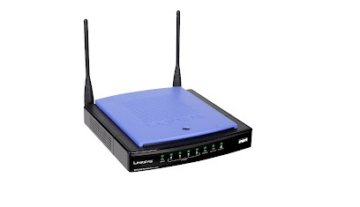

Fig: Routers

**Conclusion:** From doing this lab we know the networking devices.it will help us in next experiment.