**Lab report no: 03**

**Experiment Name:** Introduction to Packet Tracer CLI commands.

**Aim:** The aim of this lab is to study about Packet Tracer CLI commands.

**Objectives:**

* To learn about packet tracer CLI commands.
* To learn the principle work of packet tracer CLI commands.

**Description:**

**Packet Tracer Cisco CLI Commands list:**

The detailed Cisco router configuration commands list, which can be implemented with packet tracer. Packet tracer is a network simulator used for configuring and creating the virtual cisco devices and network. To configure any device in packet ,required to open or access its CLI and do it by clicking any device and then navigating to CLI tab. Perform all Cisco Commands here at CLI.

**access-cli-packet-tracer**

Cisco IOS supports numerous command modes which can be practice with packet tracer, followings are the main command modes of cisco CLI with specific commands to navigate from one mode to other.

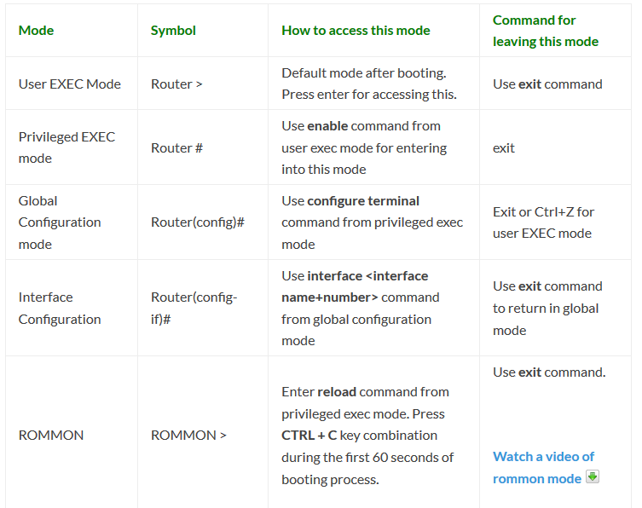

**Working procedure:**

**Change the Cisco Router name:** change the cisco router name by using command hostname in global configuration mode:



**Set the Enable password:** set the password for protecting enable mode by following command: (Following command will set the password to cisco)

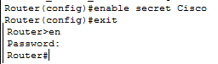

**Set the telnet password on Cisco:**

Access the cisco router remotely by VTY lines, these are the Virtual Terminal lines for access router, you can set password on these line by using the following commands:

Router(config)#line vty 0 4

Router(config-line)#password Cisco

Router(config-line)#no login

Above command will set the telnet password to “Cisco”.

**Set the IP address to Cisco interface:**

Set the IP address to any Cisco device interface by using the following commands:

Router(config)#interface <interface name&number>

Router(config-if)#ip address <IP address> <subnet mask>

**Save the configurations:**

You can use the following command for router configuration to Nvram for use at next boot up

Router#copy running-config startup-config

**Configure the access-list on Cisco:**

configure the access-list on cisco by using following commands:

Router(config)#Access-list <number> <permit|deny> <ip> <mask>

Router(config-if)#ip access-group <number> <in|out>

OR

Router(config)#Access-list <number> <permit|deny> <protocol> <from ip and mask> <to ip and mask> <port number>

Router(config-if)#

**Command Example:**

Router(config)#access-list 2 deny 192.168.0.33 0.0.0.255

Router(config)#interface fastEthernet 4/0

Router(config-if)#ip access-group 2 in

How to configure the default route on Cisco:

Following command will set the default route to 10.10.10.101.

Router(config)# ip route 0.0.0.0 0.0.0.0 10.10.10.101

**Create a static route on Cisco router:**

Router(config-router)#ip route [destination_network] [mask] [next-hop_address

you can set a static route by using above command example is also given below:

Router(config-router)#ip route 192.132.23.1 255.255.255.0 10.10.10.1

**Conclusion:** From the lab we learn about CLI commands and working principle and get extra knowledge about CISCO Packet Tracer.