**Lab report no: 02**

**Experiment Name:** Introduction to Packet Tracer.

**Aim:** The aim of this lab is to study about Packet Tracer.

**Objectives:**

* To learn about packet tracer
* To learn the principles of networking and packet tracer.

**Description:**

**Packet Tracer**: Packet Tracer is a cross-platform visual simulation tool designed by Cisco Systems that allows users to create network topologies and imitate modern computer networks. The software allows users to simulate the configuration of Cisco routers. Packet Tracer is a powerful network simulator that can be utilized in training for CCNA.

* Learn the basic operations of Packet Tracer: - File commands, visualization and configuration of networking devices.
* Simulate the interactions of data traveling through the network.
* Learn to visualize the network in logical and physical modes.
* Reinforce your understanding with extensive hands-on networking and activities.
* Get immediate feedback on your work through built-in quizzes and tests.
* Connect with the global Cisco Networking Academy community.

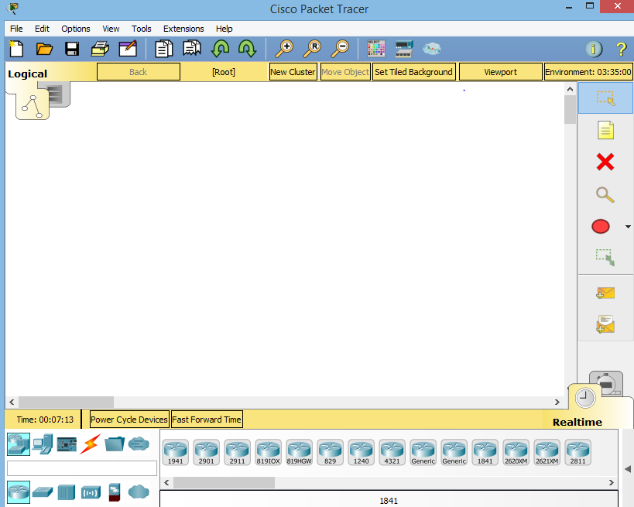

This is the opening window of packet tracer.

We are different modules and panels available in the packet tracer. Some important modules, which are important to understand for the working in Packet Tracer.

We can add many devices and make connection.

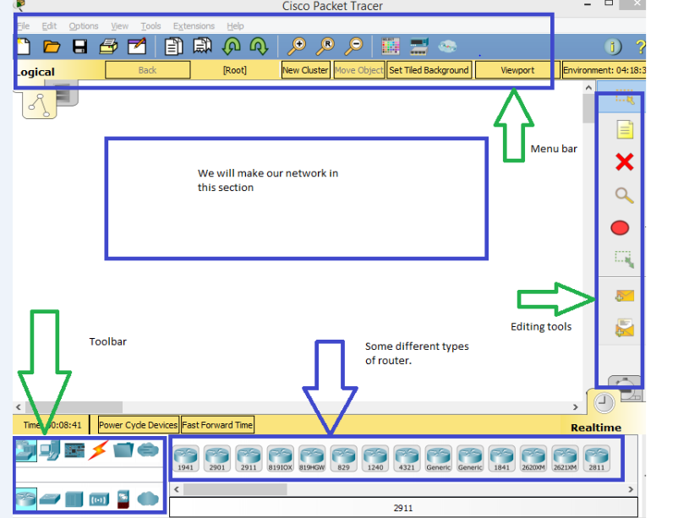

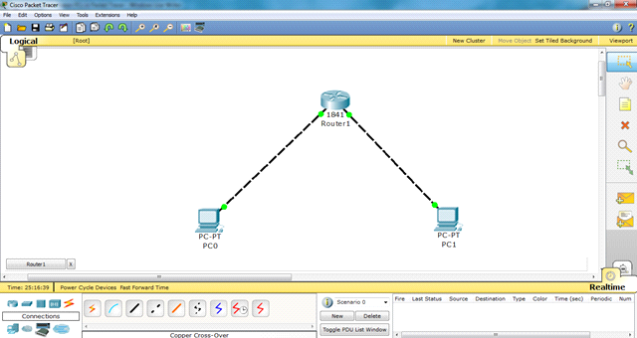

**Conclusion:** From this lab we learn about packet tracer and how it work.it will help us in next .