**Lab report no: 04**

**Experiment Name:** Introduction to Networking Cables.

**Aim:** The aim of this lab is to study about different types of wires and connection.

**Objectives:**

* To learn about different types of cable.
* To learn where and what types of cable were use.

**Description:**

**Cable**: Cable is the medium through which information usually moves from one network device to another. There are several types of cable which are commonly used with LANs such as,

1. Unshielded Twisted Pair (UTP) Cable

2. Shielded Twisted Pair (STP) Cable

3. Coaxial Cable

4. Fiber Optic Cable

**Twisted Pair Cables:**

Twisted pair cabling is a type of wiring in which two conductors of a single circuit are twisted together for the purposes of canceling out electromagnetic interference (EMI) from external sources; for instance, electromagnetic radiation from unshielded twisted pair (UTP) cables, and crosstalk between neighboring pairs

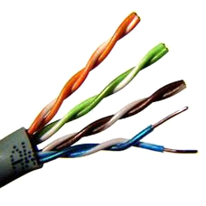

Fig: Twisted pair cable

**Characteristics of UTP categories:**

The characteristics of UTP are very good and make it easy to work with, install, expand and troubleshoot. Now, we are going to look at the different wiring schemes available for UTP, how to create a straight-through UTP cable, rules for safe operation and a lot of other interesting information.

**Coaxial Cable:**

A Coaxial cable is a cable used in the transmission of video, communications, and audio. Coaxial cable is used as a transmission line for radio frequency signals. Its applications include connecting radio transmitters and receivers with their antennas, computer network (Internet) connections, digital audio (S/PDIF), and distributing cable television signals.

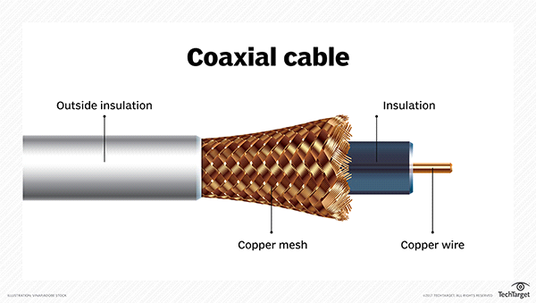

Fig: Coaxial cable

**Fiber Optic Cable:**

A fiber optic cable consists of a bundle of glass threads, each of which is capable of transmitting messages modulated onto light waves. ... Fiber optic cables have a much greater bandwidth than metal cables.

Optical fibers are used most often to transmit light between the two ends of the fiber and find wide usage in fiber-optic communications, where they permit transmission over longer distances and at higher bandwidths than wire cables.

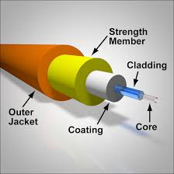

Fig: Fiber Optic Cable

**Conclusion:** From this lab we learn about different types of networking wires and this knowledge of this will be very helpful for us.