**Experiment No:** **- 05**

**Experiment Name:-** Introduction to Communication between two PCs.

**Aim:**  The aim of this report is to understand and implement the simple network using Cisco Packet Tracer.

**Objectives:**

* To learn about Cisco Packet Tracer.
* To learn the principles of networking as well as develop Cisco technology specific skills.
* To implement a simple network using Cisco Packet Tracer.

**Working Procedure:**

At first we set a router. Then set a router and connect two PC’s in Cisco Packet Tracer and connect those devices using cross cable.

* Connect the cross copper wire between router and PCs.
* Select FastEthernet 0/0 and FastEthernet 0/1.
* Set Interface FastEthernet 0/0 IP(gateway) = 192.168.1.1 and FastEthernet 0/1 IP(gateway) = 192.168.2.1 and set PC0 IP=192.168.1.2 and PC1 IP = 192.168.2.2 with their corresponding gateway.

**Figure:-**

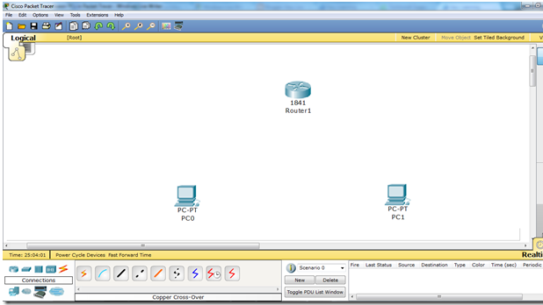

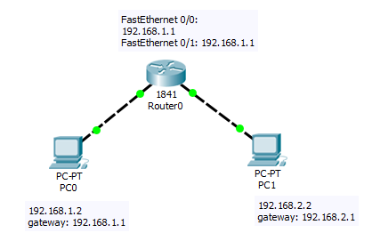

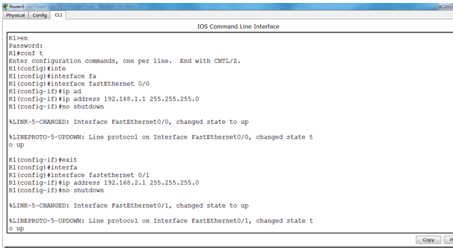

**Output:-**

G:\3-2\computer network\nework lab\pkt file\lab-05(2).PNG

**Description:** After design this protocol in Cisco packet tracer’s workspace. We have set the internet protocol address (IP) at PC0, PC1. Then the protocol will be prepared for required communication via a switch.

**Conclusion:** From this discussion, we have learned that Packet Tracer is a powerful network simulator that can be utilized in training experience troubleshooting without having to buy real Cisco routers or switches. In this report we tried best to understand about Cisco Packet Tracer and represent the simple network using it.