**Lab Report No: 07**

**Lab Report Name: Introduction to** [RIP version 2](http://bangla.salearningschool.com/15-ccna-in-bengali-rip-configuration/) on packet tracer.

**Objectives:**

* The aim of this report is to learn [rip-2 configuration](http://bangla.salearningschool.com/15-ccna-in-bengali-rip-configuration/) using Cisco Packet Tracer .
* Here the ripping properties same as version-1 .

**Description:**

Basically There is no big difference between RIP version 1 and version 2 when we are applying them in packet tracer. In order to apply RIP version 2 on packet tracer. we will just have to add the following command.

* Connect the cross copper wire between router and PCs.
* Select FastEthernet 0/0 and FastEthernet 0/1.
* Set Interface FastEthernet 0/0 IP(gateway) = 192.168.1.1,serial 0/2: 192.168.2.1 and FastEthernet 0/0 IP(gateway) = 192.168.3.1,serial 0/2: 192.168.2.2 and set PC0 IP=192.168.1.2 and PC1 IP = 192.168.3.2 with their corresponding gateway and clock=64000.

**Setting up the cable and router:**

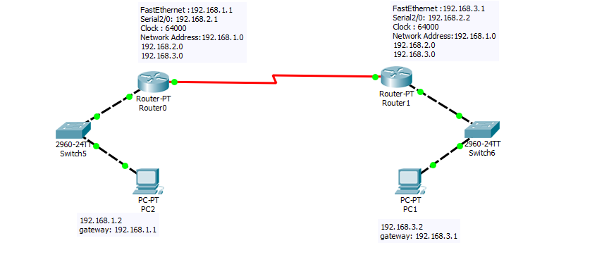

**Command line Configuration :**

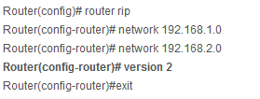

**Output:**

**G:\3-2\computer network\nework lab\pkt file\lab-07(2).PNG**

**Conclusion:**

This lab is not different from previous one here we have also learn how to rip two router with little bit of upgrade version.