**Lab Report No: 08**

**Lab Report Name:** Introduction to Enhanced Interior Gate Way Routing Protocol (EIGRP) on packet tracer.

**Objectives:**

* Here are the basic set of commands that we can apply on router CLI mode in order to apply EIGRP on router.
* This section describes some details about Cisco's EIGRP implementation.

**Description:**

**Some question on EIGRP:**

### How much bandwidth and processor resources does EIGRP use?

The bandwidth utilization issue has been addressed by implementing partial and incremental updates. Therefore, only when a topology change occurs does routing information get sent. Regarding processor utilization, the feasible successor technology greatly reduces the total processor utilization of an AS by requiring only the routers that were affected by a topology change to perform the route recomputation. Furthermore, the route recomputation only occurs for routes that were affected. Only those data structures are accessed and used. This greatly reduces search time in complex data structures.

**Does IP-EIGRP support aggregation and variable length subnet masks?**

Yes it does. IP-EIGRP performs route aggregation the same way IGRP does. That is, subnets of an IP network are not advertised over another IP network. The subnet routes are summarized into a single network number aggregate. In addition, IP-EIGRP will allow aggregation on any bit boundary in an IP address and can be configured at network interface granularity.

**Does EIGRP support areas?**

No, a single EIGRP process is analogous to an area of a link-state protocol. However, within the process, information can be filtered and aggregated at any interface boundary. If one wants to bound the propagation of routing information, multiple routing processes can be configured to achieve a hierarchy. Since DUAL itself limits route propagation, multiple routing processes are typically used to define organizational boundaries.

**Now, we are going to apply EIGRP on the following topology.**

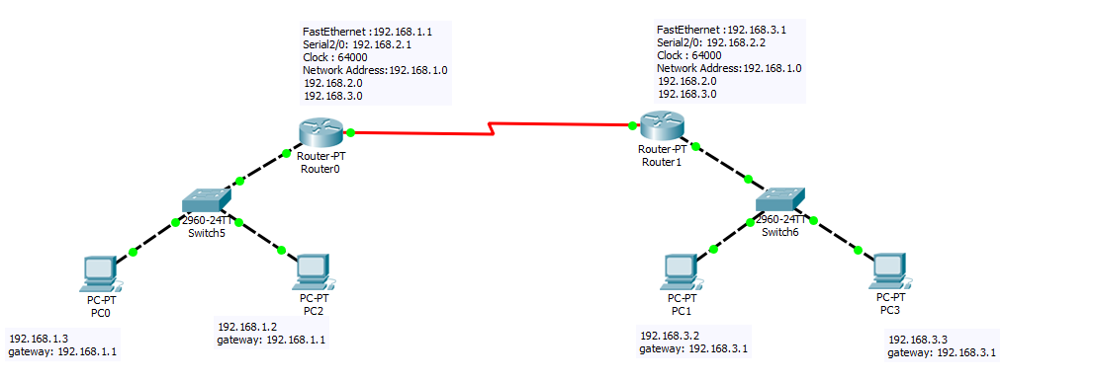

G:\3-2\computer network\nework lab\pkt file\lab-08(2).PNG

**CLI command for EIGRP:**

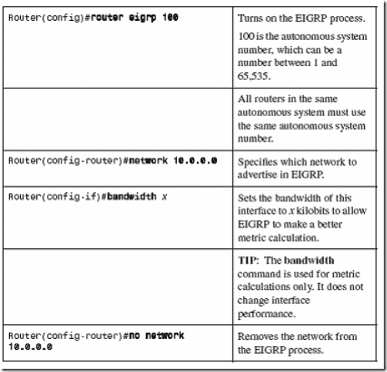

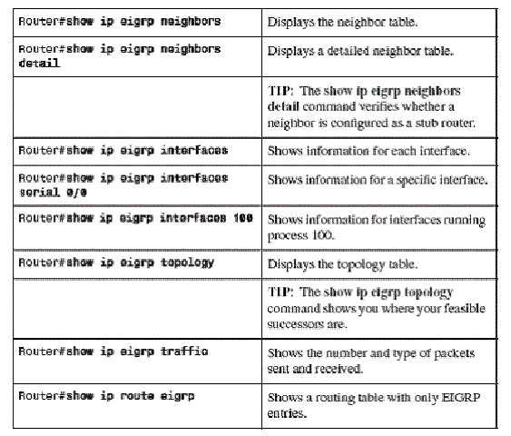

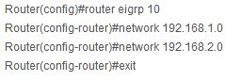

SO here the EIGRP is applied here in packet tracer.

**Conclusion:** EIGRP is an enhanced version of IGRP. The same distance vector technology found in IGRP is also used in EIGRP, and the underlying distance information remains unchanged.