**Lab Report No: 09**

**Lab Report Name: Introduction to DHCP on packet tracer.**

**Objectives:**

* **To learn about Dynamic Host Configuration Protocol**
* **To learn how client/server protocol that automatically provides an Internet Protocol(IP) host with its IP address.**

**Working Procedure:**

**Let’s apply DHCP on packet tracer.**

**First, let us make a topology with one router on which we will apply DHCP and several client PCs. More like this one,**

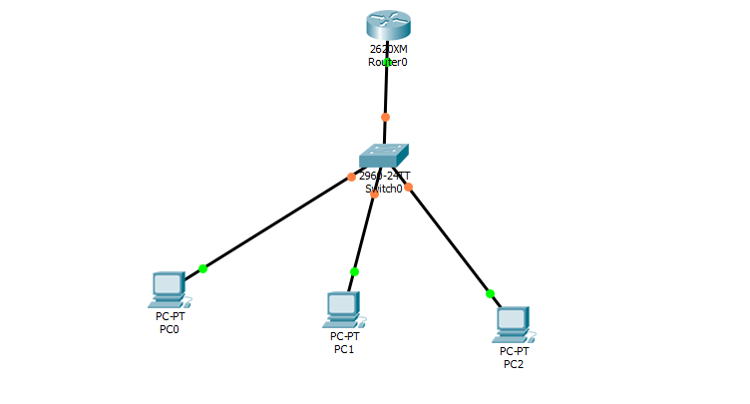

**The commands in sequence are as follows.**

|  |
| --- |
| **Router>enable**  **Router#configure terminal**  **Enter configuration commands, one per line. End with CNTL/Z.**  **Router(config)#hostname DHCP-Router**  **DHCP-Router(config)#ip dhcp pool CSL**  **DHCP-Router(dhcp-config)#network 192.168.1.0 255.255.255.0**  **DHCP-Router(dhcp-config)#default-router 192.168.1.1**  **DHCP-Router(dhcp-config)#dns-server 192.168.1.254**  **DHCP-Router(dhcp-config)#exit**  **DHCP-Router(config)#ip dhcp excluded-address 192.168.1.1 192.168.1.10**  **DHCP-Router(config)#ip dhcp excluded-address 192.168.1.254**  **DHCP-Router(config)#interface fastEthernet 0/0**  **DHCP-Router(config-if)#no shutdown**  **%LINK-5-CHANGED: Interface FastEthernet0/0, changed state to up**  **%LINEPROTO-5-UPDOWN: Line protocol on Interface FastEthernet0/0, changed state to up**  **DHCP-Router(config-if)#ip address 192.168.1.1 255.255.255.0**  **DHCP-Router(config-if)#exit**  **DHCP-Router(config)#exit**  **DHCP-Router#**  **%SYS-5-CONFIG_I: Configured from console by console**  **DHCP-Router#show running-config**  **Building configuration...**  **Current configuration : 663 bytes**  **!**  **version 12.4**  **no service timestamps log datetime msec**  **no service timestamps debug datetime msec**  **no service password-encryption**  **!**  **hostname DHCP-Router**  **!**  **!**  **!**  **!**  **ip dhcp excluded-address 192.168.1.1 192.168.1.10**  **ip dhcp excluded-address 192.168.1.254**  **!**  **ip dhcp pool CSL**  **network 192.168.1.0 255.255.255.0**  **default-router 192.168.1.1**  **dns-server 192.168.1.254**  **!**  **DHCP-Router#**  **DHCP-Router#copy running-config startup-config**  **DHCP-Router#**  **DHCP-Router#**  **DHCP-Router#copy running-config startup-config**  **Destination filename [startup-config]?**  **Building configuration...**  **[OK]**  **DHCP-Router#show ip dhcp binding**  **IP address Client-ID/ Lease expiration Type**  **Hardware address**  **192.168.1.11 000C.CF91.B463 -- Automatic**  **192.168.1.12 000C.CF9E.177E -- Automatic**  **192.168.1.13 0050.0F66.1E90 -- Automatic**  **192.168.1.14 0004.9AA5.295C -- Automatic**  **DHCP-Router#** |

**Now, open the PC and Click on IP Configuration**

**Select from Static to DHCP And after DHCP request is completed you will see the following screen**

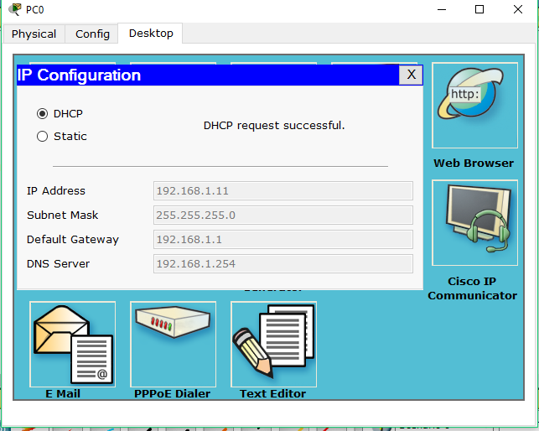

**That is all, we have applied DHCP on packet tracer.**

**OUTPUT:**

**G:\3-2\computer network\nework lab\pkt file\lab-09(12).PNG**

**Conclusion:**

DHCP allows a computer to join an IP-based network without having a pre-configured IP address. DHCP is a protocol that assigns unique IP addresses to devices, then releases and renews these addresses as devices leave and re-join the network.