**Lab Report No:10**

**Lab Report name:** DHCP on PT through Server

**Objectives:**

* Assigning IP addresses automatically through a router to some terminals implementing DHCP on PT through server.

**Requirments:**

* A router.
* Some terminals.
* A server.

**Description:**

DHCP stands for Dynamic Host Configuration Protocol. **DHCP** is a superset of the BootP protocol. This neans that it uses the same protocol structure as **BootP**, but it has enhancements added. Both of these protocols use servers that dynamically configure clients when requested. Two major enhancements are address pools and lease times.

We have designed the following network topology where each of the terminals gets their **IP** address automatically through the router or the server by **DHCP** protocol.

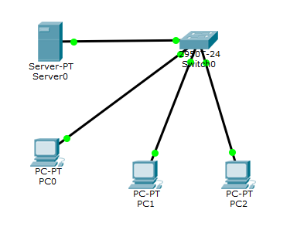

Fig: A network in which **DHCP** protocol

Let’s have a look the commands we used to configure **DHCP protocol**.

Router>en

Router#config t

Router(config)#interface FastEthernet0/0

Router(config-if)#ip address 192.168.10.1 255.255.255.0

Router(config-if)#no shutdown

Router(config)#ip dhcp excluded-address 192.168.10.1

Router(config)#ip dhcp excluded-address 192.168.10.2

Router(config)#ip dhcp pool ICT

Router(dhcp-config)#network 192.168.10.0 255.255.255.0

Router(dhcp-config)#default-router 192.168.10.1

Router(dhcp-config)#dns-server 192.168.10.2

Router(dhcp-config)#exit

Router(config)#exit

%SYS-5-CONFIG_I: Configured from console by console

Router#exit

**Output :**

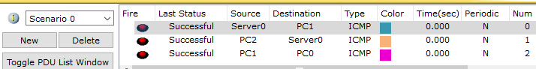

**Conclusion:**

DHCP is a very efficient protocol or method by which a large number of terminals in a network can be assigned with their IP addresses automatically from router or server. Here we used router to implement DHCP. Although this can be done by using a server.