DevOps Fundamentals [Spring, 2026]
Assignment 04 – CI/CD Pipeline Integration
Total Marks: 100 | Weeks Covered: 10 – 14 | CLO: CLO2

OBJECTIVES
Students will design and implement a complete CI/CD pipeline for a containerized web application by integrating a CI workflow (triggered on a Pull Request) with a CD workflow (triggered on a merge/push to the develop branch). The assignment covers creating a fresh GitHub repository, versioning the assignment document, configuring GitHub Environments, managing secrets, and chaining two GitHub Actions workflows.

By the end of this assignment, students will be able to:
- Create a new GitHub repository from scratch and establish a proper branching strategy.
- Version the assignment question paper inside the GitHub repository.
- Create and configure a GitHub Development Environment with appropriate secrets.
- Design and implement a CI workflow triggered by a Pull Request targeting the “develop” branch.
- Design and implement a CD workflow triggered by a push event on the “develop” branch.
- Verify end-to-end automated delivery from a code push to a live deployment on Render.

IMPORTANT INSTRUCTIONS
- Group Size: Five (5) students per group (can be six members but in that case TL has to create an additional page for that member and then assign all tasks accordingly)
- Team Lead (TL): One student will act as the Team Lead; others will be Team Members.
- New Repository: Students MUST create a brand-new GitHub repository for this assignment. Do NOT reuse or fork any repository from a previous assignment.
- Assignment Document in Repo: The Assignment 04 question paper (this .docx file) must be committed to the root of the repository. Each student must fill in their own details in their respective row in Table 1 (Group Details) directly inside the versioned document.
- Secrets Ownership: All GitHub secrets (DOCKERHUB_USERNAME, DOCKERHUB_TOKEN, RENDER_DEPLOY_HOOK_URL) must be created by the Team Lead using the TL's own Docker Hub and Render credentials. No team member other than the TL should create or modify secrets.
- All deployments MUST be triggered via the GitHub Actions CD pipeline. Manual deployment on Render is NOT allowed after the initial service setup.
- Only the Team Lead will submit the final document to the LMS.
- Plagiarism will result in ZERO marks for all involved members.
- Each team member must work on their own feature branch and open a Pull Request (PR) targeting the “develop” branch.

GROUP DETAILS
Table 1: Group Details , Each student must fill their own row (including Assigned Page) in the versioned copy inside the repo
Sr # | Student Name | GitHub Username | Role (Lead/Member) | Assigned Page | Branch Worked On | Screenshots Added (Yes/No)
1 | Abdul Rahman Asad | asad1git | Team Lead | index | Main, Develop | YES
2 | Arma Sajjad |  | Member | about | develop | YES
3 | Mohsin Ali | mohsin0165 | Member | add-task | develop | YES
4 | Abdul Ahad |  | Member | contact | develop | YES
5 | Minahil Fatima |  | Member | task-detail | develop | YES
6 | Noor Fatima | noorfatima-22 | Member | task-list | develop | YES
7 | Talha Khurram | talhakhurram1 | Member | faq | develop | YES

Group Repository URL:
https://github.com/asad1git/taskflow-cicd
Deployed Application URL:
https://taskflow-cicd-pwyt.onrender.com/

SCENARIO
Your team is the development crew for TaskFlow, a lightweight task-management web application consisting of five HTML pages. The Team Lead sets up the repository, Dockerfile, shared stylesheet, and the CI/CD pipelines. Each team member is then individually responsible for building one specific page of the application, following the full Git, GitHub, and Docker flow independently.

The 5 pages of the TaskFlow application and their assignment are defined in Table 3 below. The Team Lead takes Page 1 (Home / Dashboard) in addition to their setup responsibilities.

Table 3: TaskFlow Page Assignment
Sr # | Page File | Page Name | Page Responsibility
1 | index.html | Home / Dashboard | Overview of all tasks: summary counts (total, pending, completed), a welcome message, and navigation links to all other pages.
2 | add-task.html | Add Task | An HTML form allowing the user to enter a new task , fields for task title, description, due date, and priority (High / Medium / Low).
3 | task-list.html | Task List | A table listing all tasks with columns for title, due date, priority, and status. Includes basic filter buttons (All / Pending / Completed).
4 | task-detail.html | Task Detail | A page displaying the full details of a single selected task, with an option to mark it as complete or delete it.
5 | about.html | About / Help | A page describing the TaskFlow application, its purpose, and a simple usage guide explaining how to navigate and use the app.

Each member's individual workflow:
- Create a personal feature branch from “develop” using the naming convention: feature/<member-github-username>/<page-name> (e.g., feature/ali-hassan/add-task).
- Build the assigned HTML page with appropriate content and link it to the shared style.css.
- Commit the page file and push the feature branch to GitHub.
- Open a Pull Request (PR) targeting the “develop” branch. This triggers the CI workflow automatically.
- Once CI passes and the PR is reviewed and approved, the Team Lead merges the PR. The merge generates a push event on “develop”, which triggers the CD workflow and deploys the updated application to Render.

Complete automated flow: Feature Branch → PR opened → CI builds & pushes Docker image → PR merged → push on “develop” → CD deploys to Render → Live TaskFlow updated with the new page.

REPOSITORY SETUP (NEW REPO FROM SCRATCH)
The Team Lead must complete the following setup steps before the team starts working:
- Create a new public GitHub repository named taskflow-cicd (or a name agreed by the team). Do NOT clone or fork any existing repository.
- Create a “develop” branch from 'main' and set it as the default working branch.
- Apply Branch Protection Rules on “develop”: require at least one PR review and require the CI status check to pass before merging.
- Team Lead: Sign up on Render (render.com), create a new Web Service connected to the Docker Hub image repository, and copy the deploy hook URL from the Render service settings. This URL will be stored as the RENDER_DEPLOY_HOOK_URL secret.
- Commit the Assignment 04 question paper (this .docx file) to the root of the repository. Each team member must then update Table 1 with their own details in the file and commit to their feature branch.

Required repository structure:
Table 2: Expected Repository Structure
File / Folder | Purpose
index.html | Home / Dashboard page , created by Member 1
add-task.html | Add Task page , created by Member 2
task-list.html | Task List page , created by Member 3
task-detail.html | Task Detail page , created by Member 4
about.html | About / Help page , created by Member 5
style.css | Shared stylesheet , consistent look across all pages
Dockerfile | Dockerfile to containerize the application (nginx-based)
.github/workflows/ci.yml | CI workflow – triggered on Pull Request to “develop”
.github/workflows/cd.yml | CD workflow – triggered on push (merge) to “develop”
Assignment_04_Spring2026.docx | This assignment question paper (versioned in repo)

GITHUB DEVELOPMENT ENVIRONMENT & SECRETS (MANDATORY)
The Team Lead (TL) is responsible for creating all secrets listed below. The TL is the repository admin and the credentials in use , Docker Hub and Render , belong to the TL's accounts. No other team member should create or modify these secrets.

1. GitHub Environment
  - Go to: Repository → Settings → Environments → New environment
  - Environment Name: development

2. Required Secrets
Table 4: Secrets Configuration Reference
Scope | Secret Name | Value / Description
Repository | DOCKERHUB_USERNAME | Team Lead's Docker Hub account username
Repository | DOCKERHUB_TOKEN | Team Lead's Docker Hub Personal Access Token (PAT) , generated from the TL's Docker Hub account
Environment (development) | RENDER_DEPLOY_HOOK_URL | Deploy-hook webhook URL from the Render web service created by the Team Lead

All three secrets must be created by the Team Lead, as the TL is the repository admin and the credentials belong to them. DOCKERHUB_USERNAME and DOCKERHUB_TOKEN must be the Team Lead's own Docker Hub credentials, added as repository-level secrets (Settings → Secrets and variables → Actions → Repository secrets). RENDER_DEPLOY_HOOK_URL is obtained from the Render web service set up by the Team Lead and must be added as an environment-level secret inside the “development” environment (Settings → Environments → development → Add secret).

CI PIPELINE REQUIREMENTS (.github/workflows/ci.yml)
Trigger: The CI workflow must be triggered by a pull_request event targeting the “develop” branch only.

The CI workflow must include the following steps in order:
- Step 1 – Checkout: Check out the repository code using actions/checkout.
- Step 2 – Docker Login: Authenticate with Docker Hub using the DOCKERHUB_USERNAME and DOCKERHUB_TOKEN repository secrets.
- Step 3 – Build Image: Build the Docker image from the Dockerfile in the project root.
- Step 4 – Tag Image: Tag the image using a meaningful strategy , at minimum the 'latest' tag; optionally also tag with the short commit SHA (github.sha).
- Step 5 – Push Image: Push the tagged image to Docker Hub.

Additional requirements:
- The workflow must fail the entire run if any step fails, preventing a broken image from being available for deployment.
- The CI status check must appear as a required check in the Branch Protection Rules on “develop”.

CD PIPELINE REQUIREMENTS (.github/workflows/cd.yml)
Trigger: The CD workflow must be triggered by a push event on the “develop” branch. This push event occurs automatically when a Pull Request is merged into “develop”.

The CD workflow must include the following steps in order:
- Step 1 – Checkout: Check out the repository code using actions/checkout.
- Step 2 – Declare Environment: The job must specify environment: development so that the RENDER_DEPLOY_HOOK_URL environment-level secret is made available to the job.
- Step 3 – Deploy: Send an HTTP POST request to the Render deploy hook URL using curl:
  - curl -X POST ${{ secrets.RENDER_DEPLOY_HOOK_URL }}
- Step 4 – Confirm: Output a timestamped deployment confirmation message as the final step.

Additional requirements:
- The CD workflow file must declare runs-on: ubuntu-latest.
- The job must NOT contain any Docker build or push steps , that responsibility belongs exclusively to the CI workflow.

WORKFLOW OVERVIEW SUMMARY
Table 5: Workflow Design Reference
Workflow File | Trigger | Key Steps
ci.yml | pull_request event targeting “develop” branch | Checkout → Docker Login → Build Image → Tag → Push to Docker Hub
cd.yml | push event on “develop” branch (i.e., when a PR is merged) | Checkout → Use “development” environment → curl POST to RENDER_DEPLOY_HOOK_URL

MANDATORY TASKS
- Create a new GitHub repository from scratch (taskflow-cicd or team-agreed name). Do NOT reuse any previous repository.
- Team Lead: Set up the initial repository structure , create “develop” branch, commit the shared style.css, Dockerfile, and a skeleton index.html (Home / Dashboard page).
- Commit the Assignment 04 question paper (.docx) to the root of the repository. Every team member must fill in their details , including their Assigned Page , in their row in Table 1 in the versioned document.
- Team Lead: Create a GitHub Environment named “development” and configure all three secrets , DOCKERHUB_USERNAME and DOCKERHUB_TOKEN (TL's own Docker Hub credentials) as repository-level secrets, and RENDER_DEPLOY_HOOK_URL (from TL's Render service) as an environment-level secret inside “development”.
- Team Lead: Apply Branch Protection Rules on the “develop” branch requiring CI to pass before merging.
- Create the CI workflow at .github/workflows/ci.yml , triggered on pull_request targeting “develop”.
- Create the CD workflow at .github/workflows/cd.yml , triggered on push to “develop”.
- Each team member must independently complete the following full DevOps flow for their assigned page (refer to Table 3):
  - Create a feature branch: feature/<github-username>/<page-name>
  - Build the assigned HTML page with proper content and link it to style.css
  - Commit the page and push the feature branch to GitHub
  - Open a Pull Request (PR) targeting “develop” , verify CI workflow fires and passes
  - Request a review; after approval the Team Lead merges the PR , verify CD fires and deploys
- After all 5 PRs are merged, verify the live TaskFlow application on Render contains all five pages and navigation between them works correctly.
- Capture all mandatory screenshots (see Submission Requirements).

TASKS & MARKING SCHEME
Table 6: Marks Breakdown
Sr # | Task Description | Max Marks
 | Repository Setup & Assignment Versioning | 10 Marks
1 | Create a new GitHub repository from scratch (do NOT reuse any previous assignment repo) | 05
2 | Version the Assignment 04 question paper (Assignment_04_Spring2026.docx) inside the repo root; each member fills their row including Assigned Page | 05
 | GitHub Development Environment & Secrets Setup | 10 Marks
3 | Create a GitHub Environment named “development” | 03
4 | Configure repository-level secrets: DOCKERHUB_USERNAME, DOCKERHUB_TOKEN (Team Lead's credentials) | 04
5 | Configure environment-level secret: RENDER_DEPLOY_HOOK_URL (Team Lead's Render service) inside “development” | 03
 | Individual Page Development (Full Git & GitHub Flow) | 25 Marks
6 | Each member creates their feature branch using the correct naming convention (feature/<username>/<page-name>) | 05
7 | Each member builds their assigned HTML page with appropriate content, linked to shared style.css | 10
8 | Each member opens a PR targeting “develop”; PR description is meaningful and CI passes before merge | 10
 | CI Pipeline – Build & Push Docker Image (ci.yml) | 25 Marks
9 | CI workflow file created at .github/workflows/ci.yml with correct pull_request trigger targeting “develop” | 07
10 | Checkout code, login to Docker Hub using Team Lead's repository secrets | 06
11 | Build Docker image and tag correctly (latest and/or commit SHA) | 06
12 | Push image to Docker Hub successfully; workflow exits on any step failure | 06
 | CD Pipeline – Automated Deployment to Render (cd.yml) | 20 Marks
13 | CD workflow file created at .github/workflows/cd.yml with correct push trigger on “develop” | 06
14 | Job declares environment: development and accesses RENDER_DEPLOY_HOOK_URL correctly | 07
15 | Deploy step invokes Render webhook via curl POST; deployed app on Render contains all 5 pages | 07
 | End-to-End Verification, Screenshots & Reflection | 10 Marks
16 | Screenshots: CI run, Docker Hub image with tags, CD run, live Render URL with all 5 pages visible | 05
17 | Individual reflection (4–5 lines per member) on CI/CD integration and page development experience | 05
 | TOTAL | 100 Marks

SUBMISSION REQUIREMENTS
The Team Lead must submit the following on LMS:
- Completed Assignment 04 document with all group details filled in (including each member's Assigned Page).
- GitHub repository URL (must be public or shared with the instructor).
- Render live application URL.
- Screenshot 1: GitHub “development” Environment showing all three secrets configured.
- Screenshot 2: Each member's CI workflow run triggered by their individual PR , all steps green (one screenshot per member, or a combined view).
- Screenshot 3: Docker Hub repository page showing the pushed image with correct tags.
- Screenshot 4: CD workflow run triggered by a push to “develop” , deploy step completed.
- Screenshot 5: Live TaskFlow application on Render showing all five pages are accessible.
- Screenshot 6: The Assignment 04 .docx file visible in the GitHub repository file listing.
- Individual reflection: Each team member must write 4–5 lines on what they learnt and any challenges they faced.

VERIFICATION SCREENSHOTS
Paste your verification screenshots in the table below. Label each one clearly.
Screenshot Label | Screenshot (Paste Here)
GitHub “development” Environment & All Secrets | 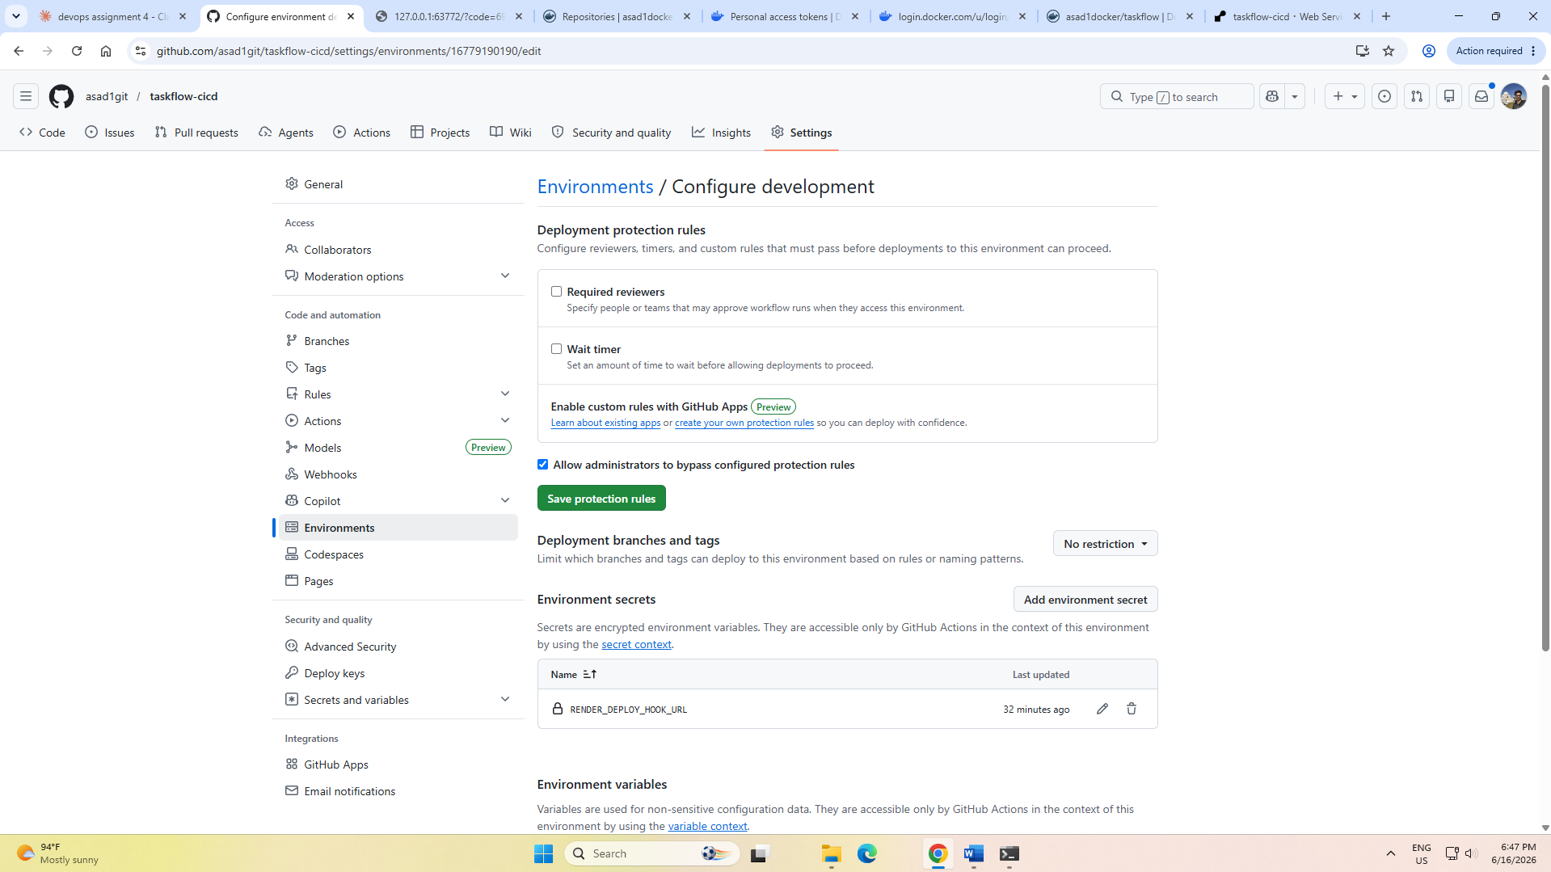
CI Workflow Runs – Triggered by each member's PR (all steps green) | 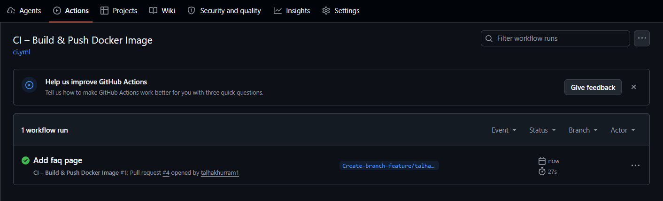
Docker Hub – Pushed Image with Tags | 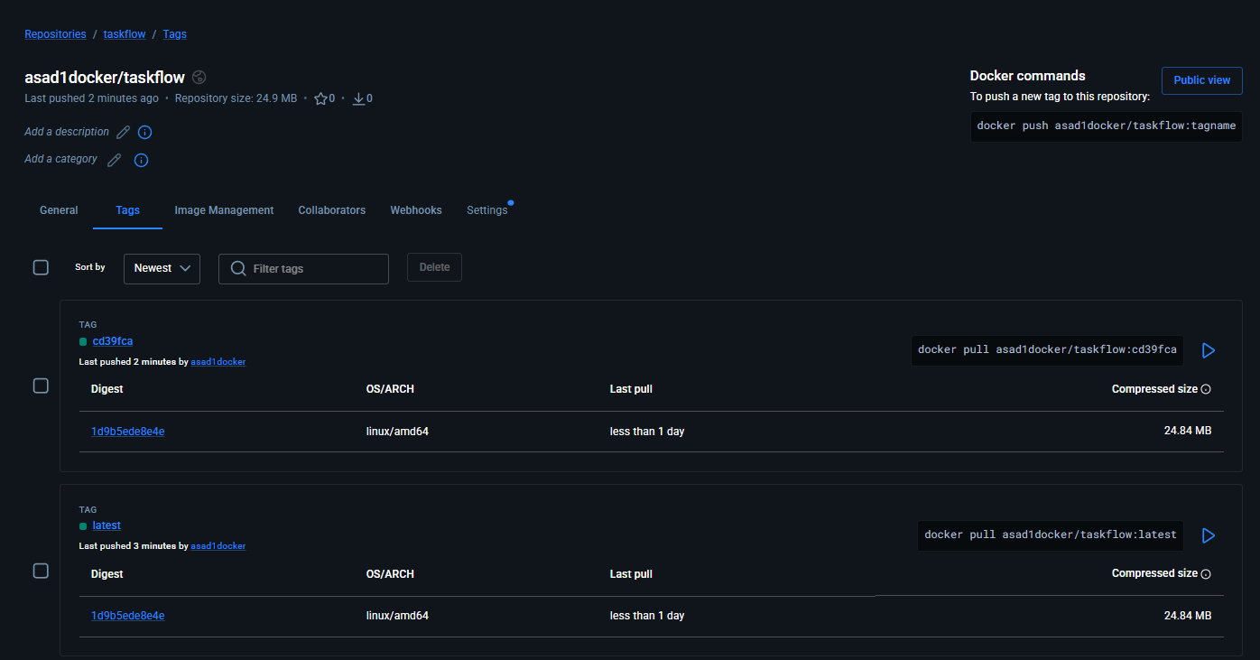
CD Workflow Run – Triggered by Push to “develop” | 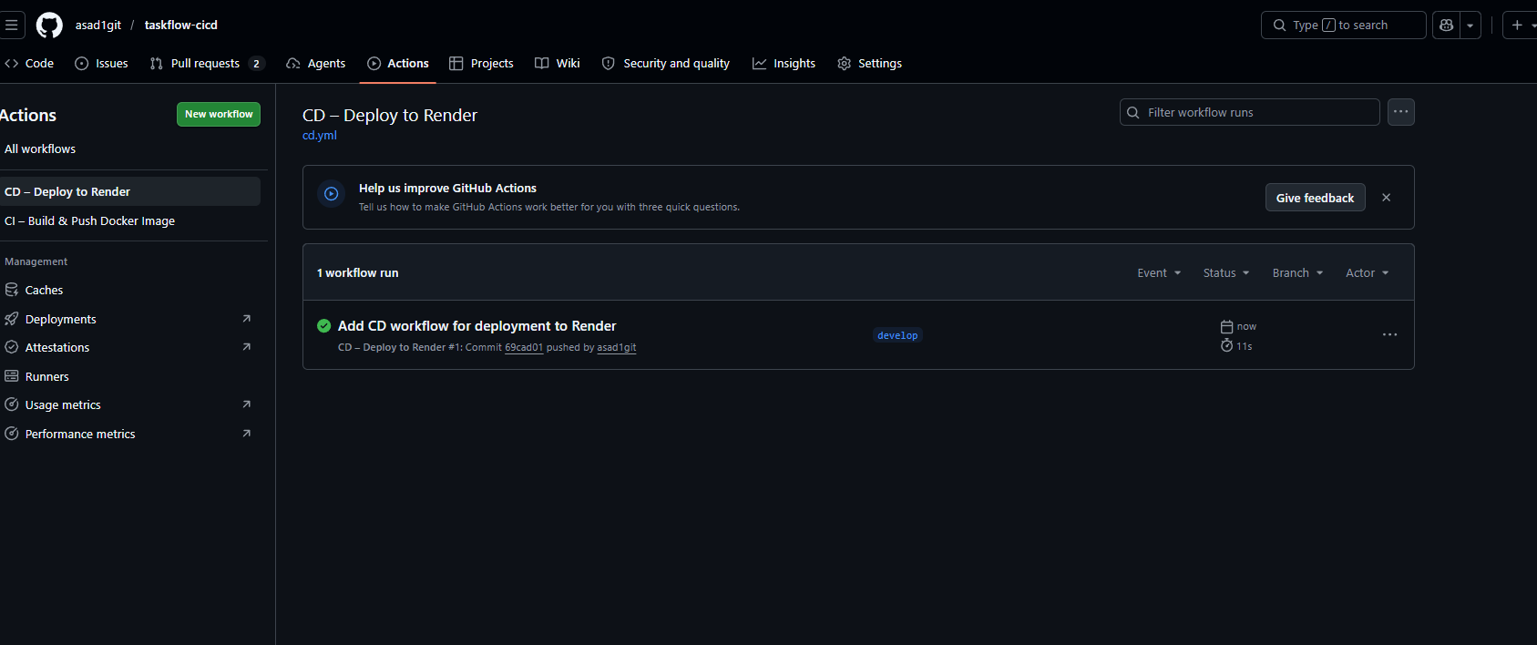
Live TaskFlow on Render – All 5 Pages Accessible | 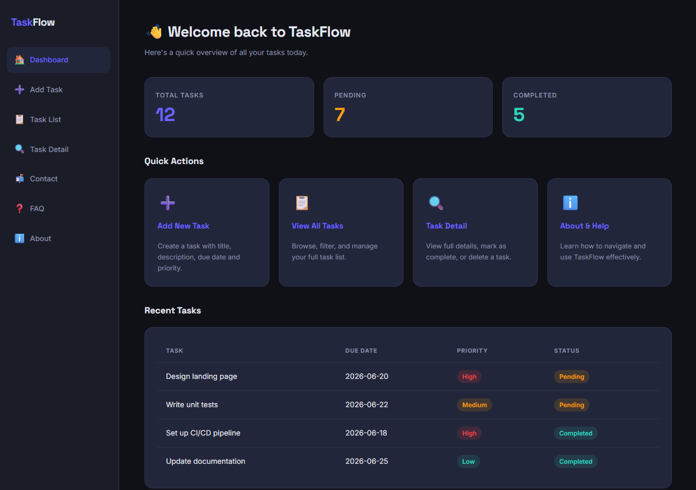
Assignment 04 .docx Visible in GitHub Repo | 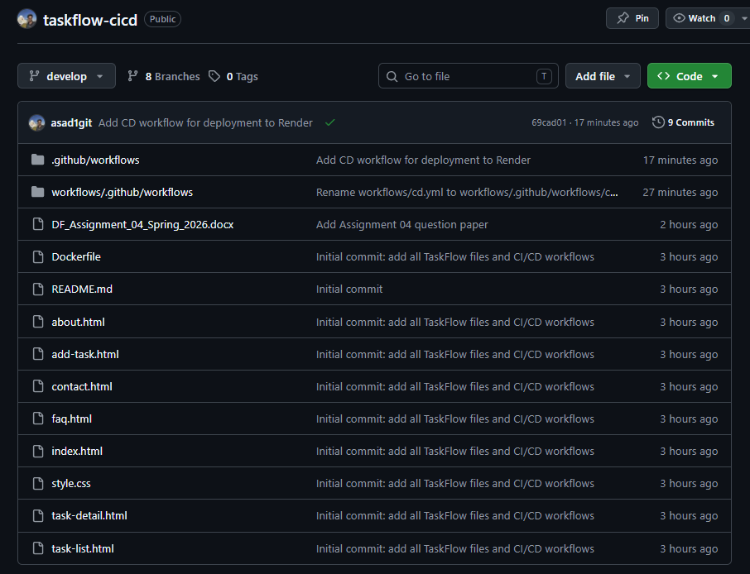

TEAM REFLECTION
Each team member must individually write 4–5 lines covering: what was learnt, the most challenging part of the assignment, and how the team resolved it.
Member 1 (Name: __Abdul Rahman Asad_____________________________________________)
In this assignment, I learnt how to set up a complete CI/CD pipeline using GitHub Actions, Docker Hub, and Render from scratch. As Team Lead, I was responsible for creating the repository, configuring secrets, setting up the GitHub Environment, and writing both the CI and CD workflow files. The most challenging part was managing branch protection rules while also ensuring all team members could contribute smoothly through Pull Requests. I also built the Home Dashboard and FAQ pages, which helped me better understand how a shared stylesheet keeps the application consistent. Our team resolved conflicts by communicating regularly and following a clear branching strategy throughout the project.

Member 2 (Name: __Arma Sajjad_____________________________________________)
Through this assignment I learnt how the Git branching workflow works in a real team setting, specifically creating feature branches and opening Pull Requests targeting a specific branch. I was responsible for building the About and Help page which describes the TaskFlow application and provides a usage guide for new users. The most challenging part for me was understanding how my individual work connects to the automated pipeline — I did not realize that simply merging a PR would trigger a live deployment automatically. The team resolved any confusion by sharing instructions clearly and the Team Lead guided us through each step patiently.

Member 3 (Name: ____Mohsin Ali___________________________________________)
This assignment taught me how containerization works with Docker and how a CI pipeline automatically builds and pushes a Docker image to Docker Hub whenever a Pull Request is opened. I built the Add Task page which includes a form with fields for task title, description, due date, and priority. The most challenging part was setting up Git on my computer for the first time and understanding the difference between the main and develop branches. Our team resolved this by following step by step instructions provided by the Team Lead and running each Git command one at a time carefully.

Member 4 (Name: ____Abdul Ahad___________________________________________)
I learnt how GitHub Actions workflows are structured using YAML files and how secrets are used to securely store sensitive credentials like Docker Hub tokens and Render deploy hook URLs. My contribution was the Contact page which includes a message form with validation and team information. The most challenging part was understanding the role of the GitHub Environment named "development" and why the Render secret had to be stored there specifically rather than as a repository secret. The team resolved this through discussion and by carefully reading the assignment requirements together.

Member 5 (Name: ___Minahil Fatima____________________________________________)
This assignment gave me hands-on experience with the full DevOps workflow, from writing code on a feature branch to seeing it live on Render after the CD pipeline runs. I developed the Task Detail page which displays full task information and allows users to mark a task as complete or delete it. The most challenging part was waiting for the CI checks to pass before the Pull Request could be merged, as I had not worked with automated status checks before. Our team stayed organized by assigning each member a specific page and branch, which prevented conflicts and made the integration process much smoother.

Member 6 (Name: ___Noor Fatima____________________________________________)
Through this assignment I learnt how a CD pipeline automatically deploys an updated application to Render every time a Pull Request is merged into the develop branch, without any manual steps. I was responsible for the Task List page which displays all tasks in a table with filter buttons for All, Pending, and Completed statuses. The most challenging part was understanding the connection between the CI and CD workflows and why they are kept as two separate files with different triggers. Our team resolved confusion by referring to the workflow summary table in the assignment and testing each step carefully before moving to the next.

Member 7 (Name: ___Talha Khurram____________________________________________)
This assignment introduced me to the concept of CI/CD pipelines and how automated workflows can save a lot of time compared to deploying manually every time a change is made. I built the FAQ page for the TaskFlow application which includes commonly asked questions about the app presented in an interactive accordion style layout. The most challenging part for me was understanding how the feature branch connects to the Pull Request and how the CI workflow gets triggered automatically just by opening a PR targeting the develop branch. Our team resolved any issues by staying in close contact and the Team Lead provided clear instructions at every step which made the whole process much easier to follow.

