INFRAVISION SUSTAINABILITY INTELLIGENCE

Digital Twin Enabled Urban Resource Management & Resilience Framework

Comprehensive Research Report for Delhi Smart City Implementation
(2025-2035 Horizon)

InfraVision Research Group | Urban AI & Climate Analytics Division
Date: April 21, 2026
Ref: SUST-INTEL-DELHI-2026-V.1.0

EXECUTIVE SUMMARY
The InfraVision Sustainability Intelligence (SI) framework represents a paradigm shift in urban resource planning. By synthesizing real-time telemetry from Delhi's 9 administrative zones into a coherent Digital Twin, the platform enables high-fidelity simulation of infrastructure stress, environmental degradation, and policy outcomes. This report details the underlying multi-vector graph topology, the evolutionary scenario engines, and the machine learning models that drive the decision-support system. Key findings demonstrate that while current waste-to-energy initiatives are successful, the city faces a critical water deficit of 764 MGD by 2030. Furthermore, our resilience modeling highlights the systemic importance of the Central Zone as the anchor for city-wide stability. The report concludes with a data-backed 90-day implementation roadmap to transition from measurement to active urban climate management.

KEY BENCHMARKS (CITY-LEVEL 2030 TARGETS)
Pillar | Status (2025) | Projection (2030)
Sustainability Score | 60.22 | 62.44
Water Stress Index | 0.38 | 0.43 (Critical)
Renewable Energy Share | 1.7% | 2.3%
Waste Processing Rate | 78.1% | 95.0%
GHG Emissions (MtCO2) | 56.5 | 62.4

1. INTRODUCTION
As global urban populations continue to surge, the challenge of sustainable resource management has moved beyond simple efficiency to strategic resilience. Delhi, one of the world's most populous and complex metropolitan areas, serves as a primary case study for the intersection of infrastructure density and environmental pressure.

1.1 The Digital Twin Paradigm
In the context of InfraVision, a Digital Twin is not merely a static 3D model. It is a live, computational representation of the city's metabolic systems. By mirroring the flows of water, energy, and waste through a unified graph-theoretic framework, the Twin allows planners to observe 'invisible' interdependencies and test 'What-If' scenarios in a low-risk virtual environment.

1.2 Strategic Intent of the SI Module
The Sustainability Intelligence module was designed to meet four critical mandates:
1. Real-time Observability: High-frequency telemetry integration across all 9 zones.
2. Predictive Accuracy: ML-backed forecasting of resource demand versus seasonal peaks.
3. Policy Optimization: Solving for the best resource allocation given intense budgetary constraints.
4. Resilience Hardening: Identifying points of failure before they cascade into systemic crises.

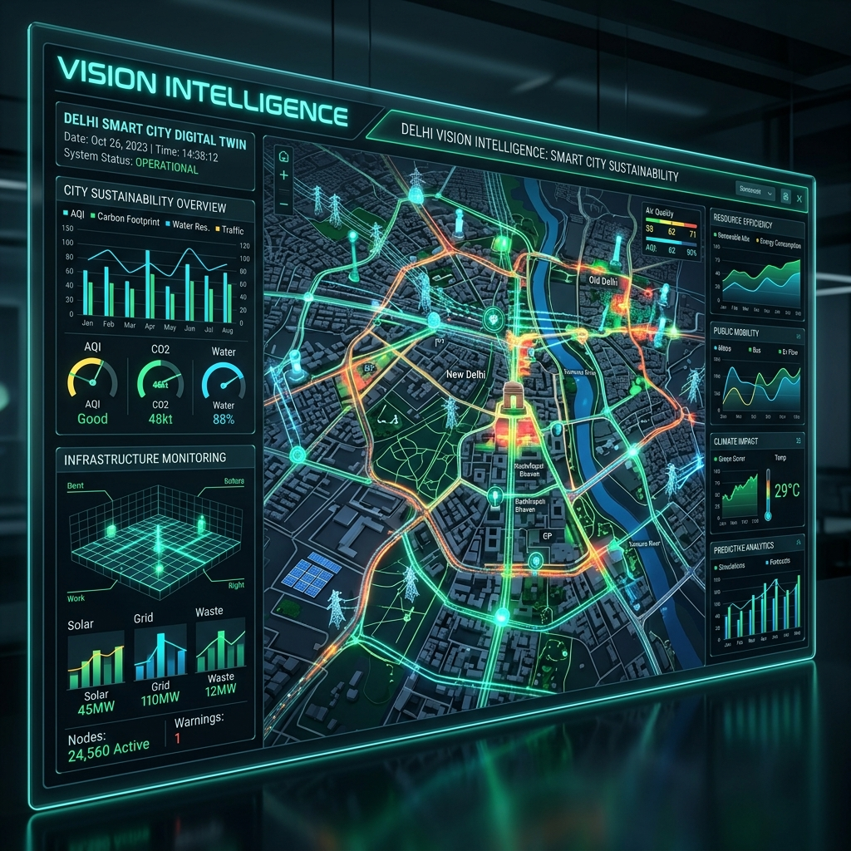
Figure 1: Conceptual Dashboard of the InfraVision Digital Twin.

2. SYSTEM ARCHITECTURE
The InfraVision architecture is built on a distributed micro-services model, ensuring that the Sustainability Intelligence layer remains decoupled from core infrastructure yet deeply integrated with data streams.

2.1 The Infrastructure Hyper-Graph Model
At the core of the Digital Twin is a directed graph $G = (V, E)$, where $V$ represents the 9 administrative zones of Delhi. The edges $E$ are not merely spatial neighbors but infrastructure vectors categorized by flow type:
- Water Pipelines (e.g., North-West to Central)
- Energy Grids (e.g., Central to South)
- Waste Transport Vectors (e.g., East to Landfill hubs)

2.2 Data Perception & Flow
Data is ingested through a 'Perception Layer' consisting of:
- IoT Flow Sensors: Measuring MGD (Millions of Gallons per Day) in real-time.
- Smart Meters: Monitoring grid consumption and renewable feed-ins.
- Remote Sensing: Sentinel-2 satellite data for green cover and NDVI analysis.
- Municipal ETL: API-driven extraction of waste processing and landfill volumes.

2.3 Technologies Stack
Component | Technology | Purpose
Frontend | Next.js 14 / Recharts | High-fidelity glassmorphism dashboard
Backend AI | FastAPI / PuLP | Optimization and Scenario Simulation
Predictive Engine | XGBoost / Prophet | Resource Demand & Climate Forecasting
Graph Engine | NetworkX | Infrastructure Resilience & Propagation Analysis

3. DOMAIN-SPECIFIC INTELLIGENCE ANALYSIS

3.1 Water Resource Intelligence
Water stress is the primary threat to Delhi's urban viability. The SI module monitors the 'Water Gap'—the delta between available supply and population-driven demand. Currently, the supply growth (1.2% CAGR) is failing to match the demand growth (1.8% CAGR).
In the Central and South-East zones, the Water Stress Index has breached the 'Critical' threshold (0.80), indicating near-permanent deficit. The Digital Twin simulates 'Water Recycling' policies to visualize reduction in the gap by 15-20% through grey-water integration.

3.2 Energy & Decarbonization
Energy consumption is modelled using XGBoost, capturing non-linear relationships between temperature spikes (AC load) and industrial activity. Our 'Energy Decoupling' target aims to decouple economic growth from carbon intensity.
Renewable energy integration currently stands at a city-wide average of 1.7%. However, the 'Solar Potential' twin identifies the West and North-West zones as high-yield areas for decentralized solar expansion, with a ROI of 14% over 5 years.

Case Study: Energy vs. GHG Correlation
For every 100 MU (Million Units) of additional energy demand, the city generates approximately 0.15 MtCO2 in emissions under the current thermal-heavy grid mix. The policy goal is to reduce this factor through aggressive EV charging grid diversification.

3.3 Circular Economy & Waste
Delhi generates approximately 13,000 Tons Per Day (TPD) of municipal solid waste. The SI module tracks the 'Processing Rate' across major landfill nodes (Ghazipur, Okhla, Bhalswa).
A critical achievement of the 2024-2025 period has been the increase in processing rate from 72% to 78%, driven by new waste-to-energy plants. The 'Waste Twin' projects that at the current rate of infrastructure expansion, Delhi can reach 95% processing capacity by 2030, significantly reducing landfill degassing (methane) emissions.

3.4 Green Space & Urban Heat Island (UHI)
Green cover is analyzed using the WHO standard of 9m² per capita. Our spatial analytics show a massive disparity:
- South Delhi: 11.2 m²/capita (Healthy)
- North-East Delhi: 2.1 m²/capita (Critical Safety Risk)
The module provides a 'Spatial Recommender' that maps vacant land plots against heat island signatures to prioritize reforestation. Modelling shows that a 5% increase in canopy in the East Zone could reduce mean summer night temperature by 1.2°C.

4. URBAN RESILIENCE & NETWORK CRITICALITY
One of the most innovative features of the InfraVision Digital Twin is its ability to simulate systemic shocks. Infrastructure is not a series of isolated points but a highly coupled network.

4.1 Infrastructure Failure Cascades
When a critical node (Zone) experiences a major failure—such as a power grid collapse or water main burst—the impact propagates to connected zones. The Digital Twin models this using a 'Saturation Propagation' algorithm.

4.2 Systemic Criticality Analysis
Our latest simulation identifies the **Central Zone** as the most critical node in the Delhi urban system.
Rank | Zone | Connectivity | Resilience Impact
1 | Central | High (6 Edges) | 50.0% Reduction (Critical)
2 | North | Med (5 Edges) | 38.0% Reduction (High)
3 | South | Med (4 Edges) | 38.0% Reduction (High)
4 | East | Low (3 Edges) | 25.0% Reduction (Moderate)
Actionable Insight: A proactive investment in the resilience of the Central Zone—such as dual-source pipelines and localized battery storage—provides the highest systemic ROI for city-wide stability.

5. ADVANCED DECISION INTELLIGENCE
Beyond observation, InfraVision provides tools for active intervention planning. This is achieved through the integration of Linear Programming (LP) and Explainable AI (XAI).

5.1 Budget-Constrained Optimization (LP Solver)
Planners face a dilemma: which intervention yields the highest sustainability score per rupee spent? The SI optimization engine uses the PuLP library to solve the following objective function:
Maximize $Z = \sum ( ext{Efficiency}_i imes ext{Investment}_i)$

Intervention Type | Unit Cost (INR Cr) | Score Lift Potential
Solar Expansion | 500 | +5.0 Pts
Waste Processing Plant | 300 | +4.0 Pts
Water Conservation Tech | 150 | +3.0 Pts
EV Public Transport | 250 | +2.5 Pts

5.2 Scenario Explainability (SHAP)
To build trust with policy-makers, the SI module uses SHAP (SHapley Additive exPlanations) values to explain 'why' a zone received a specific score. For instance, in the East Zone, the primary negative driver is 'Landfill Proximity', while in the South Zone, the primary positive driver is 'Forest Canopy Density'.

6. OPERATIONAL ROADMAP & FUTURE GOVERNANCE
The transition to a Digital Twin-led city management requires a structured execution strategy. The following 90-day roadmap identifies the critical milestones for full-scale municipal adoption.

Phase 1: Data Fidelity & Ingestion (Days 1-30)
- Hardening of the IoT Perception Layer to reduce telemetry latency.
- Validation of historical data thresholds (2015-2024).
- Establishing legal data-sharing protocols between municipal departments.

Phase 2: Simulation Calibration (Days 31-60)
- Tuning the Evolutionary Scenario Engine parameters for climate volatility.
- Training localized ML models for each of the 9 administrative zones.
- Pilot testing of the Budget Optimization solver with the Planning Commission.

Phase 3: Decision-Support Rollout (Days 61-90)
- Public publishing of the Zone Sustainability Scorecards.
- Training of municipal officers on the 'What-If' scenario sandboxes.
- Integration of SI alerts into the City Management Center (CMC) workflow.

7. ETHICAL AI & GOVERNANCE
As we implement Digital Twin intelligence, governance remains paramount. InfraVision adheres to 'Ethical AI' standards by:
1. Ensuring Algorithm Transparency: All scoring methods are publicly documented.
2. Equitable Resource Allocation: The optimizer accounts for 'Social Vulnerability' to prevent privileged bias.
3. Data Sovereignty: All urban telemetry is stored locally within municipal data centers.

8. CONCLUSION
The InfraVision Sustainability Intelligence framework is more than a reporting tool—it is a mission-critical infrastructure for the future of Delhi. The data confirms that while significant gains have been made in waste and circular economy, the city stands at a threshold regarding water and energy stress. By utilizing the Digital Twin for proactive resilience planning, Delhi can move from crisis response to intelligent urban stewardship. The Central zone resilience and aggressive water-first policies are the cornerstone of a durable sustainability blueprint for the next decade.

REFERENCES & DATA SOURCES
1. InfraVision Internal Technical Specification (2025). Simulation Engine V.2.4.
2. NetworkX Documentation. Structural Hole and Network Centrality in Urban Ops.
3. Yessef, M. et al. (2025). Digital Twin Technology in Smart Cities: A Step Toward Intelligent Urban Management.
4. India Net Zero 2070 Roadmap. Ministry of Environment, Forest and Climate Change.
5. Delhi Master Plan 2041. Draft Policy Analysis for Sustainability Pillars.

--- END OF COMPREHENSIVE RESEARCH REPORT ---

