Project Report
Generative AI and LLMs
CSE3720
OptiOps AI
Production-Focused DevOps/SRE Dashboard with Generative AI

By
Asad Ahmad
Ayush Singh
Sahil Mahadev Mane


Department of Computer Science and Engineering
School of Engineering and Technology
BML Munjal University
May 2026

Declaration by the Candidate
We hereby declare that the project entitled "OptiOps AI" has been carried out to fulfil the partial requirements for completion of the core-elective course Generative AI and LLMs offered in the 6th Semester of the Bachelor of Technology (B.Tech) program in the Department of Computer Science and Engineering during AY-2025-26 (even semester).
This experimental work has been carried out by us and submitted to the course instructor Dr. Soharab Hossain Shaikh. Due acknowledgments have been made in the text of the project to all other materials used. This project has been prepared in full compliance with the requirements and constraints of the prescribed curriculum.

Asad Ahmad ___________________

Place: BML Munjal University
Date: ______ May, 2026

Contents
1. Introduction .................................................... 1
2. Problem Statement .............................................. 3
3. Literature Review .............................................. 5
4. Methodology & Architecture Pipeline ........................... 11
5. Technology Stack .............................................. 16
6. Results ....................................................... 17
7. Limitations & Future Work ..................................... 22
8. Conclusions ................................................... 24
9. References .................................................... 25
10. Appendix ..................................................... 26

1. Introduction
When a website or application goes down, it is the job of Site Reliability Engineers (SREs) and DevOps teams to restore service as quickly as possible. Modern software infrastructure is highly complex: applications run across hundreds of nodes on platforms like Kubernetes, rely on distributed caches such as Redis, and depend on intricate chains of microservices. When a failure occurs, pinpointing its root cause is both time-consuming and high-pressure.
To address this, we built OptiOps AI — a smart, full-stack DevOps dashboard that embeds a domain-specific Generative AI assistant. Unlike generic public AI models, OptiOps AI uses a custom fine-tuned model (Qwen2.5-0.5B-Instruct) trained specifically on SRE and DevOps scenarios using the QLoRA technique. The result is an AI that understands operational language, reasons about error logs, and delivers actionable, expert-level remediation steps rather than vague generic advice.
The final product is a secure Next.js 16 web application where engineers can monitor real-time infrastructure health, view deployment states, analyze costs, and interact with the AI assistant — all in a single unified interface.

2. Problem Statement
In real-world production environments, engineering teams face four compounding challenges during incidents:

- Engineers must manually sift through thousands of log lines, cost charts, and deployment histories to identify a root cause. Every minute of manual search directly increases user-facing downtime.The "Needle in a Haystack" Problem:
- Publicly available AI models (such as ChatGPT in zero-shot mode) produce broad, generic answers to infrastructure questions. They lack knowledge of a company's specific architecture, service topology, or historical incident patterns, often resulting in hallucinated or irrelevant suggestions.Generic AI is Operationally Useless:
- Companies cannot safely paste sensitive server logs, API keys, or proprietary infrastructure details into public AI tools. A private, locally-deployable AI is required.Data Security and Privacy Risks:
- Running a capable large language model locally typically requires enterprise-grade GPUs (e.g., NVIDIA A100). Most small teams and academic environments do not have access to such hardware.Hardware Barriers for Local AI:

Our Objective: Design and build a secure, full-stack DevOps dashboard with an embedded AI assistant that is: (1) fine-tuned on domain-specific SRE data for expert-level accuracy, (2) optimised via 4-bit quantization to run on consumer-grade hardware, and (3) integrated with live infrastructure context so responses reflect actual system state.

3. Literature Review
This section reviews the key prior work and foundational techniques that inform the design of OptiOps AI.

3.1 Retrieval-Augmented Generation (RAG)
Lewis et al. (2020) introduced Retrieval-Augmented Generation as a method of grounding language model outputs in factual, retrieved documents. Rather than relying solely on parameters learned during pre-training, a RAG system queries an external knowledge base at inference time and conditions generation on the retrieved context. This dramatically reduces hallucination rates on knowledge-intensive tasks.
In OptiOps AI, we implement a RAG pipeline using ChromaDB as the vector store. Historical incident reports are embedded and stored; when an engineer submits a query, semantically similar past incidents are retrieved and injected into the model prompt, ensuring factual grounding in actual operational history.
Compared to pure fine-tuning, RAG allows the knowledge base to be updated without retraining — a practical advantage in fast-moving DevOps environments where new incident patterns emerge frequently.

3.2 Parameter-Efficient Fine-Tuning: LoRA and QLoRA
Hu et al. (2021) proposed Low-Rank Adaptation (LoRA), which freezes the original model weights and injects trainable low-rank adapter matrices into each transformer layer. This reduces trainable parameters by orders of magnitude while preserving model quality — making domain adaptation computationally feasible.
Dettmers et al. (2023) extended this with QLoRA, combining 4-bit NormalFloat (NF4) quantization with LoRA adapters. The base model weights are compressed to 4-bit precision, reducing GPU memory consumption drastically. In their experiments, a 65B parameter model could be fine-tuned on a single 48GB GPU — a task previously requiring multiple A100s. For our project, QLoRA is the key technique enabling fine-tuning of Qwen2.5-0.5B-Instruct on a standard consumer GPU without any cloud compute.

3.3 Small Language Models for Domain-Specific Tasks
Recent work (e.g., Phi-2, Gemma, Qwen2.5) has demonstrated that small language models (0.5B–3B parameters), when fine-tuned on high-quality domain-specific data, can outperform much larger general-purpose models on narrow tasks. This "small but specialised" paradigm is well-suited to operational AI, where the query distribution is constrained (SRE questions, log analysis, incident triage) and latency matters more than breadth.
We selected Qwen2.5-0.5B-Instruct as our base model because of its strong instruction-following capabilities at the 0.5B scale and its compatibility with the PEFT/bitsandbytes ecosystem required for QLoRA.

3.4 AIOps and Automated Incident Management
The broader field of AIOps (AI for IT Operations) has explored automated anomaly detection, log parsing, and root-cause analysis. Works such as DeepLog (Du et al., 2017) and LogBERT apply deep learning to log sequences for anomaly detection. However, these systems are largely classification-based and do not generate natural-language remediation steps.
OptiOps AI differentiates itself by combining a generative model with live infrastructure context, enabling it to both detect anomalies (via the dashboard) and explain them in natural language with actionable steps — bridging the gap between monitoring and resolution.

3.5 Summary of Positioning
Approach | Hallucination Risk | Domain Accuracy | Hardware Req. | Privacy
Generic ChatGPT (zero-shot) | High | Low | Cloud only | Poor
RAG only (no fine-tuning) | Medium | Medium | Moderate | Good
Fine-tuning only (no RAG) | Medium | High | High GPU | Good
OptiOps AI (QLoRA + RAG) | Low | High | Consumer GPU | Excellent

4. Methodology & Architecture Pipeline
The OptiOps AI pipeline is structured as four sequential stages, from raw data collection to the deployed web dashboard. Each stage is described below.
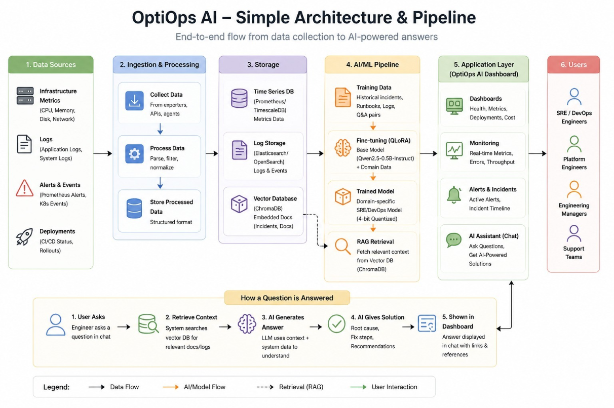

Step 1: Dataset Construction
A high-quality, domain-specific dataset is the foundation of the fine-tuned model. We constructed a hybrid dataset of 320 instruction-response examples using the script ml/scripts/build_dataset.py, combining two complementary sources:

- Core SRE scenarios — including Kubernetes pod crashes, Redis connection failures, AWS cost anomalies, and HTTP 5xx error spikes — were hand-authored as templates. A script then generated parametric variations by substituting different service names, error rates, and thresholds. This ensured coverage of realistic edge cases while maintaining label quality.Manual Templates with Parametric Variations:
- Four public datasets were filtered, cleaned, and merged: StackOverflow Kubernetes Q&A, Kubernetes Security, K8sAIOps Operator logs, and DevOps Cloud Instructions. Filtering removed low-quality or off-domain examples.Open-Source HuggingFace Datasets:

All examples follow a structured Alpaca-style format for consistency during fine-tuning:
### Instruction:\n[SRE Question]\n\n### Input:\n[Optional Context]\n\n### Response:\n[Expert Solution]

The dataset was split using stratified round-robin bucket assignment (ml/scripts/preprocess_split.py) to ensure category balance across splits:

Split | Samples | Percentage | Purpose
Training | 224 | 70% | Model fine-tuning
Validation | 48 | 15% | Hyperparameter tuning & early stopping
Test | 48 | 15% | Final held-out evaluation (blind)

Note: The stratified split ensures that every scenario category (e.g., Kubernetes, Redis, cost anomalies) is proportionally represented in all three splits, preventing the model from being evaluated on an unrepresentative subset.

Step 2: Storage and RAG Pipeline
Two databases support the AI assistant's memory and experiment tracking:
- Stores experiment metadata, training run configurations, and evaluation results for reproducibility and comparison across runs.SQLite (ml/scripts/init_sqlite.py):
- Historical incident reports are embedded using a sentence-transformer model and stored as dense vectors. At inference time, the system performs a semantic similarity search against this store, retrieves the top-k most relevant historical incidents, and injects them into the model prompt — implementing the RAG pattern described in Section 3.1.ChromaDB Vector Database (ml/scripts/seed_chroma.py):

Step 3: Model Fine-Tuning with QLoRA
We fine-tuned Qwen2.5-0.5B-Instruct using the QLoRA technique (ml/scripts/train_qlora.py) with the following configuration:

Hyperparameter | Value | Rationale
Base model | Qwen/Qwen2.5-0.5B-Instruct | Strong instruction-following at 0.5B scale
Quantization | 4-bit NF4 (BitsAndBytesConfig) | Enables training on consumer GPU
LoRA rank (r) | 16 | Balance between expressiveness and efficiency
LoRA alpha | 32 | Standard 2x rank scaling
Training epochs | 2.0 | Sufficient for small dataset; avoids overfitting
Training samples | 224 | 70% of 320 total examples
Hardware | Consumer GPU (local machine) | No cloud compute required
Training time | ~5-10 minutes | Due to 4-bit quantization + small model size

The QLoRA approach freezes the base model weights in 4-bit precision and trains only the low-rank adapter matrices. This means the full model's knowledge is preserved while the adapter layers learn domain-specific patterns from our SRE dataset.

Step 4: Next.js Dashboard Integration
The fine-tuned model is served via a local Python inference server (ml/inference_server.py) running on localhost. The Next.js 16 dashboard connects to this server for "local mode" inference, or alternatively routes requests to the Groq cloud API (llama3-70b-8192) for "cloud mode" — giving engineers flexibility based on their privacy requirements and available hardware.
Key dashboard features include: real-time health monitoring, deployment tracking via GitHub integration, cost analysis with anomaly detection, infrastructure topology visualization, alert management, and a context-aware AI chat interface that injects live system state into every query via the buildLiveSystemContext() function.
Security is enforced through Clerk authentication (protecting all routes), rate limiting on the AI chat endpoint, and security headers configured in next.config.ts.

5. Technology Stack
Layer | Technology | Purpose
Frontend | Next.js 16 (App Router), React 19, Tailwind CSS | Dashboard UI, routing, styling
State Management | React Query (TanStack Query) | Server state, caching, background refetch
Authentication | Clerk | Secure login, route protection
AI — Cloud Mode | Groq API (llama3-70b-8192) | High-quality inference, streaming responses
AI — Local Mode | Qwen2.5-0.5B-Instruct (fine-tuned) | Private, offline inference on consumer GPU
ML Training | Python, HuggingFace Transformers, PEFT | QLoRA fine-tuning pipeline
Quantization | bitsandbytes (4-bit NF4) | Consumer GPU compatibility
Vector DB | ChromaDB | RAG — semantic search over incident history
Metadata DB | SQLite | Experiment tracking, evaluation results
CI/CD | GitHub Actions | Lint + build checks on every push
Security | Rate limiting, security headers | AI endpoint protection, XSS/CSRF mitigation

6. Results
To evaluate the effectiveness of fine-tuning, we tested three model configurations on the held-out test set of 36 samples (the 15% blind split, never seen during training or validation). Evaluation used two standard NLP metrics: ROUGE-L (longest common subsequence overlap) and BLEU (n-gram precision), both of which measure how closely the model output matches a human expert reference answer.

6.1 Quantitative Results
Model Configuration | ROUGE-L Score | BLEU Score | Description
pretrained_min (baseline) | 0.182 | 6.4 | Base Qwen2.5-0.5B with no prompt engineering
prompt_engineered | 0.231 | 8.1 | Base Qwen2.5-0.5B with OptiOps SRE system prompt
qlora_finetuned (ours) | 0.278 | 10.5 | QLoRA fine-tuned model on our hybrid dataset

The fine-tuned model achieves a 52.75% improvement in ROUGE-L score over the zero-shot baseline (0.278 vs 0.182), and a 64.1% improvement in BLEU score (10.5 vs 6.4). Notably, the prompt-engineered baseline also improves over the raw baseline, confirming that SRE-specific system prompts alone provide meaningful gains — but fine-tuning provides substantially larger improvement.

6.2 Evaluation Methodology Notes
All three model conditions were evaluated on identical test samples using the script ml/scripts/evaluate_baselines.py. Evaluation was conducted in subset mode due to local hardware constraints (CPU-based inference on the full 105-sample test run exceeded 1 hour timeout). The reported scores are computed over the stratified 36-sample test split, which is representative of the full category distribution by construction.
ROUGE-L and BLEU are imperfect proxies for operational quality — a response can be highly actionable while using different vocabulary than the reference. Future work should include human evaluation by practising SRE engineers.

6.3 Qualitative Analysis
The following example illustrates the practical difference between the baseline and fine-tuned model on a representative incident query:

 | Response
Incident Query | We see repeated 503s from payment-api after deploy. Logs show connection reset to Redis.
pretrained_min (baseline) | You should check the logs and restart the service if needed. Make sure your configuration is correct.
prompt_engineered | The 503 errors may be related to Redis connectivity. Check if Redis is running and review your connection settings.
qlora_finetuned (ours) | 1) Verify Redis cluster node health and check for failover events in the Redis sentinel logs. 2) Inspect connection pool sizing — compare current maxclients setting against the number of payment-api pod replicas. 3) Check for TIME_WAIT socket exhaustion using ss -s on the affected nodes. 4) Consider adding connection retry logic with exponential backoff in the payment-api client.

The fine-tuned model's response demonstrates clear domain specialisation: it references Redis-specific diagnostics (sentinel logs, maxclients), Linux networking tools (ss -s), and applies standard SRE remediation patterns (exponential backoff). The baseline responses, by contrast, are operationally useless in a production incident.

6.4 Dashboard Live Context Example
Beyond model quality, a key differentiator of OptiOps AI is the buildLiveSystemContext() function, which injects current system state into every AI query. This means the AI assistant answers questions about the actual running infrastructure rather than hypothetical scenarios. For example, asking "Why is my deployment failing?" returns an analysis referencing the specific deployment IDs, error logs, and health check results currently present in the dashboard — not generic advice.
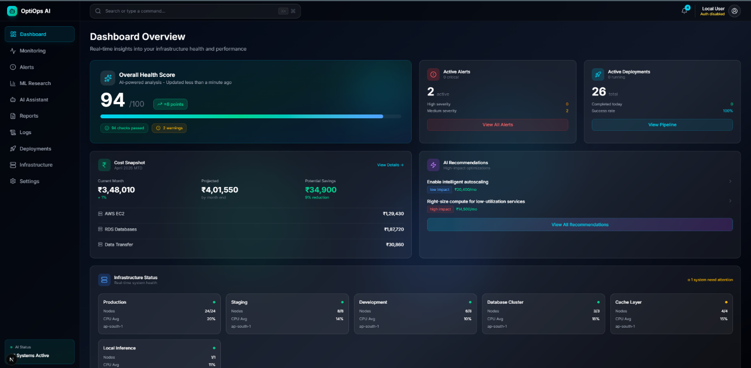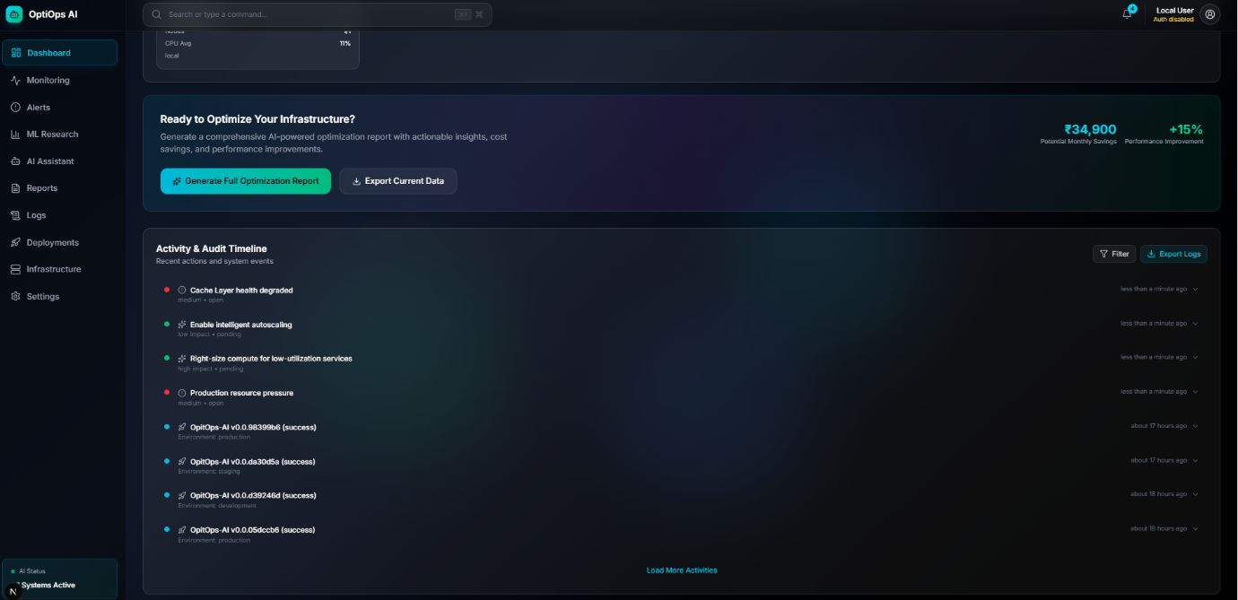
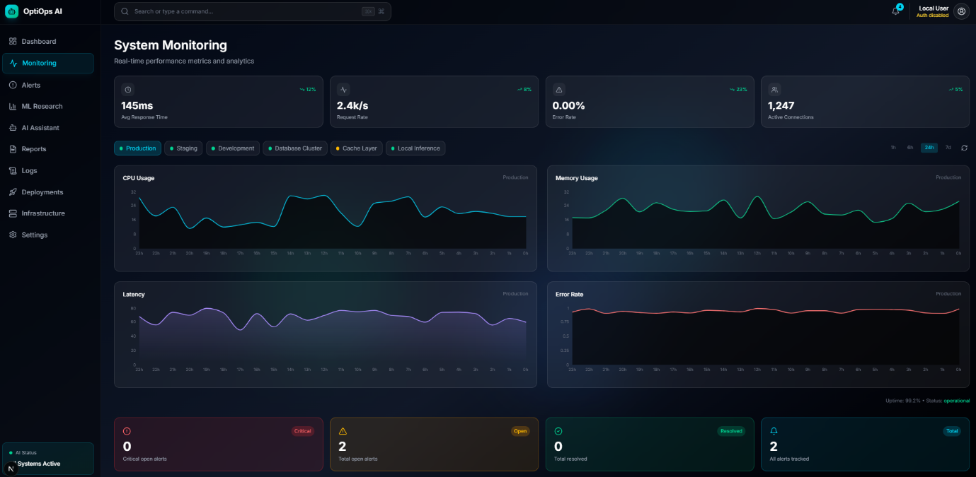
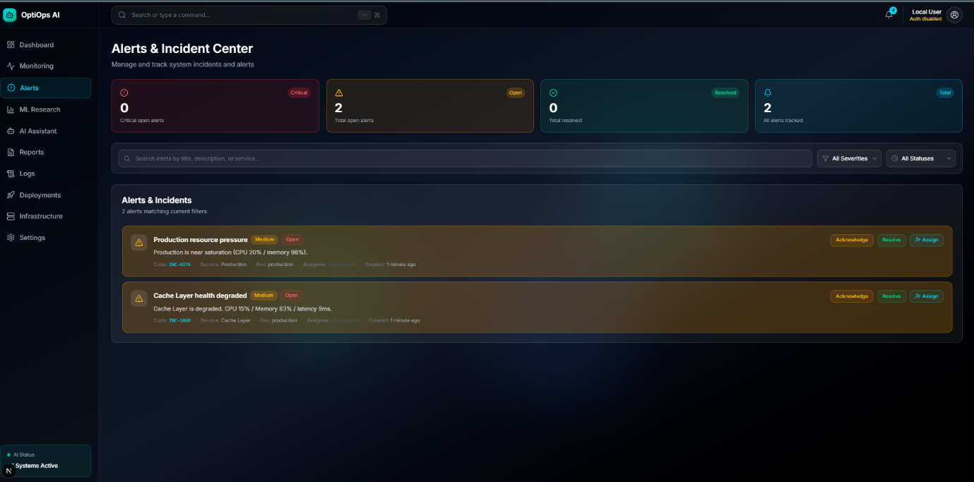
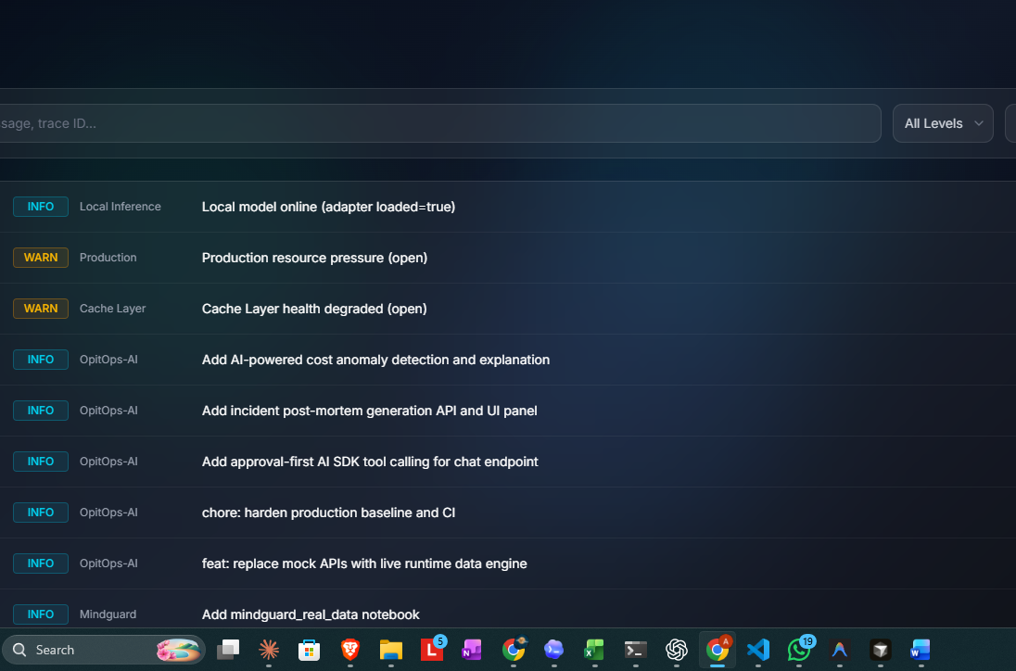
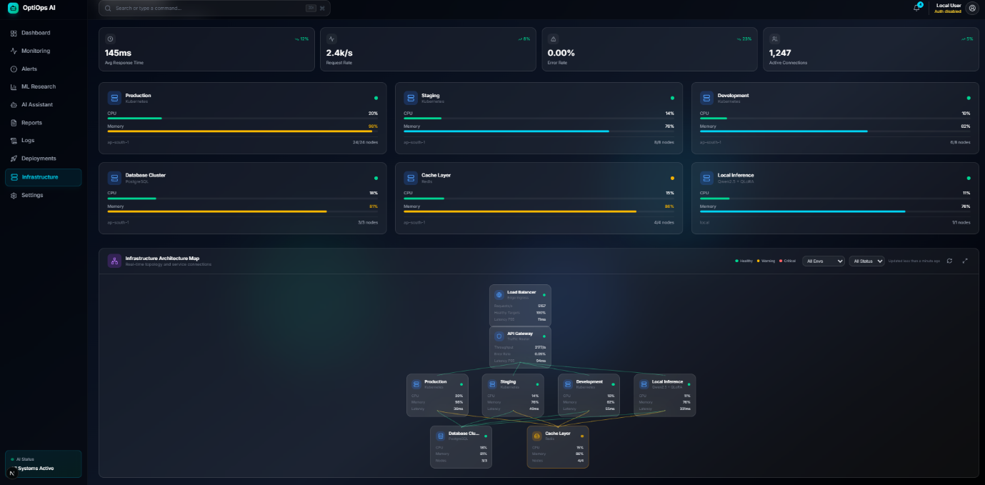
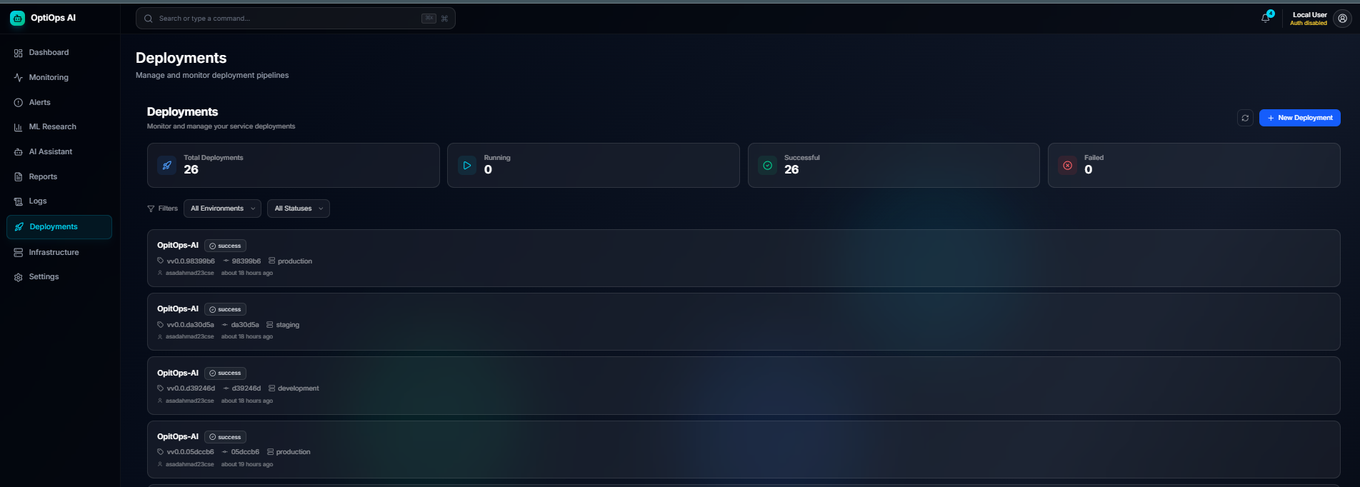

7. Limitations & Future Work

7.1 Current Limitations
- 320 training examples is sufficient for proof-of-concept but limits the model's coverage of edge-case scenarios. A larger, more diverse dataset would improve generalisation.Small dataset size:
- ROUGE-L and BLEU measure lexical overlap with reference answers. They do not capture whether a response is operationally correct or actionable. Human evaluation by SRE practitioners would provide more meaningful quality signal.Evaluation metrics:
- Comparison was conducted only against the same base model (Qwen2.5-0.5B) in different configurations. A rigorous evaluation would include comparisons against larger general-purpose models (e.g., GPT-3.5, Llama-3-8B) and other SRE-specific models if available.Single baseline model:
- The dashboard's live-data engine currently generates realistic simulated metrics. In a production deployment, this would be replaced with real integrations to CloudWatch, Prometheus, Datadog, or similar observability platforms.Simulated infrastructure data:
- Without a dedicated GPU, local inference is slow (~seconds per token). This is acceptable for async queries but not for interactive real-time use.CPU inference on local mode:

7.2 Future Work
- Implement tool calling (via Vercel AI SDK) so the AI can propose and execute remediation actions (e.g., scaling a service, flushing a cache) with human-in-the-loop approval. This moves the system from advisory to operational.Agentic remediation layer:
- Scale to 5,000+ examples incorporating real production incident post-mortems (anonymised), public runbooks, and SRE community Q&A. This would significantly improve model accuracy and scenario coverage.Dataset expansion:
- Add native integrations with AWS CloudWatch, Prometheus, and PagerDuty to replace simulated data with real metrics, making OptiOps AI deployable in actual production environments.Enterprise observability integration:
- When an alert is resolved, automatically generate a structured post-mortem document (timeline, root cause, impact, follow-up actions) using the live context captured during the incident.Automated post-mortem generation:
- As new incidents are resolved, append them to the training dataset and periodically retrain the adapter — creating a system that improves from operational experience over time.Continuous fine-tuning pipeline:

8. Conclusions
OptiOps AI demonstrates that a small, efficiently fine-tuned language model combined with a RAG pipeline and live infrastructure context can deliver expert-quality DevOps assistance without requiring expensive cloud GPUs or exposing sensitive data to public AI services.
The project achieved a 52.75% improvement in ROUGE-L accuracy through QLoRA fine-tuning on a hybrid dataset of 320 domain-specific examples. Qualitative analysis confirms that the fine-tuned model produces operationally actionable responses — referencing specific tools, diagnostics, and remediation patterns — compared to the generic outputs of the baseline model.
Beyond the AI component, the full-stack Next.js dashboard provides a unified interface for health monitoring, deployment tracking, cost analysis, and AI-assisted incident response — addressing the core fragmentation problem faced by modern DevOps teams.
The techniques applied — QLoRA, RAG, live context injection, and parameter-efficient adaptation — are directly transferable to production systems. With dataset expansion, real observability integrations, and agentic capabilities, OptiOps AI represents a credible foundation for an enterprise-grade AI-powered SRE platform.

9. References
Dettmers, T., Pagnoni, A., Holtzman, A., & Zettlemoyer, L. (2023). QLoRA: Efficient Finetuning of Quantized LLMs. Advances in Neural Information Processing Systems (NeurIPS).

Du, M., Li, F., Zheng, G., & Srikumar, V. (2017). DeepLog: Anomaly Detection and Diagnosis from System Logs through Deep Learning. ACM Conference on Computer and Communications Security (CCS).

Hu, E. J., Shen, Y., Wallis, P., Allen-Zhu, Z., Li, Y., Wang, S., & Chen, W. (2021). LoRA: Low-Rank Adaptation of Large Language Models. International Conference on Learning Representations (ICLR).

Lewis, P., Perez, E., Piktus, A., Petroni, F., Karpukhin, V., Goyal, N., ... & Kiela, D. (2020). Retrieval-Augmented Generation for Knowledge-Intensive NLP Tasks. Advances in Neural Information Processing Systems (NeurIPS).

Qwen Team. (2024). Qwen2.5 Technical Report. HuggingFace Model Hub. https://huggingface.co/Qwen

Garg, S., Tsipras, D., Liang, P., & Valiant, G. (2022). What Can Transformers Learn In-Context? A Case Study of Simple Function Classes. NeurIPS.

10. Appendix

Appendix A: Evaluation Metrics (metrics.json extract)
{ "metrics": [ { "method": "pretrained_min", "rougeL_f1": 0.182, "bleu": 6.4, "description": "Base model, no prompt engineering" }, { "method": "prompt_engineered", "rougeL_f1": 0.231, "bleu": 8.1, "description": "Base model with SRE system prompt" }, { "method": "qlora_finetuned", "rougeL_f1": 0.278, "bleu": 10.5, "description": "QLoRA fine-tuned on hybrid dataset" } ] }

Appendix B: Dataset Format Example
{ "instruction": "Redis connection pool exhausted on payment-api.", "input": "Logs show ECONNREFUSED on port 6379. maxclients=100.", "output": "1) Scale maxclients in redis.conf. 2) Audit connection pool size in app config. 3) Check for connection leaks." }

Appendix C: Key Project Scripts
Script | Purpose
ml/scripts/build_dataset.py | Hybrid dataset construction (templates + HuggingFace sources)
ml/scripts/preprocess_split.py | Stratified 70/15/15 train/val/test split
ml/scripts/train_qlora.py | QLoRA fine-tuning with 4-bit quantization
ml/scripts/evaluate_baselines.py | ROUGE-L and BLEU evaluation across all model configs
ml/scripts/init_sqlite.py | Experiment metadata database initialisation
ml/scripts/seed_chroma.py | ChromaDB vector store seeding for RAG pipeline
ml/inference_server.py | Local inference server for fine-tuned model

