**FAST ATTENDANCE**

FAST Attendance System is a FAST ATTENDANCE SMART TECHNOLOGY which helps the users and employee of the company to manage the attendance which highly qualify and secure tracking system with their location (Longitude and Latitude) and Google maps.

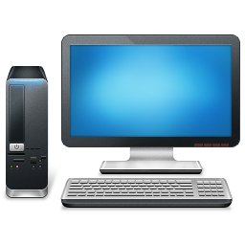***Attendance Management System Work Flow***

**

**Over Time Reports**

**Attendance and Absent Reports**

**Link to ePayroll**

**Manual Attendance Entry**

**Update Attendance**

**Employee Roster**

**Device log**

***Employee***

***Computer***

**Roster Reports**

# Employee Clock in :

Attendance System covers the clock in , where employee of the company can check in their time once and tracking time of the system starts . Time Management and Secure Time clocking for employees are maintaining in the system . User can feel freely to press the check in button and his attendance is managed over the system. that is the

# Employee Clock Out:

Attendance System has the clock out , where employee of the company can check out their time once and tracking time of the system ends . Time Management and Secure Time clocking for employees are maintaining in the system . User can feel freely to press the checkout button and his attendance is managed over the system. When the employee checkout , his overall working hours is managed in the report.

# Employee Apply Leave:

Attendance System describes the apply leave where employee of the company can apply the leave by selecting the date and time , the system will ask the reason ,leave dates from and to and full description of comments of reason that will mail to the hr of the company. If company does not have hr , so it gives the error of registering the hr account of the company.

# Employee Late Coming:

Attendance System gives the concept of late coming , where employee of the company can easily apply the late coming from anywhere at every place through web and android . If employee came late and having such type of hurdles like traffic etc , can easily inform the company from home and in some street and town from internet . Late coming has a simplified form where employee can easily fill and describes his reason for late coming. This can full the employee needs and responsibility against the company. Employee can only give the date and time and give the reason of late coming , an email has been sent to the hr of the company and employee can easily satisfy the performance and scalability.

**Database related Information :**

1 , We make employee attendance database separately and fetch value into main form dynamically from multiple table.

2, When user "Clock in" the location and time of the user are selected and insert into the database.

3 , When user "Clock out" the location and time of the user are selected and insert into the database.

4 , In the End of month the employee attendance log are maintain and this part related to the payroll module.

5 , Employee salary are generated automatically according to the employee daily attendance log.



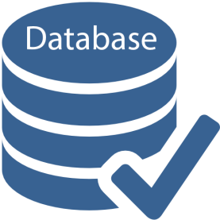

Office Employee Clock In





Office Employee Clock Out

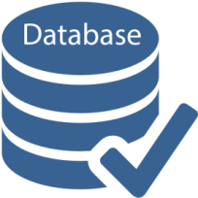

Employee Log Payroll



Employee Salary

INVENTORY

Inventory is the [raw materials](http://www.investopedia.com/terms/r/rawmaterials.asp), work-in-process goods and completely finished goods that are considered to be the portion of a business's assets that are ready or will be ready for sale. Inventory represents one of the most important assets that most businesses possess, because the [turnover](http://www.investopedia.com/terms/t/turnover.asp) of inventory represents one of the primary sources of revenue generation and subsequent [earnings](http://www.investopedia.com/terms/e/earnings.asp) for the company's shareholders/owners.

**Diagram Inventory Manage:**

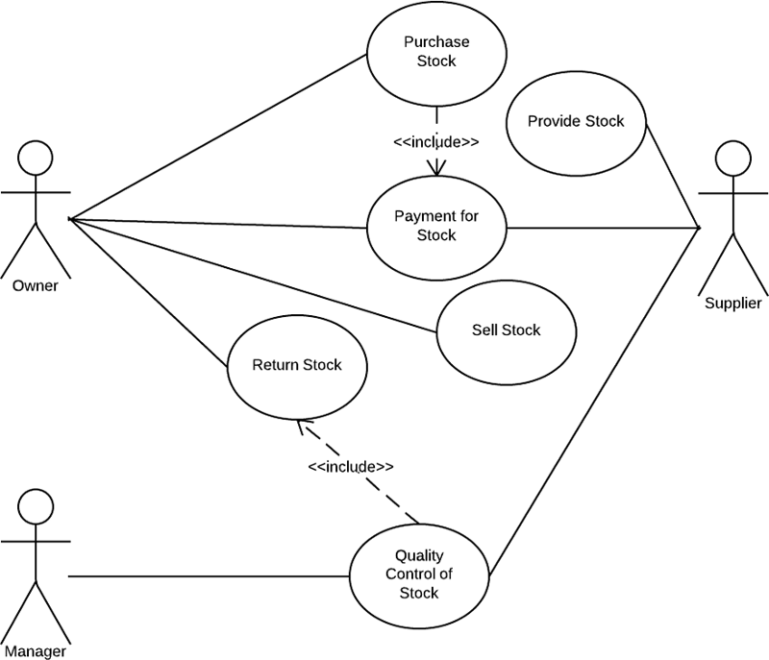

**Login To Inventory :**

1 , Admin Enter valid username and password then login to the inventory module.

2 , If admin enter invalid username and password then system shows message for reentered password.

3 , After Login Admin have a rights for fetch and insert data into database and manage the stock .

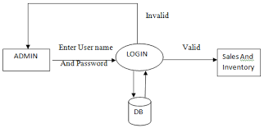

**INVENTORY MODULE :**

1 , Uniform Inventory

2 , Weapon Inventory

3 , Licenses Inventory

4, Product Inventory

**Uniform Inventory :**

Uniform inventory includes the shirts , trousers , belt , cap , shoes of Al-Khalid security company. Only one uniform set allocate to one guard for the six month only . Under the six month if guard wants another uniform set so first guard gives the application for uniform and company detect the half price of uniform from his salary . After six month company gives the new uniform set to every guard.

**Database related Information :**

1 , We make shirt , trouser, cap , shoes database separately and fetch value into main form dynamically from multiple table.

2, User select the values from drop down list like shirt size etc and the values came from database dynamically .

3 , After submission of from uniform allocate to the guard against his unique ID.

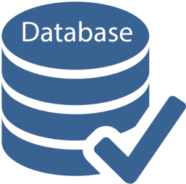

Admin Guard

Other

Shoes

Trouser

Cap

Shirt

Unique ID

**Weapon Inventory :**

Weapon inventory includes the all ammunition . Like bullets or gun related staff . Weapons and bullets allocate to guard by company by filling paper documents like weapon authority letter etc , If weapon damage or stolen by guard site so guard submit the application to the company with reasons and then company allocate the new weapon to the guard.

**Database related Information :**

1 , We make Weapon , Weapon type , Weapon Detail database separately and fetch value into main form dynamically from multiple table.

2 , User select the values from drop down list like weapon , bullets etc and the values came from database dynamically .

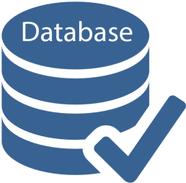3 , After submission of from weapon allocate to the guard against his unique ID.

**Admin** **Guard**

Unique ID

Weapon

Other

Weapon Detail

Weapon Type

**Licenses Inventory :**

Licenses inventory includes the licenses book in which all weapons number are noticed . One licenses have ability to write 5 weapons number on it . All Licenses are renewal every year.

**Database related Information :**

1 , We make licenses database separately and fetch value into main form dynamically .

2 , User select the values from drop down list like Licenses number etc and the values came from database dynamically .

3 , After submission of from licenses allocate to the weapon against his unique ID.

 Admin Guard

Unique ID

License Type

License Detail

Other

**Product Inventory :**

Product inventory includes camera , monitor stock and other office staff etc. If clients need security camera so company provides within a low cost.

**Database related Information :**

1 , We make product database like camera , staff equipment or others separately and fetch value into main form dynamically from multiples .

2 , User select the values from drop down list like product name ,number , quantity etc and the values came from database dynamically .

3 , After submission of from product allocate to the client or guard according to the condition against his unique ID.

Office Equipment

Monitor stock

Camera

Unique ID

Admin Guard

**PayRoll Module**

**Introduction**

Payroll Management System is basically is used to build an application program that a company uses to manage the records of the employees working in the company.

Only the administration has the legal rights to work with the system. Employees can only log on the system to see their current status

**Payroll System Is Used To:**

* Created records
* Save records
* Delete records

For employees according to their information given to the administration of the company.

**Choosing a Payroll System**

It becomes difficult to find out the payroll system you specifically require. The criteria that help one to do so are as follows:

* Security
* Compatibility
* Credibility
* Flexibility

**Payroll Management System:**

The Payroll Management System deals with the financial aspects of employee's salary, allowances, deductions, gross pay, net pay etc. and generation of pay-slips for a specific period.  
The outstanding benefit of Payroll Management System is its easy implementation. Other advantages of Payroll Management System are its extensive features and reports.

**Features**   
Payroll Management System gives you the power to:

* Manage **Employee Information**Efficiently.
* Define the **emoluments, deductions, leave**etc.
* Generate **Pay-Slip**at the convenience of a mouse click.
* Generate and Manage the **Payroll Processes**according to the **Salary Structure**assigned to the employee.
* Generate all the **Reports**related to employee, attendance/leave, payroll etc.
* Manage your own **Security**

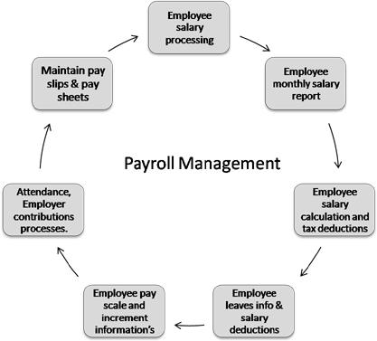

**Payroll Management Work Flow**

**MONTHLY PAYROLL**

**Attendance Leave Overtime**



**Guard**

**Accountant Advice**

**Accountant Advice**

Accountant

**Monthly Payroll**

**Monthly Payroll Process**

**END OF SERVICES**

**End of Service Statement**

**End of Service Process**

**Pay-Slip**

**Payroll Process**

**Taxation Rules**

**Employee Salary Structure**

**PF & Gratuity**

**Attendance Leave Overtime**

**HR/Finance**

**Taxation Rules**

**HR/Finance**

**Increment Bonus/PF**

**Employee Salary Structure**



**USE CASE DIAGRAMS**

**THE USE CASE DIAGRAMS DEFINES THE FLOW OF THE SYSTEM OF ADMIN , ACCOUNTANT AND OPERATOR**

**THE ADMIN DO ALL THE OPERATION OF CRUDS AND IS RESPONSIBLE FOR MAKING ACCOUNTANT AND OPERATOR.**

**ADMIN CAN DELETED ALL OPERATION , AND ALL THE THINGS IS AUTHORIZED TO ADMIN**

**ACCOUNTANT JUST DO ALL ACCOUNTING OPERATIONS AND GENERATE SALARY SHEETS OF GUARDS AND PAYSLIPS.**

**OPERATOR DO ALL THE REGISTERATION AND OTHER OPERATIONS.  
HERE ARE SOME DIAGRAMS WHICH ELABORATE YOU THE FLOW THESE ARE AS FOLLOWS :-**

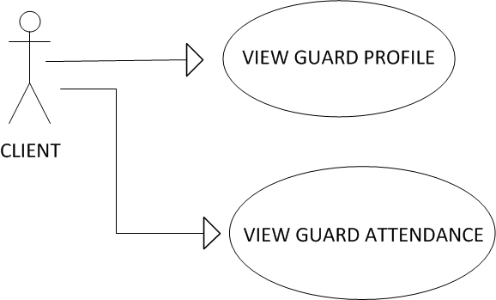

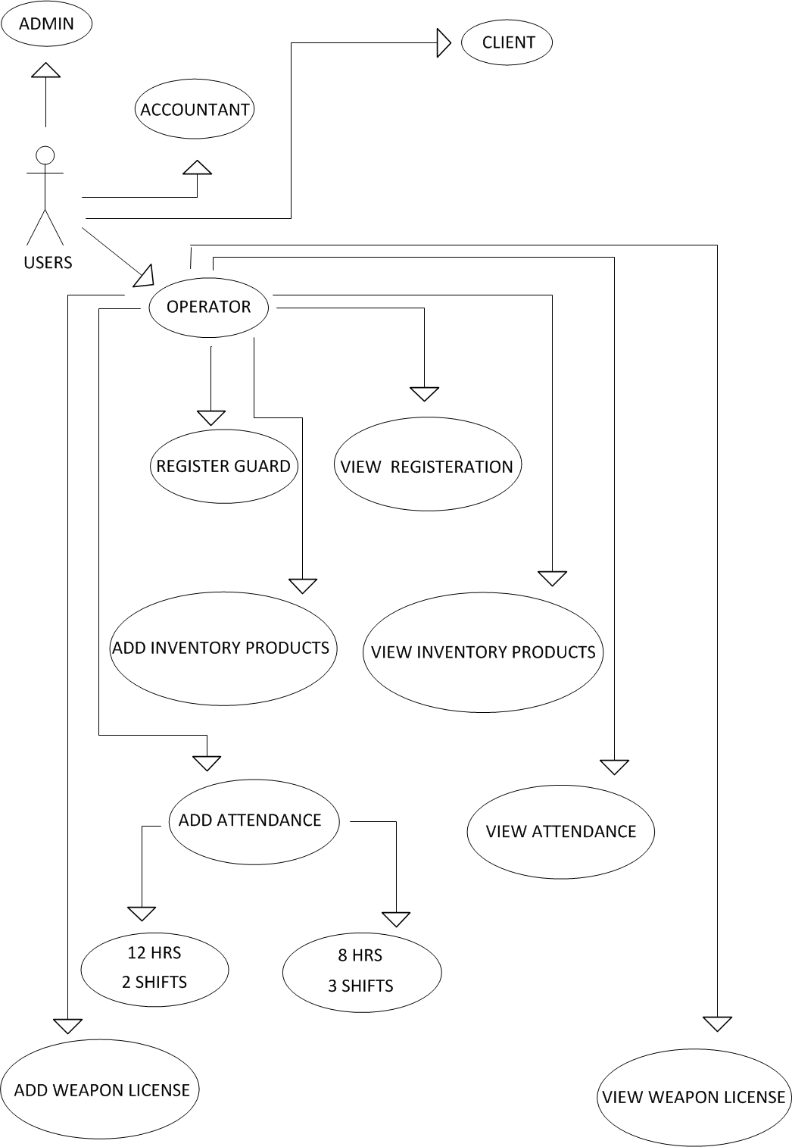

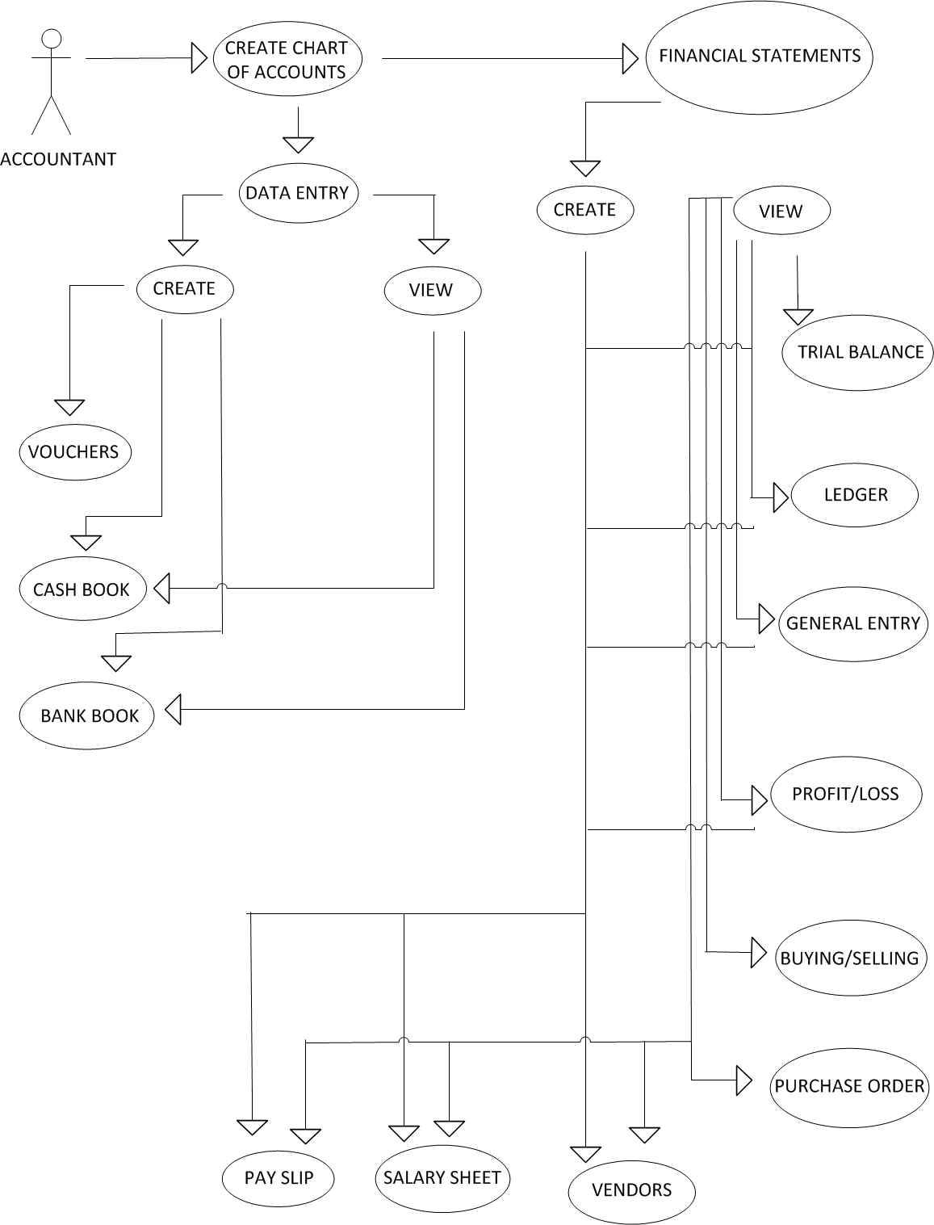

FLOW CHARTS

ADMIN FLOW CHART :-

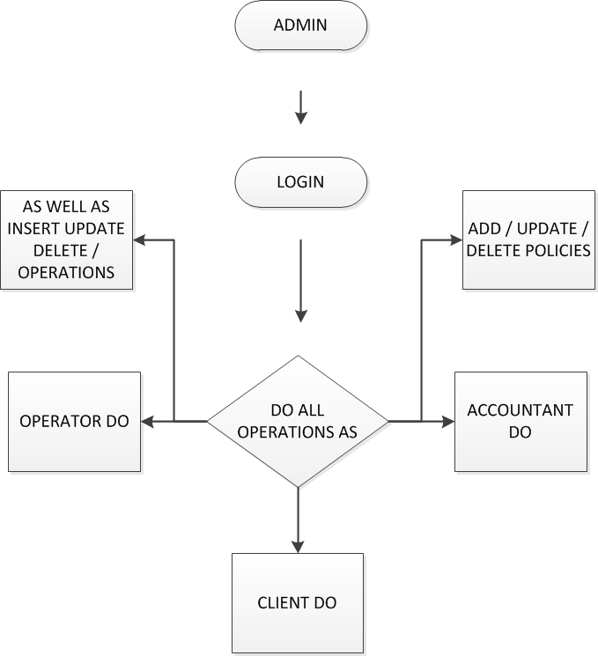

ACCOUNTANT FLOW CHARTS :-

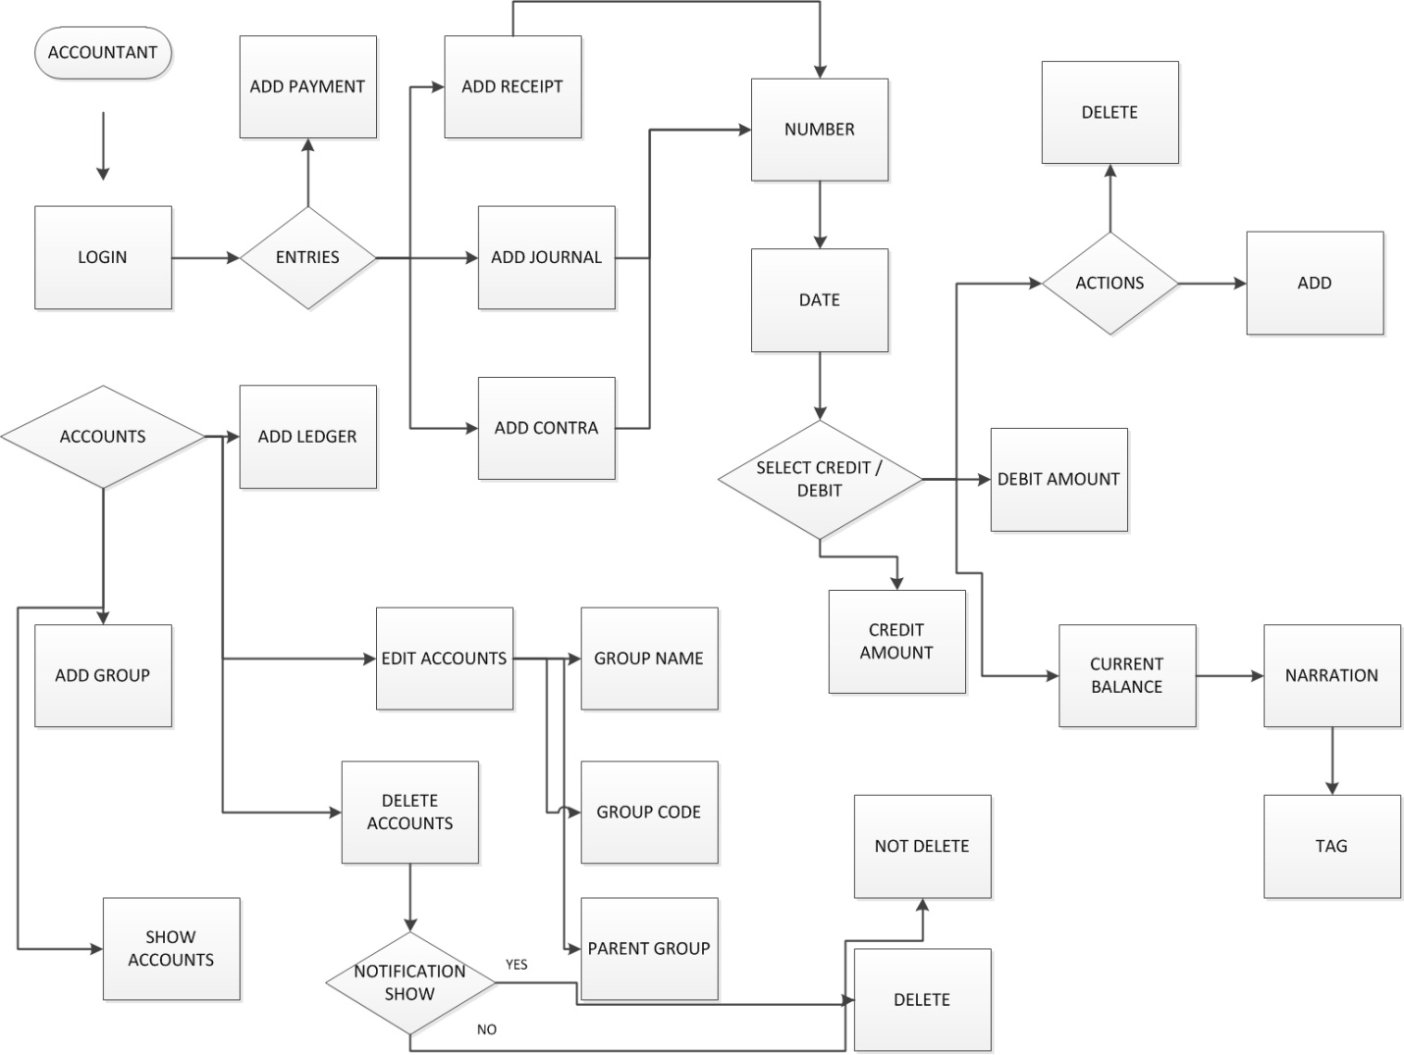

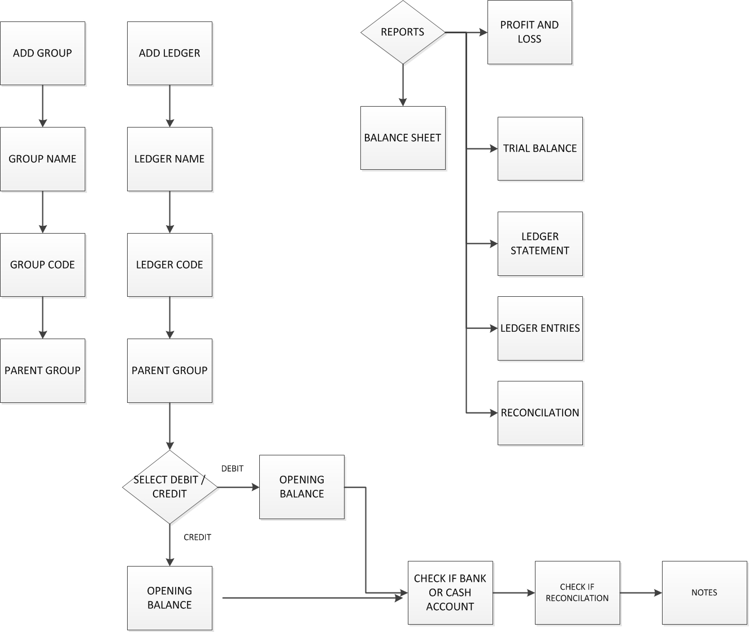

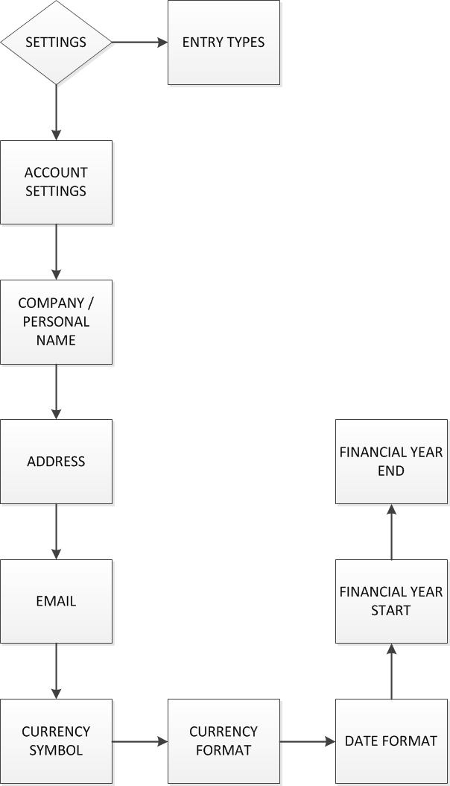

OPERATOR FLOW CHARTS :-

