# Data Analysis Report: Telco Customer Churn

This report documents the data analysis performed on the Telco Customer Churn dataset. The analysis includes data preprocessing, exploratory data analysis, machine learning model development, and a summary of findings with actionable insights.

## 1. Introduction

The objective of this analysis is to identify patterns and insights in customer churn behavior to provide actionable recommendations for reducing churn rates. This analysis aims to deliver business value by understanding key drivers behind customer retention and identifying areas for operational improvement.

## 2. Data Fetching and Preprocessing

The dataset, 'WA_Fn-UseC_-Telco-Customer-Churn.csv,' was loaded into memory using pandas. A wrangling function was applied to handle missing data and perform type conversions, such as converting the 'TotalCharges' column to numeric and 'SeniorCitizen' to categorical. Rows with missing values were removed, and unnecessary columns, such as 'customerID,' were dropped.

## 3. Exploratory Data Analysis

Key statistical insights and dataset characteristics were derived using descriptive statistics. Visualizations were generated to identify trends, correlations, and anomalies in the data.

The Key Insights are the following.

On basis of demographic of the customer who are churn

* Churn rates are equal among men and women, showing no significant gender influence.
* Senior citizens are less likely to churn, possibly due to loyalty or stable usage patterns.
* Individuals without a partner or family responsibilities are more likely to churn, suggesting greater flexibility in switching providers.

On basis of Custome account information, we can conclude that:

* Customers with long-term contracts are significantly less likely to churn compared to those with month-to-month contracts.
* Customers with longer tenure are less likely to churn, indicating loyalty increases over time.

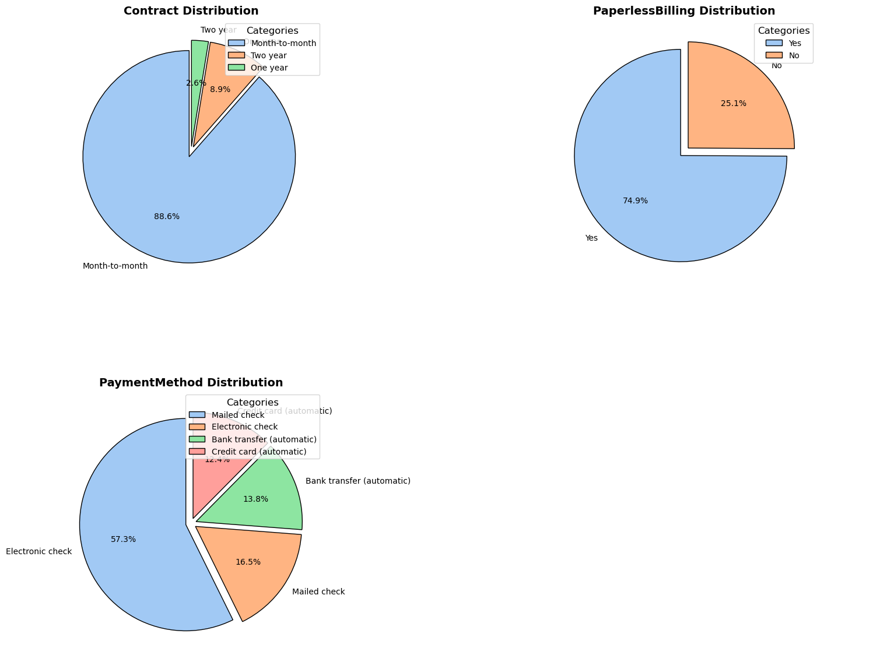

## 4. Machine Learning Model

A deep learning model was built using TensorFlow to predict customer churn. The model includes dense layers and dropout layers for regularization. Performance was evaluated using metrics such as accuracy and F1-score. Confusion matrices were used to visualize model predictions.

Additionally, several traditional machine learning models were tested, including Logistic Regression, SVC (Support Vector Classifier), Random Forest Classifier, and K-Nearest Neighbors. These models were first trained on the entire dataset, and then retrained using only the most important features. Although the results were consistent across all models, the deep learning model provided comparable performance to the traditional approaches.

## 5. Findings and Recommendations

Findings include key features contributing to customer churn, such as contract type, tenure, and monthly charges. The analysis provides actionable insights for retaining customers, such as offering promotions to long-tenure customers or providing more flexible contract options.

## 6. Time Spent

The analysis was completed in approximately 4 hours, including data preprocessing, modeling, and report preparation.

## 7. Future Work

Further analysis could include additional feature engineering, the inclusion of external data sources, and the exploration of alternative machine learning models to improve prediction accuracy.