Digital Wallet & Rewards / Loyalty System
Solution Blueprint + UI Wireframes + APIs + Database Design
Document Version: 1.0 | Date: 2026-03-15

1. Introduction
A Digital Wallet & Rewards/Loyalty System enables users to store money digitally, perform transactions (top-up, pay, transfer), and earn/redeem rewards points based on configurable business rules. This document defines the end-to-end application blueprint with roles, modules, screens, APIs, data model, and flows.

2. Objective
- Provide a secure wallet for users to add money, spend, transfer, and view statements.
- Implement a flexible loyalty engine (points, tiers, campaigns) to increase retention and repeat usage.
- Offer an admin portal for onboarding, KYC approvals.
- Generate invoices/receipts and downloadable statements for compliance and user transparency.

3. Business Benefits
- Higher customer retention via points, tiers, cashback, and targeted campaigns.
- Lower payment friction: wallet balance reduces checkout time and improves conversion.
- Better analytics: transaction + reward data enables smarter marketing and fraud detection.
- Operational efficiency: admin portal centralizes KYC, dispute handling.

4. Roles & Access Control
Role | Primary Responsibilities
Applicant/User | Registers, completes KYC, manages wallet, earns & redeems points, views statements.
Admin | Approves KYC, manages users, configures reward rules/campaigns, monitors fraud alerts, generates reports.
Support Agent (Optional) | Handles disputes/tickets and escalations (read-only financial access).
Merchant/Partner (Optional) | Provides reward catalog items/coupons, views redemption stats.

5. System Scope

5.1 In-Scope Modules
- Authentication & Session Management
- User Profile + KYC
- Wallet (Balance, Top-up, Transfer, Pay)
- Ledger & Transaction History
- Rewards/Loyalty (Points, Tier, Earn/Spend Rules)
- Rewards Catalog + Redemption
- Notifications (Email/SMS/Push)
- Admin Portal (Approvals, Campaigns, Reports, Risk/Fraud)
- Receipts/Statements (PDF/CSV)

5.2 Out-of-Scope (can be added later)
- Full banking integrations (core banking, savings accounts)
- International remittance
- Crypto wallet features
- Advanced ML-based fraud detection (beyond rule-based flags)

6. High-Level Architecture
The following diagram shows a recommended microservice-friendly architecture. The wallet uses a ledger-first approach to ensure auditable balance computations.
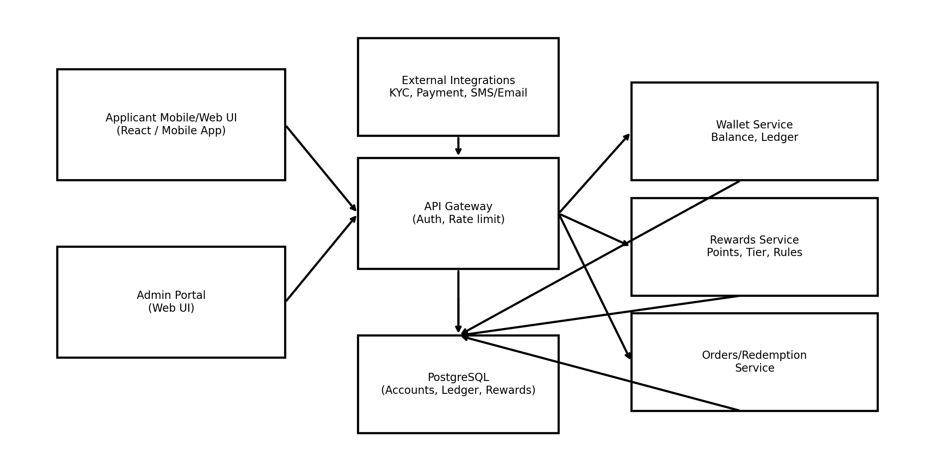

7. Screen Design (UI Wireframes)
Below are sample wireframes for key pages. These are intentionally clean and scalable for React/MUI or Bootstrap-based layouts.
UI-01 Applicant Login
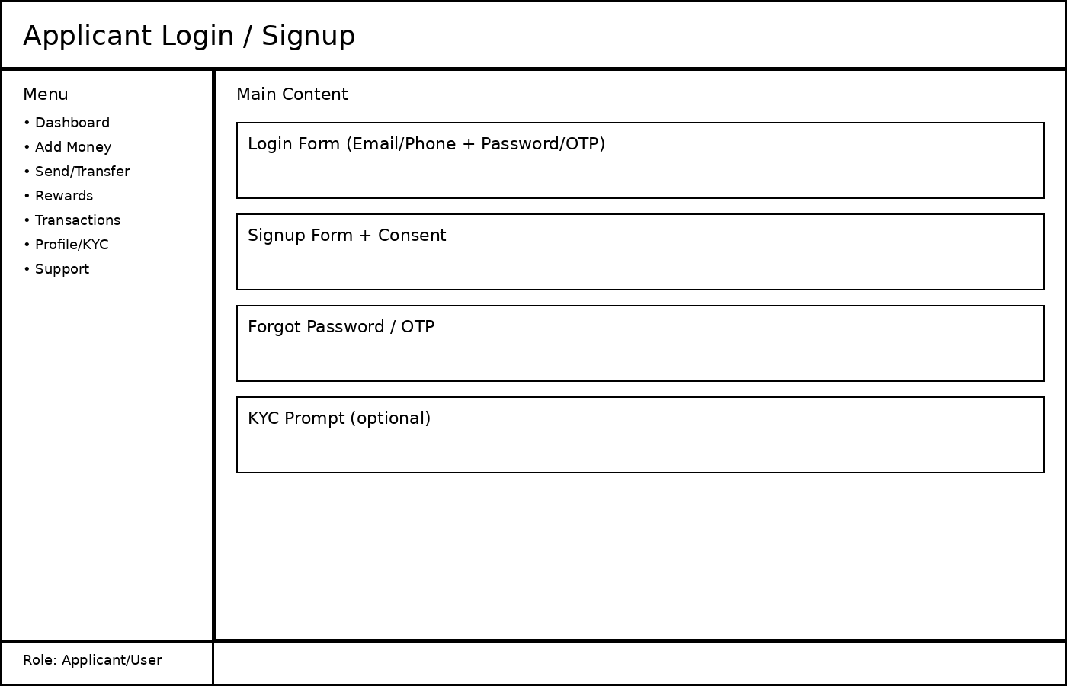
UI-02 Wallet Dashboard
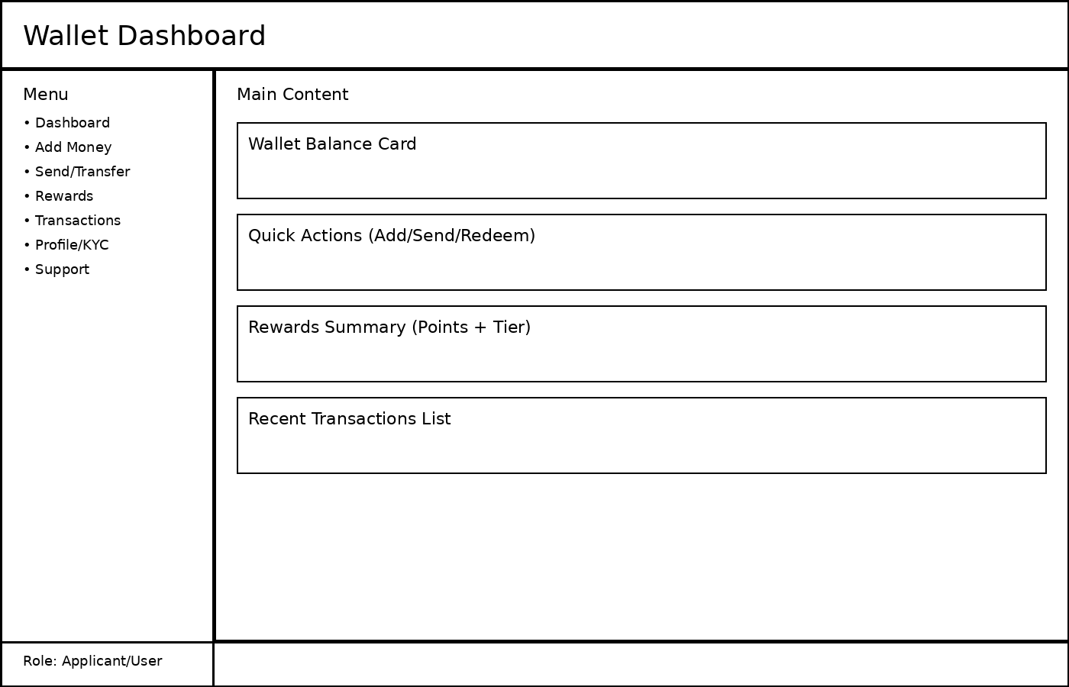
UI-03 Add Money
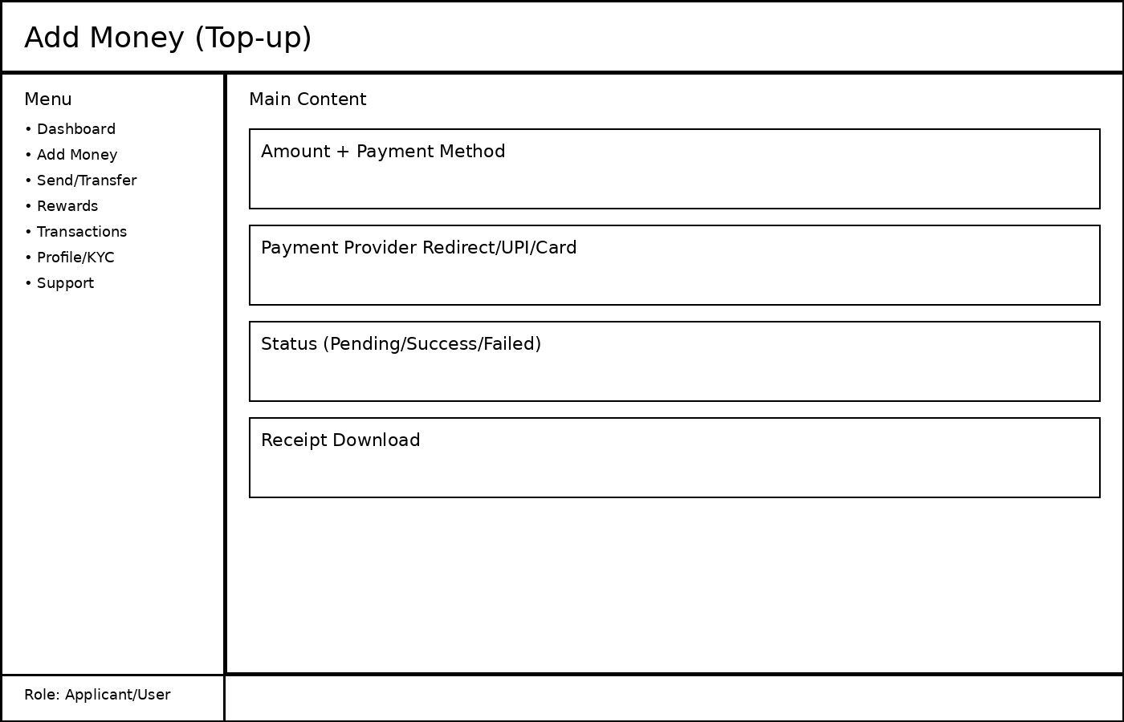
UI-04 Rewards
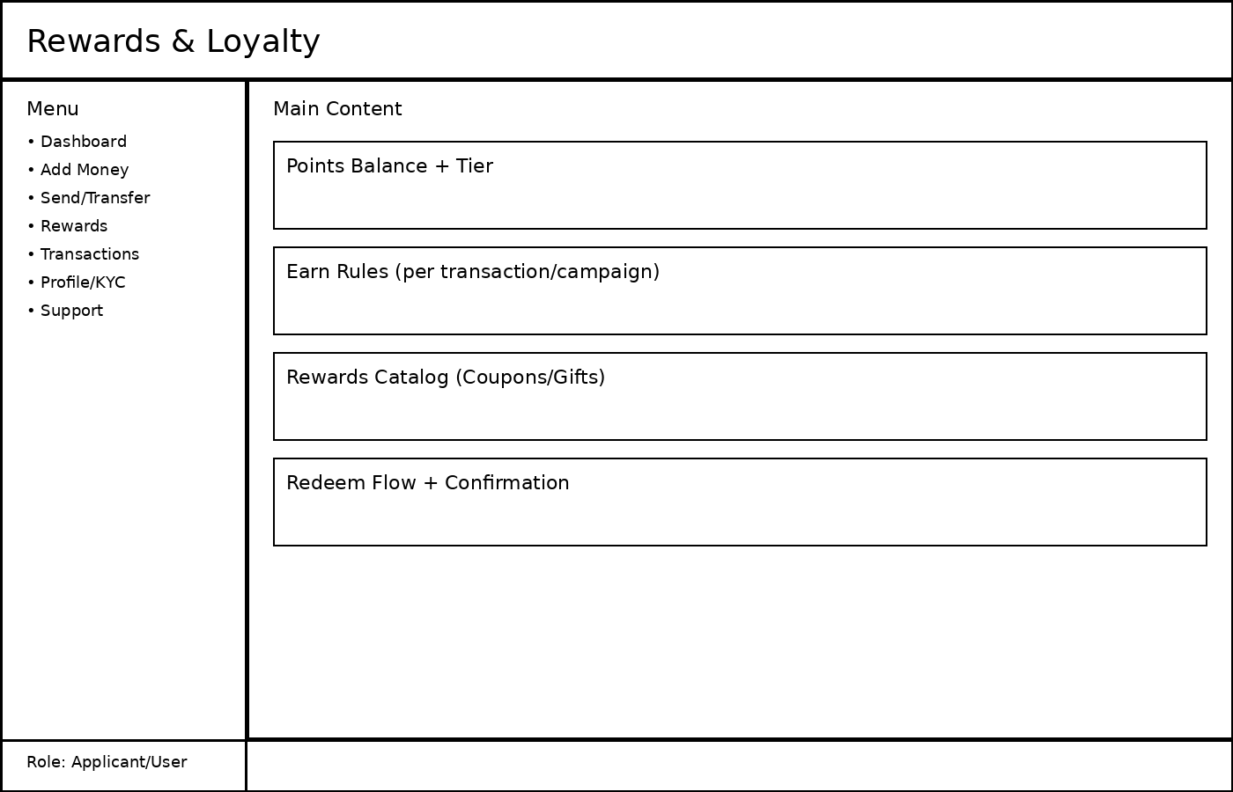
UI-05 Transactions
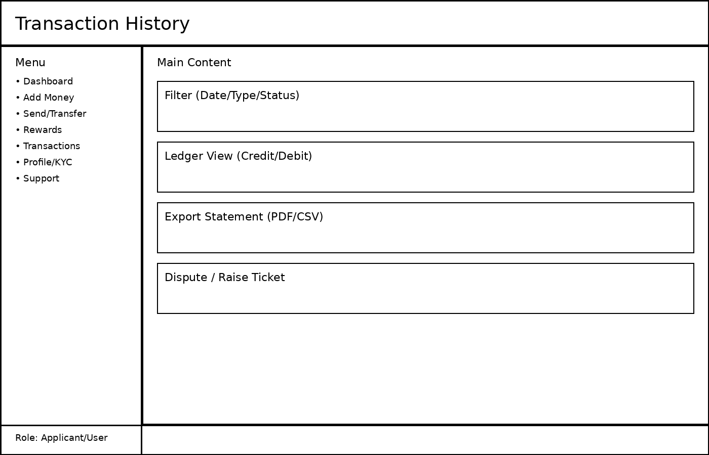
UI-06 Admin Dashboard
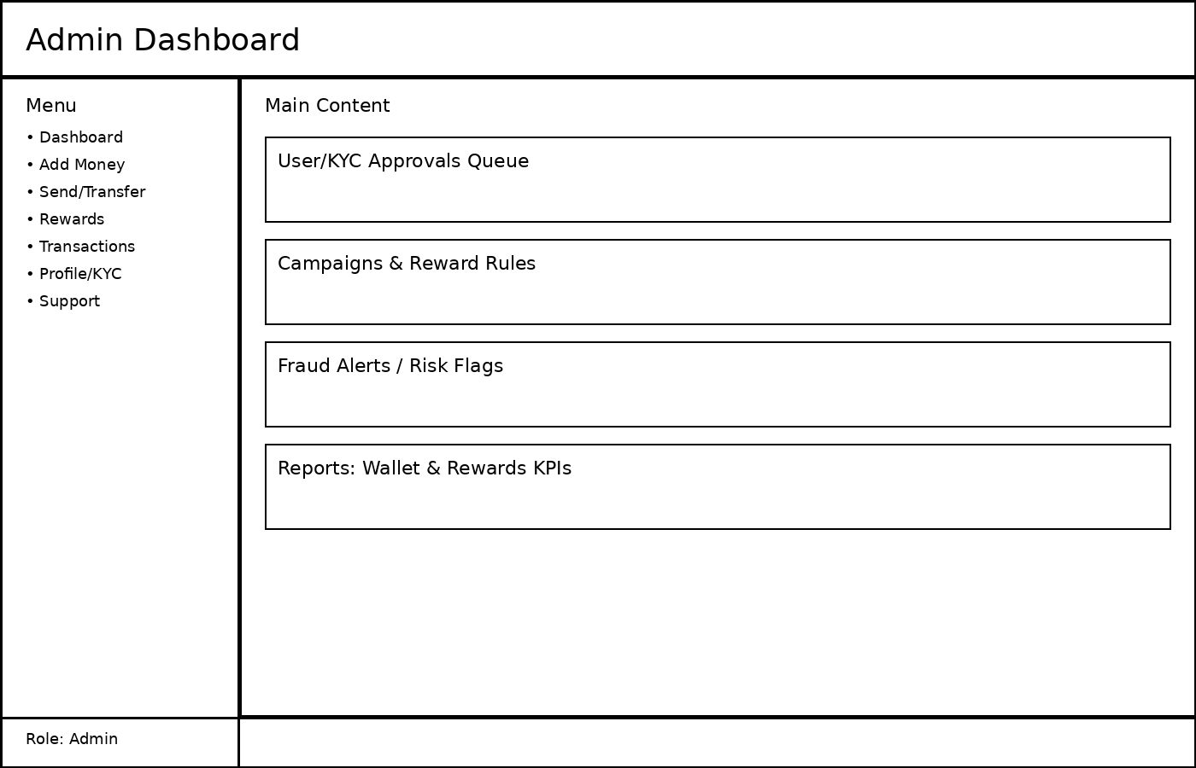

8. Functional Requirements

8.1 Applicant/User Features
- Signup/Login using Email/Phone with OTP and password (configurable).
- KYC submission (document upload + verification status).
- Wallet top-up using UPI/Card/NetBanking (payment provider integration).
- Wallet transfer to another user (P2P) with daily limits.
- Rewards points earning based on configurable rules (e.g., 1 point per ₹100 spent).
- Rewards redemption for coupons/cashback/gifts with points deduction.
- View transaction history, filter, export PDF/CSV statements.
- Raise disputes for failed/pending transactions and track ticket status.

8.2 Admin Features
- Approve/Reject KYC with reasons and audit trail.
- Create reward campaigns (time window, rule, caps, eligible users/tiers).
- Manage rewards catalog (coupons, vouchers, redemption cost, stock).
- Monitor risk flags (high velocity transfers, unusual top-ups, repeated failures).
- User management (activate/deactivate, reset password, view wallet summary).
- Reports dashboard: wallet load/spend, active users, redemption volume, tier distribution.

8.3 Business Rules (Sample)
Rule Area | Rule Examples (Configurable)
Wallet Limits | Daily top-up limit ₹50,000; daily transfer limit ₹25,000; max 10 transfers/day
Rewards Earning | 1 point per ₹100; bonus 100 points on first top-up; campaign-based cashback points
Tiering | Silver: 0–999, Gold: 1000–4999, Platinum: 5000+ points
Redemption | Minimum 100 points; points expiry after 365 days; limited stock for some rewards

9. Non-Functional Requirements
- Security: HTTPS everywhere, secure session cookies, CSRF protection for web, audit logs for admin actions.
- Data Integrity: ledger-first transactions; idempotency keys for payment callbacks; ACID DB transactions.
- Performance: dashboard loads < 2 seconds under normal load; pagination for lists.
- Availability: graceful degradation if external payment/KYC providers are down.
- Compliance: store PII securely; retention policies for logs; exportable statements.

10. Database Design (ERD)
The ERD below shows a practical schema for wallet + rewards. LedgerEntries is the source of truth for balance calculations.
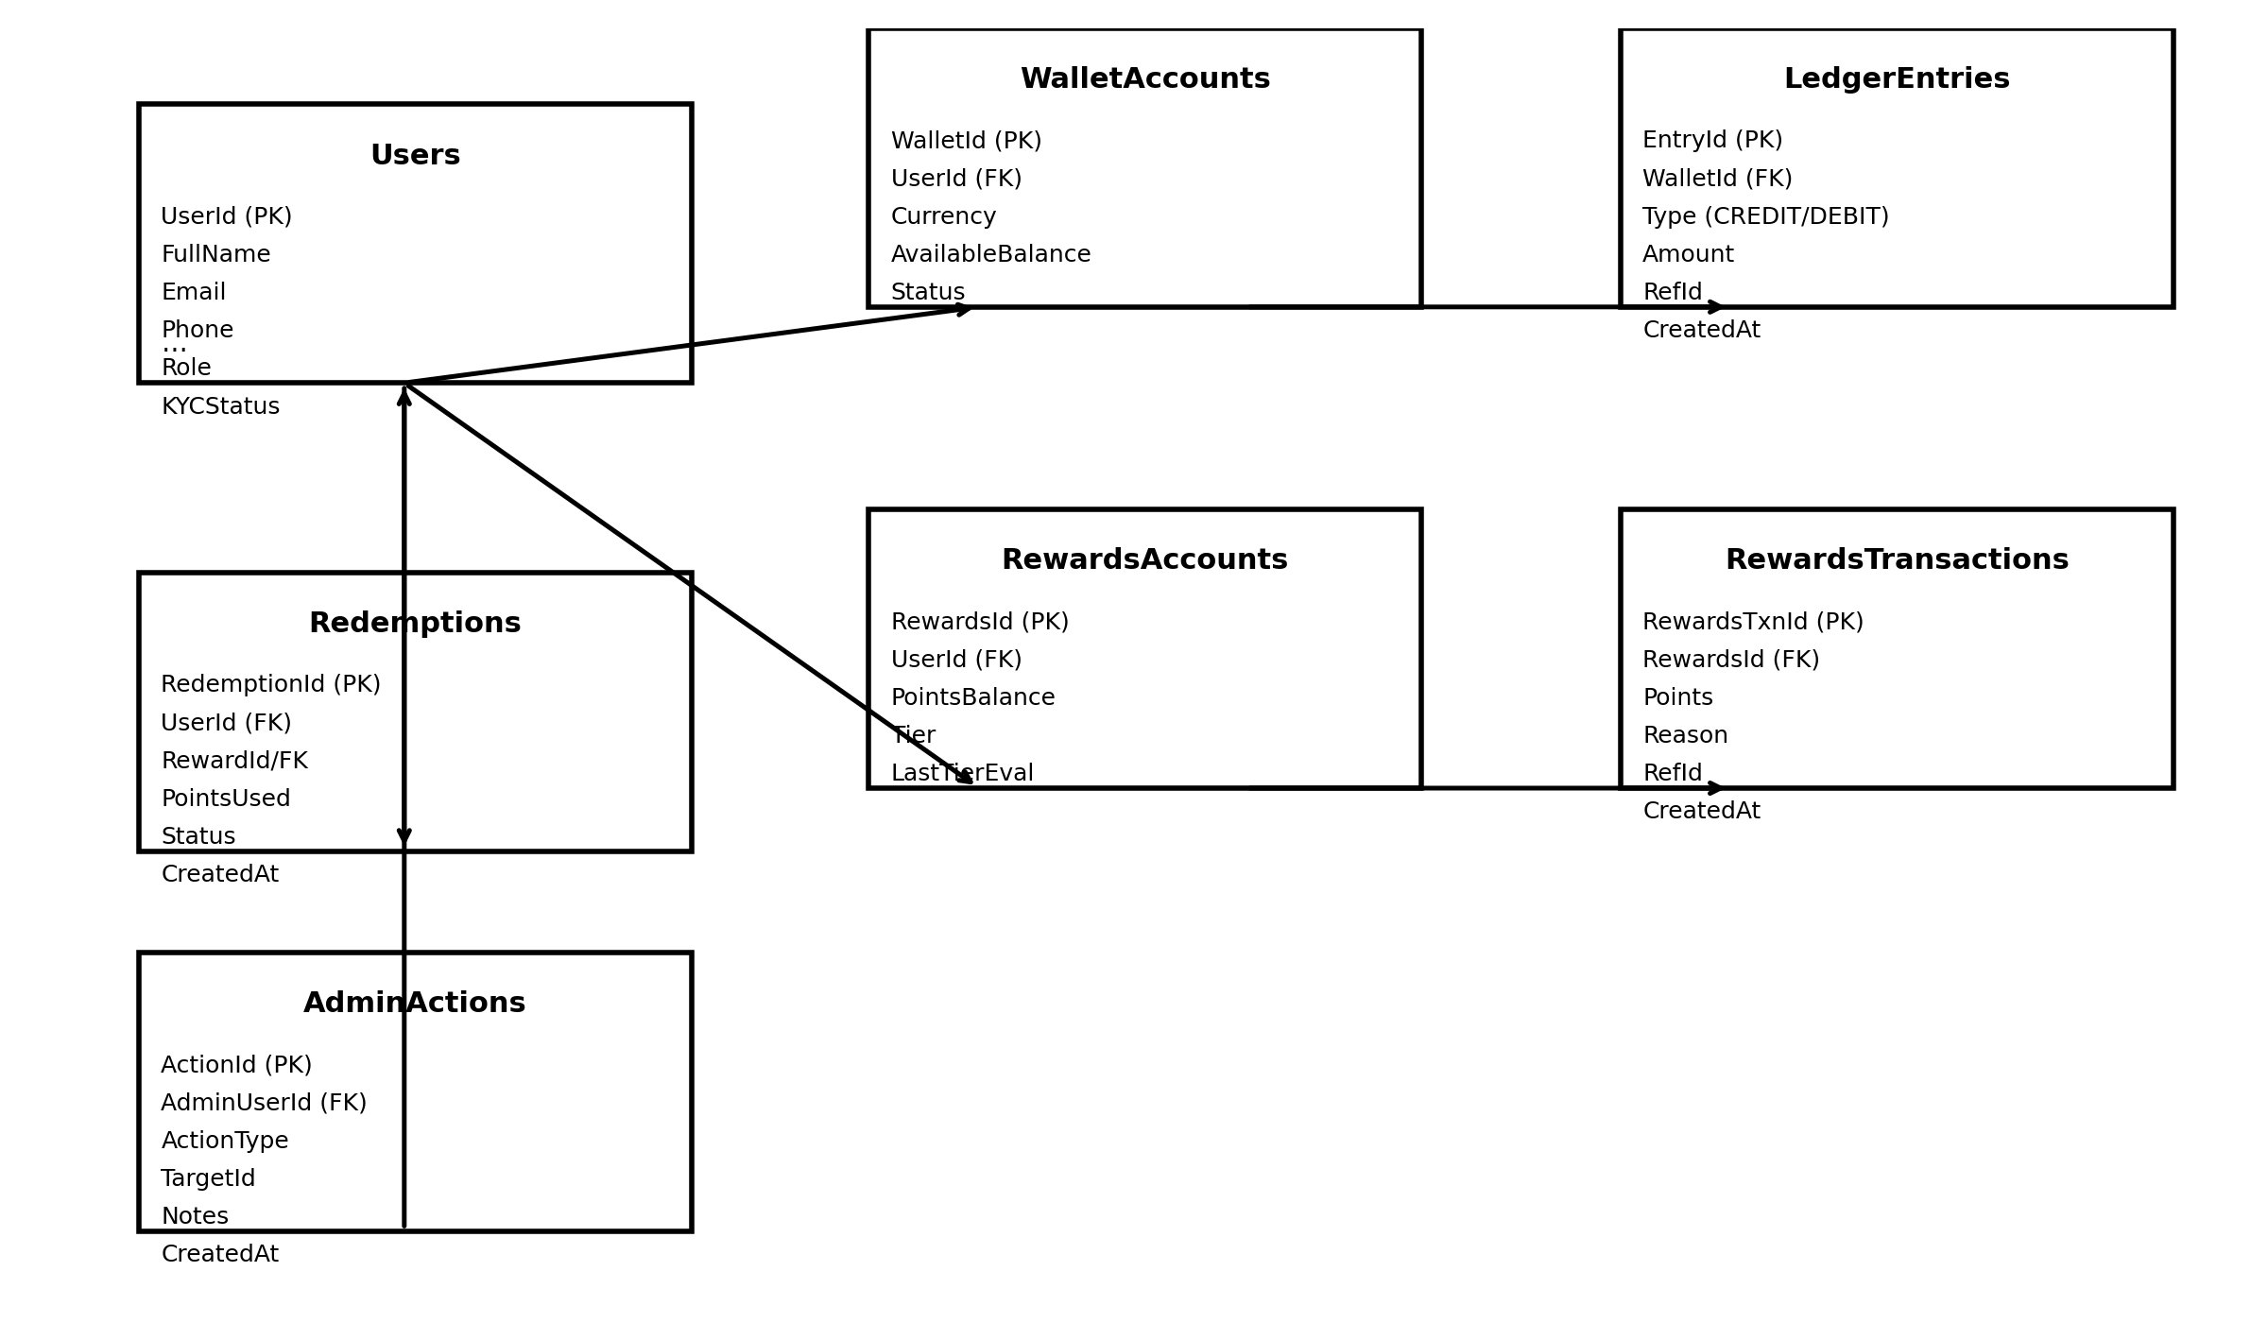

11. API Endpoints (REST)
Example endpoints (you can implement in Java Spring Boot or .NET Web API). Use session/JWT based on your security strategy.
Method | Endpoint | Purpose
POST | /api/auth/signup | Create user account
POST | /api/auth/login | Login and create session/token
POST | /api/kyc/submit | Submit KYC details/documents
GET | /api/wallet/balance | Get wallet balance
POST | /api/wallet/topup | Initiate top-up
POST | /api/wallet/transfer | Transfer money to another user
GET | /api/wallet/transactions?page=1&size=20 | List transactions (paginated)
GET | /api/rewards/summary | Get points + tier
GET | /api/rewards/catalog | List redeemable rewards
POST | /api/rewards/redeem | Redeem points for a reward
GET | /api/reports/statement?from=YYYY-MM-DD&to=YYYY-MM-DD | Download statement (PDF/CSV)
GET | /api/admin/kyc/pending | Admin: list pending KYC
POST | /api/admin/kyc/{id}/approve | Admin: approve KYC
POST | /api/admin/campaigns | Admin: create campaign
GET | /api/admin/dashboard | Admin: KPIs summary

12. Key Use Cases (Step-by-Step Flows)

12.1 Use Case: Add Money (Top-up)
- Applicant selects Add Money, enters amount, chooses payment method.
- System creates a TopUp request with status = PENDING and generates an idempotency key.
- User completes payment on provider page (UPI/Card).
- Provider calls payment callback → system verifies signature → marks as SUCCESS/FAILED.
- On SUCCESS: system inserts LedgerEntry CREDIT and updates WalletAccount snapshot balance.
- System awards reward points if an earning rule applies (campaign/standard rule).
- User sees updated balance + receipt.

12.2 Use Case: Redeem Rewards
- Applicant opens Rewards, selects an item from catalog.
- System validates eligibility (tier, points balance, expiry, stock).
- System deducts points via RewardsTransaction and creates Redemption record.
- If redemption is coupon: generate code and mark redemption as COMPLETED.
- If redemption is cashback: credit wallet via LedgerEntry CREDIT (optional business rule).
- Notify user via email/SMS/push.

12.3 Use Case: Admin KYC Approval
- Admin opens Pending KYC queue.
- Admin reviews documents + user profile and marks APPROVE or REJECT with reason.
- System updates KYCStatus and writes audit entry in AdminActions.
- On approval: user receives notification and wallet features are enabled.

13. Tools & Technology Stack (Suggested)
Layer | Options
Frontend | ReactJS (Admin + User portal), or React Native for mobile
Backend | Java Spring Boot (REST), Redis for caching (optional)
Database | PostgreSQL (ACID transactions), optional read replicas
Auth | Session-based auth OR JWT + refresh tokens
PDF | Backend PDF generator or frontend jsPDF for receipts/statements
Observability | Central logging (ELK), metrics (Prometheus/Grafana)
CI/CD | GitHub Actions / Jenkins + Docker (optional)

14. Expected Results / Deliverables
- Working multi-role application (Applicant/User + Admin).
- Wallet operations with auditable ledger and transaction history.
- Rewards engine with points earning, tiering, and redemption workflow.
- Admin portal for KYC approvals and campaign management.
- Downloadable statements/receipts and basic reporting dashboard.

— End of Document —

